Daniel Leboff – JFS School

OCR Computer Science A Level – Programming Project

Contents

Contents 1

Definition, investigation and analysis 4

Problem definition 4

Benefits of Computational Approach 4

Stakeholder 4

Selection of user group 4

Computational methods 4

Problem Recognition 4

Problem Decomposition 5

Divide and Conquer 5

Other similar products in the industry 5

Investigation and analysis 6

Stakeholder Interview Result 7

Second interview 8

Requirements of Project 8

Limitations of Project 9

Hardware and Software Requirements 9

Success Criteria 10

Design 12

Setting Up Project 12

Basic Plan – Overview of Program 12

Database Design 14

Table Relationships 17

Games 18

Graphic Design 18

Page Design 19

Page Design – General Scenes (Teachers and Students) 19

Page Design – Student Scenes 24

Page Designs – Teacher Scenes 31

Page Designs – Stakeholder Response 37

Page Designs – Revised Designs 39

Page Designs – Stakeholder Response to Revised Designs 48

Algorithm Design 48

Algorithm Design – General Scripts 51

Algorithm Design – Student Scripts 71

Algorithm Design – Teacher Scripts 85

Algorithm Design – PHP Script 93

Validation 93

Buttons 93

Scroll Rects 94

PHP GET Statements 94

Input Fields 94

Testing Methods 95

Iterative Development and Testing 95

White-Box Testing 95

Black-Box Testing 95

SQL Injection 95

General Outline of Tests during Iterative Development 96

General Outline of Post-development Tests 111

Stakeholder Testing 111

Development & Testing 112

Order of Development 112

Stage #1 – Database Creation 113

Stage #2 – General Variables 120

Stage #3 – General Functions 125

Stage #4 – Loading Scene 142

Stage #5 – Start Scene 150

Stage #6 – Create Account Scene 154

Stage #7 – Login Scene 178

Stage #8 – Teacher Main Menu Scene 186

Stage #9 – Teacher Add Class Scene 188

Success Criteria Update 201

Stakeholder Update 201

Stakeholder Update Interview 201

Response to Stakeholder Update Interview 202

Stage #10 – Student Main Menu Scene 204

Stage #11 – Student Choose Game Scene 207

Stage #12 – General Game Script 212

Stage #13 – Linear Spaceship Wars Scene 216

Stage #14 – End Game Scene 233

Stage #15 – Teacher View Classes Scene 237

Stage #16 – View Leaderboards Scene 239

Success Criteria Update 246

Stakeholder Update 246

Stakeholder Update Interview 246

Response to Stakeholder Update Interview 247

Stage #17 – Teacher Homework Menu Scene 249

Stage #18 – Teacher Set Homework Scene 251

Stage #19 – Teacher View Homeworks Scene 259

Stage #20 – Student View Homeworks Scene 267

Stage #21 – Speed Maths Scene 272

Stage #22 – Algebra Millionaire Scene 284

Success Criteria Update 307

Stakeholder Update 307

Stakeholder Update Interview 307

Response to Stakeholder Update Interview 308

Testing 312

Test 1 – SQL Injection 312

Test 2 – Concurrent Use (Single Device) 313

Test 3 – Concurrent Use (Multiple Devices) 314

Test 4 – Concurrent Database Requests 316

Test 5 – Losing Internet Connection 318

Evaluation 323

Evaluation of Success Criteria 323

Essential Features 323

Desirable Features 332

System Maintenance 333

Accessibility 334

Reflection on Program 335

General Comments 335

Bibliography 336

Final Code 338

C# Scripts (in order of development) 338

PHP 399

# Definition, investigation and analysis

## Problem definition

Using Unity3D, I am going to develop a competitive maths games resource for KS3 students. This will be a series of different games revolving around different aspects of KS3 curriculum maths. Each one of these games will have a leaderboard for each class. Examples of potential games include a basic alien shooter game where the player will need to correctly answer a maths question for the shot to take place. Currently, there are no commercially available programs where there are maths games with the functionality of classes **and** leaderboards.

## Benefits of Computational Approach

There are many benefits to this being made with a computational approach. First, it can be used by many people at the same time on different devices. Second, it can be used anywhere in the world as long as they have the program installed. In addition, a computational approach allows for an automatic leaderboard to exist and for a server to keep hold of all scores without the need for the teacher to note them down. Finally, being programmed computationally allows the game to provide randomised games where the computer can determine whether an answer is correct (allowing students to play by themselves) and the students’ scores will be stored online where teachers can access them.

Alternative approaches would be products like board games or worksheets. However, an issue with many board games is that they only have a limited number of questions (and the same issue applies with worksheets). In order for the game to be properly sustainable, there needs to be a sense of randomness which would allow a very large number of possible questions (would be infinite if I don’t implement limits on how difficult the questions are). This could be done using dice for a board game (where the values from dice rolls would form the question that the user needs to answer) but this means placing responsibility on the students to create their own random questions. This is neither fun nor fair. Therefore, the best way of creating a sustainable, fun program for students to use throughout their education is through a computational approach.

## Stakeholder

My stakeholder will be Mrs Mistry. She is a maths teacher for Key Stage 3 and has told me she finds that students coming into secondary school don’t always have a sufficient ability in mathematics to easily progress in the subject. So, she has asked me to create a program which will help students out with basic mathematics but in a way which will be fun for them so it will hopefully convince the students to continue playing and get better at maths.

## Selection of user group

My user group will be KS3 maths students (between 11 and 14 years old) and their teachers. As such, I will be continuously updating my stakeholder, Mrs Mistry (my maths teacher and teacher of KS3 maths), to ensure I am meeting her requirements and she is happy with what is being created. This will allow me to change the direction of the project if Mrs Mistry’s requirements change. In addition, I will correspond with her as to which aspects of the mathematics curriculum she wishes to focus on.

## Computational methods

This project will lend itself to multiple computational methods which I will be able to use to make the project easier to complete and give me a defined set of objectives.

### Problem Recognition

The primary difficulty in this project will likely be the integration of the database. There are multiple difficulties attached to this. First, it will be a relational database (as described later) which means all of the tables will need to link to each other using primary keys and foreign keys and this will require assuring all of the database is in 3rd normal form. Second, the database will be stored on an online server. This adds a level of difficulty when it comes to accessing that data which will again be discussed in a later section.

The rest of the project (making the games, creating the screens etc.) is relatively simple in comparison to the database aspects as all of that part of the project will be local and so there won’t be difficulties in accessing different networks. In addition, the aim is to soft-code the project so that, if extra games are added at a later date, they would be automatically added to things like the leaderboard screen or homework screen.

### Problem Decomposition

This problem can be decomposed into smaller problems. Below is a list of very basic problems which need to be solved:

1. The ability for students and teachers to create accounts and login to the program.
2. The ability for students to play games.
3. The ability for teachers to create classes.
4. The ability for teachers to set homeworks for students.
5. The ability for students and teachers to view homeworks.

There are obviously a lot of other aspects to this project but these are the most important and the others are just additional parts which add to the completeness of the problem but are not inherently integral to the project as a whole.

### Divide and Conquer

Divide and conquer is the method I am going to use to complete this project. This is an issue given the database will link together different parts of the project. However, I think dividing the project into smaller sections and focusing on that one individually is the best method as long as I am thinking about how they will integrate with other sections at the same time.

## Other similar products in the industry

After doing some research, I have found multiple sites which are similar in the sense they use games to enrich students’ mathematical abilities.

|  |  |
| --- | --- |
| prodigygame.com – This website uses games and has teacher and student codes to allow students from the same class to compete. However, as can be seen on the right image, it is oriented towards KS2 students and has basic problems whereas I will include more complex maths. My stakeholder has indicated to me that she would like this solution to focus more on the fundamentals of mathematics as opposed to specific mathematical problems.  Getting the full version of prodigygame costs $3.75 per month per student. This, especially for a school like my stakeholders with 2000 students, comes out as a significant amount and so the fact that my program will be free makes a significant difference to the school | Image result for prodigygame maths  Figure 1: Prodigy Game Screenshot |
| mymaths.co.uk – This website is primarily used for homework and uses mostly problems instead of games. It has games but doesn’t include class leaderboards.  I have spoken to multiple people who use mymaths and none of them had ever played the mymaths games and a few didn’t even know they existed. So, the games are certainly not a focus of this program whereas it will be in my project.  In addition, mymaths costs £625 per year for the school where the money may be better spent elsewhere. So, the fact that this project will be free for the users is significant for the school. | Figure 2: MyMaths Screenshot |
| topmarks.co.uk – This website includes games aimed at KS3 students. However, similar to mymaths, it doesn’t have leaderboards for classes. In addition, they feel more like a maths tool than a game whilst playing.  Although topmarks is free, it doesn’t have leaderboards which means it’s unlikely to provide the enjoyment and motivation to the students that my stakeholder is hoping. | Figure 3: Topmarks Screenshot |

My project will be similar to the websites above but will include things which don’t appear in each website.

* Prodigygame.com – My project will be oriented towards secondary school students compared to primary school students.
* Mymaths.co.uk and topmarks.co.uk – My project will include class leaderboards which is one of the main parts of the project since its increased competitiveness will lead to more enjoyment whilst practising maths skills. In addition, it should lead to students wanting to do the work as opposed to being forced to do homework.

## Investigation and analysis

My stakeholder has given me a basic idea of what she wants but I am going to interview her to get a full idea of what exactly she wants. Since this is a project which could be useful to the whole maths department, I will also interview other mathematics teachers to see if the project that my stakeholder has asked for is relevant to a wider range of people.

## Stakeholder Interview Result

Below are the questions posed to my stakeholder and her response to each question.

**Q: Please give a detailed explanation of what piece of software you want created.**

I would like a maths resource with multiple games which will help students to understand maths ideas. I also want teachers to be able to check how students are doing and what scores they are getting. The games shouldn’t be teaching students the actual topics. Rather, I would like them to be reinforcing understanding of basic mathematical concepts and gain a strong ability in them because a strong ability in basic areas of mathematics like multiplying and exponents are an important aspect of understanding more advanced topics taught in future years. Also, I would like the ability to set homework for students. Although there won’t be questions for them to solve, I want to be able to make them spend a certain amount of time playing the games.

**Q: What use do you have for a program like this?**

I plan on using the program as homework for my students to aid advance their learning. I want it to be used as a reinforcement of things they already know (by strengthening their understanding of basic concepts) as opposed to learning new ideas.

**Q: Who is the target market?**

The target market is secondary school maths teachers and their KS3 students (11-14-year olds).

**Q: What devices do you want the software to be able to run on?**

I definitely want the program to run on typical desktop computers (my school has Windows PCs) because I want to have the possibility of taking my classes to the computer rooms to use the program. Perhaps also on mobile phones because that will make it easier for them to play the games at home as part of their homework.

**Q: What is it about the software you want that you can’t get from products currently available online?**

The ability for teachers and students to view leaderboards of the games for each class. I want to use the children’s competitive nature to make them want to play these games so, if students can view the leaderboards, then they will want to play more games to come top in the standings. I think this is win-win because the students get to have fun whilst strengthening their mathematical minds.

**Q: The user would have to be online to be able to login. Would you like a guest option which would allow someone to play the games offline?**

I don’t think that is necessary since the main point of this program is that there are classes with teachers and students so I think the user should need to log in to be able to play the games.

**Q: How important is the graphics to you?**

It’s important that it looks nice and appealing to students as well as teachers. But it doesn’t need to go over the top and simple graphics for games is fine.

**Q: Do you want students to have the ability to be in multiple classes at the same time?**

Yes. Although students would only be in one class at a time, they may have multiple teachers and each teacher would want their own account with the class.

**Q: Do you want there to be any music or sound effects in the program?**

No. I think music will distract the students so it’ll be better to have no background music. I would however be ok with sound effects which would be played on occasion.

**Q: Are there any extra features which you would like?**

It would be nice if the games had different difficulty levels and either have different leaderboards for different difficulties or make it so that teachers can set the difficulty levels.

In addition, a website/app would be nice so that the students and teachers can access the program for anywhere with internet connection.

Finally, for the homework, it would be nice if you could automatically e-mail the teacher saying which students have not completed the homework in time. Also, making the students spend the time on specific games instead of just generally on the program.

## Second interview

I then conducted a second interview with my stakeholder. I told her that I hope to include most of the features she has asked for, if not all of them. However, I said there were a few features which I have labelled as being ‘extras’ – things which I will do if I finish the project in time since these are non-essential parts of the project which would take a relatively long period of time to complete. These extra features are:

* Different difficulty levels.
* A website/app.
* Automatic e-mails to teachers.

My stakeholder said this is fine so I will now start analysing the requirements of the project and start designing the program and database.

## Requirements of Project

|  |  |
| --- | --- |
| Design | |
| Requirement | **Explanation** |
| Simple Design | The design needs to make it so that the program can be easily understood by the user. It should be intuitive and users should be able to pick up how the program works immediately. |
| Aesthetically Pleasing Design | The program needs to look nice, otherwise it will be dull and boring for the users to use. Looking nice will be achieved by designing the colours and fonts of different objects in the program to look pleasing. I will therefore design each part of the program before developing them. |
| Clear Instructions for Games | The games may not be as intuitive as they seem so the user requires instructions to know what they’ll need to do. When each game loads, I will first present a list of instructions on the screen before the game starts. |
| Readable text (and generally correct sizes for all GUI objects) | The user needs to be able to easily read any text. I will also need to make sure that any text which is too long doesn’t get cut off because of its length. The same goes for all GUI objects (buttons, input fields etc); they need to be easily viewed and without the straining of eyes but they also shouldn’t be unnecessarily large. |

|  |  |
| --- | --- |
| Functionality | |
| Requirement | **Explanation** |
| Account System | Users need to have accounts (teacher and student accounts) because they will need to be identified as part of a class for use in homework and leaderboards functionalities. The best (and most maintainable) way to do this is using accounts. I will need to create the functionality for both creating an account and logging into a previously-made account. |
| Maths Games | The point of this program is to provide a form of maths education for students through the form of competitive maths games. Therefore, having maths games is a key feature. I will need to code each of the games, including functionality like generating random questions and answer checking. |
| Classes | The students will need to be grouped by class and a teacher needs to be assigned to that class. I will need to create a form for teachers to be able to add students to a new class and the teacher will be able to select those students by refining a search by school name and school year and selecting the names from a list. |
| Class Leaderboards | A significant aim of this program is to make use of the competitive nature of schoolchildren. To do this, I will create leaderboards for each class so the students can compare themselves to each other and hopefully increase their overall time. I will create this functionality by storing all top scores and referencing them to a user – allowing me to know which scores come from which user (and therefore which class). I will show the leaderboard in a special leaderboards page. |
| Homeworks | The teacher should be able to set homeworks for specific games and specific classes since homeworks are an important part of school. I will implement class-specific homeworks by referencing every homework to a class so only specific classes receive each homework. I will have a page for teachers to see which homeworks they’ve set. Likewise, I’ll have a page for students to see which homeworks they’ve been set. |

## Limitations of Project

I have noted a few limitations of my project which I have gone through with my stakeholder and we have confirmed I am ok to continue with the project. First, I will only be able to make a few games due to limited time available. Therefore, I won’t be able to cover all of the mathematical concepts I would like to. It’s also highly unlikely I would have enough time to have settings which would allow users to change their account details and other features akin to that.

## Hardware and Software Requirements

Since the program is primarily a game, the language and software I will use must have a good graphical user interface. Therefore, I have decided to use the Unity3d software and C# to program my project. The reason for this is Unity3D allows for powerful games to be made with very good graphics whilst still allowing me to program everything. Although using a game engine reduces the amount of programming required, the things that the software does are things which realistically aren’t going to be programmed in this project (good graphics and complicated physics concepts like gravity). The vast majority of the project will be programmed, including all of the logic and database manipulation. I have chosen my IDE to be Visual Studio Code due to its lightweight, fast and intelligent nature (with features like autocomplete and error highlighting being useful to me).

In addition to the C#, I will be using PHP (stored on an online server with MySQL inside the PHP files) to access the online relational database. I will then link between the C# to the PHP to allow the main program to access the database. Below are the minimum requirements for the user and justification for those requirements. These requirements are for a desktop user: the computers my stakeholder has in her school are all Windows desktops so I will not provide requirements for other brands of computer. I will add requirements for other devices if and when I program for those devices.

|  |  |
| --- | --- |
| Hardware Requirements[1] | |
| Requirement | Reasoning |
| Operating system: Windows 7 or later | Minimum operating system to run Unity games |
| Graphics Card: Must have DX10 capabilities | Minimum operating system to run Unity games |
| CPU: SSE2 instruction set support | Minimum operating system to run Unity games |
| >40MB hard drive space | Approximate file size of the final program |
| >1GB RAM | Required to run the program |
| >1GHz CPU | Required to run the program |
| A desktop monitor | Required to display output |
| A keyboard | Required to answer the maths problems |
| A mouse/trackpad | Required to interact with user interface |
| A stable internet connection | Required for all interactions with the database |
| The port that the online server is running on must be unblocked by the computer’s firewall | Required for successful interactions with the database |

There are no software requirements other than the operating system since Unity games are stored as executable files (.exe) which can be run on all Windows computers. I have checked the specification of the devices in the school and they are all above the minimum requirements. However, I cannot confirm this for student’s computers at home and they would have to make sure they have at least the minimum required specification.

## Success Criteria

|  |  |
| --- | --- |
| Success Criterion | How it will be checked |
| A login system where people can either login as a student or a teacher. | Screenshots from login screen and checking if logging in is successful and unsuccessful depending on the inputs. |
| The ability to create an account, either as a student or a teacher. | Screenshots from create account screen and checking if creating an account is successful and unsuccessful depending on the inputs. |
| The student can be added to a class. | Screenshots from the add class screen where the teacher can add students to a class. I will ensure that students can be searched through a list of students specifically at the same school in the appropriate year group. |
| The student can play maths games. | Screenshots from the screens for the games and showing how the game can be played by the students. |
| The student’s score is displayed on a separate leaderboard for each class and each game. | Screenshots of the screen for showing leaderboards and showing different leaderboards depending on the class and game inputted. |
| The teachers and students can (only) view the leaderboards which apply to their account. | Screenshots of the dropdown icon I’ll have which will list the specific leaderboard options available to the students and teachers depending on which classes they are part of. |
| The teachers can set specific homeworks based on time spent on the program. | Screenshots of the screen for setting homeworks and checking if the homework is uploaded to the database successfully if its inputs are permitted. |
| The teachers can view specific homeworks and see how much time each student has spent on it. | Screenshots of the screen for viewing homeworks. For teachers, they should be able to see who has completed the homework by the due date and who hasn’t. This should be shown simply in the screenshots. |
| The students can view their current homeworks. | Screenshots of the screen for viewing homeworks. |
| Simple and clear – it has a layout which is easy to understand and is pleasing to the eye. | Screenshots of the general layout of the program showing the colour schemes and UI design. |
| Easily Navigated – it should be easy to move from scene to scene without being confused about how to reach a certain scene | Screenshots from scenes, including back buttons. Also, it will be checked through responses from my stakeholder. In addition, I’ll have a survey with KS3 students to ensure it is easily navigable. |
| Data is not lost when the user exits the program. The data and accounts are retrievable. | I will leave the program and re-open it to check if the data can still be retrieved. I will also try it on different devices to test the portable nature of the program. |
| Games are fun to play | I will check this by running a survey with KS3 students to see what they like and dislike about each of the games. I will then try to make those changes (provided by stakeholder agrees with them) |

As various points in the development of this program, I will go through my success criteria to check which ones I have completed and make sure I am on course to fulfil them all. In these sections, I will simply copy-and-paste the above table and highlight each row in one of three colours: green (to indicate I have fulfilled that criterion), orange (to indicate I am in the process of fulfilling that criterion) or red (to indicate I have not yet begun fulfilling that criterion).

# Design

I have decided that it is better for me to do all of the planning and designing of each section of the project before developing, testing and evaluating them, in addition to one larger evaluation at the end of the project. My reasoning for this is that it means it is less likely that major changes will have to be made because I will have thought about how to structure the code and database in a way which would work for all aspects of the project, not something which works well for the create account screen but would make the login screen impossible to make.

## Setting Up Project

I have created a Unity3D project for my project. I created it as a 2D project since the games are most likely to all be in two-dimensional (although I can change this later if required). In addition, the database must be stored online. I have decided to use 000webhost as my server since it is free and gives me 2 databases, each with a size of 1GB and 150 tables, which will be more than enough for my project. I have created an account and will set up the database in the first section.

## Basic Plan – Overview of Program

Below is a list of scenes which will feature in the program and whether it will appear for students, teachers or both:

|  |  |
| --- | --- |
| Loading scene | Both |
| Start scene | Both |
| Login scene | Both |
| Create Account scene | Both |
| View Leaderboards scene | Both  (Students will be able to view leaderboards for classes that they are students of and teachers will be able to view leaderboards for classes that they are the teacher of.) |
| Student Main Menu scene | Students |
| Choose Game scene | Students |
| Game scenes (one scene per game) | Students |
| End Game scene | Students |
| Student View Homeworks scene | Students |
| Teacher Main Menu scene | Teachers |
| Add Class scene | Teachers |
| View Classes scene | Teachers |
| Homework Menu scene | Teachers |
| Set Homework scene | Teachers |
| Teacher View Homeworks scene | Teachers |

The use of each scene will be described in detail in the page design for that scene (at which point the design will explain how the functionality will work).

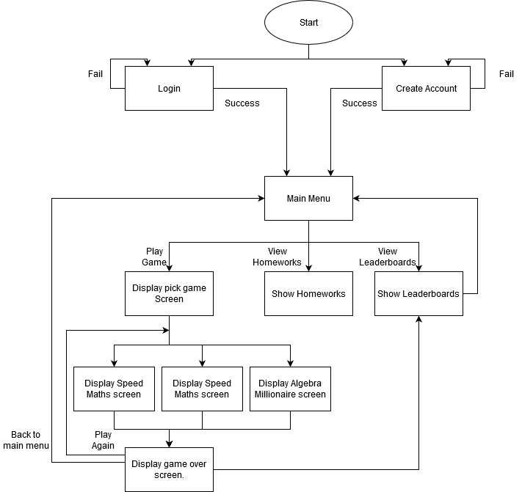

Figure 4 - Basic plan for the 'flow’ of the program for students

Above is a basic plan of how the program will run in the eyes of the user where the user is a student. First, the user will have to either login or create a new account. They will then reach the main menu with the choices of playing a game, viewing their homeworks or viewing leaderboards. If they choose to play a game then, at the end of the game, they will get the choice of either viewing the leaderboard, playing the game again or returning to the main menu.

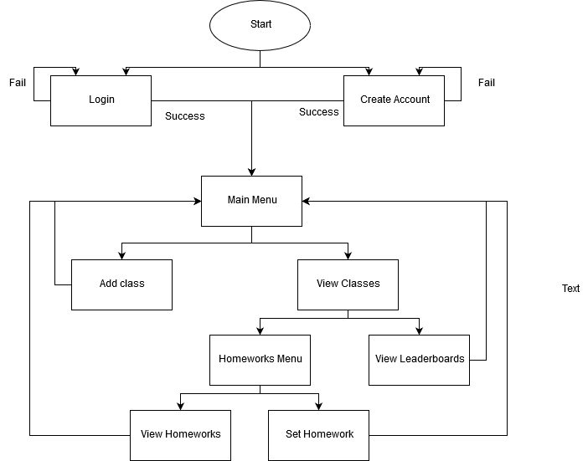

Figure 5 - Basic plan for the ‘flow’ of the program for teachers

Above is the basic plan for how the teachers will be able to manoeuvre through the program. Like the students (given the screens will be the same), there will be a login and create account screen which will lead to the main menu once submitted correctly. That would then provide multiple different options for screens relating to classes, leaderboards and homeworks. There will be back buttons to allow the user to return to previous screens, however this will only be available on screens where it would make logical sense to go back (for example, there won’t be a back button on the start screen because there’s nothing to go back to).

## Database Design

As mentioned above, I am using 000webhost to host my database. The database is going to be relational with the tables linking to each other using primary keys and foreign keys. 000webhost uses PHPmyadmin to help create and manipulate databases and I will be using MySQL in PHPmyadmin to program the database.

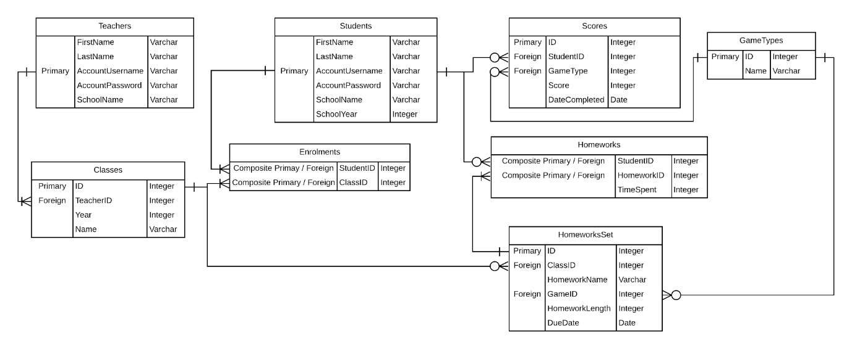

Figure 6 - Design for relational database

Above is my design for how the database will be laid out. There will be eight tables. The main tables will be Students and Teachers which will together hold the account details for all users. The other six tables are Classes, Enrolments, Scores, Homeworks, HomeworksSet and GameTypes, all of which are interconnected through relationships. The Teachers table will relate to the Classes table (each teacher will have one row in the Classes table for each of their classes) and the students will relate to the Enrolments table, Scores table (one for every high score they have) and Homeworks table.

#### Tables

##### Teachers Table

The Teachers table will have five columns. The most important is AccountUsername which will identify the user in the program and throughout the database. It is a primary key since it is unique and it will be automatically assigned to the teacher when they first create their account. The other columns are FirstName, LastName, AccountPassword and SchoolName.

##### Students Table

The Students table will have six columns. The most important is again the primary key, AccountUsername, which will identify the user in the program as it is unique. The other columns are FirstName, LastName, AccountPassword, SchoolName and SchoolYear.

##### Classes Table

The Classes table will have four columns. The first is an ID which will identify the specific teacher-class grouping. This is the primary key since it is unique and will be automatically assigned to when the teacher adds a class. The second column is TeacherID, a foreign key which references the primary key (AccountUsername) of the Teachers table, and is used to identify the teacher. The other two columns are Year and Name, which help further define the class by their school year and what the name of the class is.

##### Enrolments Table

Enrolments will be the table used to link Students and Classes. Without this table, the link would be a many-to-many relationship (since students can be part of multiple classes and classes have multiple students), so another table is required. Enrolments will simply have two columns, StudentID and ClassID which will both be foreign keys (linking to Students and Classes respectively) and will join together to make a composite primary key.

##### Scores Table

The Scores table will contain one entry for each student for each game. The first column again is the primary key, ID, to identify the specific student-game grouping. The second column is StudentID which is a foreign key referencing ID on the Users table. The other two columns are GameType (a foreign key referencing ID on the GameTypes table) and Score which will be useful for the leaderboards when the scores will be sorted by GameType.

##### Homeworks Table

The Homeworks table will contain one entry for each student for each homework. The first two columns are the foreign keys, StudentID and HomeworkID, which will group together to form a composite primary key. This works because StudentID and HomeworkID form a unique code. There will never be the same StudentID and HomeworkID together twice since that would mean the same student has been set the same homework twice, which is impossible. The third column is TimeSpent which will determine how keep a record of how long the student has been playing the specified game for since the homework was set and before the due date. It will be an integer since I will round down the number of minutes they spend each time and add that to the record – it will always be a whole number.

##### HomeworksSet Table

The HomeworksSet table will contain one entry per homework. It will primarily outline the parameters of the homework. The first column is the primary key, ID, which will be unique for each homework. ClassID and GameID are both foreign keys, relating to Classes and GameTypes respectively, which outline which class the homework is to be assigned to and which game they must play as their homework. There are also fields for HomeworkName, HomeworkLength and DueDate which define the name of the homework, how long they must spend playing the assigned game and when the homework must be completed by respectively.

##### GameTypes Table

There are going to be multiple places in the program where the games in the program are required. It therefore makes sense to place a list of the games in a table so that it can be referenced by not only the database (for use in foreign keys) but also by the program itself. For example, displaying the games in the ‘Choose Game’ scene and displaying a dropdown of games to choose from in the ‘View Leaderboards’ scene will both require a list of game names. Instead of hardcoding them, I will put them into the database so that it can be referenced everywhere from one place. (This also allows me to easily add or remove games by simply changing this list. If, for example, one of the games requires maintenance then I can simply remove that name from the list until the maintenance is complete before adding it again.)

The layout of the table will simply be a primary key, ID, to define the unique property of the game followed by a column for the GameName which will be the name of the game.

### Table Relationships

* Teacher-Classes: Each teacher will have either one or multiple rows in the Classes table and each Classes row will only have one teacher. (The same class can still have multiple teachers but they will be in different Class rows). Therefore, this is a one -to-one/many relationship.
* Classes-Enrolments: Each class will have one or many enrolments and each enrolment will have exactly one class. Therefore, this is a one -to-one/many relationship.
* Students-Enrolments: Each student will have one or multiple enrolments and each enrolment will have exactly one student. Therefore, this is also a one-to-one/many relationship.
* Students-Scores: Each student will have zero or multiple scores and each score will have exactly one student. Therefore, this is a one-to-zero/many relationship.
* Scores-GameTypes: Each score will have one game type and each game type will have zero or many scores. Therefore, this is a zero/many-to-one relationship.
* Students-Homeworks: Each student has zero or multiple homeworks and each homework has exactly one student. Therefore, this is also a one-to-zero/many relationship.
* Homeworks-HomeworksSet: Each row in the Homeworks table relates to one row in the HomeworksSet table whereas each row in the HomeworksSet table could relate to many rows in the Homeworks table. There can’t be zero Homeworks rows for a HomeworksSet row since every class must have at least one student. Therefore, this is a many-to-one relationship.
* Classes-HomeworksSet: Each class has zero or many homeworks (multiple homeworks could be given to the same class overlapping each other timewise) and each homework has a specific class. Therefore, this is a one-to-zero/many relationship.
* HomeworksSet-GameTypes: Each homework that is set has one specific game type whereas each game type has zero or many homeworks set. Therefore, this is a zero/many-to-one relationship.

## Games

In bilateral discussions with my client, we have decided on three mathematical games for me to make as part of the program. First will be a graph-based game which will be made more fun by making the lines look like laser shooting from some kind of cartoon gun which is shooting down spaceships. We decided to call it “Linear Spaceship Wars” given the lines will all be linear and it will look like a kind of war between spaceships.

The second game we discussed is a speed-based maths game called “Speed Maths”. It involves solving fairly simple (but potentially tough) addition, subtraction, multiplication, division and exponent questions in a given time limit. Mrs Mistry thought a nice touch will be to have a life-based system so the game is automatically over when the student makes their third mistake. This would stop students from randomly clicking on answers hoping they’d hit the right one since they’d be out of the game fairly quickly.

The third game we discussed is a remake of the game show, Who Wants to be a Millionaire, called “Who Wants to be an Algebra Millionaire”. This will work in a similar way to the original except the questions will be algebra based as opposed to general knowledge questions. My stakeholder made it clear that an important aspect of this will be the lifelines so I will include all lifelines.

## Graphic Design

I have checked the display size ratio of the school computers and the pixels ratio is 1152:720 which means a display ratio of 8:5. I have therefore made the Microsoft Word document landscape (since the pcs are landscape) and 30cm by 18.75cm which comes out as the same 8:5 ratio. (In addition, I have changed the viewport in the Unity editor to 8:5.)

As of now, I do not have a title for the project so I will call the project ‘Competitive Maths Games’.

I have had a discussion with my client regarding what colour schemes and features she would like for the whole program. Below are the results:

* Colour scheme of black, red and green
  + Black background
  + Buttons and text as a mixture of red and green
  + Although the colour scheme is simply three colours, she would like light and dark shades of each to be used as well.
  + We have together decided on the following RGB values for the colours:
    - Light green – (112, 173, 71)
    - Dark green – (94, 145, 59)
    - Light red – (255, 47, 47)
    - Dark red – (255, 0, 0)
* A fun and interesting font.
  + I have since chosen “AR CENA” which my stakeholder likes and has agreed to.

I have created a design of each scene in Microsoft Word and will show them to my stakeholder. Below are the originals designs for each scene.

## Page Design

### Page Design – General Scenes (Teachers and Students)

#### Page Design – Loading Scene

The loading scene is simply going to show while the client accesses the online server and retrieves information required to run the program – namely the names of the games (as shown in a later section on database design). But before it does that, it will first need to check if the user is connected to the internet. If this is not the case, then an error message will come up informing the user they have no connection and will have a button to exit the application.

In terms of the graphics, it will be very simple and just have a piece of text saying “Loading…”. Mrs Mistry suggested having an animation where the number of full stops increases from zero to three over time so that it’s clear the program is still running and hasn’t crashed.

##### Justification of Scene

For the majority of the scenes in the program, the user is going to be able to determine when the scene is changed to a new one (either by clicking a button or running out of time on a game etc). The program needs certain pieces of information (only game names for now) to be downloaded from the database for the scene in order for essential variables to be stored on the client’s computer. Therefore, the download needs to occur in a scene where the user doesn’t have control over when they move to a new scene. Otherwise, the user would be able to exit the scene before the download has completed which would mean the program would continue even though data that is required for many parts of the program to work won’t have downloaded successfully and would therefore cause issues with the program.

So, there would have to be a scene where the user cannot determine when they leave the scene and the most logical time to do that would be when the program is first run in a loading scene.



Figure 7 - Original design for Loading scene

#### Page Design – Start Scene

The start scene does not have any purpose other than to be the first major scene in the project. It will introduce the user to the program with a title and relevant images showing maths-related symbols. It will most importantly have two buttons: one linking to the login scene and one linking to the create account screen.

The login and create account scenes will be the same regardless of if the user is a student or a teacher so the start scene can also be neutral in that sense. Therefore, there will be one start scene – the same for all users.

##### Justification of Scene

This scene will help the ease of navigation in the program which is something that’s very important for my stakeholder as it is something which we found was not necessarily the case in the similar programs checked earlier. (MyMaths, for example, has multiple login pages and it’s not clear where you are in the program at some points.) The inclusion of a simple start scene with two clear-cut options makes it easy for the user to understand which button to click and how to proceed with the program. This scene will therefore follow the success criteria for the program to be simple and clear in addition to the criterion about it being easily navigable.

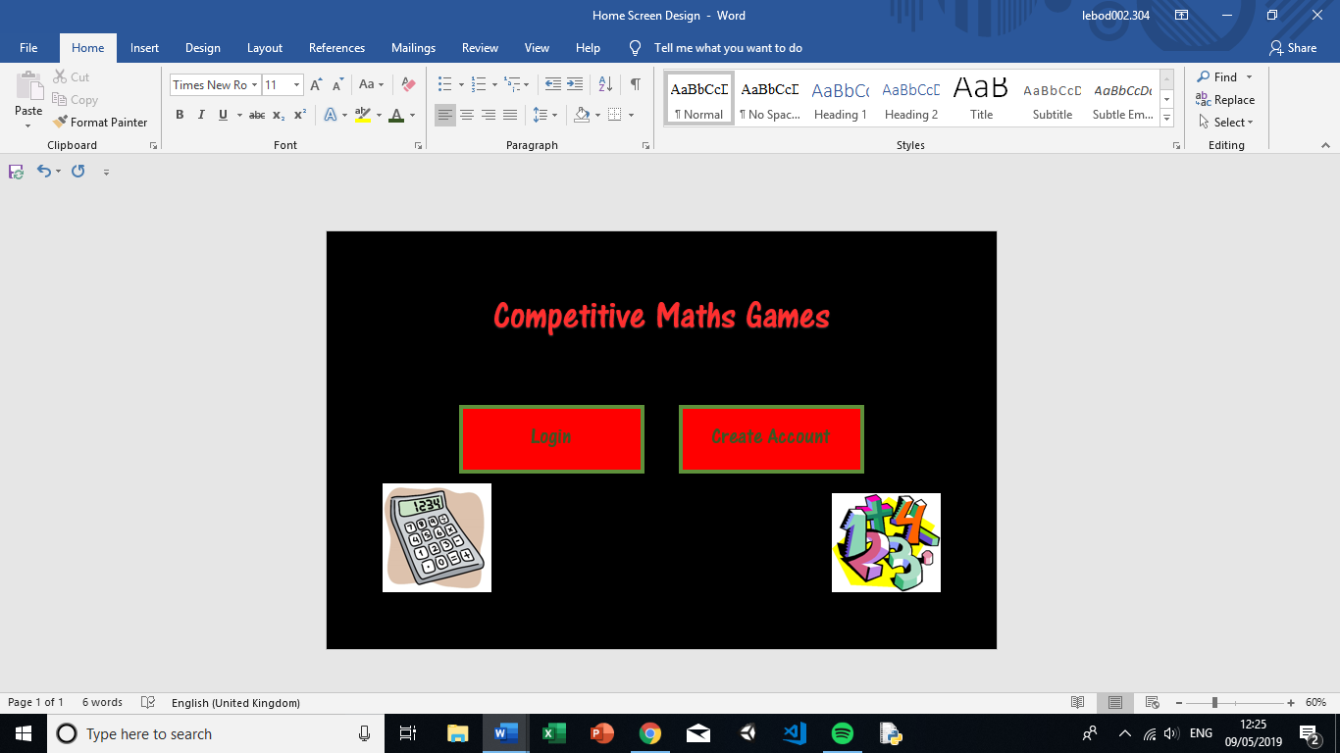

Figure 8 - Original design for Start scene

#### Page Design – Login Scene

The login scene will be basic; it will include an input field for the username and an input field for the password. There will then be a button to log in to the program. All of these colours will be in line with the colour scheme laid out earlier and, when the login button is clicked, the information will be sent to the online server which will then check if the login is successful or not. If the login is successful, a notice will appear on the screen stating the login is successful and if not, then a message will appear saying to try again.

##### Justification of Scene

Accounts are fundamental in this program as they allow students and teachers to be linked together in the form of classes. Therefore, the user must be able to login and this scene will allow the user to do so.

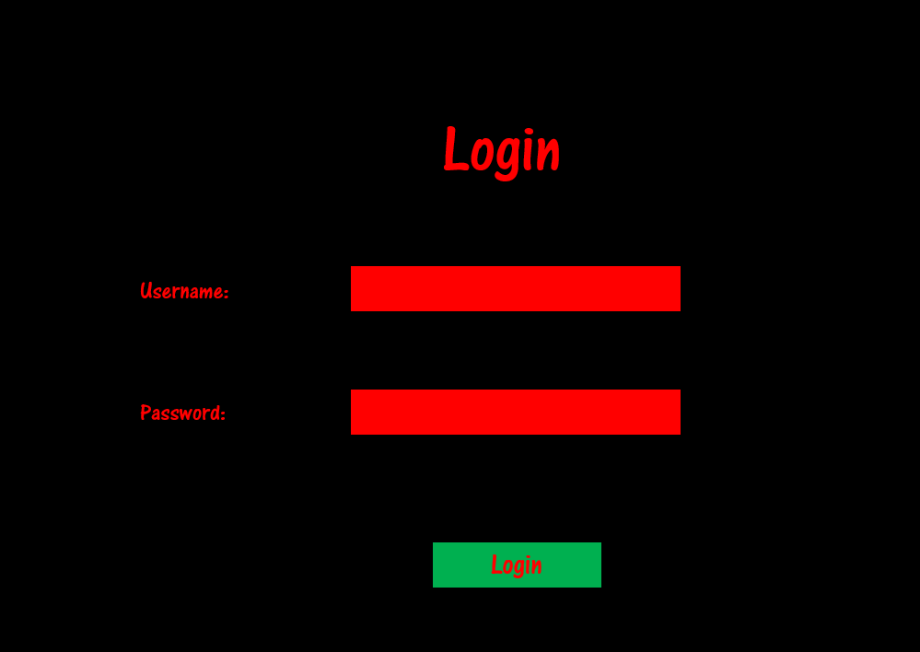

Figure 9 - Original design for Login scene

#### Page Design – Create Account Scene

The create account scene will gather all of the information required for a new user and add it to the online database. They will be entered using input fields or tick boxes (for the type of user). Finally, there will be a create account button at the bottom which will send the information to the server. What is returned will be a message saying what the user’s generated username is which can then be used to login again later.

The majority of the information required for students and teachers are the same. However, the school year field is only required for students. Therefore, the design shown below is for a student; a teacher would see the exact same design but without the school year field. In terms of recognising which scene to use, it will be done based on which tick box has been entered in the “I am a” field, therefore the scene will be dynamically changing based on the inputs.

##### Justification of Scene

Similar to the login scene, the create account scene is necessary for account management. For the user to be able to login in the login scene, they must first have an account. Therefore, this scene is necessary as essentially a signup form for the user to enter all of the information which is required from them for the program to function properly.

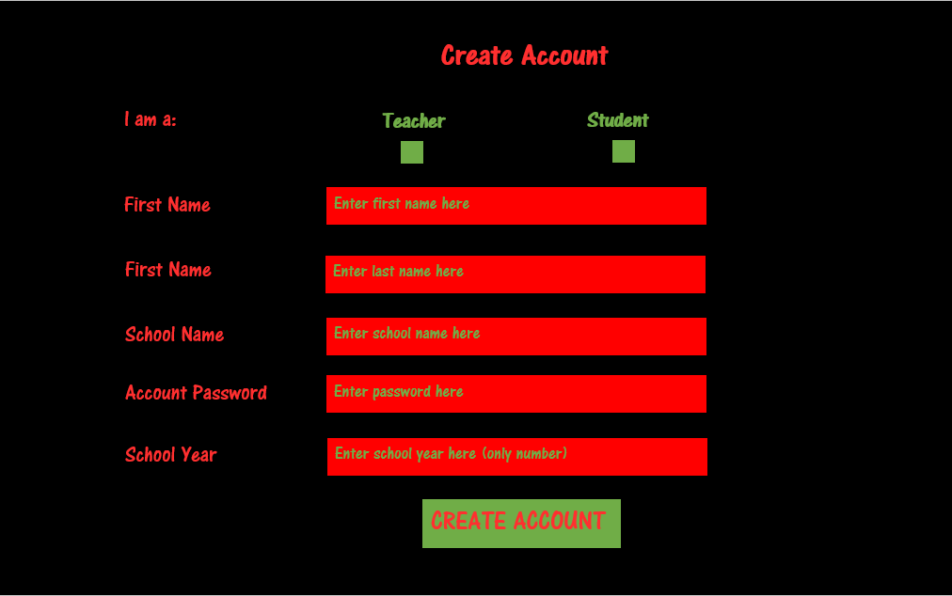

Figure 10 - Original design for Create Account scene

#### Page Design – View Leaderboards

The View Leaderboards scene is going to show the leaderboards based on two criteria: class and game. The user will be able to specify which game and for which class the leaderboard is shown for. However, the only classes which will be available as options for the user are classes which the user is part of (either as a student or as a teacher).

The layout is as follows: at the top of the screen there will be a title text saying “View Leaderboards”. Below that will be two text headings with dropdown fields directly underneath them. These will be for the user to choose the class and game. Changing one of these options will dynamically and automatically change the leaderboard itself (so no ‘update’ button is required). Under the dropdown fields will be the leaderboard which will contain names and scores in order of high score. The panel will be draggable so, even if only a certain number of records can fit on the screen, the user will be able to drag the panel and view scores which are lower down.

##### Justification of Scene

My stakeholder stated that the use of leaderboards for each game and each class is an important aspect of her vision since it captures the competitive nature of students and hopefully will convince them to get more involved in the maths. Therefore, the users (students and teachers) should be able to view the leaderboards and so I will create a scene for viewing leaderboards.

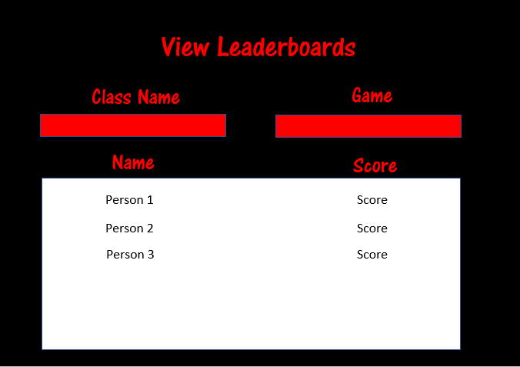

Figure 11 - Original design for View Leaderboards scene

### Page Design – Student Scenes

#### Page Design – Student Main Menu

The student main menu scene is a very simplistic scene which will be used as essentially a gateway between the start scene and the actual features of the program. It will have options as buttons: one for all of the games (this will link to a scene where the user can decide which game to play), one for viewing leaderboards (again linking to a scene where the user can decide which game and which class to view the leaderboard for) and one for viewing the student’s homeworks (linking to the view homeworks scene).

##### Justification of Scene

This scene will again be part of making the program easy to navigate and understand as it is another menu (only shown to students) which will clearly lay out the possibilities for where to go next in the program.

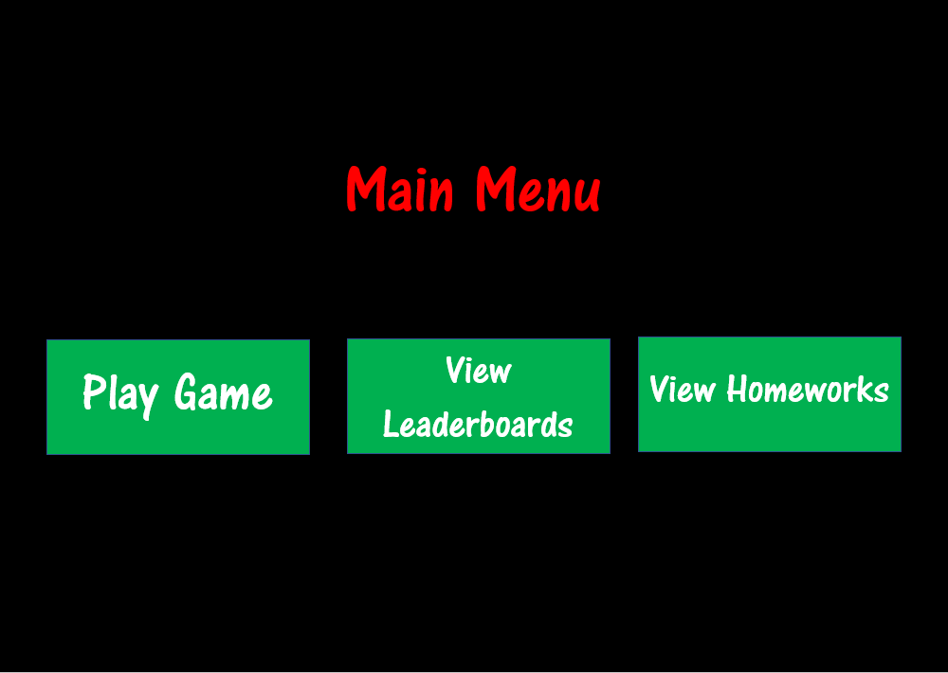

Figure 12 - Original design for Student Main Menu scene

#### Page Design – Choose Game

The choose game scene is going to effectively be a carousel. There will be one central game option and the user will be able to use the buttons in the top right and top left of the scene to move along the carousel of options and view other games. Tapping on each game button (which will have the name of the game on the button) will then move the program onto the scene for that specific game, at which point that game starts.

##### Justification of Scene

The user will need to be able to choose which game to play. I’ve decided to make this its own scene simply because it makes the design cleaner to have different sections in different scenes. The select game buttons can’t feature in the game scenes because no game has been chosen and it can’t really feature in the main menu for the student unless I add extra computation to handle the change in UI from the main menu to the choose game in that scene. This, in my opinion, is an unnecessary increase in computation and there’s no point in doing that when it could feature as its own scene.

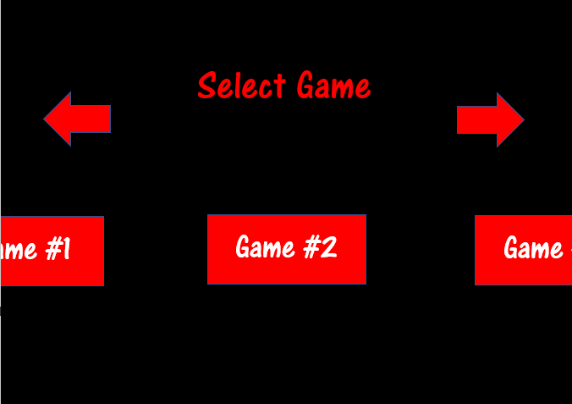

Figure 13 - Original design for Choose Game scene

#### Page Design – Linear Spaceship Wars

Linear Spaceship Wars probably has the most complex design out of the three games which will be made. It will first have a grid on the left-hand side. This grid will act as both the graph which the maths will be done using and also the area where the “spaceship wars” will occur. There will be a green spaceship which will be the allied spaceship. At the same time, there will be enemy spaceships which appear in the corner of the grid and slowly make their way towards the allied spaceship. If the enemy spaceship makes it to the allied one, then the allied spaceship is destroyed. The aim of the game is to defend the allied spaceship. This will be done using a laser. This laser can be stationed anywhere along the y-axis and will be where the laser is shot from. The enemy spaceships will die if the laser that’s shot intersects with the ship. The laser’s direction will be determined by the linear equation provided by the user. Using $y=mx+c$ as the equation of a straight line, the user will need to set values for $m$ (determining the gradient of the line) and $c$ (determining the ‘y-intercept’ of the line) which will determine the position of the laser and its direction. Since the user is theoretically able to set $m$ to 0 and $c$ to the y co-ordinate of the enemy spaceship (thus making the game simple to win and not particularly mathematical insightful for the students), the user will be unable to set $m$ values of between $-0.1$ and $0.1$ at which point a laser would no longer collide with an enemy spaceship situated at the same y co-ordinate as the laser.

On the right of the grid will appear a few features. First will be a countdown timer; this will show to the user how much time they have left in the game. Directly below that will be the user’s current score. Below the score will be the equation of the straight line. This will consist of: a text box (with the text “ $y=$”), an input field (for the user to enter their value for $m$), a text box (with the text “x + ”) and another input field (for the user to enter their value for $c$). Finally, there will be button with the text “Fire Laser”. When this is clicked, the laser will move to the position dictated by the input for $c$ then fire a red-coloured laser in the direction determined by the input for $m$.

When the game ends (either by the timer running out or by the enemy destroying the allied ship), the program will automatically go to the end game scene, at which point the user’s final score will be displayed and the score will be sent to the server to be added to the database.

##### Justification of Scene

As with the other two games below, the reason for this scene is to fulfil the main aspect of the program which is to have maths games. These three scenes will contain the actual maths games themselves.

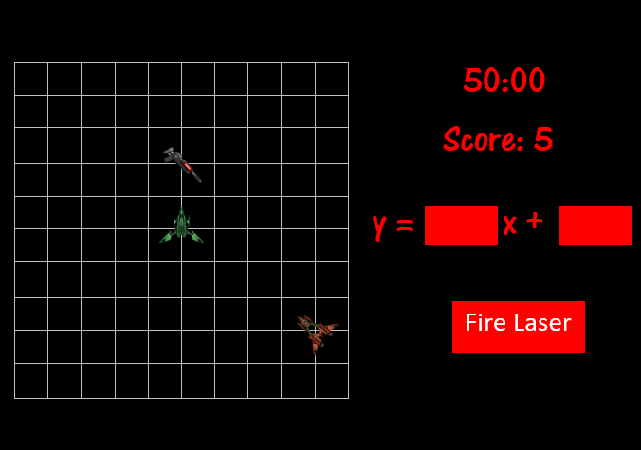

Figure 14 - Original design for Linear Spaceship Wars scene

#### Page Design – Speed Maths

The game “Speed Maths” has a very simple concept. The idea is for the student to answer as many simple maths questions as possible correctly within the time limit. The layout of the game reflects the simplicity of the game itself. In the top left of the screen, there will be a countdown timer denoting how long left the student has. In the centre of the screen will be the question ( $7+8$ for example) and the possible answers will be in four boxes, set in a 2x2 table below the question. There will also be three heart images in the top right corner of the screen which will denote the lives remaining for the user. The user will lose a life when an incorrect answer is given and, as expected, a heart will disappear. Similar to “Linear Spaceship Wars”, when either the timer runs out or three incorrect answers are given, the program will go to the end game scene at which point the score will be sent to the online server to be added to the database.

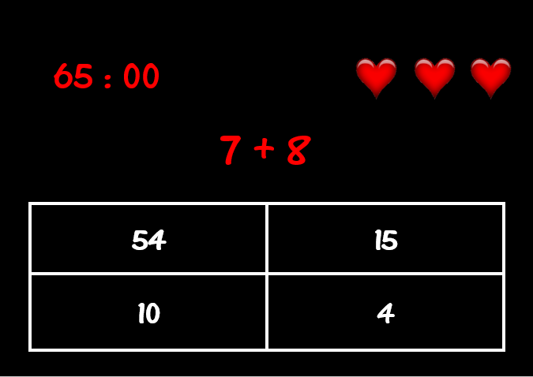

Figure 15 - Original design for Speed Maths scene

#### Page Design – Who Wants to be an Algebra Millionaire

“Who Wants to be an Algebra Millionaire” will be an attempt to replicate the TV game show “Who Wants to be a Millionaire” but with all questions being related to algebra, thus improving students’ algebra skills. The game will involve the student answering maths questions in a similar way to “Speed Maths” but with the questions being directed related to algebra as opposed to basic maths principles. The student’s score (in this case being in terms of fake money) will increase in progressions which reflect that of the TV programme and hitting ‘safe zones’ at £1000 and £32000, again similar to the programme. In addition, the student will be able to use lifelines which will help to answer the questions. These will be the same three lifelines used in the TV show: “50/50”, “Ask the Audience” and “Phone a Friend”. There will finally be the opportunity to take the money if the student isn’t sure of the answer and doesn’t want to risk losing most of the money which would occur if they attempted an answer and got it wrong.

The screen will be split into two sections: the left (which will include the timer, question, answers and lifelines) and the right (containing a grid of the money progression in the game and where the student currently is). In the top left, there will be a countdown timer denoting how long the student has left. However, the difference between the countdown timer in this game and the others is the timer is only for the current question whereas the timer for the other games lasted the whole game. In “Who Wants to be an Algebra Millionaire”, the timer will reset every question as is the case in the game show. Under the timer will be the question surrounded by a clear box with a white border. Below the question will be the four possible answers, again arranged into 2x2 boxes where each box is clear with a white border. Under the possible answers will be buttons for the three lifelines and the “Take the Money” button. On the right-hand side, there will be a grid with one column and 15 rows. Each row will have the monetary value for that position in it. When the user reaches that prize money level, that cell turns green, thus denoting the current position of the student. If the user either gets an answer wrong or the time runs out on a question, the game will end and the program will go to the end game scene which will tell the user how much money they won and upload their score to the database.

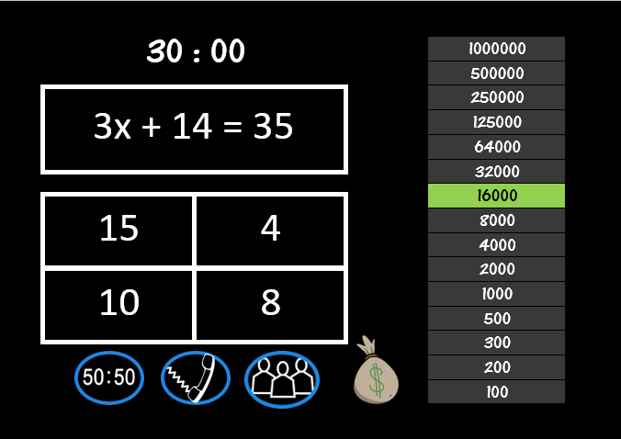

Figure 16 - Original design for Who Wants to be an Algebra Millionaire scene (assuming a student who has just reached £16000)

#### Page Design – End Game

The end game scene will have two uses. The first is to tell the user that the game has finished and tell the user what score they got. This will be done using two pieces of text: the first saying “Game Over” and the second saying “You Scored” followed by the score received in the game. Both of these will be in the centre of the screen so that it is prominent. The second use is to provide the user with a list of options for how to continue on the program. The options are: “Play Again” (where the user will be able to play the same game again), “View Leaderboards” (where the user will be able to view all of the leaderboards – not just for that game) and “Main Menu” (which will return the user to the student main menu).

##### Justification of Scene

This scene is important for navigation reasons. At the end of the game, the user should find it easy to understand where s/he can go next and this scene will simply lay out those possibilities. I could have placed this scene at the end of each game scene but that would mean using the same scene in different places. I believe this is a better solution, where the same scene is called from different places as opposed to being shown in different places.

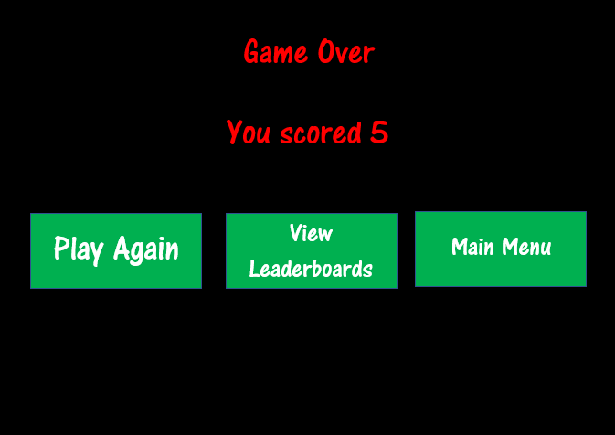

Figure 17 - Original design for End Game scene

#### Page Design – Student View Homeworks

The Student View Homeworks scene will unsurprisingly display all of the student’s current homeworks. It will look similar to the View Leaderboards scene in the sense that it will have a panel with columns and rows of information. However, the view homeworks scene will have more columns (5 to be precise) and (at least hopefully for the student) less rows. There will be a title text in the top centre of the screen describing what scene the user is on. Below that will be headings for each column before the actual panel. The panel will consist of five columns: “Name” (the name of the student), “Class” (which class the homeworks has been given to), “Game” (which game the homework is for), “Length” (how long the students must spend on that game) and “Due Date” (when the homework is due). It will only display homeworks for which the due date has not yet passed. Similar to the View Leaderboards scene, the homeworks panel will be draggable allowing the students to view all of their homeworks, even if there are too many to fit onto the screen.

##### Justification of Scene

This scene will allow the student to view their current homeworks. One of the success criteria outlined at the beginning of the project was the ability for students to view their homeworks. This scene will fulfil that criterion and show the relevant information.

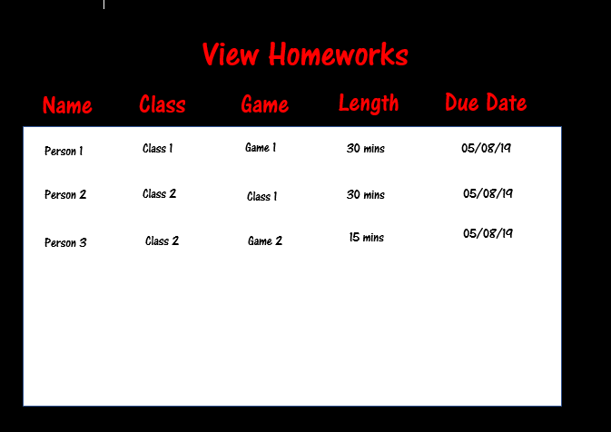

Figure 18 - Original design for View Homeworks scene

### Page Designs – Teacher Scenes

#### Page Design – Teacher Main Menu

Similar to the Student Main Menu, this scene will be very basic. It will simply have buttons linking to two more menus. The buttons will be “Add Class” and “View Classes” which will give the teacher two distinct directions to take the ‘path’ of the program. Clicking “View Classes” will then include things like viewing the leaderboards and setting/viewing homeworks.

##### Justification of Scene

As with previously described menu scenes, this scene will be used to help ease the navigation of the program (in this case specifically for teachers) and make the program simple and understandable for the user.

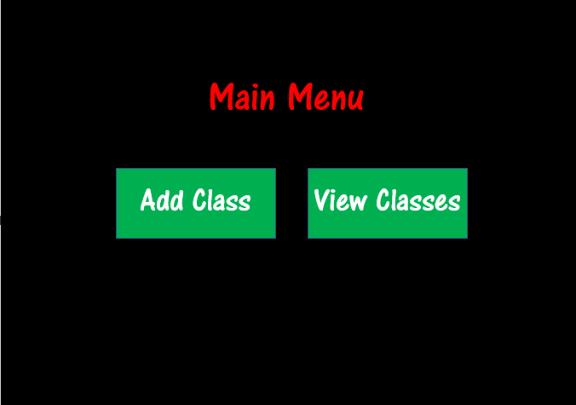

Figure 19 - Original design for Teacher Main Menu scene

#### Page Design – Add Class

The Add Class scene will allow the teacher to add a class to the database with the user being automatically added as the teacher. Three pieces of information are required for the database. These are: school year, class name and students. The first two will be entered using input fields which will feature on the left- and right-hand side of the screen respectively, below the title text.

Entering the students is a bit more complicated. There will be an input field on the left-hand side of the screen with two panels (one on each side). When the teacher enters a school year, all of the students in that year at the teacher’s school will appear in a list in the left-hand panel. The teacher then has two options. First, the teacher can look through the list in the panel (which is again draggable to allow for many students) and select them. The second option is to use the input field for typing a student’s name. The panel on the left will then automatically only show the students which have the input in their name. When a student is selected, they will then be removed from the panel on the left and added to the panel on the right (which therefore becomes a list for students which have been added to the class). Finally, there will be a button at the bottom of the screen to finalise the class and add the class to the database.

##### Justification of Scene

A major part of the project is the ability to have classes. This scene allows the classes to be created, an event which must occur at some point. Since there’s a few pieces of information required for the class to be created (school year, class name and student names), it makes sense for this to be in its own scene as opposed to being part of a general classes script.

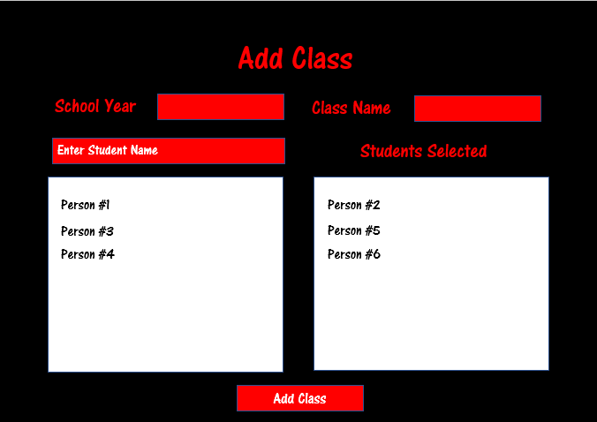

Figure 20 - Original design for Add Class scene

#### Page Design – View Classes

This scene is again simply a menu. It will provide the teacher with the options of “View Leaderboards” and “Homeworks” where the Homeworks button will lead to yet another menu with the option of either setting or viewing the homework.

##### Justification of Scene

Since there are two different pieces of data available to teachers with regards to classes (viewing the leaderboards and viewing/setting homeworks), I think it makes sense to have a menu for viewing classes which features these options.

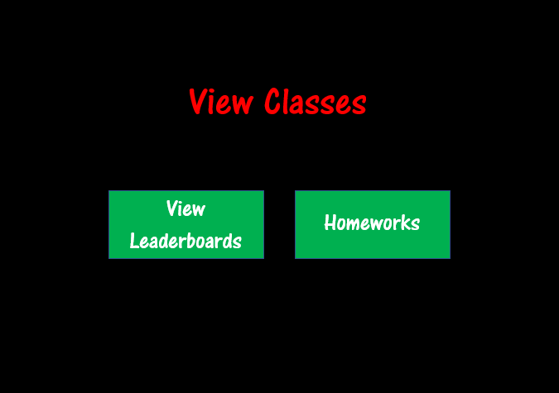

Figure 21 - Original design for View Classes scene

#### Page Design – Homework Menu

This will be the menu described earlier which will allow the teacher to choose between setting a new homework or viewing previously set homeworks. There will be a button for each option and the buttons will lead to scenes specific for that option.

##### Justification of Scene

As with previous menus, this will simply set out the possible options, allowing easy navigation for the teacher, in keeping with the defined success criterion for a simple navigable program.

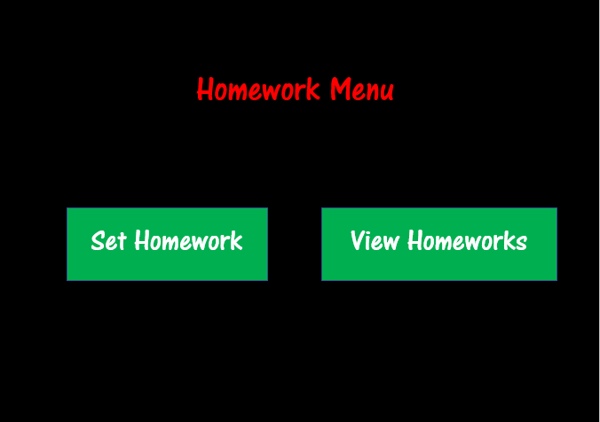

Figure 22 - Original design for Homework Menu scene

#### Page Design – Set Homework

This scene will allow the teacher to set a new homework. This requires the following pieces of information:

* **Class Name** – which class the homework is to be assigned to
* **Homework Name** – the name of the homework (sometimes helpful as it can include some extra information for the students)
* **Game** – which game the homework is on
* **Homework Length** – how long the students should spend on the game specified
* **Due Date** – the date by which the students should have completed the homework

The ‘Homework Name’, ‘Homework Length’ and ‘Due Date’ fields will all be input boxes allowing the teacher to enter whatever they like (excluding obvious restrictions such as the input must be an integer for the ‘Homework Length’ field). The ‘Class Name’ and ‘Game’ fields will however be dropdown fields since there are distinct options which are already known since the teacher’s classes and the list of games are both stored on the database.

The design of the scene is simply the title, five fields (either dropdown or input) with a submit button at the bottom-centre of the screen.

##### Justification of Scene

This scene allows the teacher to set homeworks, which is outlined as one of the success criteria. As a program for maths classes at school, the ability to set homeworks is integral.

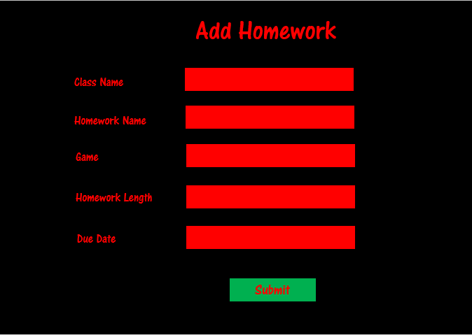

Figure 23 - Original design for Set Homework scene

#### Page Design – Teacher View Homeworks

This scene will allow teachers to be able to view all of the current homeworks and which students have completed them. There will be a dropdown field which will allow the teacher to choose which homework to analyse. Once selected, the panel below will show a list of students with columns for how long they’ve spent on the homework and whether they have completed the specified amount in time. As with previously described scenes, the panel will be draggable to allow many students to be analysed by the teacher even if there isn’t enough space for all of the students to show on the screen at the same time.

##### Justification of Scene

Similar to the requirement that student must be able to view their homeworks, teachers also need to be able to view their class’s homeworks. It makes most sense to put it as its own scene as I have done.

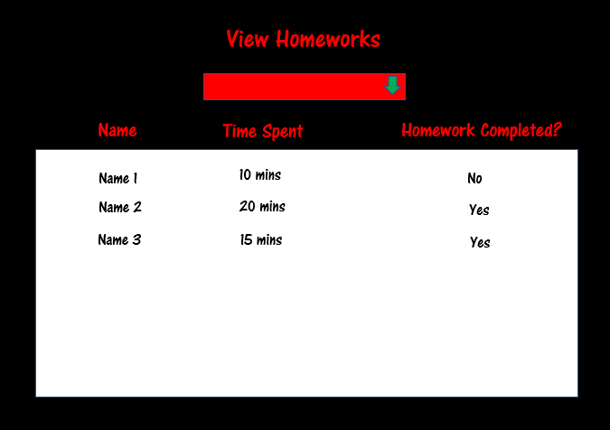

Figure 24 - Original design for Teacher View Homeworks scene

### Page Designs – Stakeholder Response

After making these designs, I sent them to my stakeholder, Mrs Mistry, and below are her responses shown in a table with each row a response for a particular scene.

|  |  |
| --- | --- |
| Scene | Response |
| General | Positives:   * Colour scheme * Nice and simple layout   Improvements:   * Add border to buttons (not all but most places it would look better with an outline) * Font size is off in some places (explained in scene-specific cells) |
| Loading Scene | No issues |
| Start Scene | * Increase font size for title. * Increase font size for text in buttons. * Move the images further away from the buttons. |
| Login Scene | * Size of the font for field names (currently too small) * Size of the login button (currently too small) |
| Create Account Scene | * Increase size of title text * Decrease size of text on ‘create account’ button   + De-capitalise the text on ‘create account’ button   + Add a red border to the ‘create account’ button * Circular checkboxes instead of square ones |
| View Leaderboards | * Remove the blue border from ‘Class Name’ and ‘Game’ fields |
| Student Main Menu | * Replace the blue border from the buttons with a red border and make it significantly thicker |
| Choose Game | * Decrease the size of the arrows * Move the arrows to make it in line with the title text * Replace the blue border from the buttons with a green border and make it significantly thicker * Remove the blue border from the arrows |
| Linear Spaceship Wars | * Change ‘Fire Laser’ button to green and make the text vertically central * Move the grid slightly to the right to provide an equal distance between the left-hand side of the screen and the grid and between the grid and the beginning of the linear equation |
| Speed Maths | * Make 9 possible answers in a 3x3 layout instead of 4 possible answers in a 2x2 layout * Make the answer cells green instead of black * Create a white background to the cells (like a panel in the view leaderboard scene) |
| Who Wants to be an Algebra Millionaire | * Move the lifelines to the left so that all four (including the ‘Take the Money’ icon) is under the possible answers * Add a background panel to the grid on the right-hand side. Colour should be grey but slightly lighter than the grid cell colour |
| End Game | * Add a colon after “You Scored” * Replace the blue border from the buttons with a red border and make it significantly thicker |
| Student View Homeworks | * Remove the ‘Name’ column since it’s going to be the student’s name every time |
| Teacher Main Menu | * Replace the blue border from the buttons with a red border and make it significantly thicker * Move buttons down a little |
| Add Class | * Remove blue border from the buttons * Add green border to the ‘add class’ button * Make the students’ names appear in the centre of the lists in the horizontal axis * Decrease height of the lists * Increase height of the ‘add class’ button   + Increase font size of the ‘add class’ button |
| View Classes | * Replace the blue border from the buttons with a red border and make it significantly thicker |
| Homework Menu | * Replace the blue border from the buttons with a red border and make it significantly thicker * Make the ‘View Homeworks’ button thinner |
| Set Homework | * Add red border to the ‘Submit’ button * Increase font size of the field names * Change font colour of ‘Submit’ button to white * Increase height of ‘Submit’ button |
| View Homeworks | * Replace the blue border from the dropdown field with a green border and make it thicker * Make the arrow in the dropdown field thinner and shorter * Move the ‘Time Spent’ column to the right a little * Move the ‘Homework Completed?’ column to the left a little |

### Page Designs – Revised Designs



Figure 25 - Revised design for Loading scene

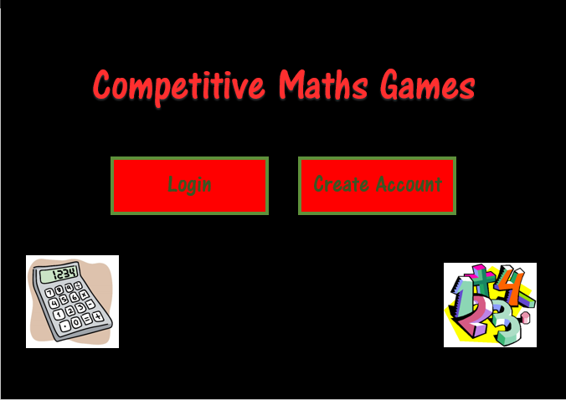

Figure 26 - Revised design for Start scene

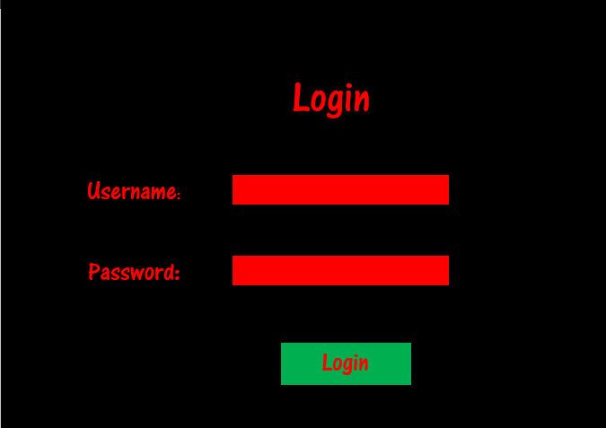

Figure 27 - Revised design for Login scene

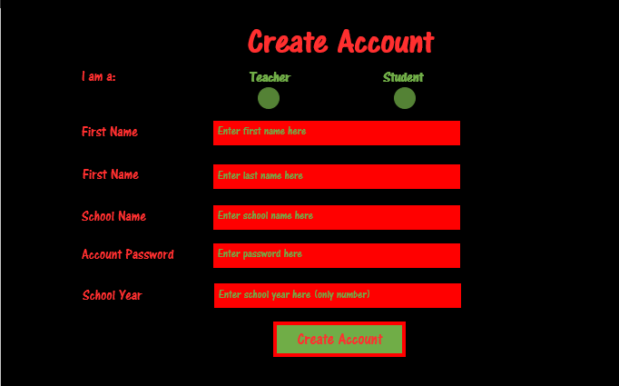

Figure 28 - Revised design for Create Account scene

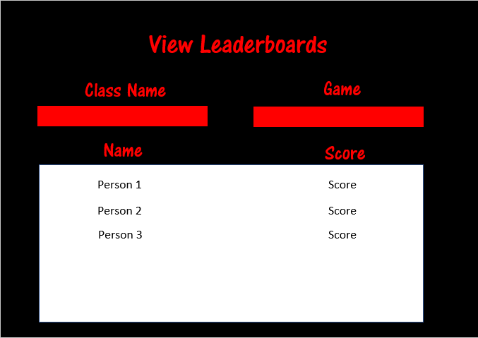

Figure 29 - Revised design for View Leaderboards scene

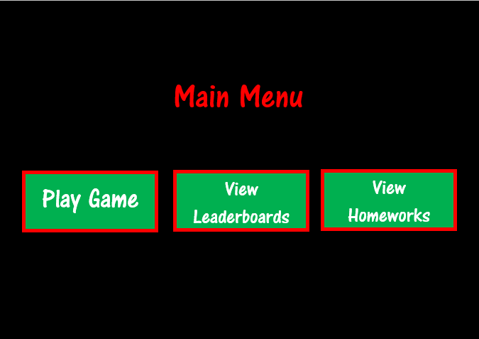

Figure 30 - Revised design for Student Main Menu scene

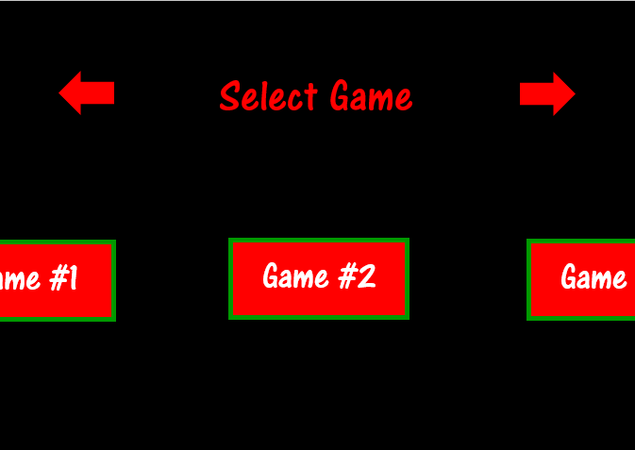

Figure 31 - Revised design for Choose Game scene

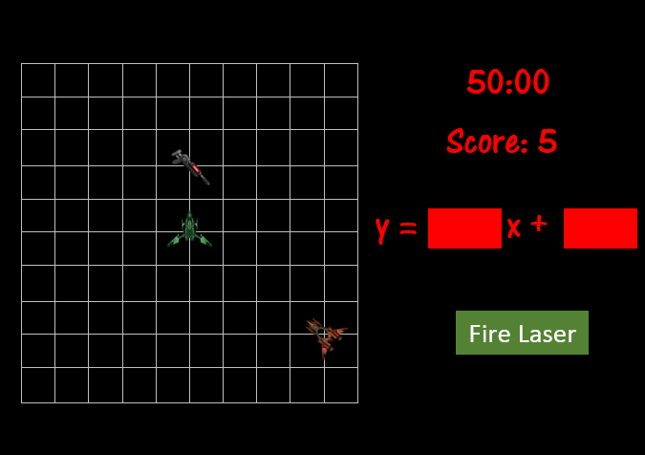

Figure 32 - Revised design for Linear Spaceship Wars scene

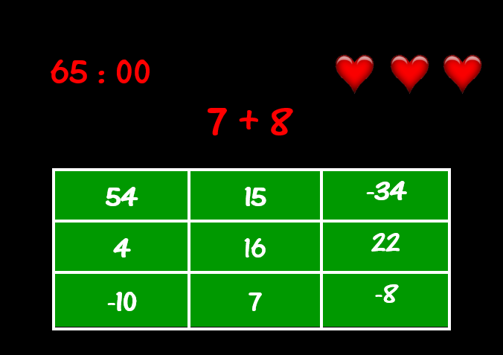

Figure 33 - Revised design for Speed Maths scene

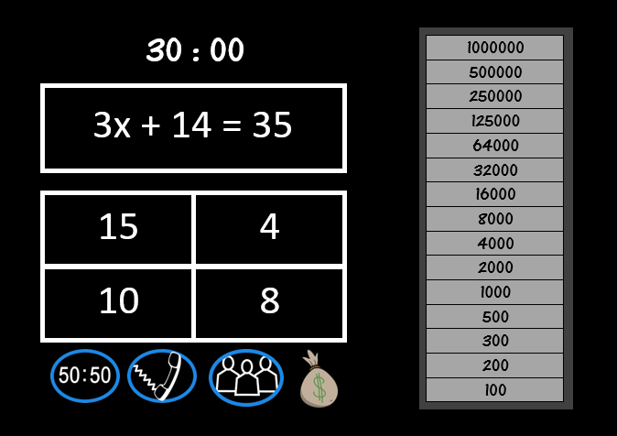

Figure 34 - Revised design for Who Wants to be an Algebra Millionaire scene

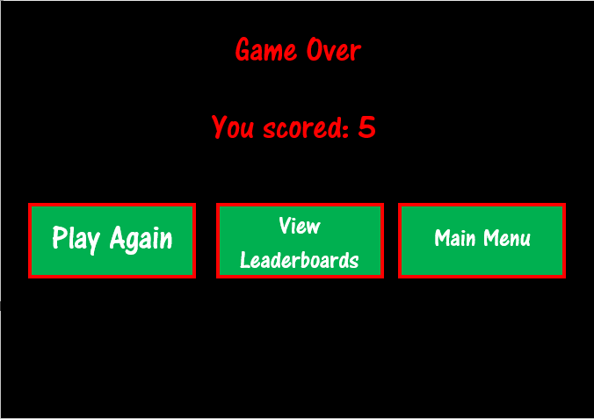

Figure 35 - Revised design for End Game scene

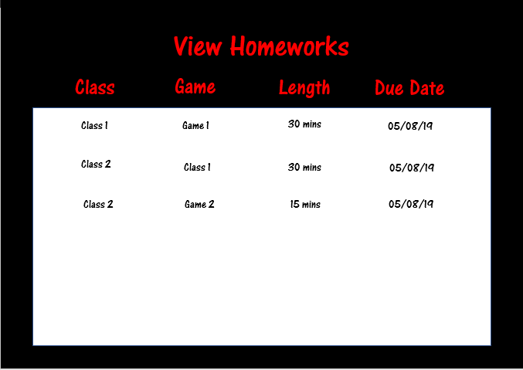

Figure 36 - Revised design for Student View Homeworks scene

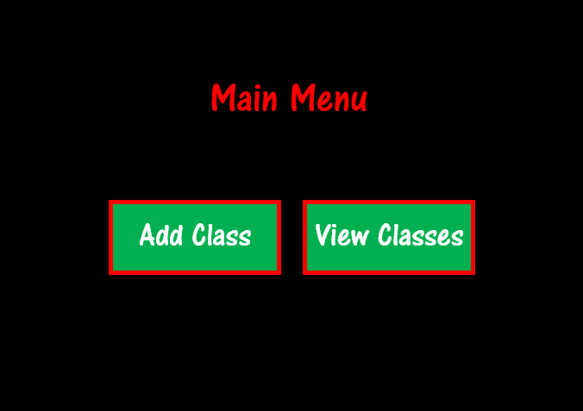

Figure 37 - Revised design of Teacher Main Menu scene

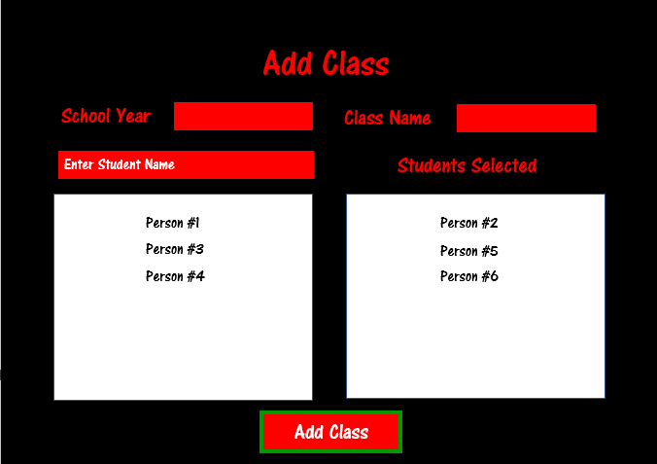

Figure 38 - Revised design of Add Class scene

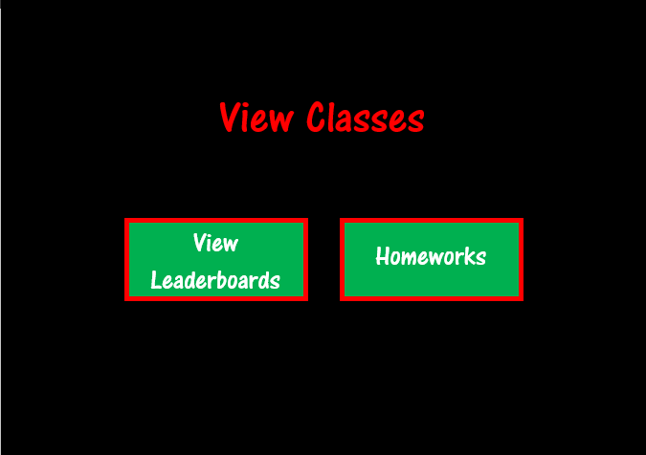

Figure 39 - Revised design of View Classes scene

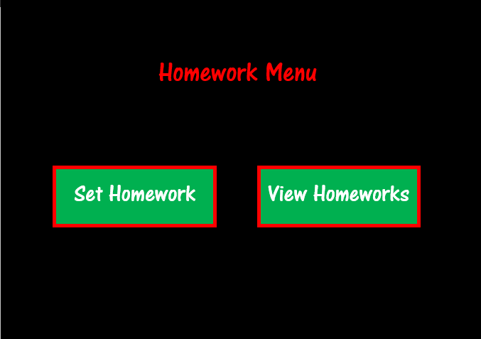

Figure 40 - Revised design of Homework Menu scene

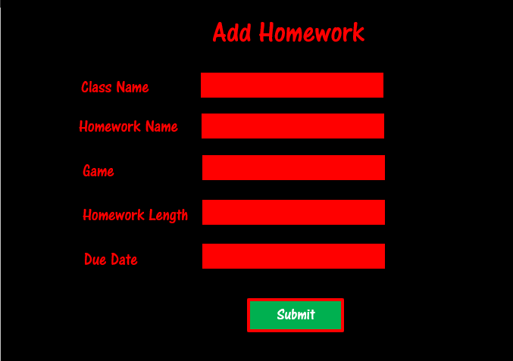

Figure 41 - Revised design of Set Homework scene

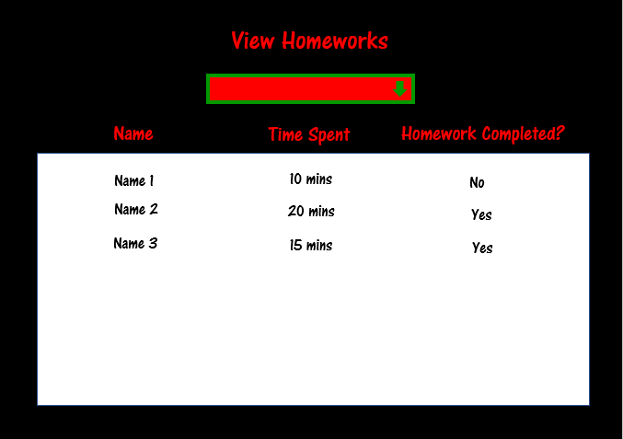

Figure 42 - Revised design of Teacher View Homeworks scene

### Page Designs – Stakeholder Response to Revised Designs

After having sent my revised plan for all of the scenes, Mrs Mistry replied saying all of the scenes look good so I will use these designs as the basis for the UI aspect of the development of the program.

## Algorithm Design

For each scene, I will outline how it will be developed and how all of the functionality will work. I will include some flowcharts and some pseudo code to better describe the programming aspect of the program. In addition, I will describe some of the important variables in the script (especially for GeneralVariables script) and explain how they are going to be used.

In general, I’m planning on having one script per scene. However, there are currently two exceptions where the script is not part of any scene. I’ve called these: “GeneralFunctions” and “GeneralVariables”. GeneralFunctions will be a script containing all of the functions which are used throughout the program and so should be accessible from every scene. GeneralVariables is similar but contains all of the variables which need to be accessed from any scene as opposed to functions.

In addition to these C# scripts, I will have a series of PHP scripts. Since all of these will have nearly the exact same function (to either add to or retrieve something from the database), they also will be designed in a very similar way. Therefore, I will create a design for a generic PHP script which will adapted for each specific script when I reach development.

I plan to have 32 scripts in total: 21 in C# and 11 in PHP. Each of these scripts is outlined below:

|  |  |  |
| --- | --- | --- |
| Script Name | Programming Language | Use |
| GeneralFunctions | C# | This will contain all of the functions which are going to be used throughout the program, in the majority of scenes. |
| GeneralVariables | C# | This will contain all of the variables which are going to be used throughout the program. These must all be accessible from any scene. |
| LoadingSceneScript | C# | This will run the loading scene. |
| StartSceneScript | C# | This will run the start scene. |
| LoginSceneScript | C# | This will run the login scene. |
| CreateAccountSceneScript | C# | This will run the create account scene. |
| ViewLeaderboardSceneScript | C# | This will run the view leaderboard scene. |
| StudentMainMenuSceneScript | C# | This will run the student main menu scene. |
| StudentChooseGameSceneScript | C# | This will run the choose game scene. |
| GeneralGameScript | C# | This will contain functions which are going to be required for all game scenes but not all scenes in general. |
| GameLinearSpaceshipWarsSceneScript | C# | This will run the game, “Linear Spaceship Wars”. |
| GameSpeedMathsSceneScript | C# | This will run the game, “SpeedMaths”. |
| GameAlgebraMillionaireSceneScript | C# | This will run the game, “Who Wants to be an Algebra Millionaire”. |
| EndGameSceneScript | C# | This will run the end game scene. |
| StudentViewHomeworksSceneScript | C# | This will run the student view homeworks scene. |
| TeacherMainMenuSceneScript | C# | This will run the teacher main menu scene. |
| TeacherAddClassSceneScript | C# | This will run the add class scene. |
| TeacherViewClassesSceneScript | C# | This will run the view classes scene. |
| TeacherHomeworkMenuSceneScript | C# | This will run the homework menu scene. |
| TeacherAddHomeworkSceneScript | C# | This will run the add homework scene. |
| TeacherViewHomeworksSceneScript | C# | This will run the view homeworks scene. |
| CheckInternetConnectionScript | PHP | This script will be called from the LoadingSceneScript to check if the user has internet connection or not. |
| GetGameNamesScript | PHP | This script will be called from the LoadingSceneScript to gather the ids and names of the games in the program. |
| GetClassesScript | PHP | This script will be called from multiple scripts to gather the ids and names of the classes which the user is part of. |
| LoginScript | PHP | This script will be called from LoginSceneScript to check if the user’s input is related to a real account or not. |
| CreateAccountScript | PHP | This script will be called from CreateAccountSceneScript to add a new user’s details into the database. |
| ViewLeaderboardScript | PHP | This script will be called from ViewLeaderboardSceneScript to gather the information for the specific leaderboard as requested from the user’s input. |
| SendScoreToDatabase | PHP | This script will be called from EndGameSceneScript to add the score to the database. |
| UpdateHomeworkToDatabase | PHP | This script will be called from EndGameSceneScript to add the homework (if the student’s gameplay formed part of one) to the database. |
| TeacherAddClassScript | PHP | This script will be called from TeacherAddClassSceneScript to add a new class to the database. |
| TeacherSetHomeworkScript | PHP | This script will be called from TeacherAddHomeworkSceneScript to add a new homework, for a specific class, to the database. |
| ViewHomeworks | PHP | This script will be called from StudentViewHomeworksSceneScript and TeacherViewHomeworksScene- Script, returning data relating to the student’s homeworks or the class’s homeworks respectively. This will only return homeworks where the due date has not already passed. |

### Algorithm Design – General Scripts

#### Algorithm Design – GeneralVariables

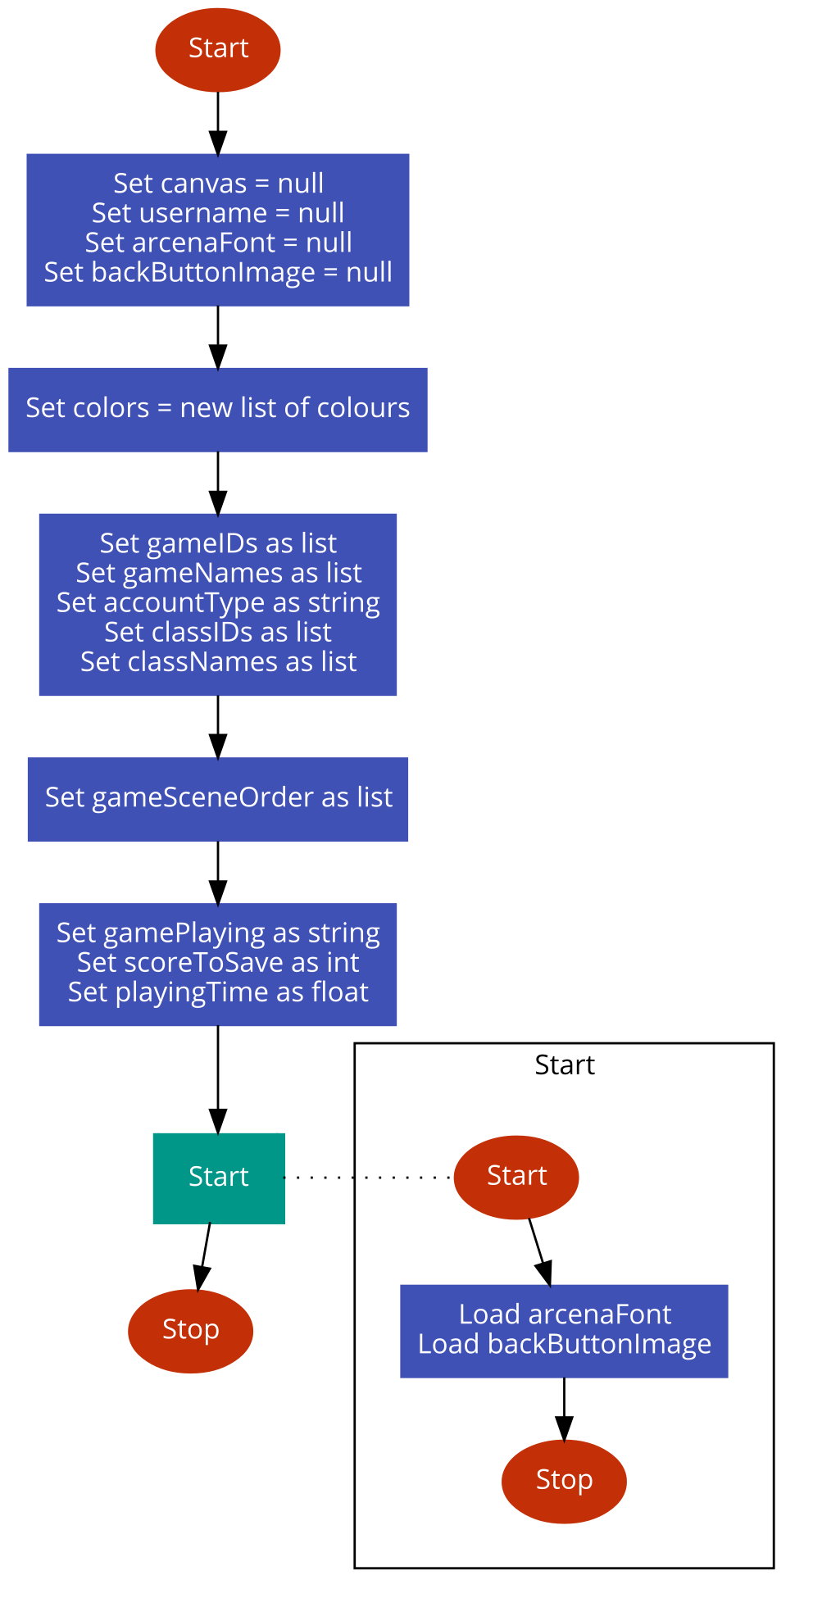

Figure 43 - Flowchart for General Variables script

Since this script is GeneralVariables, the only thing that occurs in the script is the creation and setting of variables. Each variable is created globally and either set initially to null, an empty list or 0. The Start function is automatically called by Unity3D at the creation of the scene where the script is contained but I have included a calling of the function from outside the function to visually show when it would be called by Unity3D. In the Start function, the arcenaFont and backButtonImage variables will be set. They must be set in the Start function and not when the variable is created because the values are both stored as resources so the file must fully load before they can be set.

|  |  |  |
| --- | --- | --- |
| Variable Name | Data Type | Use |
| canvas | GameObject (Unity3D data type) | The canvas is the area in Unity3D projects where all of the UI is displayed. Since this program will have a lot of buttons, input fields and images, the canvas will be used a lot. |
| username | string | This will store the username of the user. This means there’s no need to store any other information about the user whilst they’re online because the username will allow the program to access everything else via the database. |
| arcenaFont | Font | This is a variable of data type ‘Font’ which will contain the font ‘AR CENA’ which Mrs Mistry and I previously agreed on. All text will be in this font. |
| backButtonImage | Sprite (Unity3D data type) | All screens where it will make sense to have a back button will have one. Since the same image of a back button will be used, it would make sense to store it as a variable in this script. |
| colors | Dictionary  Keys – string  Values – Color32 (Unity3D data type) | Since Mrs Mistry and I have agreed on a particular colour scheme, these colours will appear quite a lot so I have decided to create a dictionary which will relate the name of colours (the key) to an RGB representation of that colour (the value) |
| gameIDs | List of strings | When the program first runs in the loading scene, the GameTypes table will be downloaded to the client. The IDs of the games will be stored in this list to be used throughout the program. |
| gameNames | List of strings | Similar to above, the names of the games will be downloaded when the program is first run, to be used later on. All values in gameNames will have the same indices as their respective id in game IDs. |
| accountType | string | This variable will determine whether the user is a student or a teacher. This technically isn’t required because the information could be retrieved from the database (since we have the account username). However, since the program will need the information quite a lot, it would make sense to store it client-side due to the fact it could take a while to retrieve the information from the online server. |
| classIDs | List of strings | In a similar way to downloading the game ids, the program will download all of the user’s class ids when they log in. This is because it will be required at multiple times such as viewing homeworks or viewing leaderboards. |
| classNames | List of strings | Similar to classIDs but with the class names. |
| gameSceneOrder | List of integers | This variable will be a list of the progression of scenes that the user has been to. It will essentially be a stack and will be used to determine which scene to go to when the back button is clicked. |

The following variables are variables which will be in GeneralVariables but will only contain values for student users. (For teachers, all of these variables will be null.)

|  |  |  |
| --- | --- | --- |
| Variable Name | Data Type | Use |
| gamePlaying | Boolean | This will be set to the string name of which game the user was last playing. This is required for determining which records to add the time and score to for leaderboards and homeworks. |
| scoreToSave | integer | This will be set to the integer value of the score that needs to be added to the database. The adding to database will occur in the EndGame script instead of the game scrip itself (since the code would then be repeated for each game) so the score must be saved somewhere. |
| playingTime | float | This will be set to the float value of how long the user was playing the most recent game. For the same reason as above, it must be saved in this script so that it can be then accessed by the EndGame script. |

#### Algorithm Design – GeneralFunctions

The GeneralFunctions script is a script made up of lots of individual functions which will be called throughout the program. Therefore, I will have a separate flowchart for each function.

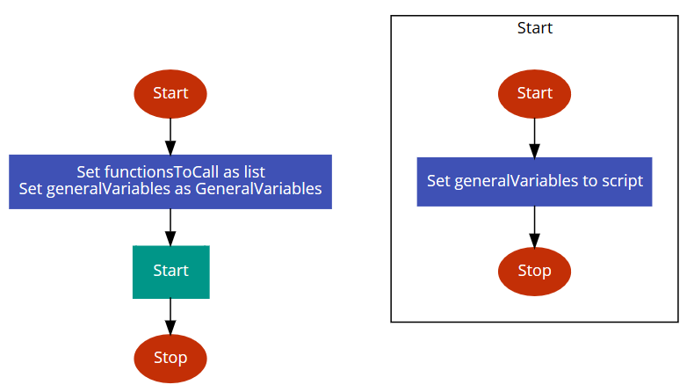

Figure 44 - Flowchart for beginning of GeneralFunctions script and the Start function

First, a list of functions is going to be created called functionsToCall which will be a list of functions which are to be called from buttons or UI boxes. The Start function is then called which sets the generalVariables variables equal to the script instance of GeneralVariables from the scene.

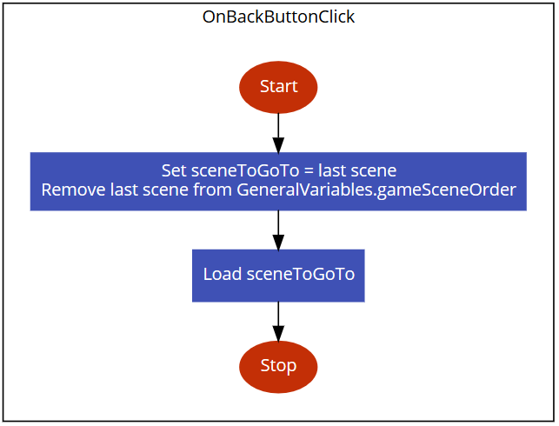

Figure 45 - Flowchart for OnBackButtonClick function

The OnBackButtonClick function is a function which will be called as an event whenever the back button is clicked. It will check what the most recent scene accessed was (by checking gameSceneOrder in GeneralVariables) and load that scene.

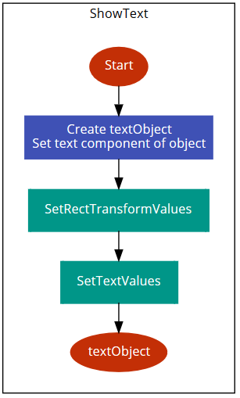

The ShowText function will be called whenever text is to be displayed on the screen. It will create a text object and add a text component. It will then call SetRectTransformValues (which will put it in the right place) and SetTextValues (which will add the text with the right font, alignment etc.). The function will then return textObject so it can be used if necessary.

Figure 46 - Flowchart for ShowText function

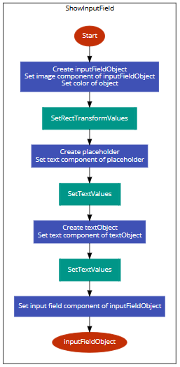

The ShowInputField function will show an input field on the screen. First, an object is created. An image component will be added so that a block colour can be used for the object (best way to do it in Unity3D). Next, the position and size of the object is defined before adding a placeholder text and creating a text child of the textObject. After the text is added to the object, an input field component is added before the parent object is returned from the function.

Figure 47 - Flowchart for ShowInputField function

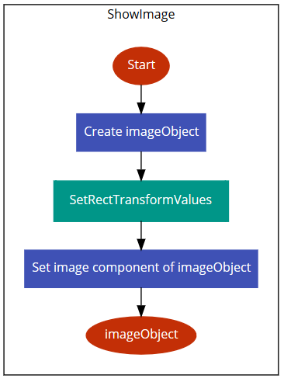

The ShowImage function will show an image on the screen. It requires, as one of its parameters, the sprite to be used. First, an image object is created with its position and size defined. Then, an image component is added to it with the inputted sprite before returning the image object.

Figure 48 - Flowchart for ShowImage function

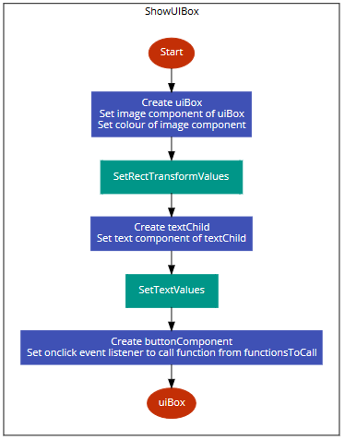

The ShowUIBox function is going to show a big green panel with text on it whenever a message or error is to be displayed to the user. First the object is created and its position and size are defined. Then, the text is added and a button component is added to the object. The way of exiting the UI box will be to simply click or tap anywhere on the box.

Figure 49 - Flowchart for ShowUIBox function

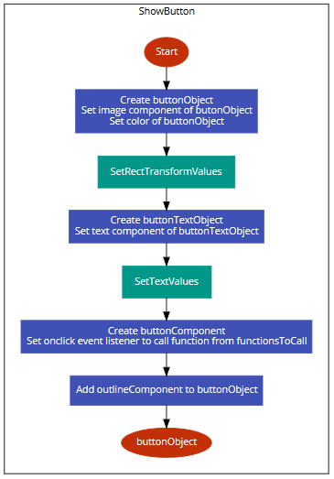

The ShowButton function will show a button to the user. The object will be created, text added and button component added in the same way as described in previous functions before returning the object for later use.

Figure 50 - Flowchart for ShowButton function

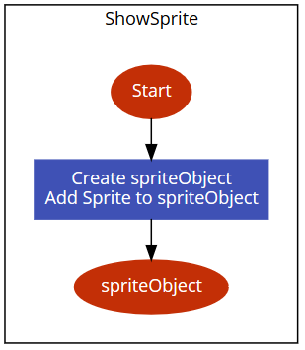

The ShowSprite function will do nearly the same thing as ShowImage. The difference between a sprite and an image in Unity3D is that images are part of the GUI whereas sprites are part of the game scenes themselves. There are scenarios where I want the sprites to interact with the game so they cannot be part of the GUI and must be part of the game scenes. Therefore, sprites are required at times in addition to images.

Figure 51 - Flowchart for ShowSprite function

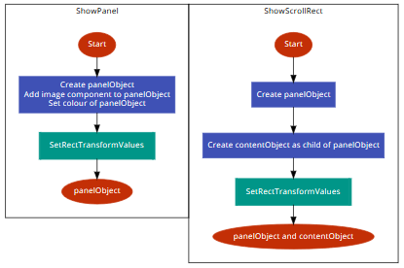

Figure 52 - Flowchart for ShowPanel and ShowScrollRect functions

The ShowPanel function will create a panel – essentially a large rectangle which can be used as a parent of other objects. An object is created and an image component is added to it with a certain, specified colour. The position and size of the panel is set before returning the object.

The ShowScrollRect function is an example of when panels are used as the parent of other objects. A panel object is created by calling ShowPanel before creating a new object called contentObject which will be a child of that object. The position and size of the contentObject is defined before returning both the panel and the scroll rect. The data which is to be shown on the scroll rect is added in the original function after it calls ShowScrollRect, allowing for more customisability.

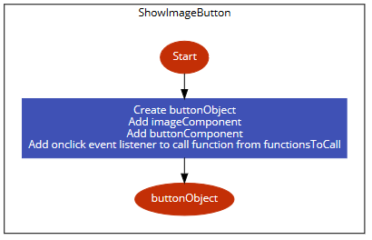

Figure 53 - Flowchart for ShowImageButton function

There are certain occasions when an image is going to be required as an image and a button. A main example of this is the back button which will be an image which can be clicked. So, this is a function specifically for that scenario where it will create an object, add both an image component and a button component before adding an event listener and returning the object.

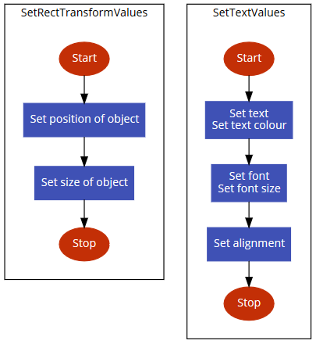

Figure 54 - Flowcharts for SetRectTransformValues and SetTextValues functions

These two functions are going to be called whenever the position and size of an object needs to be defined and when text needs to be added respectively. Although these are short functions, they are going to be called so frequently that it would be more efficient for them to be defined as their own function as opposed to repeating the code all the time. There is no need to return the object at the end of the functions because the functions change values for objects which have already been defined.

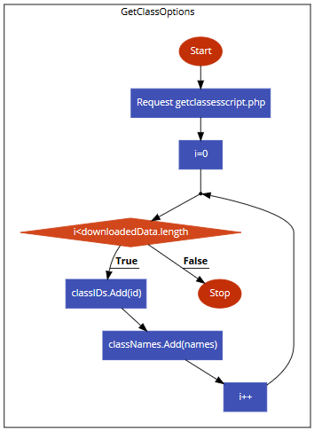

Figure 55 - Flowchart for GetClassOptions function

Add certain times, it is required to retrieve all of the classes that the student or teacher is part of. This will be done by requesting getclassesscript.php on the online server and downloading the relevant records from the classes table. The program will then loop through those records adding the class ids to the classIDs list and the class names to the classNames list.

#### Algorithm Design – LoadingSceneScript

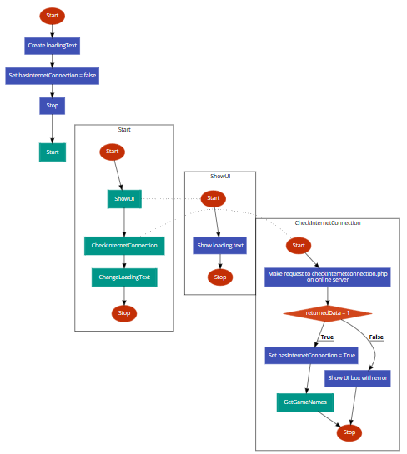

Figure 56 - Flowchart for beginning of LoadingSceneScript and Start, ShowUI and CheckInternetConnection functions

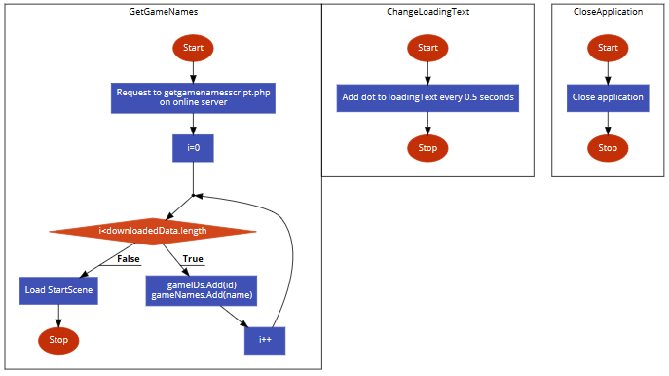

Figure 57 - Flowchart for GetGameNames, ChangeLoadingText and CloseApplication functions

The flowcharts above show very nicely the difference between scripts in my program. The GeneralFunctions script is going to be made of distinct functions which are called from other scripts. On the other hand, the Loading scene has no user input and so everything in the script links between the functions. There is quite literally a flow from one function to the next until eventually, the next scene is loaded.

First, there are two global variables in this script. They are the loading text object and a Boolean stating whether there is internet connection or not. This is automatically set to false and will be changed to true if there is internet connection. The Start function is called which will simply call three other functions. The first of these is ShowUI which will create and show the loading text. Next called is CheckInternetConnection. This function will make a request to a PHP script called checkinternetconnection.php and will check what is returned. (This script just prints “1” so there is no need for me to write a flowchart for it.) If what is returned is “1” then hasInternetConnection becomes true and GetGameNames is called. If this isn’t the case, then an error message will show saying there’s no internet connection and the application will exit when the user clicks on the error message (by calling CloseApplication). The final function called from Start is ChangeLoadingText which will add a full stop to the loading text every 0.5 seconds until there are 3 full stops at which point it will return to 0. This will be useful for the user because, if the program is taking a long time to retrieve the data from the database, then the user will want to know whether it’s just taking a long time to load or if the system has crashed. By having changing text, the user will know it’s just taking a while to load.

If there is internet connection, then GetGameNames is called. This will make a request to getgamenamesscript.php on the online server which will return all of the games in the program. I will then loop through them and add the ids to the id list in GeneralVariables and the names to the name list in GeneralVariables.

#### Algorithm Design – StartSceneScript

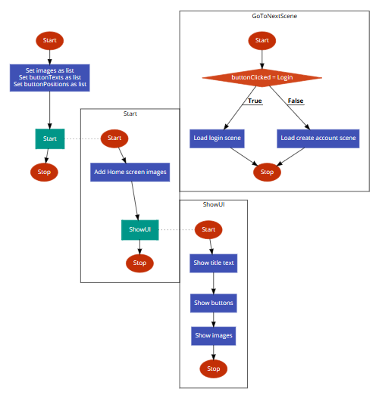

Figure 58 - Flowchart for StartSceneScript

First, a global list of images is created. This list is of the two mathematical images which will appear in the bottom-right and bottom-left of the screen. In addition, two more lists are created which will define the position and text of the login and create account buttons. The Start function is then called which first assigns the values for the images (by getting them from the Resources folder in Unity3D) before calling ShowUI. ShowUI will call the relevant functions in GeneralFunctions to show the title text, the buttons and the images. When one of these buttons is clicked, GoToNextScene is called and, depending on which button was clicked, either the login scene or create account scene loads.

#### Algorithm Design – LoginSceneScript

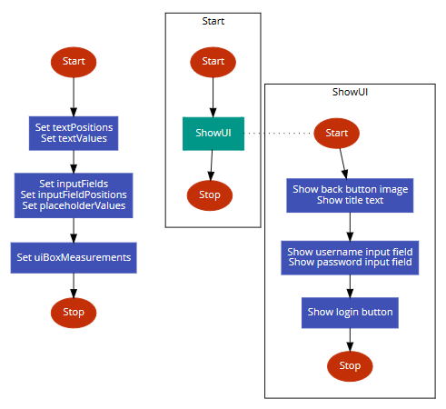

First, the positions and values of the headings of the input fields (“Username” and “Password”) are defined. The input fields (for now an empty list), their positions and their placeholder values are all then defined before the size of the UI box is defined.

The Start function is called which then calls ShowUI. ShowUI shows the back-button image, the title text, the input fields and the login button.

Figure 59 - Flowchart for beginning of LoginSceneScript, Start and ShowUI functions

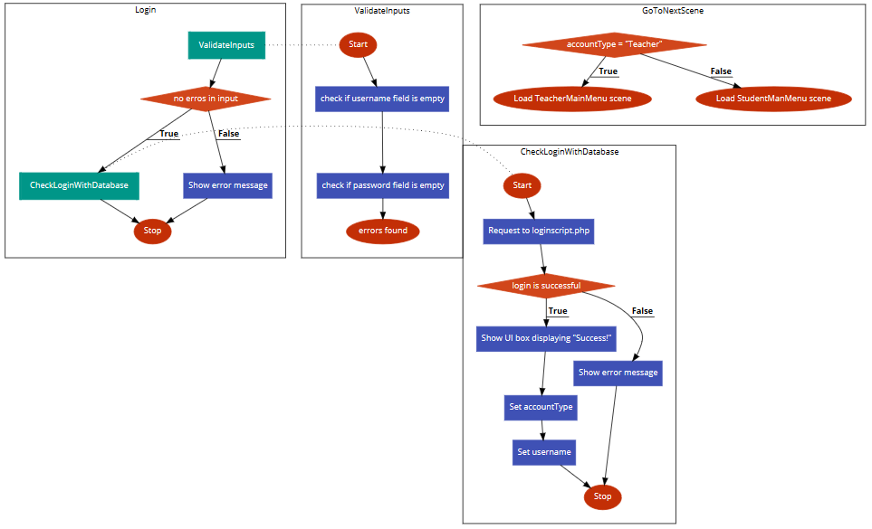

Figure 60 - Flowchart for Login, ValidateInputs, CheckLoginWithDatabase and GoToNextScene functions

When the user has inputted their username and password and clicks login, the Login function is called. This then calls ValidateInputs which checks if the entered values are acceptable to the system. If they are not then an error message appears. If they are then CheckLoginWithDatabase is called. This function requests loginscript.php on the online server which will enter the inputted information. If it returns a result, then there is an account matching those details and the login succeeds, leading them to another screen (via the GoToNextScene function). If not, then an error message appears.

#### Algorithm Design – CreateAccountSceneScript

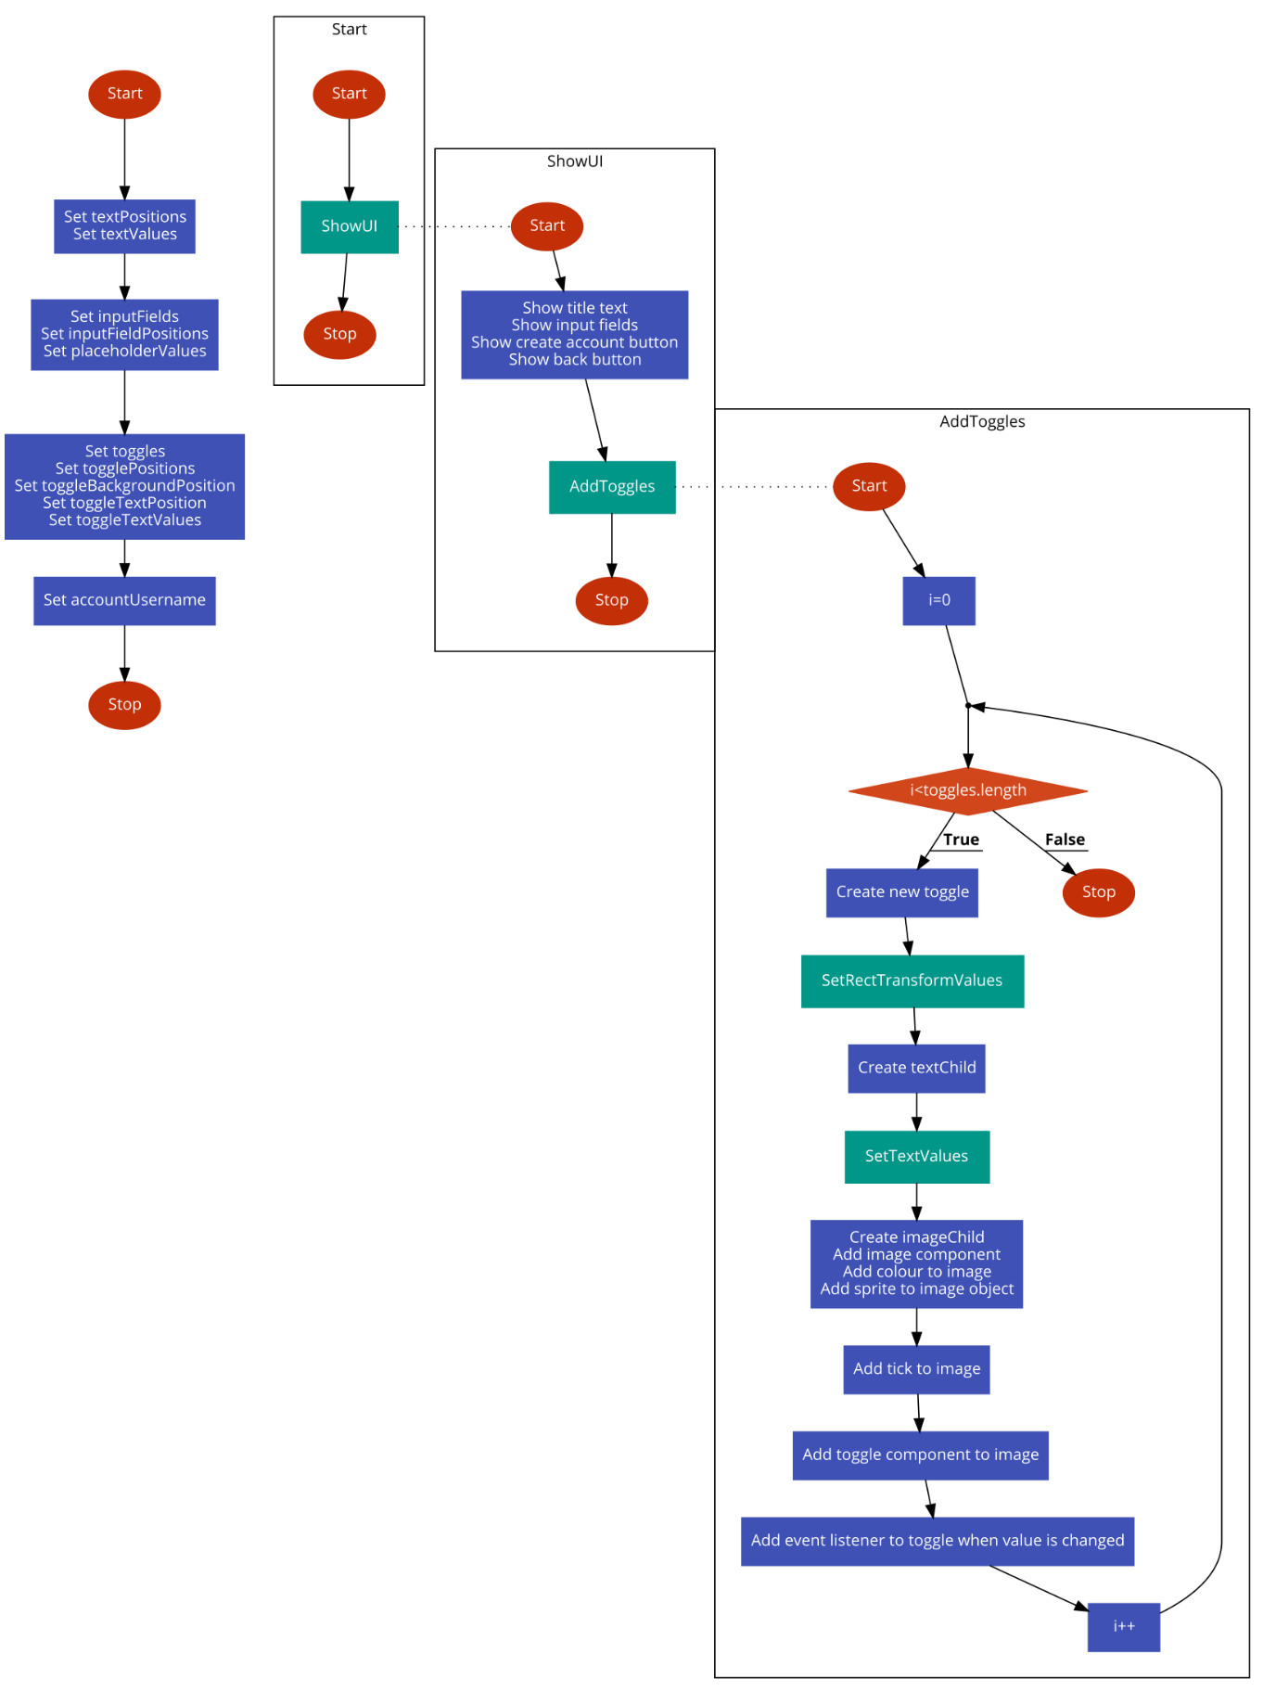

Figure 61 - Flowchart for beginning of CreateAccountSceneScript, Start, ShowUI and AddToggles functions

First, the global variables for the UI are defined, including the toggles, toggle positions, text, input fields and placeholders. In addition, there is a variable for the account username which will be assigned in this script. The Start function calls ShowUI which will set up all of the UI apart from the toggles. Since toggles aren’t part of GeneralFunctions (as this is the only time, they’ll be required so it wouldn’t be a general function), they must be created in this script which takes a lot more code so I will put it in its own function. This function, AddToggles, will loop through the required number of toggles (currently 2 – teacher and student) and create a new toggle for each one, including the background circle, tick image and text. In addition, an event listener will be created which will call ChangeToggle whenever the value of the toggle is changed.

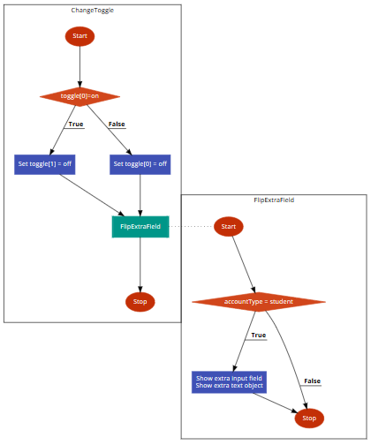

Figure 62 - Flowchart for ChangeToggle and FlipExtraField functions

ChangeToggle will be used to switch the toggles. For example, if the teacher toggle is currently selected and the user clicks on the student toggle, then in addition to the student toggle becoming selected, the teacher toggle will become unselected. As stated earlier in the project, the student version of the Create Account scene will include an extra input field and text object. FlipExtraField is there to add/remove these features when the toggle is changed and is called from the ChangeToggle function.

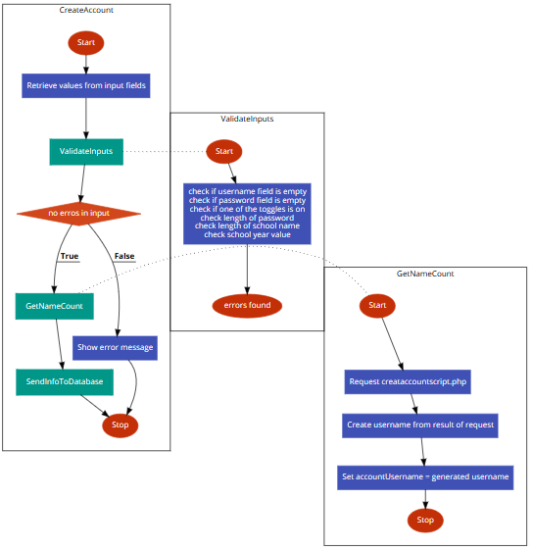

Figure 63 - Flowchart for CreateAccount, ValidateInputs and GetNameCount functions

The CreateAccount function will take the inputs from the user and call ValidateInputs. ValidateInputs will then check if the inputs are valid or not. If they’re not then an error message appears and if they are then GetNameCount is called. GetNameCount check how many people are already on the database with the same first two letters of their first name and surname (creating the same username). That value is then returned from the PHP script and an account username is generated. CreateAccount will hen call SendInfoToDatabase.

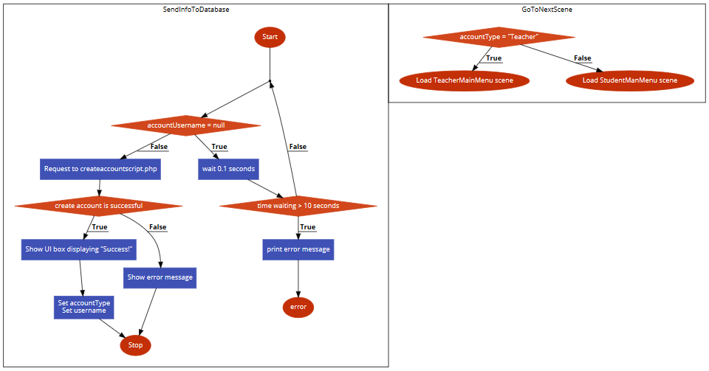

Figure 64 - Flowchart for SendInfoToDatabase and GoToNextScene functions

The SendInfoToDatabase function will first wait until the GetNameCount function gets a response because otherwise this function can’t continue. Once a response is found, it will make a request to createaccountscript.php to add the account. If that is successful, then the user will be notified and informed of their new username. If not, then an error message will appear and they will be able to either try again or return to the start scene. When the success message is clicked, GoToNextScene will be called and either the TeacherMainMenu scene or the StudentMainMenu scene will load depending on the account type of the new user.

#### Algorithm Design – ViewLeaderboardScript

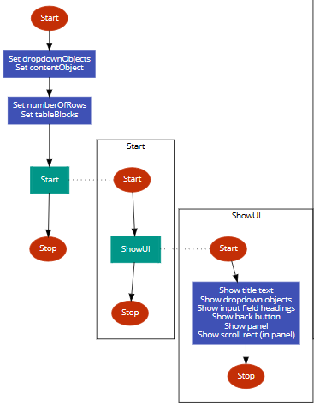

Figure 65 - Flowchart for beginning of ViewLeaderboardSceneScript, Start and ShowUI functions

First, the dropdown objects, content object, numberOfRows and tableBlocks variables are created. numberOfRows will store the number of rows in the current scroll rect. This is important to be known in the program because it will determine the size of the scroll rect. tableBlocks will store the actual rows themselves. The Start function will be called which will just call ShowUI. The ShowUI function will show the text, dropdown fields, panel, scroll rect and back button.

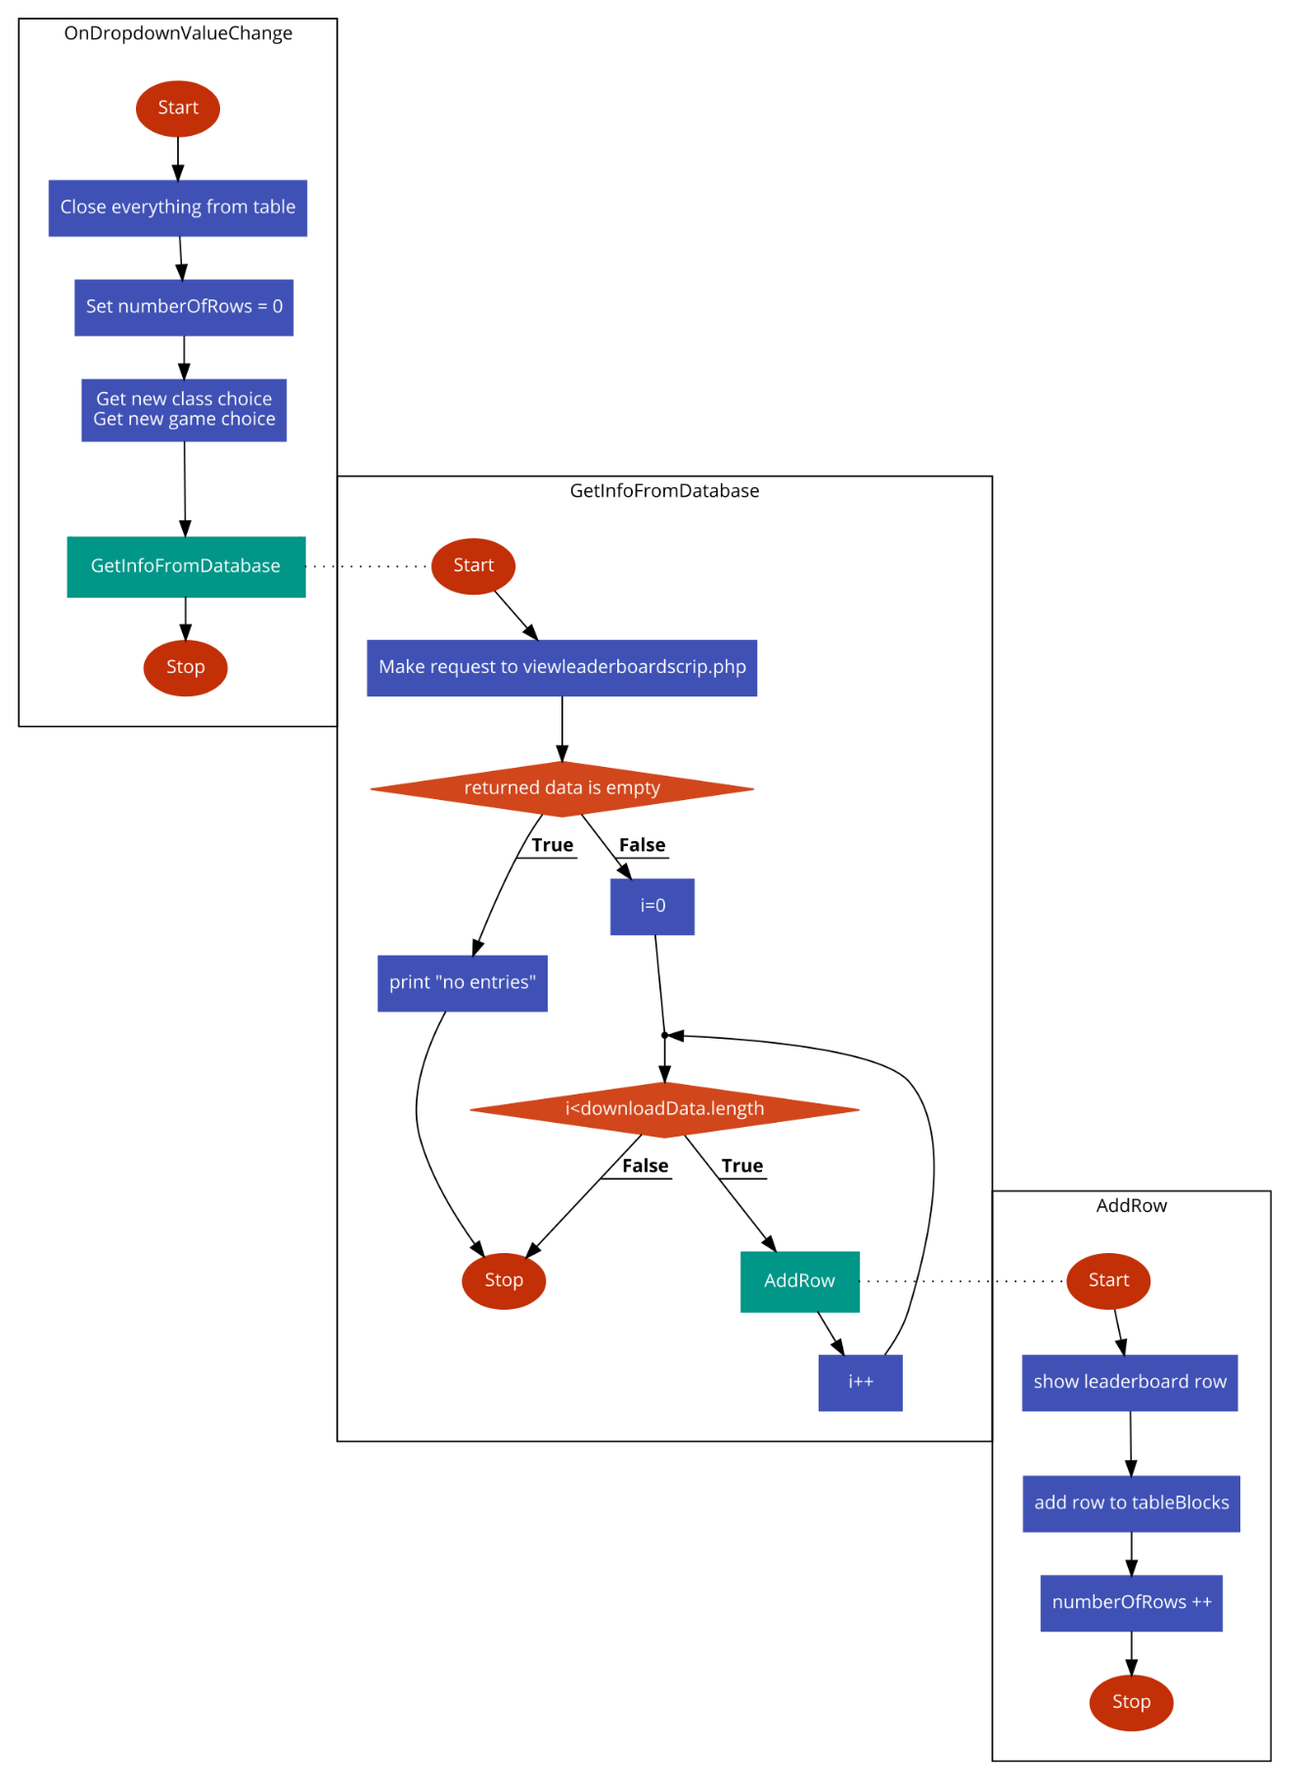

Figure 66 - Flowchart for OnDropdownValueChange, GetInfoFromDatabase and AddRow functions

When the user changes the value on either of the dropdown fields, the OnDropdownValueChange function will be called. This will reset the table of scores and select the new class and game that was chosen by the user. It will then call GetInfoFromDatabase. GetInfoFromDatabase will make a request to viewleaderboardscript.php and the PHP script will return every student’s high score for that specific game, given the student is part of the selected class. I will also set up a condition for if there are no returned values. Similar to before, it could appear that the program has crashed if nothing happens so I will add an error message informing the user that there are no entries. For each row returned from the database, the function AddRow will be called. AddRow will create the new row, add it to the list of rows and increase the numberOfRows count.

### Algorithm Design – Student Scripts

#### Algorithm Design – StudentMainMenuScript

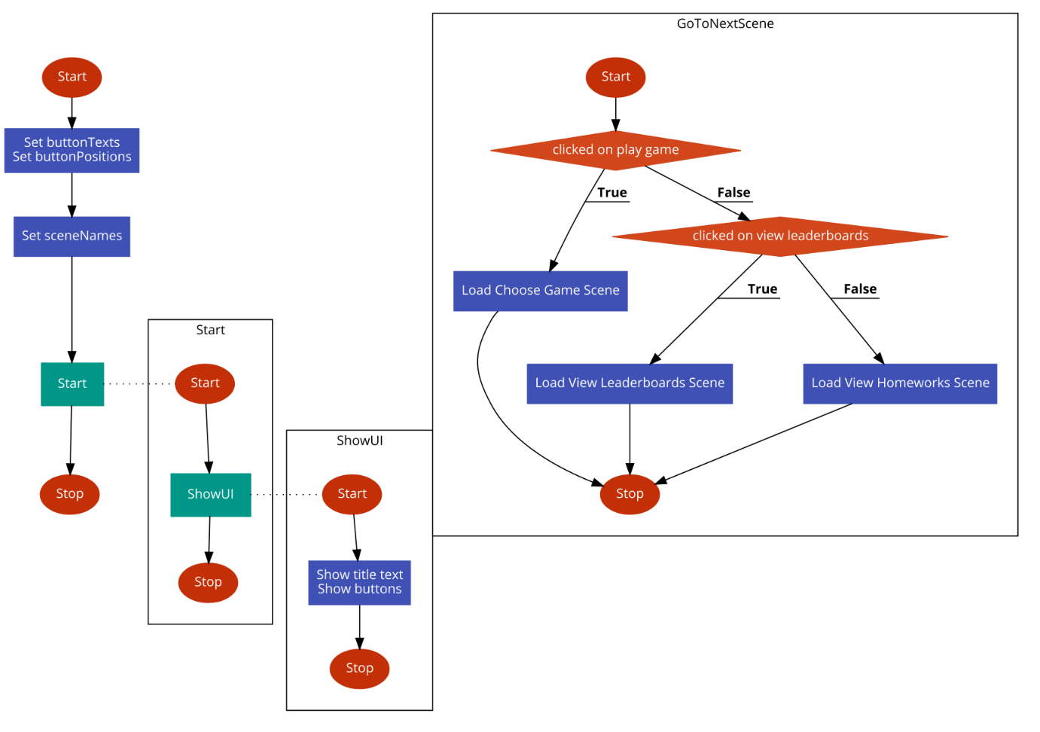

Figure 67 - Flowchart for StudentMainMenuScript

First, the buttonText values, buttonPositions values and scene names are defined. In the Start function, ShowUI is called as with previous scripts. In ShowUI, the title text and buttons are created. When one of the buttons is clicked, GoToNextScene is called. The next scene is then loaded; the scene which loads is dependent on which button was clicked.

#### Algorithm Design – ChooseGameSceneScript

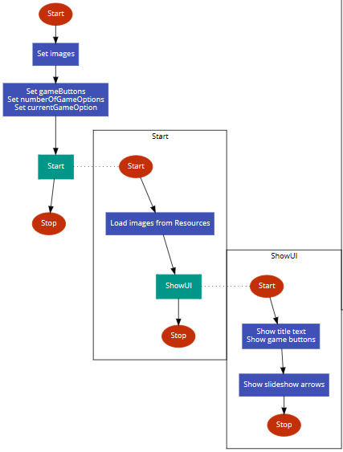

Figure 68 - Flowchart for beginning of StudentChooseGameSceneScript, Start and ShowUI functions

First, the images list (arrow images) is created (but not assigned to) and the game buttons, number of game options and current game options are created. The Start function is then called which assigns the arrow sprites to the images list from the stored resources in Unity3D then calls ShowUI. ShowUI will display the title text, game buttons and slideshow arrows.

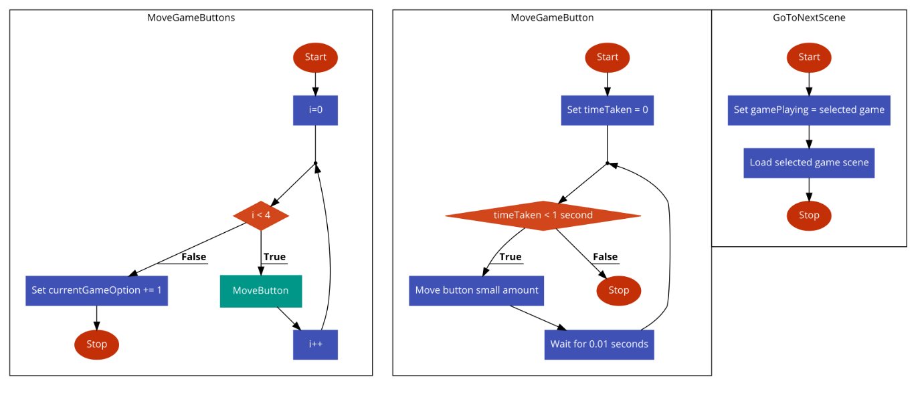

Figure 69 – Flowchart for MoveGameButtons, MoveGameButton and GoToNextScene functions

When one of the arrow buttons are clicked, the event triggers the function MoveGameButtons to run. This function loops through values between one and four. The reason for this is because four game buttons will be involved in the movement of the buttons: the three which are currently on the screen as well as the button which is about to move into the screen. For each one, MoveGameButton is called and after the loop, the current game option is incremented (or decremented if the left button is clicked) because the central option has now increased (or decreased). MoveGameButton will move the button in the x direction. However, instead of one swift movement, it will be an animation by looping over a certain amount of time and moving the button a small distance until it has covered the required amount. (I’ve put 1 second in the flowchart but that is an arbitrary value and I will test to see what works well.)

Finally, when one of the game buttons is clicked, a game scene will load. The scene which loads will be dependent on the game button clicked.

#### Algorithm Design – GameLinearSpaceshipWarsSceneScript

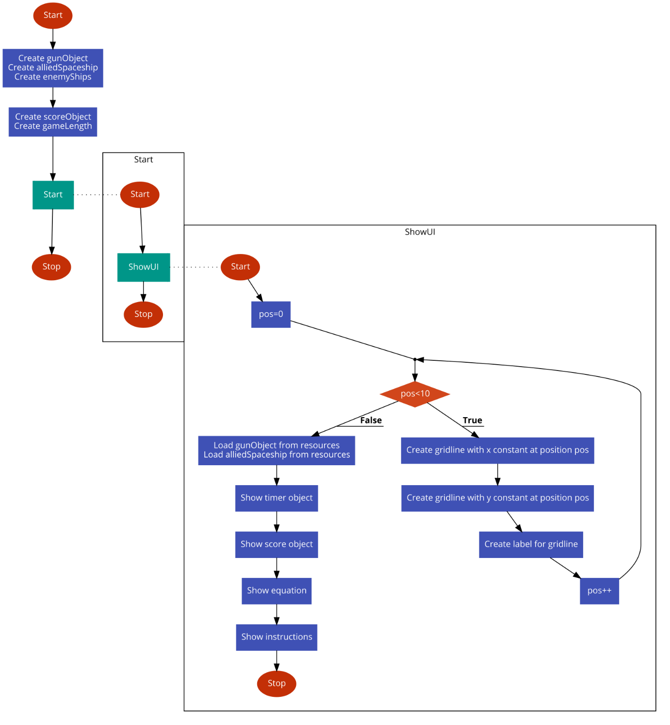

Figure 70 - Flowchart for beginning of GameLinearSpaceshipWarsSceneScript, Start and ShowUI functions

First, the gun and ship variables are created and the score object and game length are determined. I have decided to have game length soft-coded, thus making it a lot easier to change in the future if required. Then, Start is run which simply calls ShowUI. ShowUI first creates the grid, using a for loop between the x and y values for the gridlines, which will appear on the left-hand side of the screen (refer to page design of Linear Spaceship Wars scene). After the grid is created, the images for the gun and allied ships are retrieved from the resources folder and assigned to the variables created earlier. After that, the timer, score and equation are created and displayed before showing the instructions as a UI box.

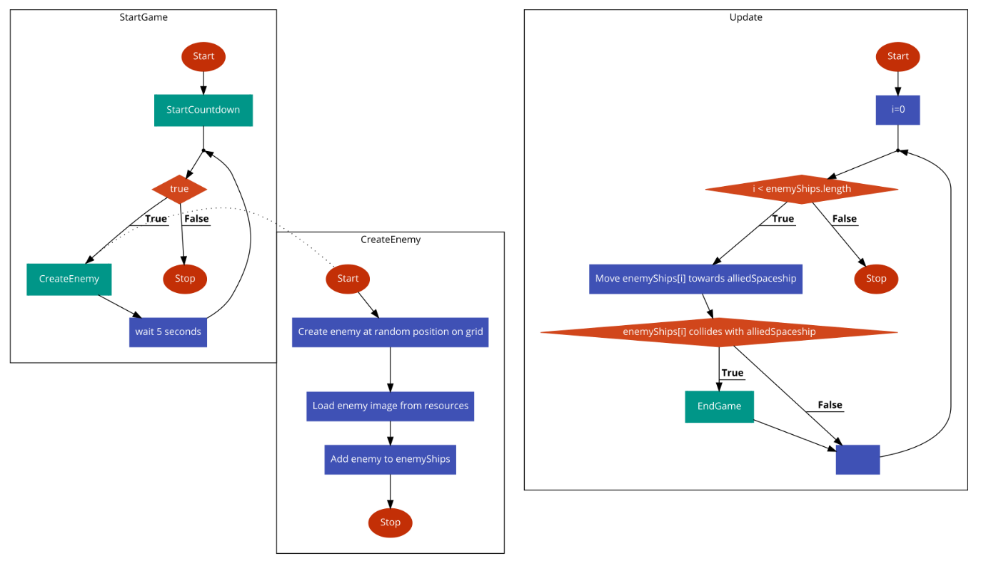

Figure 71 - Flowchart for StartGame, CreateEnemy and Update functions

StartGame will be called as an event when the instructions box is clicked. It will first call the StartCountdown function (which will be defined in GeneralGameScript.cs). It will repeatedly call CreateEnemy every five seconds until the game ends. CreateEnemy loads the enemy ship sprite from resources and creates an enemy object, positioning it in a random place on the outskirts of the grid. Lastly, the newly-created enemy object is added to the list of enemy ships.

Update is another function which is automatically run by Unity3D and it is run every frame. In the Update function, I will iterate through all of the live enemy ships and move each of them a little bit closer to the allied spaceship (which remains stationary throughout the game). I will then check if the enemy ship has ‘collided’ with the allied spaceship. If this is the case, then the student has lost the game and EndGame will be called (in EndGameSceneScript.cs).

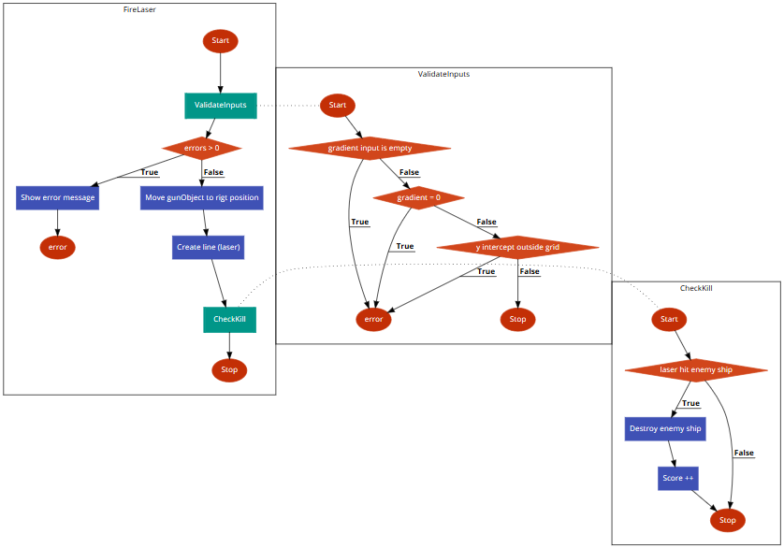

Figure 72 - Flowchart for FireLaser, ValidateInputs and CheckKill functions

FireLaser will be called as an event every time the user clicks on the ‘Fire Laser’ button. It will first call ValidateInputs, which will check if there are any errors regarding the inputs to the equation (such as the gradient field being empty). If there are any errors, then an error box will appear and the function will end there. If there aren’t any errors then the gun object will move to the inputted y-intercept and a laser will be created before CheckKill is called. CheckKill will check if the laser hits any of the enemy ships. If this is the case then the enemy ship is destroyed and the student’s score for the game is incremented by one.

#### Algorithm Design – GameSpeedMathsSceneScript

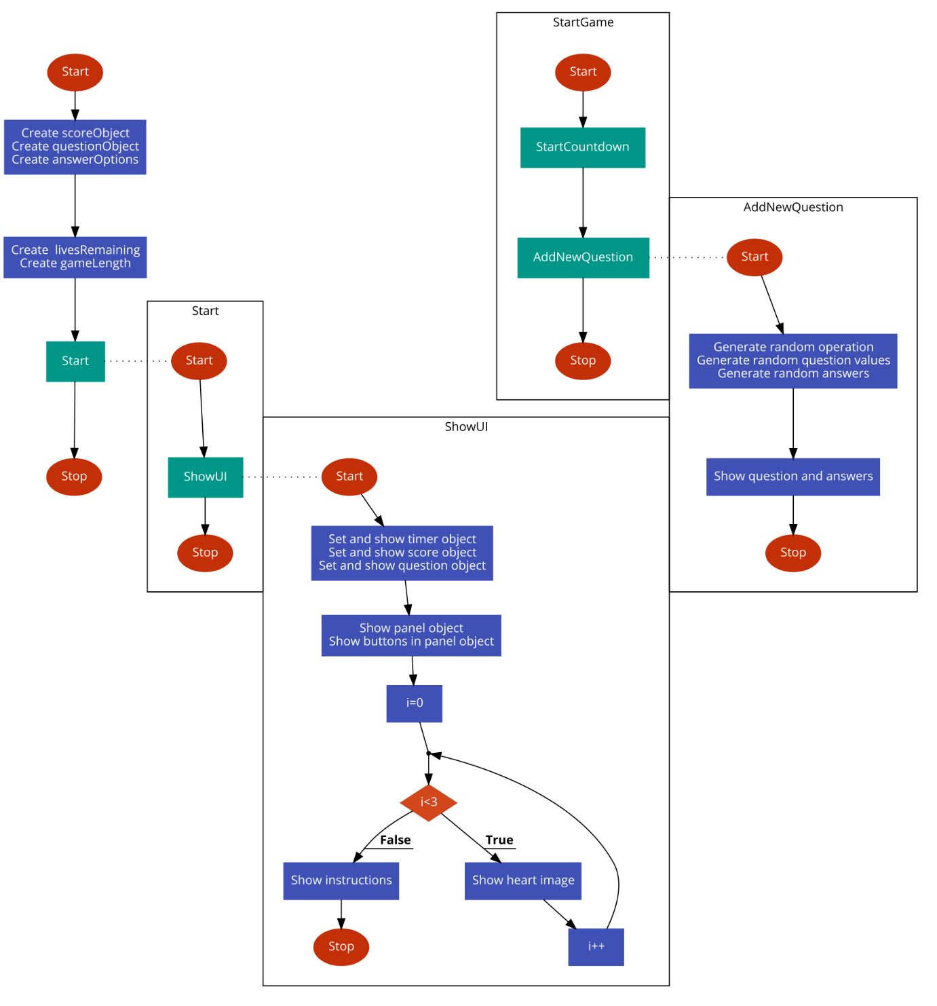

Figure 73 - Flowchart for beginning of GameSpeedMathsSceneScript and Start, ShowUI, StartGame and AddNewQuestion functions

First the variables for the score, question and answer objects are created. Two integer variables are going to be used during the game: livesRemaining and gameLength. livesRemaining will determine how many more incorrect answers the student can make before the game is over. Having this as a variable allows it to be changed (e.g. have different number of lives for differing difficulties). The Start function will call ShowUI which will show all of the UI for the scene: the timer object, score object, question object, panel object, buttons in the panel and the three heart images. It will then display the instructions to the user, in the form of a UI box.

When the user clicks on the instructions (implying they are ready to start the game), the StartGame scene is triggered. This will call two functions: StartCountdown from the GeneralGameScript (which will start the countdown for the game) and AddNewQuestion. AddNewQuestion will generate which operation the question should use randomly before generating random values for the question and random possible answers. All of these randomly-generated values are found according to certain rules to ensure the question will be feasible for the student to solve. For example, for a question which is in the form of an exponent ($a^{b}$), I will ensure $b≤5$ because otherwise the question becomes very difficult for the student to solve, especially as the game is intended to be done in the student’s head and not using paper. The relevant object variables are then set to the question and possible answers before displaying them to the user.

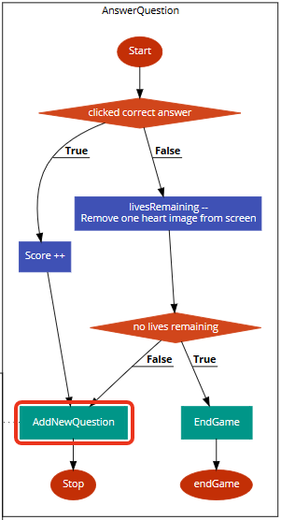

Figure 74 - Flowchart for AnswerQuestion function

The AnswerQuestion function is run when the student clicks on one of the answers. If the answer is correct, then their score is incremented and a new question is created by calling the AddNewQuestion function. If their answer was incorrect, then the function will check if the student has any lives remaining. If they do then a new question will be shown and if not, then the student has lost the game and the EndGame function will be called.

#### Algorithm Design – GameAlgebraMillionaireSceneScript

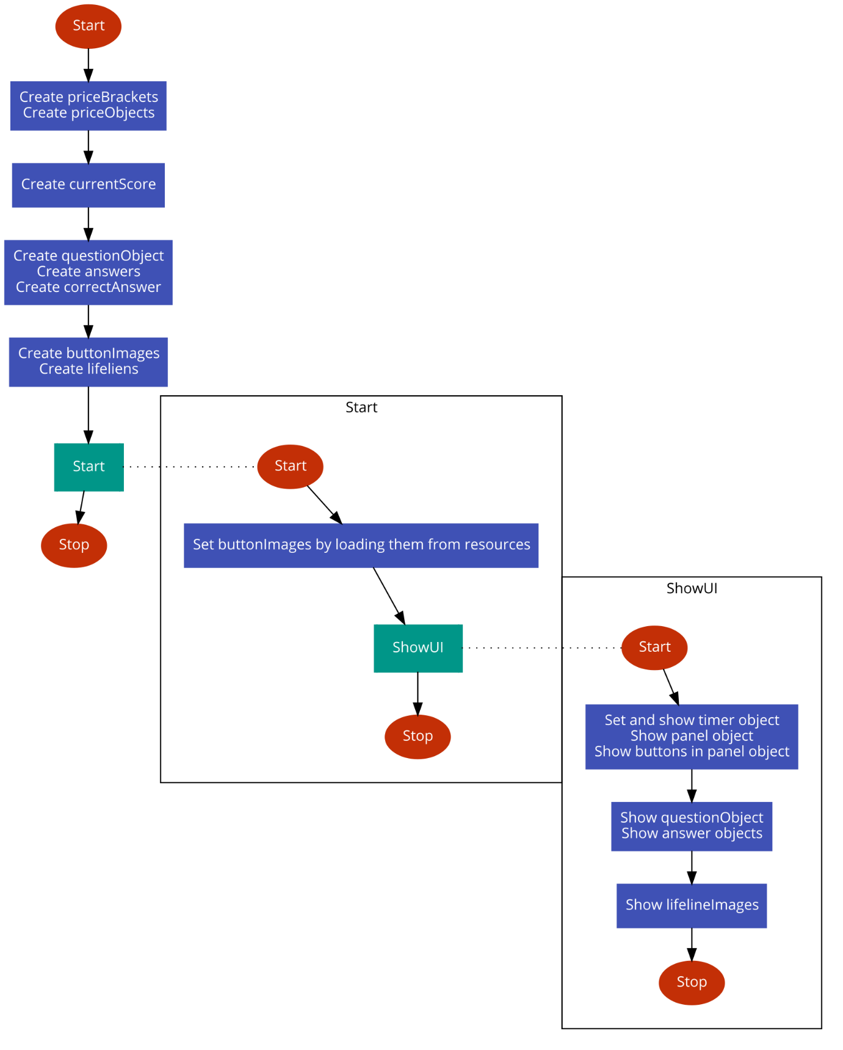

Figure 75 - Beginning of GameAlgebraMillionaireSceneScript and Start and ShowUI functions

First, the objects for the right-hand side of the screen is created: the price objects and a list of their object’s respective values. It then creates a variable for the current score, creates the question and answer objects before creating the button images and lifelines. The Start script is then called which retrieves the image files from resources and adds them to the right images then ShowUI is called. ShowUI will show the timer, panel and question objects in addition to a panel object to allow scrolling of scores. This function will also show the lifeline images, done by setting the lifelineObjects equal to each of the images which were previously loaded in the Start function.

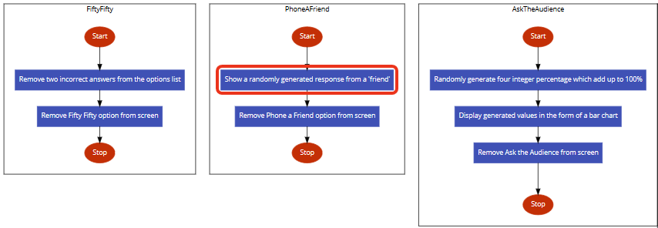

Figure 76 - Flowchart for FiftyFifty, PhoneAFriend and AskTheAudience functions

If the user clicks on the 50/50 lifeline then the FiftyFifty function will be triggered which will remove two of the incorrect answers will be removed from the list of possible answers. The two which are chosen to be removed will be at random. PhoneAFriend will be triggered when the phone a friend lifeline button is clicked. There will be a set of potential phrases which the computer could return, varying between knowing the answer for certain and not having a clue. The one which is returned is again at random and is displayed using a UI box. AskTheAudience will be triggered when the user clicks on the ask the audience lifeline button. Four randomly-generated values will be created where the four values have a sum of 100% and there is a high chance of the correct answer having the highest probability (because, generally speaking, the audience gets the right answer in the game show). For all three of these lifelines, when the lifeline is used, the lifeline image will be removed from the screen making it impossible for the student to use the same lifeline twice in the same game.

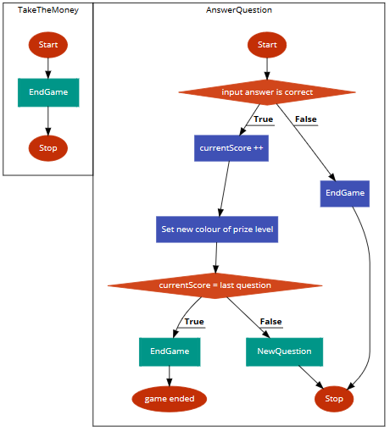

Figure 77 - Flowcharts for TakeTheMoney and AnswerQuestion functions

If the user clicks on the money button, then the game will end and go to the EndGame scene. If the user answers a question by clicking on one of the answers, AnswerQuestion is triggered. It will first check if the answer is correct. If it is incorrect, then the game will end. If the answer is correct, then there will be another check to see if that was the last question. If it was then the game will end and if not, then a new question will be asked.

#### Algorithm Design – GeneralGameScript

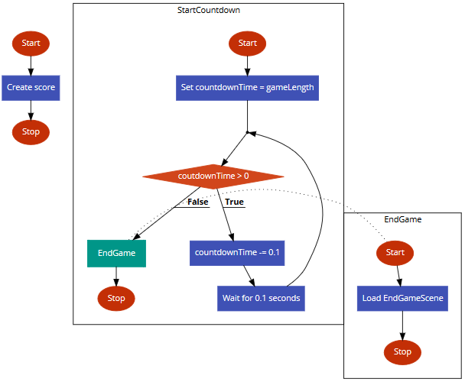

Figure 78 - Flowchart for GeneralGameScript

GeneralGameScript will contain functions which are going to be used in all (or at least most) of the games. As of now, I can think of two such functions: StartCountdown and EndGame. When the script initialises, a score variable is created and set to 0. StartCountdown will begin a countdown and will link to the timer object which appears in the actual game scripts. It will progressively decrease a timer variable and, at the same time, update the value on the time object that is shown to the user. When the timer reaches zero, the user has run out of time so the student has lost the game and EndGame is run. The EndGame function will load the next scene, which will always be the EndGameScene.

#### Algorithm Design – EndGameSceneScript

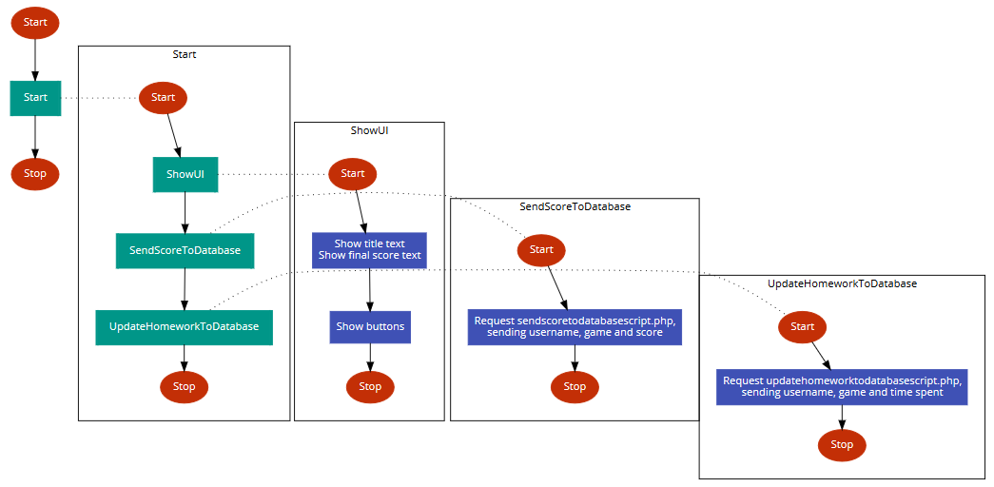

Figure 79 - Flowchart for Start, ShowUI, SendScoreToDatabase and UpdateHomeworkToDatabase functions of EndGameSceneScript

First, in the Start function, ShowUI is called which shows the title text, final score text and shows the buttons which will allow the user to choose what to do next. The Start function will also call the functions SendScoreToDatabase and UpdateHomeworkToDatabase which both connect to the online server and add the score and homework information respectively to the relevant tables in the database.

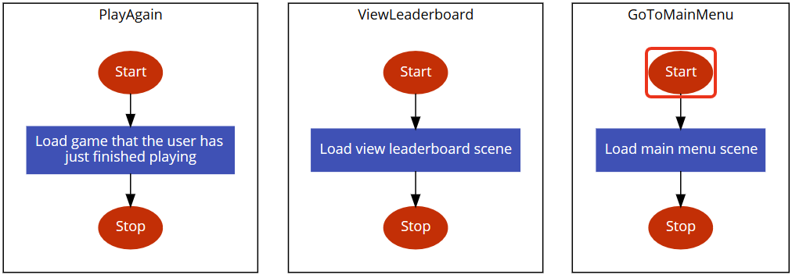

Figure 80 - Flowchart for PlayAgain, ViewLeaderboard and GoToMainMenu functions

Above is the design of the three functions which will be invoked when one of the buttons is clicked by the user. As expected, they each simply load the scene which is relevant to the button which is linked to it. (For example, clicking the “view leaderboard” button will invoke the ViewLeaderboard function which will load the View Leaderboards scene).

#### Algorithm Design – StudentViewHomeworksSceneScript

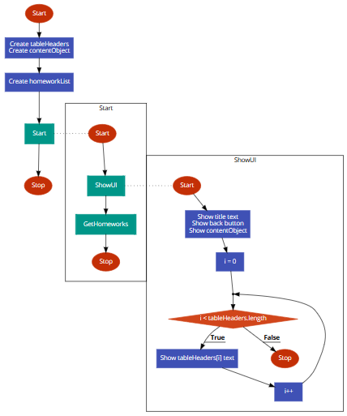

Figure 81 - Flowchart for beginning of StudentViewHomeworksSceneScript and Start and ShowUI functions

First, the variables for the table headers (the column names: Name, Class, Game, Length and Due Date) and the content object are created. In the Start function, the functions ShowUI and GetHomeworks are called. ShowUI will show the title text, back button, assign an object to the contentObject variable and loop through the list of table headers, creating a new text object for each one.

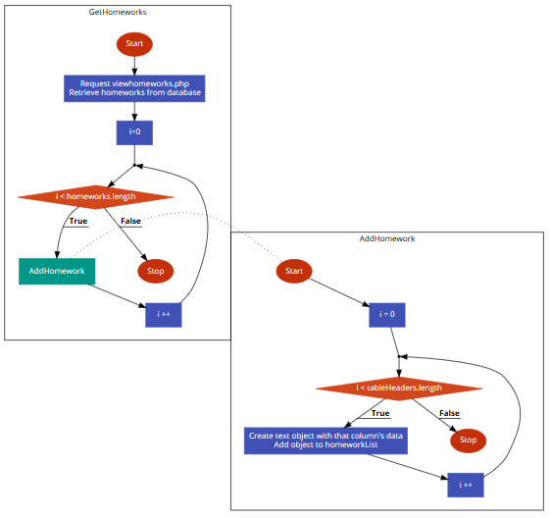

Figure 82 - Flowchart for GetHomeworks and AddHomework functions

GetHomeworks is called from Start (as shown above). The function will make a request to the php script, viewhomeworks.php and, for each homework found for that specific student where the due date has not already passed, it will call AddHomework. The AddHomework function will take the data from GetHomeworks and turn it into visualisable data by creating a new text object for each piece of data and displaying it as a column in a row of the homeworks panel for that specific homework.

### Algorithm Design – Teacher Scripts

#### Algorithm Design – TeacherMainMenuSceneScript

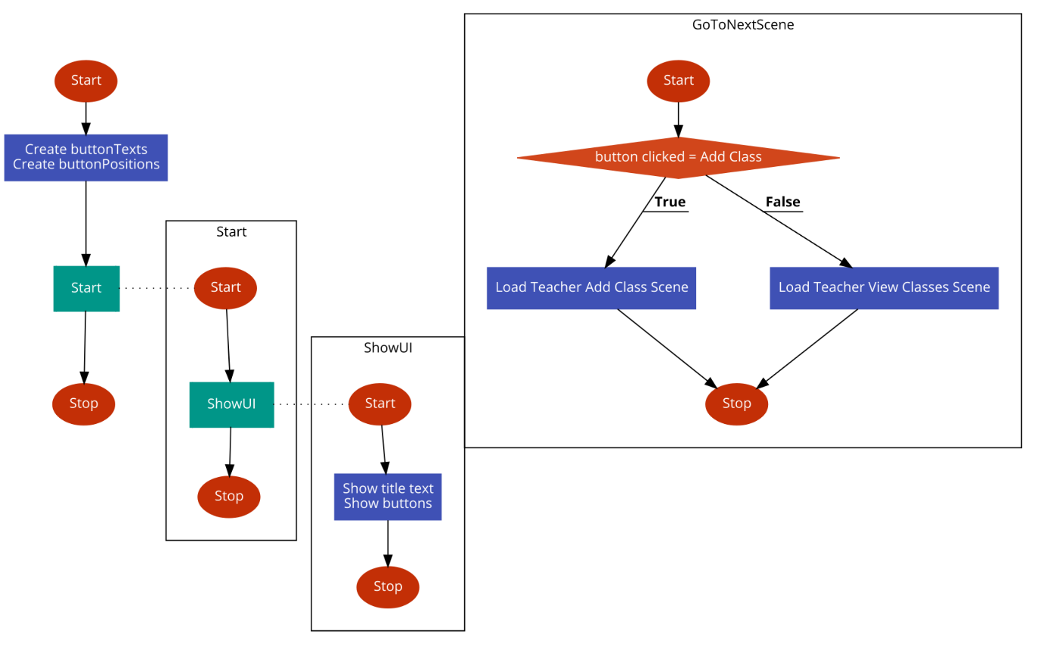

Figure 83 - Flowchart for TeacherMainMenuSceneScript

First, the buttons’ text values and positions are defined before Start is called. In the Start function, ShowUI is called. ShowUI will display the title text and the buttons onto the screen. When either of the buttons (“Add Class” or “View Classes”) is clicked, the GoToNextScene function is executed. Depending on the button clicked, a new scene will load (either the “Add Classes” scene or the “View Classes” scene).

#### Algorithm Design – TeacherAddClassSceneScript

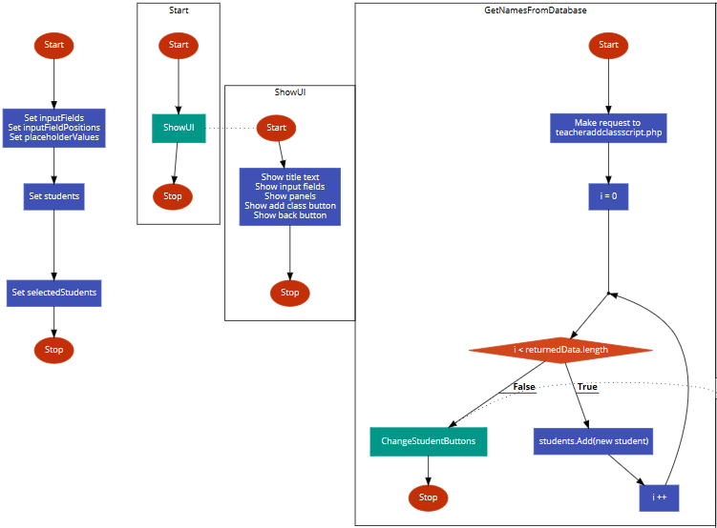

Figure 84 - Flowchart for beginning of TeacherAddClassSceneScript and Start, ShowUI and GetNamesFromDatabase functions

First, variables for the input fields, their positions and their placeholder values are defined. Next, a list will be created for all of the students which are eligible for the class and another list will be created for the students which have been selected by the teacher. The Start function will call the ShowUI function which will display all of the UI elements: the title text, input fields, panels and buttons. The GetNamesFromDatabase function will be called whenever there is a change in the input field where the teacher is meant the class’s school year. The function will make a request to teacheraddclassscript.php which will respond with a list of all of the students who are eligible for the class due to their age and school. It will then loop through all of these students, adding them to the previously-defined list for students, before calling ChangeStudentButtons.

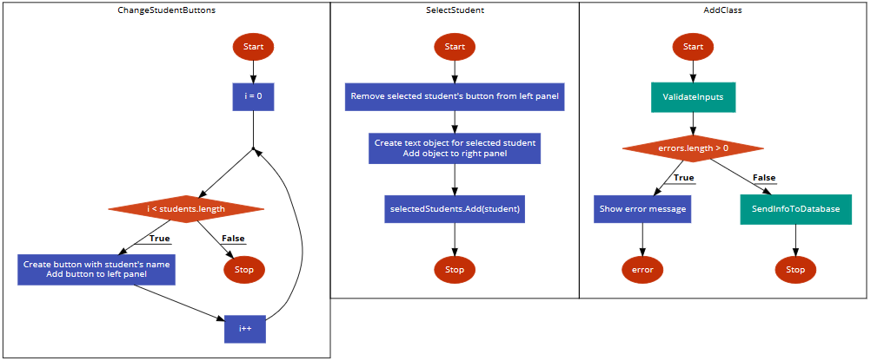

Figure 85 - Flowchart for ChangeStudentButtons, SelectStudent and AddClass functions

The ChangeStudentButtons function is called from GetNamesFromDatabase, as mentioned earlier. The function will loop through all of the students, creating new button for them and adding that button to the left-hand panel (the list of students for the teacher to choose from). When one of these buttons is clicked on, the SelectStudent function is called. This function will remove the student as an option from the left-hand panel but do the same thing as the ChangeStudentButtons function and create a new button but this time adding it to the right-hand panel instead (the list of students who have been selected). The student is then added to the list of selected students.

When the teacher clicks on the “Add Class” button, the AddClass function is executed. It checks with ValidateInputs if there are any errors. If there are, then an error message appears and the function ends. If not, then SendInfoToDatabase is called.

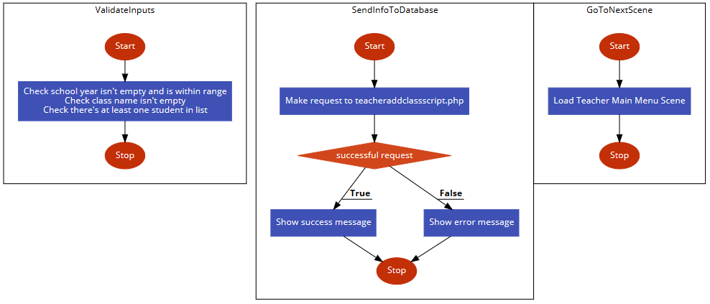

Figure 86 - Flowchart for ValidateInputs, SendInfoToDatabase and GoToNextScene functions

The ValidateInputs function will check if all of the inputs from the input fields are valid as well as ensuring there is at least one student being added to the class. When SendInfoToDatabase is called, it makes a request to teacheraddclassscript.php, sending with the request the relevant details to create the class (the teacher’s username, the year group, the class name and a list of students). If the request was a success then there will be a success message. If it was not successful, then an error message will show and the function will end. When the success message is clicked on, GoToNextScene will be invoked which will return the teacher to their main menu scene.

#### Algorithm Design – TeacherViewClassesSceneScript

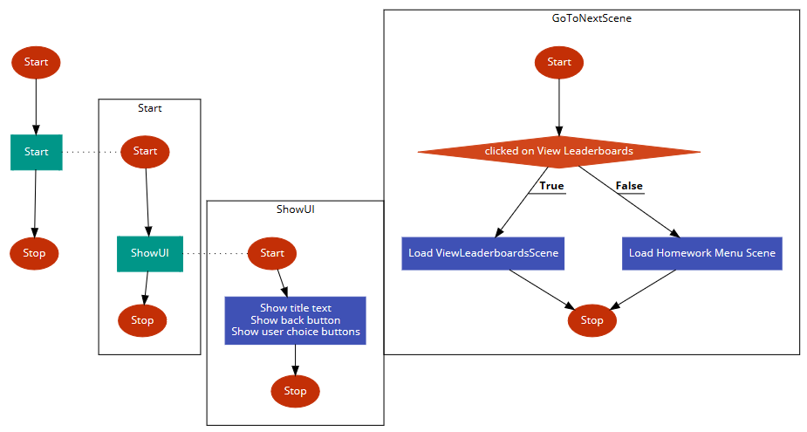

Figure 87 - Flowchart for TeacherViewClassesSceneScript

This scene is just a simple menu so there isn’t much complicated in the design of the script for this scene. The Start function will call ShowUI which will show the title text and the buttons. When one of these buttons is clicked on, GoToNextScene is invoked which will check which button was clicked. If the user clicked on the “View Leaderboards” button then the program will load the View Leaderboards scene whereas, if the user clicked on the “View Homeworks” button then the program will load the Homework Menu scene.

#### Algorithm Design – TeacherHomeworkMenuSceneScript

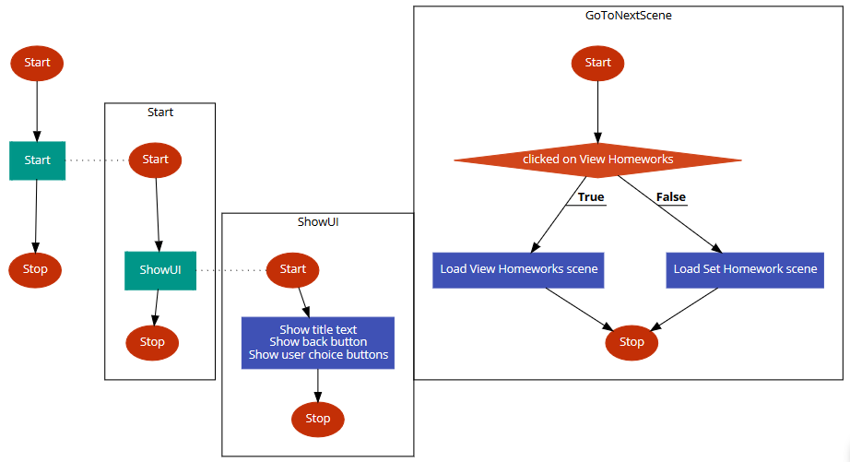

Figure 88 - Flowchart for TeacherHomeworkMenuSceneScript

This script will be almost identical to TeacherViewClassesSceneScript so I will not add any new explanation of the design of the script. The only differences are the text in the buttons and the scenes which are loaded in the GoToNextScene function. In this script, if the user clicks on the “View Homeworks” button then the View Homeworks scene is loaded. However, if the user clicks on the “Set Homework” button then the Add Homework scene is loaded.

#### Algorithm Design – TeacherAddHomeworkSceneScript

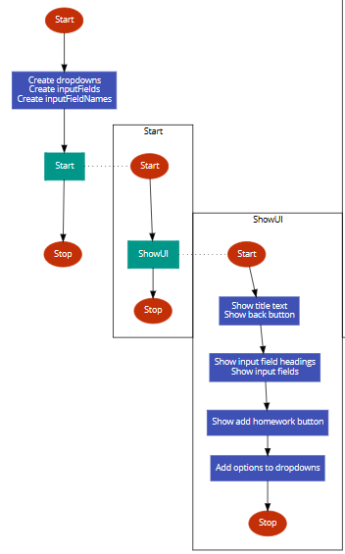

Figure 89 - Flowchart for beginning of TeacherAddHomeworkSceneScript and Start and ShowUI functions

First, the dropdown field and input field variables are created. In ShowUI, the title text, buttons and options to the dropdown menus are added. Since the dropdown menus are for classes and games, both have already been downloaded in previous scenes and kept in GeneralVariables so accessing the database is not required.

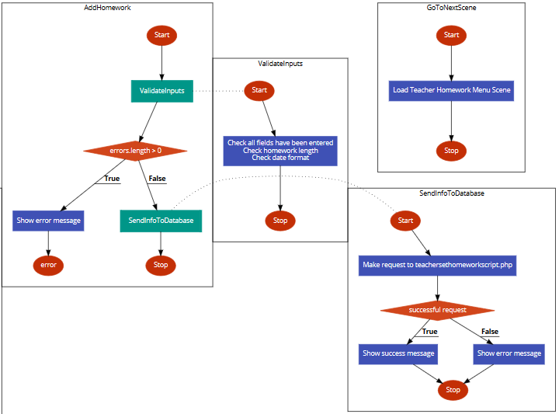

Figure 90 - Flowchart for AddHomework, ValidateInputs, SendInfoToDatabase and GoToNextScene functions

When the teacher clicks on the create account button, the same thing will happen as described in the Add Class scene script. It will first check if all of the inputs are valid before sending the data to teachersethomeworkscript.php which will add the new homework to the database. Again, there will then be either a success message or an error message which will end that function. When the success button is clicked, the program will return to the Homework Menu scene so that the teacher can now view the homework if they want to or return to the main menu by using the back button.

#### Algorithm Design – TeacherViewHomeworksSceneScript

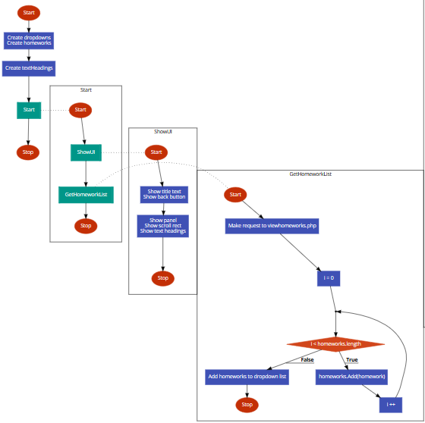

Figure 91 - Flowchart for beginning of TeacherViewHomeworksSceneScript and Start, ShowUI and GetHomeworkList functions

First, variables for the dropdown fields and input fields are created and the text headings (the columns for the table) are defined. The Start function will call two functions: ShowUI and GetHomeworkList. ShowUI will load all of the UI content: the title text, back button, panel, scroll rect and text headings before displaying them on the screen. GetHomeworkList makes a request to viewhomeworks.php which will return a list of homeworks which the teacher has set. The function will then loop through these homeworks and add them to a list of homeworks. After the iteration has completed, the list of homeworks is added to the dropdown list, making the dropdown list show each homework as an individual option.

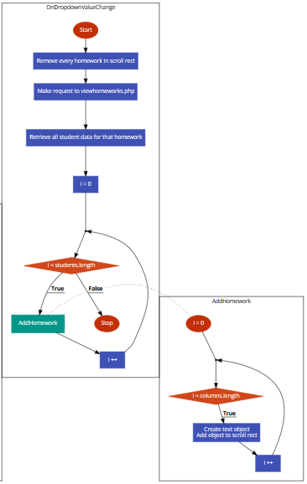

Figure 92 - Flowchart for OnDropdownValueChange and AddHomework functions

The function OnDropdownValueChange will be automatically called (as a trigger event) whenever the user picks a new dropdown item. When this happens, the scroll rect will be cleared by removing every piece of data in the table before making a request to viewhomeworks.php on the online database again to download the new data for that homework. For each student that is ‘part of’ this homework, the function AddHomework will be called. AddHomework will loop through the columns in the table (Name and Time Spent), creating a new text object for each column and showing the object on the scroll rect and as part of the table.

### Algorithm Design – PHP Script

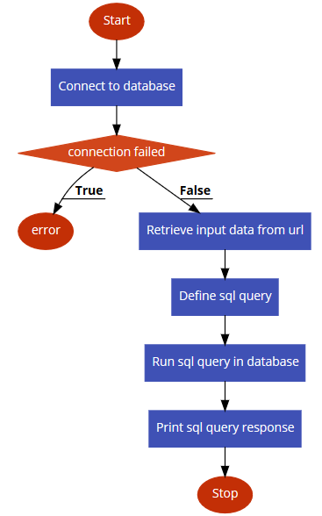

Figure 93 - Flowchart for a generic PHP script in the program

Above is the design for a generic PHP script in this program. They all begin by connecting to the database using a database name, username name and password. It then checks if the connection was successful. If it was unsuccessful, then it will return an error and end the script. However, if the connection is successful, then the script will first retrieve the input data which will be stored in the URL sent from a C# script. The relevant SQL query will then be defined before running that query and outputting the response in the form of a print statement (which can then be read from the C# script).

## Validation

### Buttons

Buttons are part of Unity3D and is implemented by their software. Therefore, buttons are already robust and shouldn’t accept any unauthorised or incorrect input. Although the buttons always link to a function, the function will nearly take parameters since it is not possible to create a function delegate which takes a parameter easily in Unity3D. Therefore, given there will be no user input from the button to the function, there is nothing which can be inputted incorrectly and thus, no validation would be required for the buttons.

### Scroll Rects

Unity3D also controls the scroll rects. However, the software doesn’t control how they act. For example, if the scroll rect was very large, then the user would be able to scroll down a very long way even if there is only a very small amount of data to view. I will combat this error by dynamically determining the height of the scroll rects. The scroll rects will start at a predetermined height (probably the height of the panel) and the height will be increased every time an additional piece of data is put into the list. Therefore, the height of the scroll rect will always be the height of the list of data that needs to be viewed and thus preventing issues like infinite scrolling, where the user will move the scroll rect well beyond the final piece of data and getting lost from the data the user actually wants to see.

### PHP GET Statements

In the PHP scripts, the data from the C# script will be retrievable using GET statements where the data will be part of the URL. However, PHP causes errors when the script runs a GET request on a string which doesn’t exist in the URL. Therefore, I will validate the PHP scripts so that it will only run a GET request when there the string actually features in the URL. I will do this using the function “isset”[2] which will determine if the string features in the GET statement section of the URL (the section after a ‘?’ symbol).

### Input Fields

The main use of validation in my program is going to be with regards to input fields. These are situations where the user can quite literally type whatever they like, regardless of the type of data the program is expecting to take in. I am going to tackle the issue of input fields with two solutions. Firstly, since input fields are defined objects in Unity3D, there are certain limitations that you are able to impose on the input. The limitation I will use is the limitation of content type. For example, for an input field where the user needs to enter a school year, Unity3D allows me to only allow the user to enter integers. If the user enters the letter ‘A’ then it will just not appear in the input field and the keypress would be essentially ignored by the system. I will use this solution for certain input fields where there needs to be a restriction on data type.

However, the solution above is not particularly versatile because, although it will succeed in its job fairly easily, it will only cover the validation requirements of a few input fields. Most fields have other pieces of validation which must be applied. Therefore, a second solution is also needed. What I will do is as follows: for every scene where an input field appears and is used by the user, I will have a specialist function in that scene’s script dedicated to validating inputs (the ‘ValidateInputs’ function as seen in the algorithm designs earlier).

The advantage of using a system like this is that I can specialise the validation for each script individually. So, a value can be set to be between 4 and 15 in one scene but between 10 and 20 in a different scene without any complications. In these ValidateInputs functions, the script will check if the input is valid according to the rules of that specific input field and will return error messages as a list. The function that called ValidateInputs will then check the list of errors. If the length of the list is zero then the list is empty and there are no errors, therefore meaning the script can carry on as intended. If, however, the length of the list is non-empty then there is at least one error in the input and the error messages will be printed to the user to correct.

## Testing Methods

### Iterative Development and Testing

I am going to split the development of my program into many sections, progressively creating scenes from the beginning of the program (starting with Loading Scene then Start Scene etc.). During the development, each script will be tested (and more specifically, every function will be tested individually). In addition, the functionality of the whole scene will be tested after every scene before making one full test at the end of the whole program. The function testing will check that the function runs properly, given certain inputs. The script testing will check if the functionality of the scene works properly and the overall test at the end of the development process will be mainly aimed at testing the linkage between scenes. All of the outputs will be printed to the Unity3D debug console so that I will be able to analyse the results and see if each test was successful or not.

For the testing, I will use a series of methods including both black-box testing and white-box testing.

### White-Box Testing

White-box testing is when you test the function using knowledge of the function itself. I will be testing the functions using white-box testing mainly in one way: fault injection.

#### Fault injection

Fault injection is when you provide the function with inputs which you know are going to cause an error or is an input which should not be permitted as an input by the program. I will use fault injection by entering values which should cause errors (for example, by inputting a string into an integer input field) and analysing the output. The aim is for the program to either disregard any invalid input or to show an error message to the user (depending on the specific function involved).

### Black-Box Testing

Black-box testing is when you provide the function with inputs without knowledge of how the function actually works. The function is considered a black box because you can only see the input and the output, not the actual function itself. The only black-box test I will use will be boundary testing.

#### Boundary Testing

Boundary testing is when inputs are entered on the very limits of what should be considered a valid input. For example, if an integer is meant to be entered between 15 and 30, then boundary testing would be using the inputs 15 and 30 (as well as possibly 14 and 31 to make sure they cause an erroneous response from the program). The aim will be for the boundary tests themselves to be considered valid by the program and output the right value, whereas values just outside the boundary tests will be considered invalid by the program and so the function wouldn’t continue running beyond the validation detection point.

### SQL Injection

Since my program involves sending data to, and requesting data from, a database, it is important that I defend the database against SQL injection. I will do this using certain statements which are known for causing issues with SQL queries and which would theoretically cause the program or database to crash. Hopefully, the PHP scripts will defend against such tests. However, in the scenario that it does some damage to the database, I will have backed up the database offline before starting the tests so that there is no lasting effect on the online database.

### General Outline of Tests during Iterative Development

There are some sections when a lot of testing will be required so I will split the testing into different sections, represented by different tables in this document, split by what objects and features are being tested.

#### General Functions

|  |  |  |  |
| --- | --- | --- | --- |
| Test function | Expected Output | Output | Correct? |
| GetClassOptions (Teacher - user has no classes) | Class variables should be empty |  |  |
| GetClassOptions (Teacher - user has at least one class) | Class variables should have correct values |  |  |
| GetClassOptions (Student - user has no classes) | Class variables should be empty |  |  |
| GetClassOptions (Student - user has at least one class) | Class variables should have correct values |  |  |
| OnBackButtonClick (Scene list has no values) | Nothing |  |  |
| OnBackButtonClick (Scene list has at least one value) | Error saying scene not found (other scenes won’t have been created by this point) |  |  |
| ShowText (short message) | Text shows on screen with right attributes |  |  |
| Show Text (long message) | Whole text is shown but with a smaller font to allow all of the text to show. |  |  |
| ShowInputField (Alphanumeric) | Input field shows on screen with right attributes. Only letters and numbers should be permitted |  |  |
| ShowInputField (Integer) | Input field shows on screen with right attributes. Only numbers should be permitted |  |  |
| ShowImage | Image shows on screen with right attributes |  |  |
| ShowUIBox | UI box shows on screen with right attributes. Goes away when clicked on |  |  |
| ShowUIBox (when UI box is already on screen) | Nothing. (Old UI box remains) |  |  |
| ShowButton | Button shows on screen with right attributes. Prints ‘clicked’ when clicked |  |  |
| ShowSprite | Sprite shows on screen with right attributes |  |  |
| ShowScrollRect | Panel and scroll rect show on screen with right attributes. Rect is draggable |  |  |
| ShowImageButton | Image shows on screen with right attributes. Prints ‘clicked’ when clicked |  |  |

#### General Variables

|  |  |  |
| --- | --- | --- |
| When user has internet connection | | |
| Expected Feature | **Output** | **Correct?** |
| Loading text appears on screen |  |  |
| Loading text adds full stop every 0.3 seconds |  |  |
| Loading text returns to having no full stops after there are 3 (and repeats sequence) |  |  |
| Game data is downloaded |  |  |
| Program goes to Start Scene. (Should give error saying no Start Scene created yet.) |  |  |

|  |  |  |
| --- | --- | --- |
| When user doesn’t have internet connection | | |
| Expected Feature | **Output** | **Correct?** |
| Loading text appears on screen |  |  |
| Loading text adds full stop every 0.3 seconds |  |  |
| Loading text returns to having no full stops after there are 3 (and repeats sequence) |  |  |
| Error message appears for no internet connection |  |  |
| Program exit when error message is clicked on |  |  |

#### Start Scene

|  |  |  |
| --- | --- | --- |
| Expected Feature | Output | Correct? |
| Title text appears with correct attributes |  |  |
| Buttons appear with correct position, size, colour, text etc. |  |  |
| Buttons run correct response when clicked on (errors saying the scenes haven’t been created yet) |  |  |
| Images appear with correct attributes |  |  |

#### Create Account Scene

|  |  |  |  |
| --- | --- | --- | --- |
| General Tests | | | |
| Test | **Expected Output** | **Output** | **Correct?** |
| Click back button | Program goes to previous scene |  |  |
| Click submit button (with valid inputs) | New account is created – success bar appears |  |  |
| Clicks on success UI box | Error message appears saying main menu scene hasn’t been created yet |  |  |

|  |  |  |  |
| --- | --- | --- | --- |
| Toggle Fields | | | |
| Test | **Expected Output** | **Output** | **Correct?** |
| Click on Teacher toggle | Teacher toggle tick should appear |  |  |
| Click on Student toggle | Student toggle tick should appear, extra field should appear |  |  |
| 1. Click on Teacher toggle 2. Click on Student toggle | 1. Teacher tick should appear 2. Teacher tick should disappear, student tick should appear, extra field should appear |  |  |
| 1. Click on Student toggle 2. Click on Teacher toggle | 1. Student tick should appear, extra field should appear 2. Student tick should disappear, teacher tick should appear, extra field should disappear |  |  |
| 1. Click on Teacher toggle 2. Click on Teacher toggle | 1. Teacher tick should appear 2. Teacher tick should disappear |  |  |
| 1. Click on Student toggle 2. Click on Student toggle | 1. Student tick should appear, extra field should appear 2. Student tick should disappear, extra field should disappear |  |  |

|  |  |  |  |  |
| --- | --- | --- | --- | --- |
| Input Field #1 (First Name) | | | | |
| Test | **Test input** | **Expected Output** | **Output** | **Correct?** |
| Enter nothing |  | Error message when submitted |  |  |
| Enter integer value | 15 | Won’t be permitted to enter integers. |  |  |
| Enter string (1 character) | ‘L’ | Error message when submitted |  |  |
| Enter string (more than 2 but less than 40 characters) | ‘Dan’ | No error message – account should be made |  |  |
| Enter string (more than 40 characters) | ‘aaaaaaaaaaaaaaaaaaa  aaaaaaaaaaaaaaaaaaa  aaaaaaaaaaaaaaaaaaa  aaaaaaaaaaaaaaaaaaa’ | Won’t allow more than 40 characters |  |  |
| Enter string (more than one word) | ‘Dan Leb’ | Won’t allow space |  |  |
| Enter symbols inside string | ‘Dan£$%()>?|\/~#@[]{}’ | Won’t be permitted to enter symbols |  |  |
| Enter function keys (including print screen, tab etc) | ‘Dan’ + pressing function keys | Nothing will happen |  |  |

|  |  |  |  |  |
| --- | --- | --- | --- | --- |
| Input Field #2 (Last Name) | | | | |
| Test | **Test input** | **Expected Output** | **Output** | **Correct?** |
| Enter nothing |  | Error message when submitted |  |  |
| Enter integer value | 42 | Won’t be permitted to enter integers. |  |  |
| Enter string (1 character) | ‘F’ | Error message when submitted |  |  |
| Enter string (more than 1 but less than 40 characters) | ‘Leb’ | No error message – account should be made |  |  |
| Enter string (more than 40 characters) | ‘aaaaaaaaaaaaaaaaaaa  aaaaaaaaaaaaaaaaaaa  aaaaaaaaaaaaaaaaaaa  aaaaaaaaaaaaaaaaaaa’ | Won’t allow more than 40 characters |  |  |
| Enter string (more than one word) | ‘Dan Leb’ | Won’t allow space |  |  |
| Enter symbols inside string | ‘Leb)(*&^%$£’ | Won’t be permitted to enter symbols |  |  |
| Enter function keys (including print screen, tab etc) | ‘Leb’ + pressing function keys | Nothing will happen |  |  |

|  |  |  |  |  |
| --- | --- | --- | --- | --- |
| Input Field #3 (School Name) | | | | |
| Test | **Test input** | **Expected Output** | **Output** | **Correct?** |
| Enter nothing |  | Error message when submitted |  |  |
| Enter integer value | 42 | Won’t be permitted to enter integers. |  |  |
| Enter string (1 character) | ‘W’ | Error message when submitted |  |  |
| Enter string (more than 1 but less than 40 characters) | ‘JFS’ | No error message – account should be made |  |  |
| Enter string (more than 40 characters) | ‘aaaaaaaaaaaaaaaaaaa  aaaaaaaaaaaaaaaaaaa  aaaaaaaaaaaaaaaaaaa  aaaaaaaaaaaaaaaaaaa’ | Won’t allow more than 40 characters |  |  |
| Enter string (more than one word) | ‘JFS School’ | Won’t allow space |  |  |
| Enter symbols inside string | ‘JFS)£$%^$£’ | Won’t be permitted to enter symbols |  |  |
| Enter function keys (including print screen, tab etc) | ‘JFS’ + pressing function keys | Nothing will happen |  |  |

|  |  |  |  |  |
| --- | --- | --- | --- | --- |
| Input Field #4 (Account Password) | | | | |
| Test | **Test input** | **Expected Output** | **Output** | **Correct?** |
| Enter nothing |  | Error message when submitted |  |  |
| Enter integer value | 424265181 | No error message – account should be made |  |  |
| Enter string (1 character) | ‘O’ | Error message when submitted |  |  |
| Enter string (more than 1 but less than 7 characters) | ‘Word’ | Error message when submitted |  |  |
| Enter string (7 characters) | ‘Word123’ | Error message when submitted |  |  |
| Enter string (8 characters) | ‘Password’ | No error message – account should be made |  |  |
| Enter string (more than 8 characters) | ‘TestPassword123’ | No error message – account should be made |  |  |
| Enter string (more than one word) | ‘Test Password’ | No error message – account should be made |  |  |
| Enter symbols inside string | ‘Password)£$%^$£’ | No error message – account should be made |  |  |
| Enter function keys (including print screen, tab etc) | ‘Password’ + pressing function keys | Nothing will happen |  |  |

|  |  |  |  |  |
| --- | --- | --- | --- | --- |
| Input Field #5 (School Year) | | | | |
| Test | **Test input** | **Expected Output** | **Output** | **Correct?** |
| Enter nothing |  | Error message when submitted |  |  |
| Enter string value | ‘Hello’ | Won’t allow letters |  |  |
| Enter integer (negative) | -4 | Error message when submitted |  |  |
| Enter integer | 0 | Error message when submitted |  |  |
| Enter integer | 1 | No error message – account should be made |  |  |
| Enter integer | 5 | No error message – account should be made |  |  |
| Enter integer | 15 | No error message – account should be made |  |  |
| Enter integer | 16 | Error message when submitted |  |  |
| Enter symbols inside string | ‘14%^&’ | Symbols won’t be permitted |  |  |
| Enter function keys (including print screen, tab etc) | ‘11’ + pressing function keys | Nothing will happen |  |  |

#### Login Scene

|  |  |  |  |
| --- | --- | --- | --- |
| General Tests | | | |
| Test | **Expected Output** | **Output** | **Correct?** |
| Click back button | Program goes to previous scene |  |  |
| Click submit button (with valid inputs) | New account is created – success bar appears |  |  |
| Clicks on success UI box | UI box disappears. Error message in console saying scene hasn’t been created yet |  |  |
| Click submit button (with invalid inputs) | Error message appears |  |  |
| Clicks on error message | Error message goes away |  |  |

|  |  |  |  |
| --- | --- | --- | --- |
| Input Field #1 (Username) | | | |
| Test | **Expected Output** | **Output** | **Correct?** |
| Empty string | Error message when submitted |  |  |
| String of letters | No error – should attempt login when submitted |  |  |
| String of digits | No error – should attempt login when submitted |  |  |
| Alphanumeric string | No error – should attempt login when submitted |  |  |
| Symbols | Symbols shouldn’t be permitted by input field |  |  |
| Function keys | Symbols shouldn’t be permitted by input field |  |  |

|  |  |  |  |
| --- | --- | --- | --- |
| Input Field #2 (Password) | | | |
| Test | **Expected Output** | **Output** | **Correct?** |
| Empty string | Error message when submitted |  |  |
| Integer value | No error – should attempt login when submitted |  |  |
| Enter string | No error – should attempt login when submitted |  |  |
| Enter string (multiple words) | No error – should attempt login when submitted. Space should be added to input when typed. |  |  |
| Enter symbols | No error – should attempt login when submitted |  |  |
| Function keys | Symbols shouldn’t be permitted by input field |  |  |

#### Teacher Main Menu Scene

|  |  |  |  |
| --- | --- | --- | --- |
| Test | Expected Output | Output | Correct? |
| Retest from previous scene. Enter scene from create account | Scene should load |  |  |
| Retest from previous scene. Enter scene from login scene | Scene should load |  |  |
| N/A | UI should all appear with right attributes |  |  |
| Click on View Classes button | Error message in console saying scene not created yet |  |  |
| Click on Add Class button | Error message in console saying scene not created yet |  |  |

#### Teacher Add Class Scene

|  |  |  |  |
| --- | --- | --- | --- |
| General Tests | | | |
| Test | **Expected Output** | **Output** | **Correct?** |
| Retest. Enter scene from Main Menu | Scene opens |  |  |
| N/A | All UI looks correct and in right place |  |  |
| Click back button | Goes to Teacher Main Menu scene |  |  |
| Click Add Class button | Submits class |  |  |
| Click success UI box | Goes to Teacher Main Menu scene |  |  |

|  |  |  |  |
| --- | --- | --- | --- |
| Input Field #1 (School Year) | | | |
| Test | **Expected Output** | **Output** | **Correct?** |
| Empty string | Error message when clicked out of input field (shown by me, not a coding error) |  |  |
| String of letters | User shouldn’t be able to enter letters |  |  |
| String of digits | No error – should generate left-hand panel properly |  |  |
| Alphanumeric string | User should only be able to type the integer parts of the string |  |  |
| Symbols | Symbols shouldn’t be permitted by input field |  |  |
| Function keys | Symbols shouldn’t be permitted by input field |  |  |

|  |  |  |  |
| --- | --- | --- | --- |
| Input Field #2 (Class Name) | | | |
| Test | **Expected Output** | **Output** | **Correct?** |
| Empty string | Error message when submitted |  |  |
| String of letters | No error – should attempt to create class when submitted |  |  |
| String of digits | No error – should attempt to create class when submitted |  |  |
| Multi-word string | No error – should attempt to create class when submitted |  |  |
| Alphanumeric string | No error – should attempt login when submitted |  |  |
| Symbols | Symbols shouldn’t be permitted by input field |  |  |
| Function keys | Symbols shouldn’t be permitted by input field |  |  |

|  |  |  |  |
| --- | --- | --- | --- |
| Input Field #3 (Student Name) | | | |
| Test | **Expected Output** | **Output** | **Correct?** |
| Empty string | Nothing should happen. Left-hand panel should show all name options. |  |  |
| String of letters | No error. Left-hand panel should only show names which the user input forms part of |  |  |
| String of digits | Shouldn’t be permitted |  |  |
| Multi-word string | No error. Left-hand panel should only show names which the user input forms part of |  |  |
| Alphanumeric string | Only letters should show in input field. Left-hand panel should only show names which the user input forms part of |  |  |
| Symbols | Shouldn’t be permitted |  |  |
| Function keys | Symbols shouldn’t be permitted by input field |  |  |

#### Student Main Menu Scene

|  |  |  |
| --- | --- | --- |
| Expected Feature | Output | Correct? |
| Retest – Running program to see if the Main Menu scene now loads after login/create account. |  |  |
| Title text appears with correct attributes |  |  |
| Buttons appear with correct position, size, colour, text etc. |  |  |
| Buttons run correct response when clicked on (errors saying the scenes haven’t been created yet) |  |  |

#### Student Choose Game Scene

|  |  |  |  |
| --- | --- | --- | --- |
| Test | Expected Output | Output | Correct? |
| Retest from previous scene. Enter scene from student main menu | Scene should load |  |  |
| N/A | All UI elements in right place with right attributes |  |  |
| Click back button | Student Main Menu scene should load |  |  |
| Click right arrow (after loading the scene) | All buttons should shift to the left. ‘Algebra Millionaire’ should now appear on the right |  |  |
| Click left arrow (after loading the scene) | All buttons should shift to the right. ‘Speed maths’ should now appear on the left |  |  |
| Click ‘Linear Spaceship Wars’ button when in centre of screen | Error saying ‘Linear Spaceship Wars’ game scene not created |  |  |
| Click ‘Linear Spaceship Wars’ button when in side of screen | Error saying ‘Linear Spaceship Wars’ game scene not created |  |  |
| Click ‘Speed Maths’ button when in centre of screen | Error saying ‘Speed Maths’ game scene not created |  |  |
| Click ‘Speed Maths’ button when in side of screen | Error saying ‘Speed Maths’ game scene not created |  |  |
| Click ‘Algebra Millionaire’ button when in centre of screen | Error saying ‘Algebra Millionaire’ game scene not created |  |  |
| Click ‘Algebra Millionaire’ button when in side of screen | Error saying ‘Algebra Millionaire’ game scene not created |  |  |

#### General Game Script

|  |  |  |
| --- | --- | --- |
| Expected Output | Output | Correct? |
| Timer object shows (with right attributes) |  |  |
| Timer object decreases (along with real time) |  |  |
| Timer object stops decreasing when it reaches zero |  |  |
| Error message saying ‘End Scene not created’ when timer object reaches zero |  |  |

#### Linear Spaceship Wars Scene

|  |  |  |  |
| --- | --- | --- | --- |
| General Tests | | | |
| Test | **Expected Output** | **Output** | **Correct?** |
| Retest from Student Choose Game Scene | Game scene loads |  |  |
| N/A | Gridlines in correct place |  |  |
| N/A | X-axis and Y-axis gridlines are thicker than the others |  |  |
| N/A | Timer object shows correctly |  |  |
| N/A | Instructions show correctly |  |  |
| N/A | Gun object and allied spaceship show |  |  |
| Click on instructions box | Instructions box disappears and game begins |  |  |
| N/A | Score object appears with right attributes |  |  |
| N/A | Equation objects appear with right attributes |  |  |
| N/A | ‘Fire Laser’ button appears with right attributes |  |  |

|  |  |  |  |
| --- | --- | --- | --- |
| Gameplay Tests | | | |
| Test | **Expected Output** | **Output** | **Correct?** |
| N/A | Enemy objects appear every five seconds (except first one which should appear after one second) |  |  |
| Click ‘Fire Laser’ button (with valid inputs) | 1. Gun object moves to y-intercept 2. Laser is fired from gun object 3. Laser fired with right equation 4. Laser disappears after a quarter of a second. |  |  |
| Click ‘Fire Laser’ button with inputs which should hit an enemy | 1. Enemy ship disappears 2. Score object increases value by 1 |  |  |
| Enemy ship reaches allied spaceship | Error saying End Game Scene not created yet |  |  |
| Time runs out | Error saying End Game Scene not created yet |  |  |

|  |  |  |  |
| --- | --- | --- | --- |
| Input Field #1 (Gradient) | | | |
| Test | **Expected Output** | **Output** | **Correct?** |
| Empty string | Error message when ‘Fire Laser’ is clicked |  |  |
| String of letters | User shouldn’t be able to enter letters |  |  |
| Float where $gradient<-0.1$ | No error – should fire laser when button is clicked |  |  |
| Float where $-0.1< gradient<0$ | Error message when ‘Fire Laser’ is clicked. Timer pauses |  |  |
| Float where $0<gradient<0.1$ | Error message when ‘Fire Laser’ is clicked. Timer pauses |  |  |
| Float where $gradient>0.1$ | No error – should fire laser when button is clicked |  |  |
| Symbols | Symbols shouldn’t be permitted by input field |  |  |
| Function keys | Symbols shouldn’t be permitted by input field |  |  |

|  |  |  |  |
| --- | --- | --- | --- |
| Input Field #2 ($y-intercept$) | | | |
| Test | **Expected Output** | **Output** | **Correct?** |
| Empty string | No error – should fire laser when button is clicked with a $y-intercept$ of 0. |  |  |
| String of letters | User shouldn’t be able to enter letters |  |  |
| Float | No error – should fire laser when button is clicked |  |  |
| Symbols | Symbols shouldn’t be permitted by input field |  |  |
| Function keys | Symbols shouldn’t be permitted by input field |  |  |

#### End Game Scene

|  |  |  |  |
| --- | --- | --- | --- |
| Test | Expected Output | Output | Correct? |
| Retest – Play Linear Spaceship Wars and wait for timer to end | End Game scene should load. |  |  |
| Retest – Play Linear Spaceship Wars and wait for the enemy ship to hit the allied spaceship | End Game scene should load |  |  |
| N/A | All text appears with correct attributes |  |  |
| N/A | Buttons appear with correct position, size, colour, text etc. |  |  |
| Click ‘Play Again’ button | Linear Spaceship Wars scene should load |  |  |
| Click ‘View Leaderboards’ button | Error saying scene not created |  |  |
| Click ‘Main Menu’ button | Student Main Menu scene should load |  |  |

#### Teacher View Classes Scene

|  |  |  |  |
| --- | --- | --- | --- |
| Test | Expected Output | Output | Correct? |
| Re-test. Click View Classes button from teacher main menu | View Classes Scene loads |  |  |
| Click back button | Teacher Main Menu Scene loads |  |  |
| N/A | All UI appears correctly |  |  |
| Click view leaderboards button | Error message should appear saying scene not created yet. |  |  |
| Click homeworks button | Error message should appear saying scene not created yet. |  |  |

#### View Leaderboards Scene

|  |  |  |  |
| --- | --- | --- | --- |
| Test | Expected Output | Output | Correct? |
| Re-test. Click on view leaderboards from student main menu | View Leaderboard Scene should load |  |  |
| Re-test. Click on view leaderboards from view classes scene. | View Leaderboard Scene should load |  |  |
| N/A | All UI elements show correctly |  |  |
| Click on class dropdown | 1. Class names show  2. Can use scrollbar to scroll through list |  |  |
| Click on game dropdown | Game list appears |  |  |
| Click on new class option | 1. Selected option should show in box.  2. Entries should appear in white box. |  |  |
| Click on new game option | 1. Selected option should show in box.  2. Entries should appear in white box. |  |  |
| Click back button (student). | Student Main Menu scene loads |  |  |
| Click back button (teacher). | View Classes scene loads |  |  |

#### Teacher Homework Menu Scene

|  |  |  |  |
| --- | --- | --- | --- |
| Test | Expected Output | Output | Correct? |
| Re-test. Click Homework button from view classes | Homework Menu Scene loads |  |  |
| Click back button | View Classes Scene loads |  |  |
| N/A | All UI appears correctly |  |  |
| Click view homeworks button | Error message should appear saying scene not created yet. |  |  |
| Click set homework button | Error message should appear saying scene not created yet. |  |  |

#### Teacher Set Homework Scene

|  |  |  |  |
| --- | --- | --- | --- |
| General Tests | | | |
| Test | **Expected Output** | **Output** | **Correct?** |
| Re-test. Click set homework button from homework menu | Set Homework Scene should load |  |  |
| N/A | All UI elements appear correctly |  |  |
| Click back button | Homework Menu Scene should load |  |  |
| Click Set Homework button (with valid inputs) | 1. Success UI box should show.  2. Should load Homework Menu Scene when UI box is clicked on. |  |  |
| Click class dropdown list | Dropdown options show |  |  |
| Select option in class dropdown | Option now becomes selected in class field |  |  |
| Click game dropdown list | Dropdown options show |  |  |
| Select option in game dropdown | Option chosen becomes selected in game field |  |  |

|  |  |  |  |
| --- | --- | --- | --- |
| Input Field #1 (Homework Name) | | | |
| Test | **Expected Output** | **Output** | **Correct?** |
| Enter nothing | Error message when submitted |  |  |
| Enter integer value | No error - should set homework when submitted |  |  |
| Enter string (1 character) | No error - should set homework when submitted |  |  |
| Enter string (more than 2 but less than 40 characters) | No error message – should set homework when submitted |  |  |
| Enter string (more than 40 characters) | Won’t allow more than 40 characters |  |  |
| Enter string (more than one word) | No error – should set homework when submitted |  |  |
| Enter symbols inside string | No error – should set homework when submitted |  |  |
| Enter function keys (including print screen, tab etc) | Nothing will happen |  |  |

|  |  |  |  |
| --- | --- | --- | --- |
| Input Field #2 (Homework Length) | | | |
| Test | **Expected Output** | **Output** | **Correct?** |
| Enter nothing | Error message when submitted |  |  |
| Enter integer value ($n<0$) | Error message when submitted – value out of range |  |  |
| Enter integer value ($n=0$) | Error message when submitted – value out of range |  |  |
| Enter integer value ($0<n<5$) | Error message when submitted – value out of range |  |  |
| Enter integer value ($n=5$) | No error – should set homework when submitted |  |  |
| Enter integer value ($5<n<120$) | No error – should set homework when submitted |  |  |
| Enter integer value ($n=120$) | No error – should set homework when submitted |  |  |
| Enter integer value ($n>120$) | Error message when submitted – value out of range |  |  |
| Enter string | Shouldn’t be able to type string letters |  |  |
| Enter symbols inside string | Shouldn’t be able to type symbols |  |  |
| Enter function keys (including print screen, tab etc) | Nothing will happen |  |  |

|  |  |  |  |
| --- | --- | --- | --- |
| Input Field #3 (Due Date) | | | |
| Test | **Expected Output** | **Output** | **Correct?** |
| Enter nothing | Error message when submitted |  |  |
| Enter integer | Error message when submitted – value out of range |  |  |
| Enter string | Error message when submitted |  |  |
| Enter date with correct format | No error – homework should be set when submitted |  |  |
| Enter date with four values.  E.g. 2019-12-13-04 | Error message when submitted |  |  |
| Enter date with separation being ‘/’.  E.g. 2019/12/13 | Error message when submitted  (wrong separator) |  |  |
| Enter date with non-integer components.  E.g. 2019-hi-13 | Error message when submitted |  |  |
| Enter date with wrong number of characters in first column  E.g. 201-12-13 | Error message when submitted |  |  |
| Enter date with wrong number of characters in second column.  E.g. 2019-123-13 | Error message when submitted |  |  |
| Enter date with wrong number of characters in third column.  E.g. 2019-12-133 | Error message when submitted |  |  |
| Enter symbols (not ‘-’) inside string | Error message when submitted |  |  |
| Enter function keys (including print screen, tab etc) | Nothing will happen |  |  |

#### Teacher View Homeworks Scene

|  |  |  |  |
| --- | --- | --- | --- |
| Test | Expected Output | Output | Correct? |
| Re-test. Click View Homeworks button from Homework Menu Scene | Teacher View Homeworks Scene should load |  |  |
| Click back button | Homework Menu Scene should load |  |  |
| N/A | All UI appears correctly |  |  |
| Click on dropdown field | Correct options appear in dropdown list |  |  |
| Select new dropdown value | 1. New dropdown value appears in dropdown field  2. Homework results appear correctly  3. Dropdown list disappears |  |  |
| Select empty (default) dropdown value | 1. Dropdown field should become empty  2. Homework results table should become empty |  |  |

#### Student View Homeworks Scene

|  |  |  |  |
| --- | --- | --- | --- |
| Test | Expected Output | Output | Correct? |
| Re-test. Click View Homeworks button from Student Main Menu Scene | Student View Homeworks Scene should load |  |  |
| Click back button | Student Main Menu Scene should load |  |  |
| N/A | 1. All UI appears correctly  2. Correct homework information should appear |  |  |
| N/A | Homeworks should be sorted by date |  |  |
| Drag down on scroll rect | Scroll rect should ‘move down’ and rows lower down in the list should be viewable |  |  |
| Drag down on scroll rect beyond last row | I shouldn’t be able to scroll past the final row of the homeworks list. |  |  |
| Drag up on scroll rect above first row | I shouldn’t be able to drag the scroll rect past the first row. |  |  |

#### Speed Maths Scene

|  |  |  |  |
| --- | --- | --- | --- |
| General Tests | | | |
| Test | **Expected Output** | **Output** | **Correct?** |
| Re-test. Click Speed Maths button from Choose Game Scene | Speed Maths Scene should load |  |  |
| N/A | 1. All UI elements appear correctly.  2. Instructions appear over question and answer area. |  |  |
| Click on instruction box | 1. Instructions box should disappear  2. UI elements should appear correctly  3. Question should appear.  4. Answers should appear in three-by-three layout (with at least one correct answer)  5. Timer starts to count down |  |  |
| Click on correct answer | 1. Score should increase by one  2. New question should appear  3. Possible answers should change |  |  |
| Click on incorrect answer | 1. Score should remain at current score  2. One heart image should disappear  3. New question should appear  4. New answers should appear |  |  |
| Click on third incorrect answer | 1. End Game Scene should load  2. Correct score should show |  |  |
| Timer runs out | End Game Scene should load |  |  |

|  |  |  |  |  |
| --- | --- | --- | --- | --- |
| Question Generation | | | | |
|  |  | **Output (Each run 10 times)** | |  |
| Test | **Expected Output** | **Question** | **Valid question?** | **Correct?** |
| Wait for addition question | Question should appear in the form $x+y$. Values can be any integer within range |  |  |  |
| Wait for subtraction question | Question should appear in the form $x-y$. Values can be any integer within range |  |  |  |
| Wait for multiplication question | Question should appear in the form $x*y$. Values can be any integer within range |  |  |  |
| Wait for division question | Question should appear in the form $x/y$. $x$ must divide $y$ |  |  |  |
| Wait for exponential question | Question should appear in the form $x^{y}$. $x$ and $y$ must be integers where $-12≤x≤12, x∉\{-1,0,1\}$ and $2≤y≤5$ |  |  |  |
| Wait for factorial question | Question should appear in the form $x!$, where $2≤x≤8$. |  |  |  |

#### Algebra Millionaire Scene

|  |  |  |  |
| --- | --- | --- | --- |
| General Tests | | | |
| Test | **Expected Output** | **Output** | **Correct?** |
| Re-test. Click Algebra Millionaire button from Choose Game Scene | Algebra Millionaire Scene should load |  |  |
| N/A | All UI should look correct |  |  |
| N/A | First question should appear – in valid format |  |  |
| N/A | Four answers should appear – within permitted range |  |  |
| N/A | Timer should start counting down from 30 seconds |  |  |
| Click on correct answer | 1. New question should show.  2. New answers should show.  3. New price bracket should be highlighted green.  4. Old price bracket should no longer be highlighted |  |  |
| Timer reaches zero (no correct answers) | End Game Scene should load. £0 should be won. |  |  |
| Timer reaches zero (between one and four correct answers) | End Game Scene should load. £0 should be won. |  |  |
| Timer reaches zero (five correct answers) | End Game Scene should load. £1000 should be won. |  |  |
| Timer reaches zero (between six and nine correct answers) | End Game Scene should load. £1000 should be won. |  |  |
| Timer reaches zero (10 correct answers) | End Game Scene should load. £32000 should be won. |  |  |
| Timer reaches zero (between 11 and 13 correct answers) | End Game Scene should load. £32000 should be won. |  |  |
| Timer reaches zero (14 correct answers) | End Game Scene should load. £32000 should be won. |  |  |
| Incorrect answer given (no correct answers) | End Game Scene should load. £0 should be won. |  |  |
| Incorrect answer given (between one and four correct answers) | End Game Scene should load. £0 should be won. |  |  |
| Incorrect answer given (five correct answers) | End Game Scene should load. £1000 should be won. |  |  |
| Incorrect answer given (between six and nine correct answers) | End Game Scene should load. £1000 should be won. |  |  |
| Incorrect answer given (10 correct answers) | End Game Scene should load. £32000 should be won. |  |  |
| Incorrect answer given (between 11 and 13 correct answers) | End Game Scene should load. £32000 should be won. |  |  |
| Incorrect answer given (14 correct answers) | End Game Scene should load. £32000 should be won. |  |  |
| Get 15 correct answers. | End Game Scene should load. £1000000 should be won. |  |  |

|  |  |  |  |
| --- | --- | --- | --- |
| Lifelines | | | |
| Test | **Expected Output** | **Output** | **Correct?** |
| Click on ‘50/50’ button | 1. Two incorrect answers disappear.  2. ‘50/50’ image button should disappear. |  |  |
| Click on ‘Phone a Friend’ button | Message appears showing friend’s response with an attempt to answer the question. |  |  |
| Click on ‘OK’ button on ‘Phone a Friend’ response | 1. Whole message should disappear.  2. ‘Phone a Friend’ image button should have disappeared. |  |  |
| Click on ‘Ask the Audience button’ | A bar chart appears showing percentages for each option. |  |  |
| Click on exit button on ‘Ask the Audience’ panel | 1. ‘Ask the Audience’ panel should disappear.  2. ‘Ask the Audience’ image button should disappear. |  |  |
| Click on ‘Take the Money’ button. (After 3 correct answers) | End Game Scene should load. User should have won £300. |  |  |
| Click on ‘Take the Money’ button. (After 7 correct answers) | End Game Scene should load. User should have won £4000. |  |  |
| Click on ‘Take the Money’ button. (After 13 correct answers) | End Game Scene should load. User should have won £250000. |  |  |
| Click on ‘Phone a Friend’ having already used ‘50/50’ in the same question | Should work in the same way as before. The answer given by the friend should be one of the two remaining options. |  |  |
| Click on ‘Ask the Audience’ having already used ‘50/50’ in the same question. | Should work in the same way as before. Bars should only appear for the two remaining answers (but the two bars should still look like they add to make 100%). |  |  |

### General Outline of Post-development Tests

|  |  |  |
| --- | --- | --- |
| Test Number | Test action | Expected Response |
| 1 | SQL injection into input fields in Create Account Scene, Login Scene and Add Class Scene (all of the scenes where the result of an input field is sent to the database). | The system should handle input without any error being displayed to the user. (Of course, the SQL injected statement shouldn’t pass.) |
| 2 | Running multiple instances of the application on the same PC. | Both applications should run fine without errors. |
| 3 | Running multiple instances of the application on different devices at the same time. | Both applications should run fine without errors. |
| 4 | Making multiple connections to the database (including accessing the same tables) concurrently. | All accesses to the database should be handled and the program should run properly on all instances of the program. |
| 5 | Internet connection drops out during the program (after *LoadingScene*). | Error saying ‘No Internet Connection’ should show when connection to database is attempted. |

### Stakeholder Testing

After performing all of my tests as the developer (alpha testing), when I believe the program is free of bugs and issues, I will send my program to my stakeholder for her to run the program and provide me with a response. In addition to informing me of things she would like changed or improved, I will also ask her to inform me of any part of the program where she noticed an error or something not happening quite as it should. Essentially, Mrs Mistry will be my beta tester and inform me of any issues which I may not have noticed during or after development. I thought about asking my stakeholder about each section as soon as it has been developed. However, I considered this to cause a lot of meetings which we both agreed was unnecessary.

# Development & Testing

## Order of Development

The order in which I will develop the project is as follows:

1. Set up database
2. General Variables script
3. General Functions script
4. Loading Scene
5. Start Scene
6. Create Account Scene
7. Login Scene
8. Teacher Main Menu Scene
9. Add Class Scene
10. Student Main Menu Scene
11. Choose Game Scene
12. General Game script
13. Create first game
14. End Game Scene
15. View Classes Scene
16. View Leaderboards Scene
17. Homework Menu Scene
18. Set Homework Scene
19. Teacher View Homeworks Scene
20. Student View Homeworks Scene
21. Create second game
22. Create third game

The general idea of how the order was created is in terms of requirements. Each scene can only be created when other features which are required for it to work have been made. For example, the loading scene doesn’t have any prerequisite requirements other than a working database, which will be done beforehand. The End Game scene, as another example, can only realistically be developed after at least one game has been made. So, it has been placed in order after the first game is developed.

As part of creating each scene, PHP scripts relevant to that scene will be developed in addition to that scene’s C# script. This makes sense as it ensures all features are working with the database at all times.

## Stage #1 – Database Creation

Below is the SQL code I have written to create each of the tables in the database.

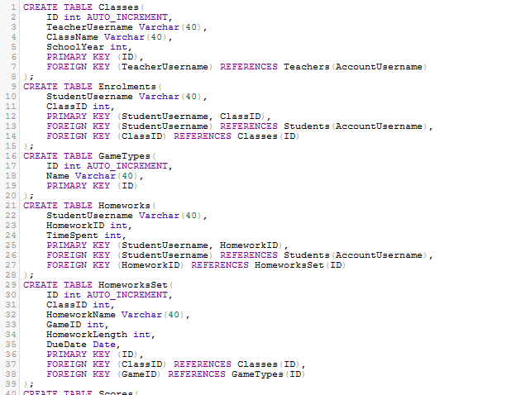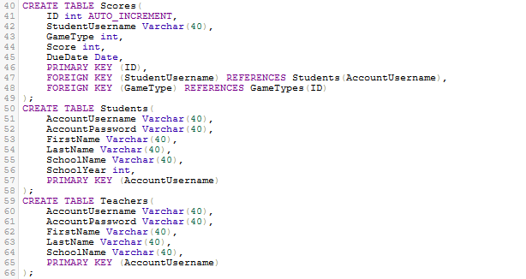

Figure 94 - Original SQL code for creating databases

This code was written in PHPmyadmin, as described in the database design section, as opposed to a dedicated IDE. Each table is created in the same way. It begins with the ‘CREATE TABLE’ keyword before naming the table. Then, the columns of the table are defined. Each column is defined using the name of the column, the data type it should take in and, in the case of varchars (essentially strings), the largest-length value that should be permitted. After the columns are defined, the primary key is defined and the foreign keys are defined (if there are any foreign keys in that table), in addition to which table and column they are meant to reference. For the primary keys, if they are *ID*s (as is the case in the *Classes*, *GameTypes*, *HomeworksSet* and *Scores* tables), I have added an additional setting called ‘Auto Increment’. This is an in-built feature of MySQL and means I do not have to assign the *ID* values. Instead, the value will automatically be assigned as the next positive integer that hasn’t yet been assigned as a value. (In other words, it will be assigned in the order $1,2,3,4…$). This means that the *ID* values will always be unique (in their own table at least), allowing that column to be used as a primary index.

#### Testing

Upon running this code, I received the following error:

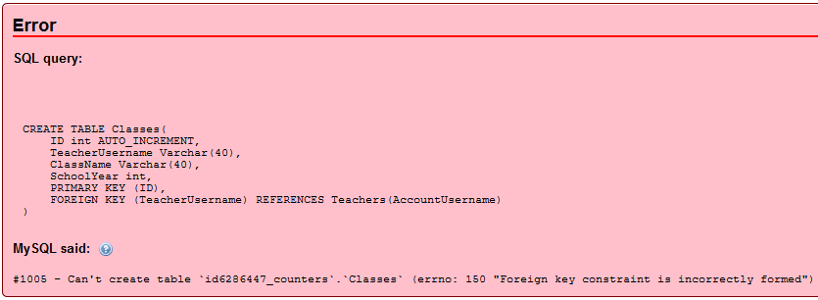

Figure 95 - Database creation error

The error has been given as the foreign key constraint (*TeacherUsername*) being incorrectly formed. The issue, I have discovered, is as a result of the order in which I have coded the creation of the tables. I did it in alphabetical order. However, the above error message has reminded me that, due to foreign keys, only certain orders will work. A table can only be created if it doesn’t reference any tables which haven’t been created yet. For example, in this case, I’ve tried to reference the *Teachers* table during the creation of the *Classes* table but the *Teachers* table creation is later in my code. Therefore, I have had to restructure the code to the following:

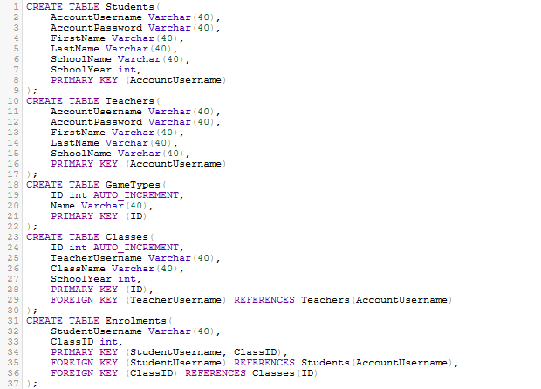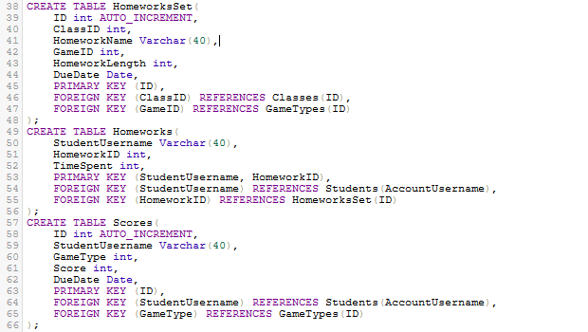

Figure 96 - Restructured code

I have kept the code the same but I have swapped some of the lines around. I have put the *Students*, *Teachers* and *GameTypes* tables first since none of them use any foreign keys so they don’t require any tables to be created before them. In addition, most of the tables reference the *Students* or *Teachers* tables so having these two first would make more sense. In general, the error shown earlier should now be prevented by this restructuring.

Upon running the above code, there were no errors. Since there are no visuals in the database creation, it is fairly difficult to determine whether the code has been successful or not. Luckily, PHPmyadmin allows developers to see the status of the tables, including their columns and keys. Below are the screenshots of these statuses:

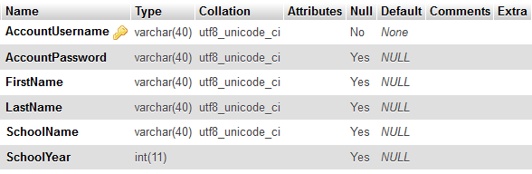

Figure 97 - Status for Students table

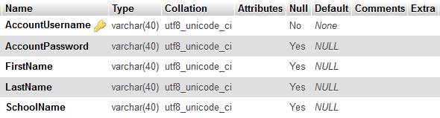

Figure 98 - Status for Teachers table

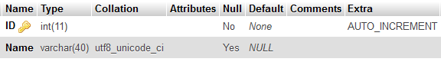

Figure 99 - Status for GameTypes table

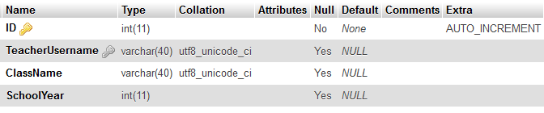

Figure 100 - Status for Classes table

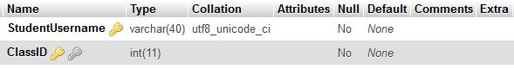

Figure 101 - Status for Enrolments table

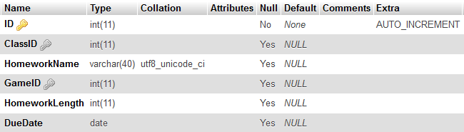

Figure 102 - Status for HomeworksSet table

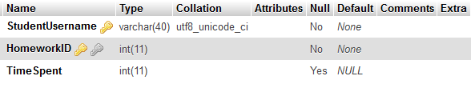

Figure 103 - Status for Homeworks table

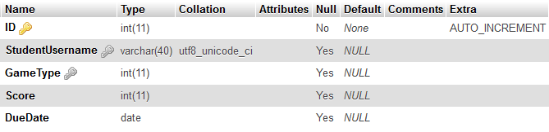

Figure 104 - Status for Scores table

|  |  |  |
| --- | --- | --- |
| Table Name | Status as expected? | Problem Solved? |
| Students | Yes | N/A |
| Teachers | Yes | N/A |
| GameTypes | Yes | N/A |
| Classes | Yes | N/A |
| Enrolments | Yes | N/A |
| HomeworksSet | Yes | N/A |
| Homeworks | Yes | N/A |
| Scores | No. The column called *DueDate* should have been named *DateCompleted*. This was done by accident and will be corrected. | I used the ‘ALTER TABLE’ command in MySQL to change the name of the column and it now works. |

All of the tables (with the exception of the naming issues in *Scores*) have been shown by PHPmyadmin exactly as I’d hoped. However, although the tables appear to have been created correctly, I am going to enter sample data to each of the tables to ensure they are added correctly. Two things must be noted though. First, I will insert the rows manually since I haven’t yet created the scripts which they will actually be entered using in the program. Second, I will only test data which is expected to succeed. The reason for this is because my handling for invalid data inputs will be in my program client-side in the C# code as opposed to in the database. Therefore, I’m not expecting the incorrect data to be handled properly. I only need to test valid data at this time.



Figure 105 - Test row for Students table



Figure 106 - Test row for Teachers table

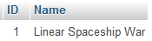

Figure 107 - Test row for GameTypes table

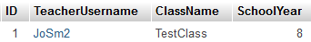

Figure 108 - Test row for Classes table

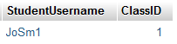

Figure 109 - Test row for Enrolments table



Figure 110 - Test row for HomeworksSet table

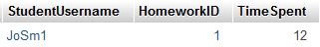

Figure 111 - Test row for Homeworks table

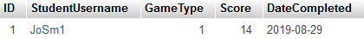

Figure 112 - Test row for Scores table

As shown in the above screenshots, examples of correct pieces of data have been inputted manually into the tables and they have all been successfully accepted by the database. I have now deleted the test data to ensure everything that occurs from now on is as a result from the code itself.

##### *GameTypes* table

In the case of the *GameTypes* table, the data is a constant that isn’t going to be changed unless new games are created in the few. Therefore, I have added the following code to add the data to the table:

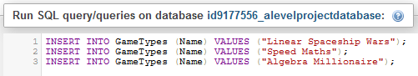

Figure 113 - SQL code to add data to GameTypes table

On PHPmyadmin, the table is now shown correctly, as expected:

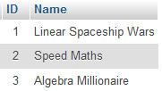

Figure 114 - GameTypes table

#### Review

##### Content of Section

The database for the program has been created, with all of the tables currently working and all of the primary and foreign keys defined and referenced. This has been done using MySQL code which has been written directly into the PHPmyadmin console.

##### Testing

The testing was somewhat limited for this section, as described earlier. It simply involved manually inputting data which should be valid and ensuring no errors occurred.

##### Meeting Success Criteria

The creation of the database is the outline for the success criterion that the program can be used on different devices and that data should be stored over time. Both of these can be done thanks to a database since the data and account details will be stored in tables on this database.

##### Summary of the Program at this Stage

No front-end has been developed yet so the program (from a user’s point of view) currently does not exist.

##### Changes from Design

No changes were made to the database design during development.

## Stage #2 – General Variables

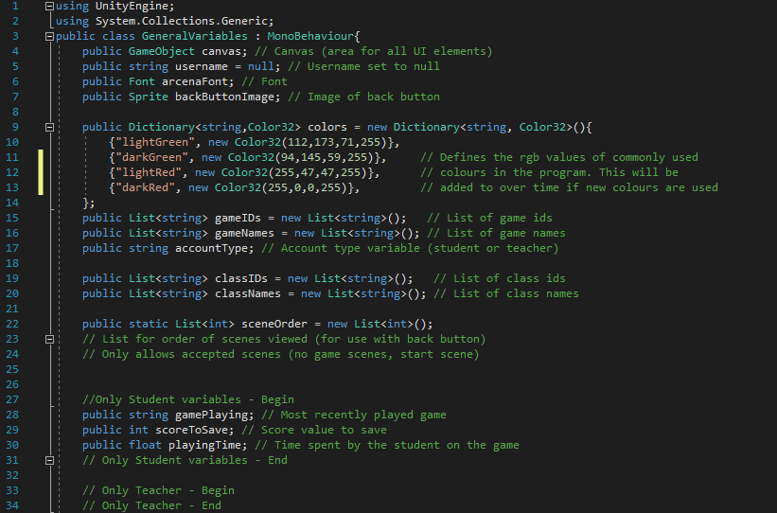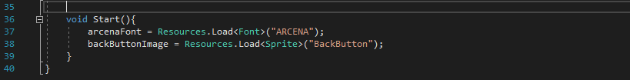

Figure 115 - Original code for General Variables script

Since this script is the General Variables script, it is nearly completely just defining variables, there isn’t a larger amount of computation in this script. The script consists of creating all of the variables which are going to be used quite a lot in the program and variables which need to be transferred between scenes. The *Canvas* variable has been created using the data type ‘GameObject’. GameObjects are essentially objects which will be shown on the screen. So, all UI elements (text, buttons, input fields etc), in addition to game elements like cubes, are GameObjects. *Canvas* is created but not defined (as the majority of these variables are initially). The reason for this is because there will be a new canvas for each scene. So, I will define the canvas when each scene is loaded.

The *username* variable is created as a string and set to *null*. It will then become defined properly when the user either logs in or creates a new account. The *arcenaFont* variable has been created using the ‘Font’ datatype which is another data type used by Unity3D. The sprite *backButtonImage* is also created. After that, the colours are defined. These are colours which are going to be used frequently in the program (since my stakeholder has decided upon this kind of colour scheme). It’s probably quite likely that there are other colours which will be used frequently, in which case I will add them to this dictionary as well. I’ve decided to use a dictionary so that I can reference them using their common names (as keys) and use their more specific RGB values as the actual colour (as values).

After the colours, I create four lists. The first two will hold the information about the games and the second two will hold the information about the user’s classes. These are also not initialised because they will be added to when the data is retrieved from the database. Then, I have used comments to create two sub-sections of the variables. First are a few variables which are only used in student accounts, where *gamePlaying*, *scoreToSave* and *playingTime* are created. The second is a section for teacher-only variables. Although I don’t currently have any variables which are specific only to teachers in this script, I think it would be useful to have a section available for it, if it becomes necessary at some point. Finally, the *Start* function is called automatically when the script loads. The two lines in this function both retrieve something from the Resources folder and assigns it to the variable.

#### Testing

Since this script just creates and defines variables, there isn’t much that can be done in the way of testing. However, I will do the following things:

* + - 1. Run the script and check for any errors
      2. Print out all variables (looking out for *arcenaFont* and *backButtonImage* especially)
      3. Create rectangles with each colour (to make sure the colours are right)

##### Test #1

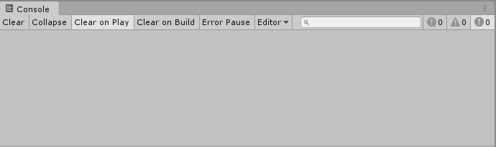

Figure 116 - Console output

The above image shows the output in the console as a result of simply running the script. The console is empty which means there are no errors (or even warnings) in the code.

##### Test #2

I have written a function which will print all of the variables. It will be called after the Start function runs so the *backButtonImage* and *arcenaFont* variables should be correctly defined. The below code was created for the test.

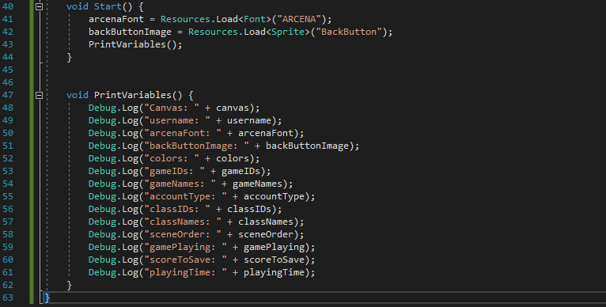

Figure 117 - Test code

|  |  |  |  |
| --- | --- | --- | --- |
| Variable Name | Expected Output | Output | Correct? |
| canvas | null | null | Yes |
| username | Nothing | Nothing | Yes |
| arcenaFont | ARCENA font | ARCENA font | Yes |
| backButtonImage | Sprite (says it’s an image as opposed to showing the image) | Sprite | Yes |
| colors | Dictionary  Keys of strings  Values of Colors | Dictionary [String, Color32] | Yes. Color32 is the Unity3D data type for colours. |
| gameIDs | List of strings | List of strings | Yes |
| gameNames | List of strings | List of strings | Yes |
| accountType | Nothing | Nothing | Yes |
| classIDs | List of strings | List of strings | Yes |
| classNames | List of strings | List of strings | Yes |
| sceneOrder | List of integers | List of Int32s | Yes. Int32 is the specific data type Unity3D and C# use for integers. |
| gamePlaying | Nothing | Nothing | Yes |
| scoreToSave | Nothing | 0 | No |
| playingTime | Nothing | 0 | No |

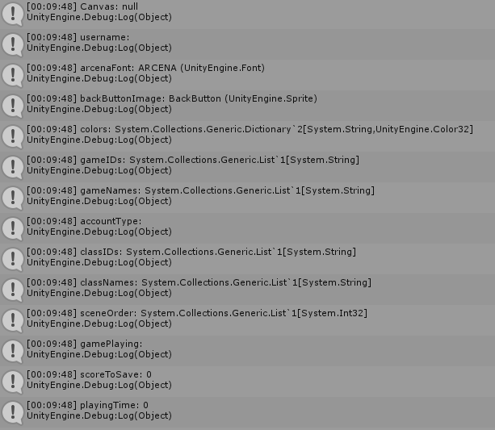

Figure 118 - Console output

As shown in the above table and image, the majority of the variables came out as expected. The two which didn’t were *scoreToSave* and *playingTime*. I was expecting them both to have no value since I created them without initialising them to a value. However, both have been outputted with the value 0. I have discovered that integers (in the case of *scoreToSave*) and floats (in the case of *playingTime*) are both automatically initialised in C# to the value $0$. Since these two values are going to be set when required, the fact that they are $0$ at the moment doesn’t really matter so I am happy to leave it like that.

##### Test #3

Similar to Test 2, I have created a piece of test code which will create a small rectangle with a certain colour.

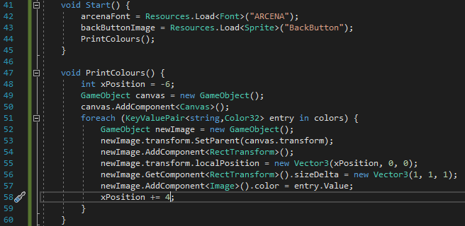

Figure 119 - Test code

I have added the function *PrintColours*. It first creates a canvas (since all UI elements must be the child of a canvas to be shown properly on the screen) and crucially add a canvas component to it (since the component is what actually makes it a canvas). I then iterate through the *colors* dictionary and create a new image object (which in this case is simply a rectangle), adding the relevant colour to it. The variable *xPosition* is used here to make sure the rectangles don’t overlap.

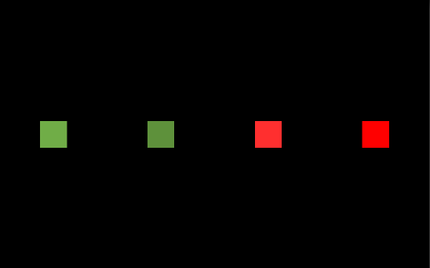

Figure 120 - Game display

As shown in the above image, all four of the images appear to be the correct colour. My slight worry is the two greens are a bit similar to each other and perhaps one of them should be changed. After e-mailing my stakeholder with the above image and my suggestion, we have decided to change the dark green colour to (18, 92, 10) on the RGB scale.

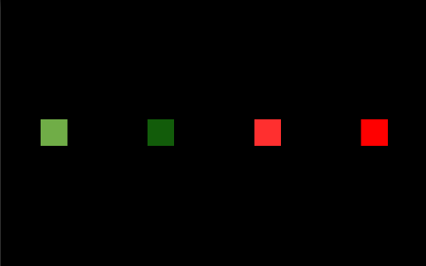

Figure 121 - Game display for revised colours

I changed the RGB values of the dark green colour in the *colors* dictionary and above is the result when the code was run again. There is now a much more distinct difference between the two greens so I am now happy with the result of this test.

#### Review

##### Content of Section

In this section, I have created the first part of the program client-side, involving the variables which are going to be used frequently throughout the program and variables which must be accessed from different scenes.

##### Testing

The testing again was somewhat limited given the script is simply creating and defining variables. However, testing did come in the form of printing the variables and checking if the colours were correct.

##### Meeting Success Criteria

This script doesn’t directly contribute to any of the success criteria. Rather, it allows the code to be more streamlined (without the same variables having to be created in different scripts) and will be a helpful script in the overall development of the program.

##### Summary of the Program at this Stage

As with the first section, there still hasn’t been any front-end programmed yet so there is no visual program from the point of view of a client.

##### Changes from Design

The only change made from the design is the RGB values used for the dark green colour. It has changed from (94, 145, 59) to (18, 92, 10). Other than that, the script follows the general idea outlined in the algorithm design.

## Stage #3 – General Functions

#### C# - GeneralFunctions

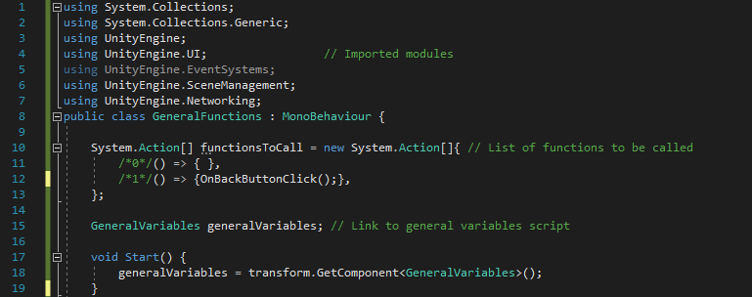

Figure 122 - Code for beginning of General Functions script

First, many modules need to be accessed in this script so they are imported at the beginning. In the table below are the list of modules and where they will be used in the script.

|  |  |
| --- | --- |
| Module Name | Use |
| System.Collections | This module is necessary to allow IEnumerators to be defined. An IEnmerator is required in the GetClassOptions function. |
| System.Collections.Generic | This module is necessary to allow lists to be defined. A list will be required in the ShowUIBox function. |
| UnityEngine | This module is required for all programming concepts related to Unity3D. Features in use in this script include GameObjects, transforms and vectors. |
| UnityEngine.UI | This module is required for all UI aspects of the program. This includes things like buttons, images and text. |
| UnityEngine.EventSystems | This module is required for the functionsToCall array. EventSystems is used in relations to events such as on button click, which is the event used in this script. |
| UnityEngine.SceneManagement | This module is required for changing scenes, which will take place in the OnBackButtonClick scene. |
| UnityEngine.Networking | This module is required for any time the internet is accessed. This will be done when I connect to the database in the GetClassOptions function. |

After the modules are imported, the two variables are defined. The first, *functionsToCall*, is a list of the data type System.Action. This data type allows functions to be called. So, essentially what is happening is I am storing the line of code which, when executed, will call the function. When the UI box, for example, is clicked then it will retrieve that value from the list and execute that line of code, thus running the function. I will therefore enter a parameter to the UI box function which will say which index of the list the code should reference. The second variable is *generalVariables* which is an instance of the GeneralVariables script. Since the variables in GeneralVariables are non-static, C# requires an instance of the script to be created. Inside the Start function, *generalVariables* is defined by taking the script from *Transform* (the object which the scripts are both stored in).

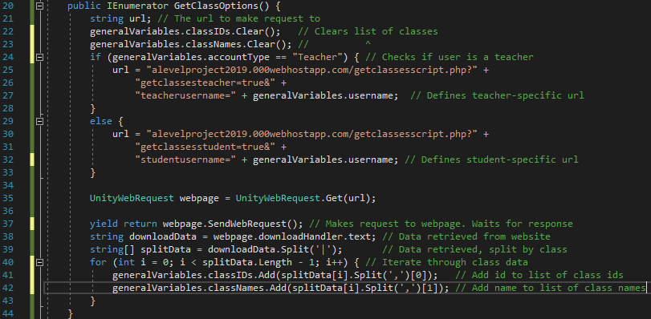

Figure 123 - Code for GetClassOptions function

First the function is defined as an IEnumerator. This means that it will yield at some point during the function and wait for a certain event to occur before continuing. It is required for this function as described later. First the *url* variable is created but not defined as it could have two possible values. Next, the classes are cleared since the new classes are about to be added. After that, on lines 25-33, I check if the user is a teacher or a student. If the user is a teacher then the url includes the GET code *getclassesteacher=true&teacherusername=* whereas a student would have *getclassesstudent=true&studentusername=* in their url. The function will then make a request to that url and wait for the webpage to return a result (hence the requirement for an IEnumerator). The downloaded result is defined as *downloadData*, which is then split by class into the array of strings *splitData.* Finally, the function iterates through the list of classes, adding the ids to the list of class ids and the names to the list of class names.

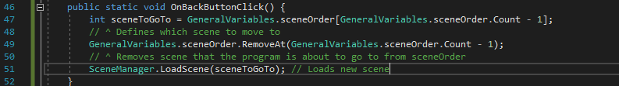

Figure 124 - Code for OnBackButtonClick function

*OnBackButtonClick* is going to be called, as an event, whenever the user clicks on the back button. The scene index for it to go to is defined as the most recent value in the *sceneOrder* list in the GeneralVariables script. This essentially makes *sceneOrder* a stack as it is LIFO (last in, first out). The scene index is then removed from the list (since it is no longer ‘the most recent scene’) and the new scene is loaded.

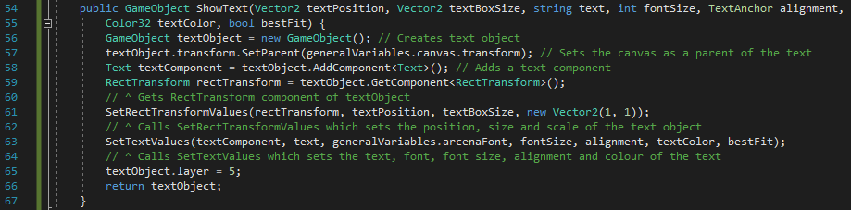

Figure 125 - Code for ShowText function

The function *ShowText* is going to be used in all situations where text is shown on the screen, no matter where it is, what colour the text is, what size it is etc. Therefore, many parameters need to be taken into the function to allow it to be as flexible as possible. That is why this function takes seven parameters. (The other functions in the script follow a similar idea since they are all general functions as well.) First, a new GameObject object is defined and the canvas is set as its parent (a requirement for any UI element). A text component is added to it before two functions are called. These functions are going to be defined later. Finally, the layer of the object is defined as $5$ (the Unity3D-defined value for UI elements) and the object is returned. It is returned in case the caller function needs to do anything specialist to the object which isn’t done in the general function.

The functions from here until the end of this script will have less commenting because the functions follow a similar pattern to the *ShowText* function.

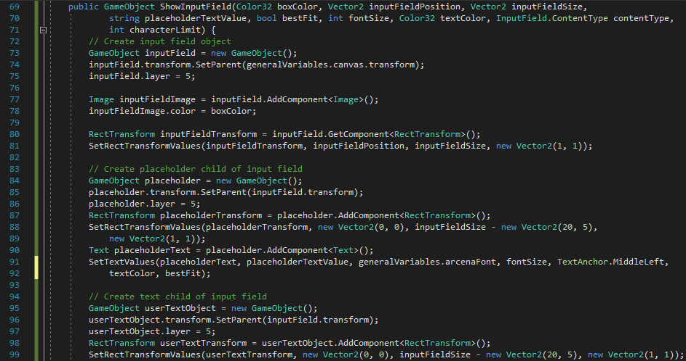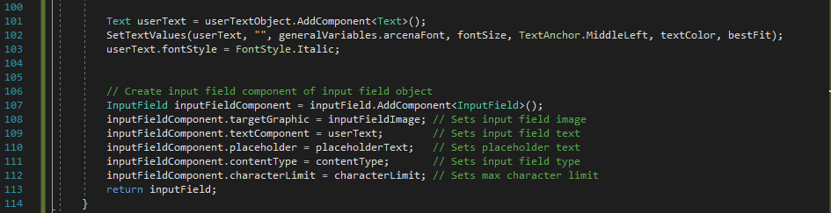

Figure 126 - Code for ShowInputField function

First, the input field object is created, the parent is set as the canvas and its layer is set to $5$. Next, an image component is added to the object and the colour is set to the parameter *boxColor*. The image component is what will actually be seen on the screen; it will be a rectangle with a certain colour. Its transform values (position, size and local scale) are set by calling *SetRectTransformValues*. The placeholder object is then created. This is the text which will show in the input field before the user types anything. It is created in the same way as the input field, as is the text child which is what the user actually types into. The function *SetTextValues* is called for the placeholder and text objects in order to customise the text (as described later). Finally, the actual input field component is added to the object. This is what actually makes it an input field and the relevant attributes are then defined: the target graphic (the image), the text component, placeholder component, content type (e.g. only integer values are permitted) and character limit (maximum size of input).

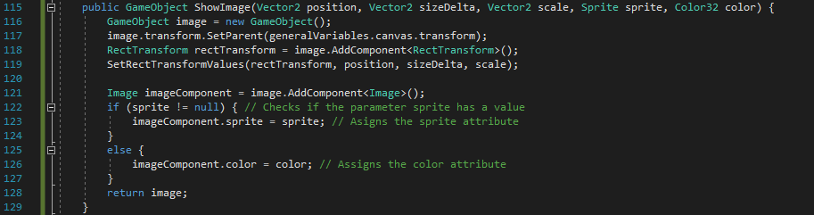

Figure 127 - Code for ShowImage function

The image object is first defined and its transform attributes are set, in the same way that the previous objects have been defined. An image component is then added. There are two uses for images in my program. The first is as an actual image with a sprite whereas the second is just a coloured rectangle. Therefore, a check is made to see which one is intended. The check is made by seeing if the *sprite* parameter is null. If it is null, then it is a coloured rectangle since it has no image to display. If it is a proper image, then its sprite attribute is defined. If that’s not the case, then the color attribute is defined.

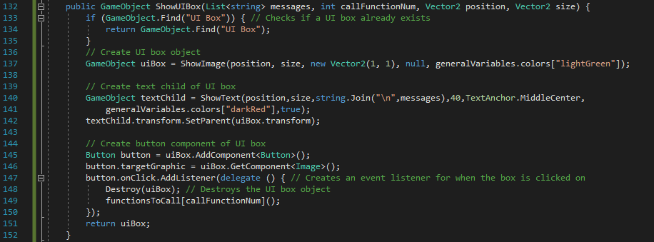

Figure 128 - Code for ShowUIBox function

The *ShowUIBox* function is called whenever a message or error is to be displayed to the user. At any given time, only one UI box should be on the screen so the function begins with an if statement checking if there are any boxes already. If there are, then the function will simply return the box that has already been created and not make a new one. If there aren’t any already, then a new one is created in much the same way as all other UI objects. The UI box is made of an image, text and a button component. The image and text are created by calling the functions already created, thus not requiring code to be repeated. The button component could also be created in the *ShowButton* function but there is a difference in the delegate which is created. This would cause a bit of trouble so I think it would be better to create it again in this function.

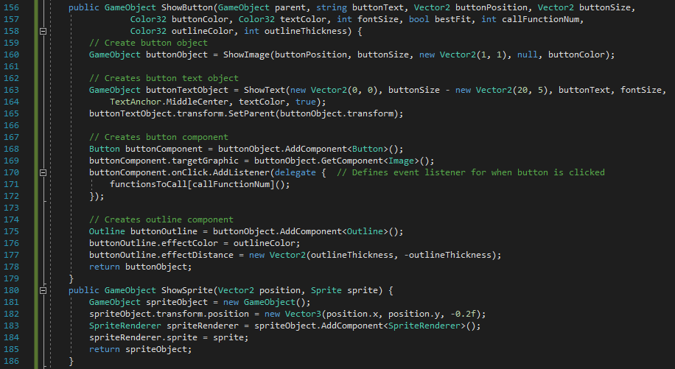

Figure 129 - Code for ShowButton function

The *ShowButton* function follows the same idea as *ShowUIBox*. It creates the button using *ShowImage* and *ShowText* before creating the button component. The delegate defines what will happen when the button is clicked. When it is clicked, the relevant function will be called by referring to the list *functionsToCall* described earlier. An additional part to this function, compared to *ShowUIBox* is the outline. Buttons will usually have an outline because it gives it a nicer look (as my stakeholder said in her response to my page designs). I create an outline component and set its colour and size (size being set using the *effectDistance* attribute). If there is a situation where I don’t want a button to have an outline, then setting the thickness to $0$ should work but I will test that later.

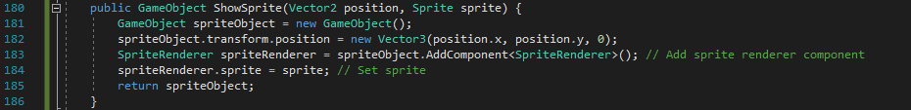

Figure 130 - Code for ShowSprite function

In my design, I described the difference between a sprite and an image. Sprites are going to be used in the actual games themselves as opposed to being UI objects. They are created in the same way as any other objects but a SpriteRenderer component is added instead of an Image component. The sprite is then assigned and the object is returned.

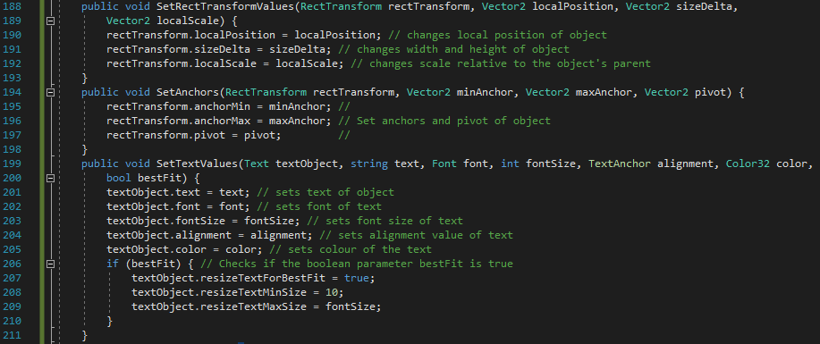

Figure 131 - Code for SetRectTransformValues, SetAnchors and SetTextValues functions

The content of these three functions are used so many times that it would make sense for them to be made as their own functions, even if they are short functions. The first, *SetRectTransformValues* was partly described earlier. It allows other functions in this script (and potentially other scripts) to set the position, size and local scale of newly-created objects in one line by simply calling the function and assigning the values as parameters. *SetAnchors* and *SetTextValues* do similar things but with different attributes. *SetAnchors* will be called whenever the object needs to change size. The anchors and pivot which are defined will determine how the object changes size and relative to where in the object. (Unity3D has objects changing size from the centre automatically. It is unlikely that that is something I will want in things like Scroll Rects.)

*SetTextValues* is used whenever text is shown. It allows the simple customisability of text, font, font size, alignment and colour in addition to a feature called ‘best fit’. Best fit is an attribute in text objects in Unity3D which allows the font size to dynamically change if there isn’t enough space to fit all of the text. I have set that as a Boolean parameter as it may be good in some situations but not others. I have used an if statement to check if the *bestFit* value is true. If it is then the relevant attribute is assigned to true before defining the minimum and maximum possible sizes. I have set the minimum size to 10 (approximately the smallest font size that the user would be able to view easily) and the maximums size to whatever the argument is for font size.

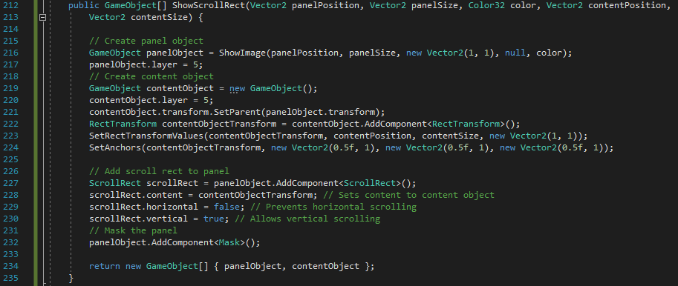

Figure 132 - Code for ShowScrollRect function

*ShowScrollRect* will show a panel and a content box where a series of information will be available to the user in a scrolling format (in a leaderboard, for example). First a panel object is created; it is essentially just an image so the *ShowImage* function is called to create it. The content object is then created as a child of the panel object. In addition to its position being set in *SetRectTransformValues*, its anchors are set in *SetAnchors*. They are set such that the content object will expand downwards and keep its same top level. (This makes sense thinking about a scrolling leaderboard. If it starts at the top of the leaderboard, you shouldn’t be able to go further up). The ScrollRect component is then added which provides the proper functionality of the object. In addition to the content object being selected, it is defined that only vertical scrolling is permitted. At this moment, I can only think of (and have only designed) situations where the scrolling is done vertically. If there is a point where a horizontal scroll is required, I will assign a new parameter to the function, allowing it to be customisable as to which direction the scrolling should occur. In other functions, the object has been returned. However, in this case, the panel object and scroll object may be useful so the function will return an array of the two objects.

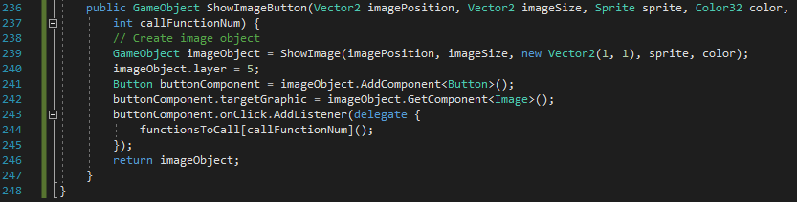

Figure 133 - Code for ShowImageButton function (+ final closing bracket to indicate end of script)

There are a few situations (back button, for example) where the button is also an image. This could be incorporated into the button function but it seems more appropriate for it to feature as its own function. So *ShowImageButton* merges buttons and images to create an object which has an image component in addition to being a button. I won’t explain the code as it follows the same logic as the *ShowButton* function.

#### PHP - GetClassOptions

In addition to the C# script shown above, the *GetClassOptions* function calls a PHP script.

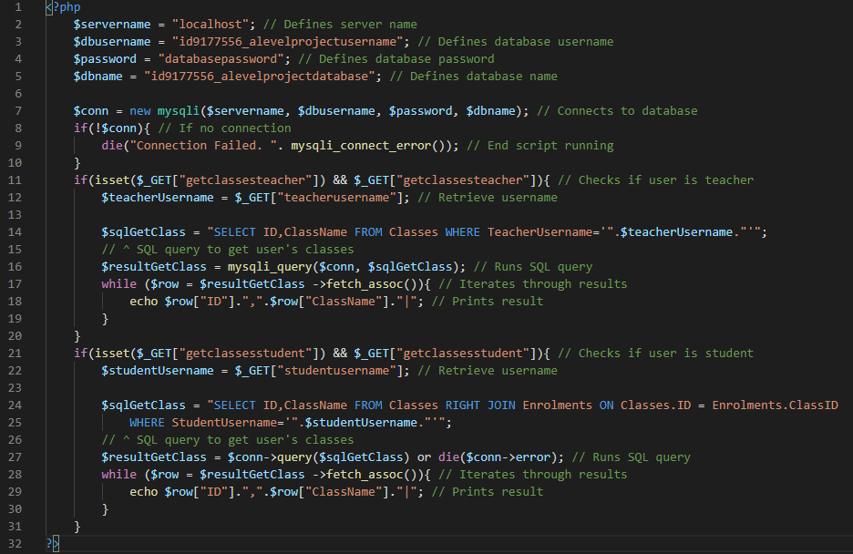

Figure 134 - Code for getclassesscript.php

First, the database ‘login details’ are required: the server name, username, database password and database name. Line 7 then connects to the database using those login details and the following lines check if the connection has been made or not. If not, then the script stops running with an error message printed. If there is a connection, then there are two if statements: one checking if the user is a teacher and one checking if the user is a student. If the user is a teacher then an SQL query is made to select the ID and class name from the table *Classes* where the username is that of the user’s username. Line 16 then runs the SQL query and the following lines iterate through the results and print each one. The exact same thing occurs for students, with the exception of the SQL query where the same information is retrieved but the *Classes* table needs to be joined to the *Enrolments* table in order to connect the student with their class. (This is because, as shown in the database design, a link between the *Students* and *Classes* tables would be a many-to-many relationship which isn’t allowed. Therefore, the information can only be accessed via the *Enrolments* table.) When the C# script then retrieves the ‘output’, it is actually receiving anything which is printed from the PHP script, i.e. the class ids and names.

#### Testing

In terms of testing, I will run each function with reasonable attributes. In certain functions where there can be errors caused (by there not being any classes, for example), I will test them as well. In the case of *SetRectTransformValues*, *SetAnchors* and *SetTextValues*, the performance of these will be determined by how the other functions work. Also, the performance of the PHP script will be determined by the output of the *GetClassOptions* function. If functions which use these functions provide the expected output, then I can be sure to a fair extent that these functions are working.

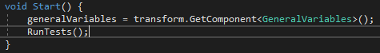

Figure 135 - Change to Start function

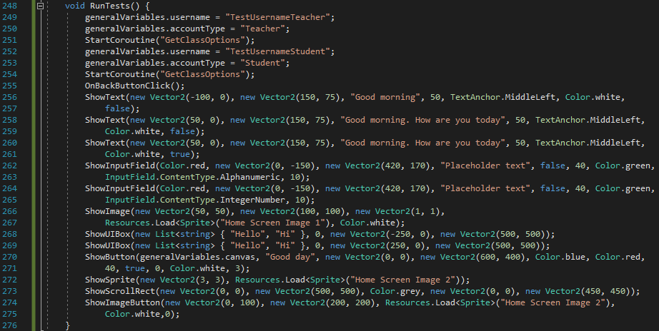

Figure 136 - Code for RunTests function

First, I have added a line in the *Start* function which calls the new function *RunTests*. *RunTests*, as shown in the image above, tests all of the functions in the way set out in the table below. For test functions where it assumes there is more than one result or value in list, I will manually add it for the duration of the test before removing it. During each test, I will comment all of the other lines to ensure only one test is running at a time.

|  |  |  |  |
| --- | --- | --- | --- |
| Test function | Expected Output | Output (In some screenshots, only part of the screen is captured) | Correct? |
| GetClassOptions (Teacher - user has no classes) | Class variables should be empty |  | Yes |
| GetClassOptions (Teacher - user has at least one class) | Class variables should have correct values |  | Yes |
| GetClassOptions (Student - user has no classes) | Class variables should be empty |  | Yes |
| GetClassOptions (Student - user has at least one class) | Class variables should have correct values |  | Yes |
| OnBackButtonClick (Scene list has no values) | Nothing |  | No. (Error #1) |
| OnBackButtonClick (Scene list has at least one value) | Error saying scene not found |  |  |
| ShowText (no best fit) | Text shows on screen with right attributes |  | Yes |
| Show Text (no best fit – long message) | Only part of text shown on screen |  | Yes |
| Show Text (with best fit – long message) | Text shows on screen with right attributes (with smaller font than defined) |  | Yes |
| ShowInputField (Alphanumeric) | Input field shows on screen with right attributes. Only letters and numbers should be permitted |  | Yes |
| ShowInputField (Integer) | Input field shows on screen with right attributes. Only numbers should be permitted |  | Yes |
| ShowImage | Image shows on screen with right attributes |  | Yes |
| ShowUIBox | UI box shows on screen with right attributes. Goes away when clicked on | When clicked: Nothing on screen | Yes |
| ShowUIBox (when UI box is already on screen) | Nothing. (Old UI box remains) |  | No. (Error #2) |
| ShowButton | Button shows on screen with right attributes. Prints ‘clicked’ when clicked | When clicked: nothing happens | No. (Error #3) |
| ShowSprite | Sprite shows on screen with right attributes |  | Yes |
| ShowScrollRect | Panel and scroll rect show on screen with right attributes. Rect is draggable | Left-hand side: *Scene* view Right-hand side: *Game* view | Yes. The inner square in the *scene* view shows the scroll rect. I tested its draggability and it works. |
| ShowImageButton | Image shows on screen with right attributes. Prints ‘clicked’ when clicked | When clicked: nothing happens | No. (Error #4) |

##### Error #1

I have noticed there is no control in the *OnBackButtonClick* function for when there is no scene to go back to (when the scenes list is empty). Therefore, I have added the following line of code at the beginning of the function:

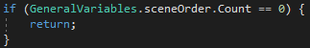

Figure 137 - Change to OnBackButtonClick function

When there are no scenes to go back to, the function will just end and return no value. Now, after running the test again, there are no errors and, as expected, nothing is printed.

##### Error #2

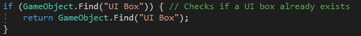

Above are the lines I have used to check if a box already exists and to just exit if that’s the case. It does it by checking if there are any GameObjects with the name ‘UI Box’. When a UI box is created, I haven’t actually named it. This means it is searching for something which is in the screen but with a different name and fails. I have therefore added the following line to the *ShowUIBox* function and it now works.



Figure 138 - Added code to ShowUIBox function

##### Error #3

I have noticed that in the line where I call *ShowButton* in the test, I have set the index of *functionsToCall* as 0 when it should have actually been 2. The function to call at index 0 actually doesn’t do anything and doesn’t call any function (as is the case when certain buttons are clicked – like UI boxes). So, I have changed the line:



Figure 139 - Error-causing line of code

To:



Figure 140 - Changed code in RunTests function

The button now prints the expected output when clicked on as seen in the screenshot below:



Figure 141 - Test output

I have noticed that this error is the exact same for Error #4. So, I have made the same change and it works now. These two errors have made me realise that, when one of my tests fails, it isn’t necessarily because of the code. It could be that I have written my tests wrong. Therefore, in future sections of the project I’ll be more careful to write the test functions better and prevent and issues which should have been avoided.

Since all of these tests have now succeeded, I can be fairly sure that the functions (and PHP script) which haven’t been checked also work, since they are integral in the working of functions which I have tested.

#### Review

##### Content of Section

In this section, I have implemented all of the functions which are going to be used many times in the program. These functions consist mainly of creating UI elements (e.g. button creation, input field creation) but also other functions like an event for when the back button is clicked and retrieving the user’s classes from the database.

##### Testing

The testing of this section was even more important than the testing of other scripts. That’s because the functions in the *GeneralFunctions* script are going to be used so often that it is integral that everything is running properly. The testing consisted of running each of the functions with both correct inputs and with situations which I thought could cause problems. Each of the problems that was found has been sorted out and everything now appears to be working.

##### Meeting Success Criteria

Similar to *GeneralVariables*, this section does explicitly meet any of the success criteria. It does, however, help streamline the code greatly and will therefore make it easier to develop the rest of the program.

##### Summary of the Program at this Stage

As with before, no front-end has been developed yet (although front-end features like UI elements have). So, as of now, there is no program from a client’s point of view.

##### Changes from Design

The only change I have made since the design is with regards to the panel. I had designed a function called *ShowPanel* which would create a panel. However, I have since noticed that *ShowPanel* is essentially the same as *ShowImage* so I haven’t developed the *ShowPanel* function. So, in the *ShowScrollRect* function, *ShowImage* is now called to create the panel as opposed to *ShowPanel*. Other than that, the script follows the outline of the algorithm design for this script.

## Stage #4 – Loading Scene

#### Unity Editor

For all of the scenes in my program, I will have the same layout in the Unity editor. These are things which cannot (or it is unnecessarily complicated to) be done through code and needs to be done in the Unity editor. Since they will occur in all scenes, I will only describe it here.

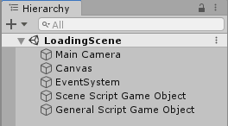

Figure 142 - Unity editor hierarchy

The above image shows all of the objects which will feature in every scene. The *Main* *Camera* will essentially ‘show’ the screen. The *Canvas* allows all of the UI elements to be shown; *EventSystem* is required for the *Canvas* to work. *Scene Script Game Object* will simply contain the script/s for that specific scene and *General Script Game Object* will contain the general scripts – *GeneralFunctions* and *GeneralVariables*.

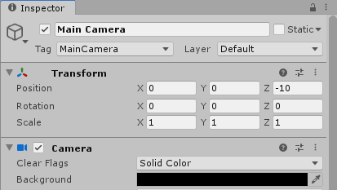

Figure 143 – Camera object settings

For the *Main Camera*, I have kept all of the default values apart from the background which I have set to black, as per my page designs.

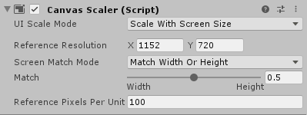

Figure 144 - Canvas object settings

For the *Canvas*, I have changed the mode to ‘Scale with screen size’ and set the size to the pixel width and height noted in the design. Apart from that, I have kept the default values. I have also kept *EventSystem* as its default.

#### C# - LoadingSceneScript

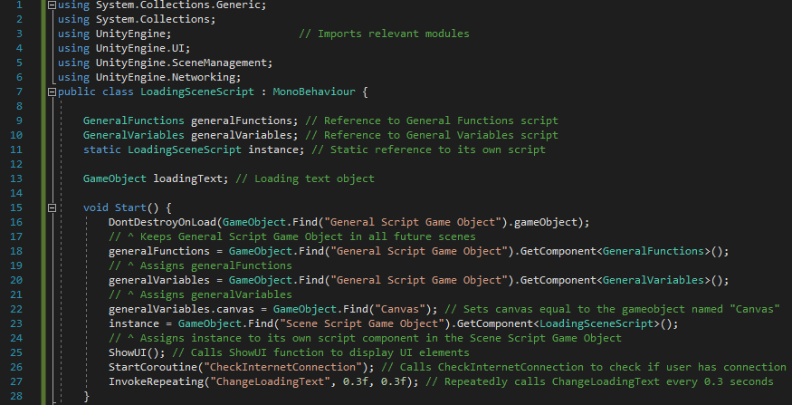

Figure 145 - Code for beginning of LoadingSceneScript and Start function

First, the relevant modules are imported. Another feature which will probably come up on most, if not all, scripts are lines 9-11. These define three scripts: *GeneralFunctions*, *GeneralVariables* and its own script (described as *instance*). The first two will be used to access non-static variables and functions in their respective scripts while *instance* will be used to access non-static variables in the *LoadingSceneScript* from static functions. (This is a required feature in C#.) In addition, I have created a variable to store the loading text object so that its text component can be changed continuously.

The *Start* function begins by implementing a Unity3D feature which means the same instance of the *General Script Game Object* (which contains *GeneralFunctions* and *GeneralVariables*) will be in every scene. Lines 19-26 are things which will probably come up in the *Start* function of most scripts. First, the earlier-made variables are assigned values by finding them in the relevant GameObjects. In addition, the *canvas* variable is defined for use in UI elements later. Then, the *ShowUI* function is called. After that, the IEnumerator *CheckInternetConnection* is called and the function *ChangeLoadingText* is repeatedly invoked every 0.3 seconds.



Figure 146 - Code for ShowUI function

In this scene, the only UI element is the text stating the program is loading. This could have been done in the *Start* function since it is only one line. However, I am going to use the same template for every scene script and that involves a *ShowUI* function. It will allow easier changing of code if required because I know which function to go to if I need to change the UI. The text is created in the centre horizontally but slightly above centre vertically, with a font size of 75, an alignment to the left of the text object and red.

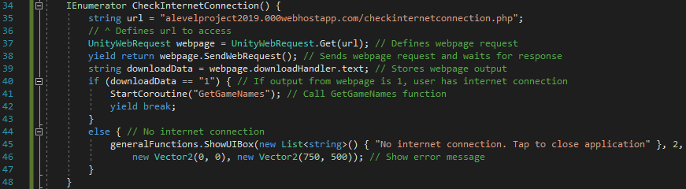

Figure 147 - Code for the IEnumerator CheckInternetConnection

This function will check if the user has internet connection or not. Since, internet connection is a fundamental part of the program (since most scenes will interact with the database for scores, classes etc.), the user will not be permitted to continue if there is no internet connection. First, the url that is going to be ‘pinged’ is defined. The following few lines define the webpage request and sends the request before waiting for a response and storing it. If the output from the webpage is ‘1’ (which will be the output defining a successful internet connection), then the *GetGameNames* IEnumerator is called and the function ends. If there is no connection, then an error message is shown using a UI box. The *functionsToCall* index is 2 as I have added the second value of the *functionsToCall* list as a link to the *QuitApplication* function.

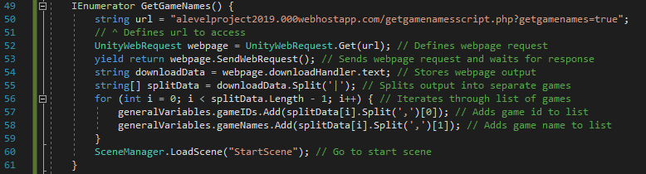

Figure 148 - Code for GetGameNames IEnumerator

*GetGameNames* is used to retrieve the game names and classes. The url is defined before the request being made to the PHP script (in the same way as done in *CheckInternetConnection*). The response from the webpage will consist of a piece of text where each game is split from each other using the ‘|’ character. So, the downloaded string is split with ‘|’ as the separator and the function iterates through each one. For each game, the game id and game name are split using a comma. So, the first value (the id) is added to *gameIDs* and the second value (the name) is added to *gameNames*, both stored in *GeneralVariables*. Then, since this is the final thing that needs to be done in the scene, the program will load the next scene which is the start scene.

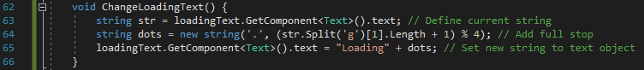

Figure 149 - Code for ChangeLoadingText function

The loading text is going to change every 0.3 seconds to show the user that the program hasn’t crashed and is instead just loading. The function consists of retrieving the current text from the GameObject, adding a dot (or removing the dots if there are three currently) and adding the text back to the GameObject.

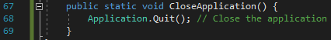

Figure 150 - Code for CloseApplication function

This function simply makes use of an in-built feature of Unity3D which closes the application. The function has to be static so that it can be easily executed from *GeneralFunctions* (as will be the case with other functions called from *GeneralFunctions*).

#### PHP

##### CheckInternetConnection

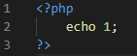

Figure 151 - Code for CheckInternetConnection script

This script is most likely the simplest in the whole program. All it does is prints the value ‘1’. The reason for this is, I only need to check if the user has internet connection. If they do, then ‘1’ will be returned after calling this PHP script. If there’s no connection then ‘1’ will not be returned because the script won’t be found (as the PHP script is stored online). Therefore, there’s nothing more than one line required here.

##### GetGameNamesScript

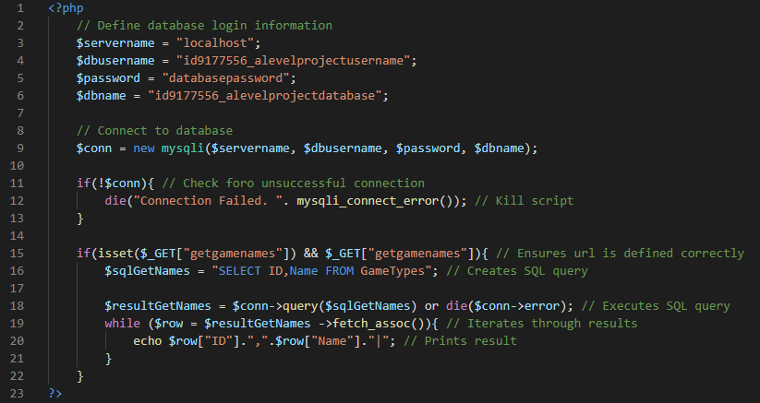

Figure 152 - Code for GetGameNamesScript

Lines 1-13 follow the same as all of PHP scripts (obviously excluding *CheckInternetConnection*) by defining the database login information, connecting to the database and ending the script if the connection is unsuccessful. Line 15 checks if the GET variable *getgamenames* exists and checks if it is equated to *true*. Checking if it exists isn’t strictly necessary since I will always be requesting the url from the C# script where that part of the URL is hard-coded. However, I think it would be better practice to have the check there anyway. The next lines define and execute the SQL query (which will retrieve all of the data from the *GameTypes* table). The list of results is then iterated through on line 19 and each result is printed using the same format as *GetClassOptions* and all other PHP scripts (‘|’ to separate rows and ‘,’ to separate columns in each row).

#### Testing

Since this scene occurs without any user input (as everything stems from the *Start* function), there is nothing really to test other than running the script. However, I will run the script twice: once with internet connection and once without. The list of features and whether they have succeeded or not are outlined below.

|  |  |  |
| --- | --- | --- |
| When user has internet connection | | |
| Expected Feature | **Output** | **Correct?** |
| Loading text appears on screen | Nothing appears on screen and error in console. | No. (Error #1) |
| Loading text adds full stop every 0.3 seconds |  | Yes |
| Loading text returns to having no full stops after there are 3 (and repeats sequence) |  | Yes |
| Game data is downloaded |  | Yes |
| Program goes to Start Scene. (Should give error saying no Start Scene created yet.) |  | Yes. This was the expected error |

|  |  |  |
| --- | --- | --- |
| When user doesn’t have internet connection | | |
| Expected Feature | **Output** | **Correct?** |
| Loading text appears on screen |  | Yes. The first image is what’s shown on the screen because it found no internet so quickly, the loading text cannot be seen.  The second image shows the Unity3D scene view which shows the loading text is there. |
| Loading text adds full stop every 0.3 seconds | See image above. | Yes. Again, in the scene view it is correct. |
| Loading text returns to having no full stops after there are 3 (and repeats sequence) |  | Yes. Again, in the scene view it is correct. |
| Error message appears for no internet connection |  | Yes |
| Program exit when error message is clicked on[3] | Application closed when I clicked on the error message | Yes |

##### Error #1

This error refers to line 62 in *GeneralFunctions*. This is in the *ShowText* function and is specifically when it defines the canvas as the parent of the new text object. The error ‘Object reference not set to an instance of an object’ implies that the *canvas* variable has not yet been defined, despite line 22 in *LoadingSceneScript* defining it. After a while of thinking about the issue, I realised that the *GeneralVariables* and *GeneralFunctions* scripts need to load before the other scripts, since the other scripts reference them all the time. I think the issue here is *LoadingSceneScript* runs before *GeneralVariables* so line 22 in *LoadingSceneScript* doesn’t ‘know’ what to define. Luckily, Unity3D has a feature called ‘Script Execution Order’, which allows you to order which scripts are executed when. As shown in the image below, I have set the two general scripts to be executed slightly before the ‘Default Time’.

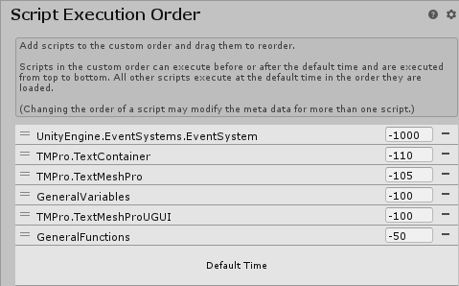

Figure 153 - Modification to Script Execution Order (All other scripts are built-in Unity scripts and have been left unchanged.)

In the image above, I have set *GeneralVariables* to execute slightly before *GeneralFunctions* (and both before ‘Default Time’) because *GeneralFunctions* does reference *GeneralVariables* so I’ve set it as a precaution to make sure *GeneralVariables* is loaded by the time it is referenced

After running the script again, I received the expected result, as shown below. Since this error could potentially compromise prevent the other tests from succeeding, I have fixed this error before running my other tests.

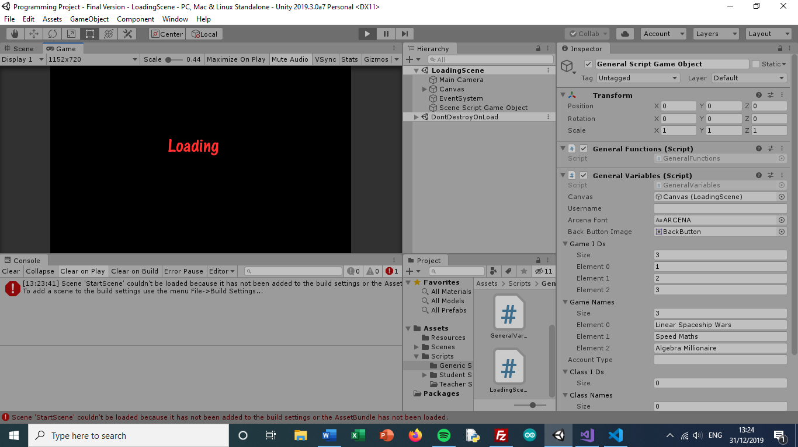

Figure 154 - Screen for Loading Scene

Given that the *CheckInternetConnection* and *GetGameNames* functions worked as expected when run with an internet connection, I can conclude the PHP scripts are working properly as well as they would have caused errors if there was an issue in one of those scripts.

#### Review

##### Content of Section

In this section, I have created the loading scene, using one C# script and two PHP scripts. The purpose of the loading scene, as explained in the design, is to check if the user has internet connection or not, and to download information about the games.

##### Testing

The testing for this section simply involved running *LoadingSceneScript* and making sure all of the expected outcomes occurred and checking why things weren’t happening as expected. The reason for this simple method of testing is because this scene involved no user input so there is no situation where an improper input could be entered. The only two variations in outcome were whether the user had internet connection or not, both of which were tested.

##### Meeting Success Criteria

The loading scene doesn’t directly meet any of the success criteria. However, it indirectly helps meet the success criteria related to the user being able to play games (since the data related to the games is downloaded in this scene) and the fact that the data is easily stored and maintainable (by storing the game data on a database and not stored on the client, it can be easily changed on all versions of the program at once).

##### Summary of the Program at this Stage

This stage involved the first part of the program being made from the user’s point of view. The user will see a black screen with red text saying the game is loading. If the user has internet connection, an expected error will then occur (because the start scene hasn’t been made yet). If the user has no internet connection, an error message will appear and the application will be exited.

##### Changes from Design

In my algorithm design for the C# script, I had a variable called *hasInternetConnection*. I noticed that this Boolean variable didn’t actually have any purpose as it didn’t need to be checked at any point. So, during development of the script, I left out the creation and assigning of that variable. Other than that, the scripts all follow the plan outlined in the algorithm design.

## Stage #5 – Start Scene

First, the editor has been set up in the same way as described in the Loading scene section. It includes a Camera (with background colour set to black), a Canvas (for displaying UI elements), an Event System (required for the Canvas to work) and the *SceneScriptGameObject*. The only difference is I haven’t included the *GeneralScriptGameObject* since this should be transferred to the Start scene from the Loading scene when the Start scene loads. For this reason, all of my tests throughout this program will need to begin at the Loading scene and I won’t be able to start at a later point. (This is unless I add the *GeneralScriptGameObject* at a later point for testing purposes. However, doing this would lead to other problems, like the game data not been downloaded, so I will not do this.)

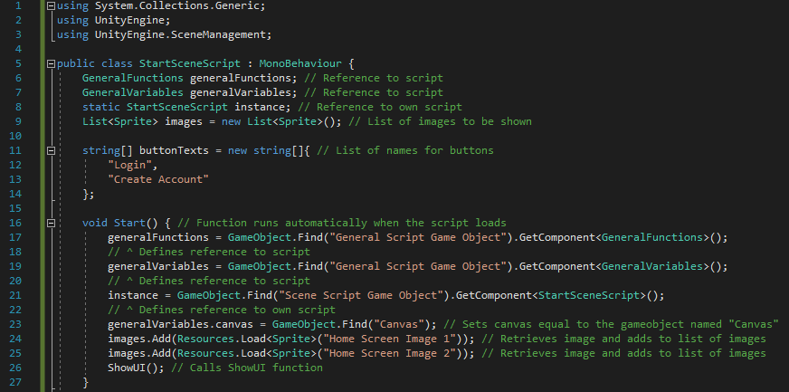

Figure 155 - Code for beginning of StartSceneScript and Start function

The script begins with the importing of modules and the creation of the script references, as with *LoadingSceneScript*. In addition, I have a list of sprites called *images*, which contains the two images which are shown in the bottom corners of the screen, and a list of strings which will be the text inside each of the buttons. The *Start* function begins in the same way as the previous script (and probably most future C# scripts) with the variables *generalFunctions*, *generalVariables*, *instance* and the *canvas* being defined. The images are then retrieved from the Resources folder and stored before *ShowUI* is called.

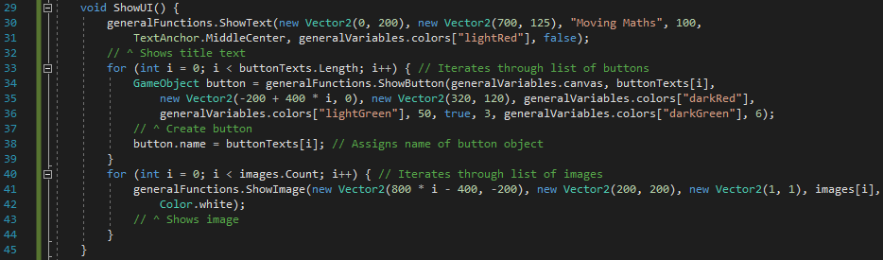

Figure 156 - ShowUI function

The *ShowUI* function, as always, displays all of the UI elements on the screen. It, in this script at least, goes in order of position from top of the screen to the bottom. So, it first displays the title text (since the design my stakeholder has decided to call the program ‘Moving Maths’ as it is going to be available on people’s devices at home) at the top of the screen. After that, I iterate through the list *buttonTexts* and create a button object for each one with that text value[4]. Then, each of the images are shown on the screen by calling the *ShowImage* general function.

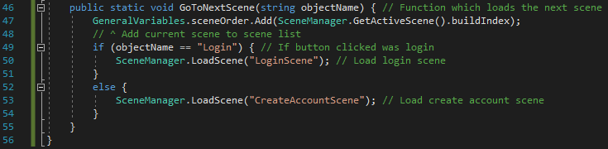

Figure 1575 - GoToNextScene function and end of script



Figure 158 - Addition to functionsToCall

*GoToNextScene* is defined as ‘static’ (which makes it easier to be called from *GeneralFunctions*) and with the parameter *objectName* which refers to the name of the GameObject that was clicked on. If the name of the object is ‘Login’ then the program will load the login scene and similarly, if not then that indicates the create account button has been clicked so that scene loads. The addition to the *functionsToCall* list is shown directly above, where *EventSystem.current.currentSelectedGameObject.name* is the way you can get the name of the GameObject that’s been clicked on in Unity3D.

#### Testing

The testing is going to be very basic for this scene since there is nothing really here. The only things to check for are the positioning and showing of the UI elements and whether the buttons perform correctly or not.

|  |  |  |
| --- | --- | --- |
| Expected Feature | Output | Correct? |
| Retest from *LoadingSceneScript*. Running program to see if the Start scene now loads. | Loads Start scene | Yes |
| Title text appears with correct attributes |  | Yes |
| Buttons appear with correct position, size, colour, text etc. |  | Yes |
| Buttons run correct response when clicked on (errors saying the scenes haven’t been created yet) |  | Yes. This console is a result of me clicking the login button then clicking the create account button. |
| Images appear with correct attributes |  | Yes |

All of these tests have succeeded (even if one of the results was that an expected error would occur). I am therefore content with the development of this scene.

#### Review

##### Content of Section

In this section, I have developed the Start scene. This is the first proper scene that the user will see and, since the user will need to be logged in to be able to use the program, they will face the options of either logging in or creating a new account.

##### Testing

The testing for this section was fairly basic and consisted of just making sure all of the UI elements were in the right place and that the buttons did their job when clicked on. However, an important test was the first one where I retested a test from the Loading scene and checked to make sure the Start scene loaded from the Loading scene. Since before, I was expecting an error and now I wasn’t (since I’d now created the scene), I needed to retest it to make sure the right outcome occurred.

##### Meeting Success Criteria

This scene, like some others in the program, is mainly a navigation scene (as well as essentially a welcome scene). Therefore, it aims at following the success criterion that the program should be easily navigable and the layout should be simplistic.

##### Summary of the Program at this Stage

At this stage, in terms of the user’s experience, the program will begin with the Loading scene then (assuming the user has internet connection) will move onto the Start scene. As of now, nothing will happen when one of the buttons are clicked. But, when the Login and Create Account scenes are created, the program will move to those scenes when their respective button is clicked.

##### Changes from Design

The only change from the design is the use of the arithmetic sequence (as described in the footnote earlier) to determine the position of some of the UI elements, as opposed to the designed use of an extra list. Other than that, the development of this section has followed the design.

## Stage #6 – Create Account Scene

The editor has been set up in the same way as the previous scenes, with the Main Camera, Canvas etc.

#### C# - CreateAccountSceneScript

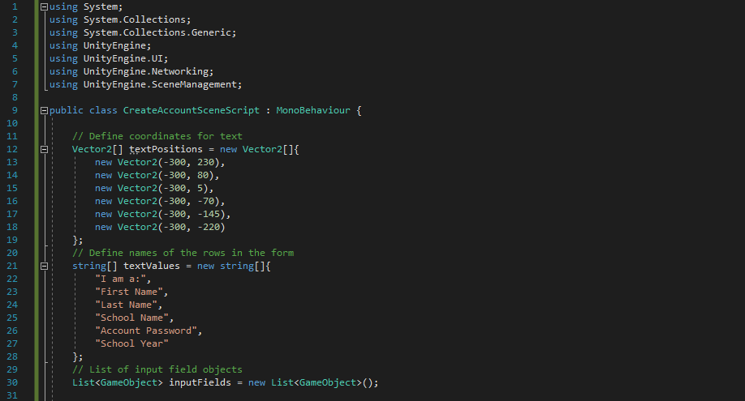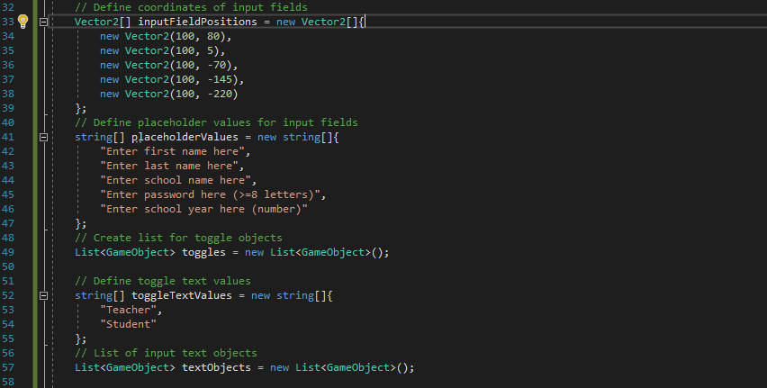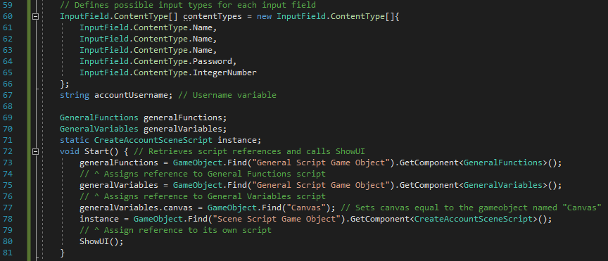

Figure 159 - Code for beginning of CreateAccountSceneScript and Start function

First, as with previous scripts, the required modules are defined. I then define a series of lists aimed at easing the programming of the input fields and also maintaining a largely soft-coded solution. These include a list of text positions, a list of text values[5], a list of input fields, a list of input field positions etc. I also have: a list of *ContentTypes* which define what values are permitted in each input field, a*ccountUsername*, which will be a temporary variable for the user’s automatically-created username. As well as these variables, I, of course, have the variables for my general scripts in addition to *instance*. In the *Start* function, the general scripts and *instance* are assigned and *canvas* is defined. Then *ShowUI* is called.

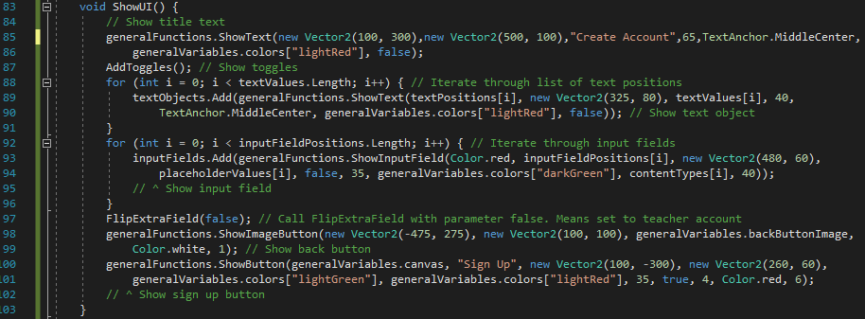

Figure 160 - Code for ShowUI function

The *ShowUI* function first shows the title text before calling *AddToggles* (which is a fairly large piece of code so I’ve made it its own function) and iterating through the list of text objects and input fields, displaying them on the screen. I then call *FlipExtraField* with the parameter being set to *false*, instructing the school year field to be hidden. I also then show the back button and the sign-up button (adding the relevant line to *functionsToCall* as well in index 4).

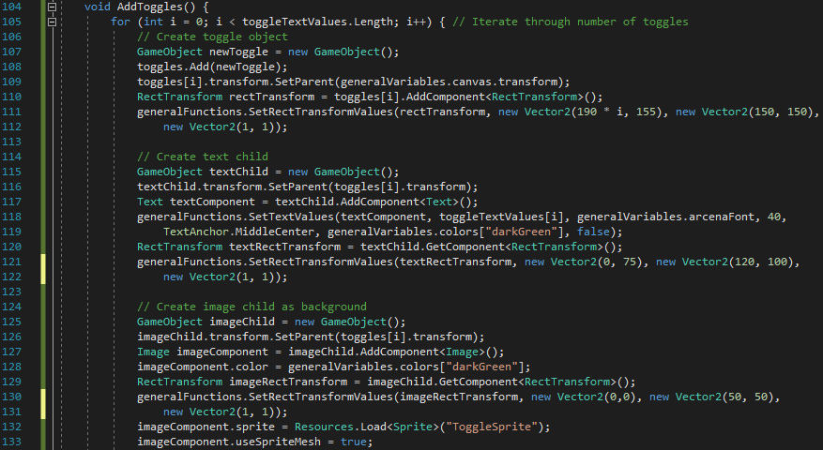

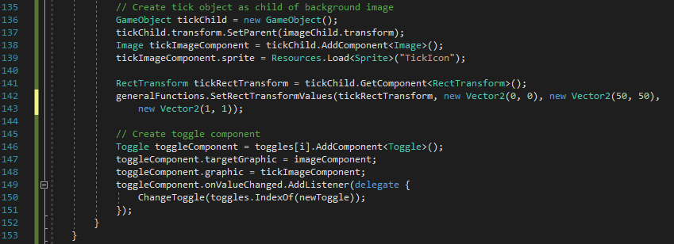

Figure 161 - Code for AddToggles function (#2)

Unfortunately, the toggles can’t be made easily using the *ShowText* and *ShowImage* functions in *GeneralFunctions* since they have special attributes which aren’t included in the general versions. Therefore, they need to be created from scratch in this function. First, I iterate through the number of toggles (which is two) and, for each one, creates an empty object assigning it a position and size. I then create its text child (the heading for the toggle that will appear above it) and the image child (what the toggle actually looks like) using the same methods used in the general functions (except the addition of a parent which isn’t *Canvas*). Finally, *tickChild* is created (the object which will have the sprite of a tick to indicate a selected toggle) and a toggle component is added which tells the program to call *ChangeToggle* if and when the value of the toggle is changed.

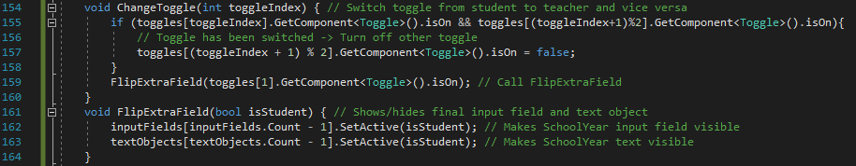

Figure 162 - Code for ChangeToggle and FlipExtraField

*ChangeToggle*, as said above, is the function that is called when a toggle is clicked on. The parameter taken in, *toggleIndex*, is the index of the toggle which has been clicked on. Since both toggles can’t be on at the same time, the if statement on line 155 checks if both are on. If that is the case, then the toggle which hasn’t just been clicked on is turned off. Finally, *FlipExtraField* is called with the Boolean value of if the student toggle is on is taken as a parameter. *FlipExtraField* is used to switch the showing and hiding of the final input field since that one (school year) is only meant to be shown for students. So, the parameter checks if the user is a student or not. The final input field and text object are both then set to the same visibility value as the Boolean *isStudent*. If the user is a teacher, then *isStudent* is false and the objects will be hidden. Likewise, if the user is a student then *isStudent* is true and the objects will be shown.

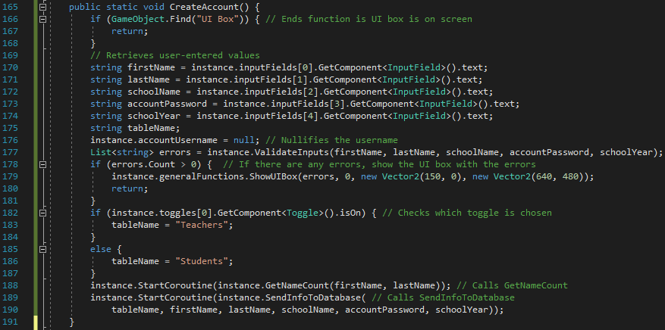

Figure 163 - Code for CreateAccount function

*CreateAccount* is the function that gets called when the submit button is clicked. It checks if everything is in order and, if it is, calls two functions which create the account. First, the program needs to make sure there isn’t a UI box on the screen. If there is then that needs to be sorted out first so the function returns empty. Assuming there’s no box, all of the user inputs are retrieved from the input fields and *ValidateInputs* function is run with them. Assuming there are no errors, the right table is assigned using the toggles and *GetNameCount* and *SendInfoToDatabase* are called. If there are any errors, an error message shows and the function returns empty.

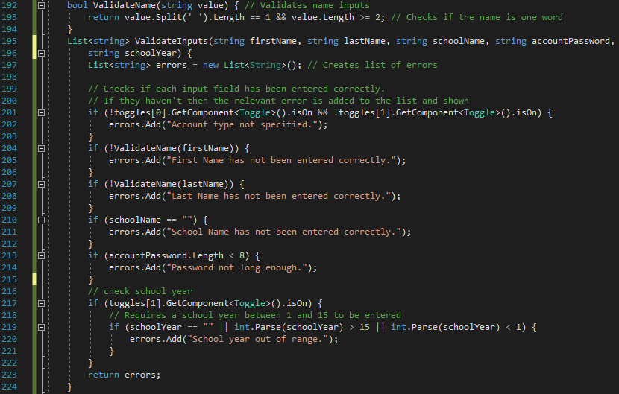

Figure 164 - Code for ValidateName and ValidateInputs

*ValidateInputs* checks each of the inputs against restrictions which I have pre-defined. These are:

1. One of the toggles must be selected.
2. First name and last name must be one word and have at least two characters.
3. School name must be entered.
4. Password must be at least eight characters long.
5. School year must be between two and 14.

Each of these checks are done individually between lines 195 and 222. (*ValidateName* is a function created for checking restriction #2 because it is used twice so I’ve added the function to prevent the same code being repeated.) If any of them fail, a specific error message is added to a list of strings called *errors* which is then returned. In *CreateAccount*, if there are errors, each of the errors are printed in the error message.

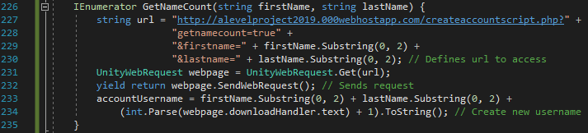

Figure 165 - Code for GetNameCount

The username is automatically generated for new users by concatenating the first two characters of their first name, the first two characters of their surname and a number (which is the lowest positive number which has not yet been used with respect to those specific four characters). This is done by first requesting a PHP file called *createaccountscript* and specifically accessing the part of code talking about retrieving name counts. This will return the positive integer defined above. *accountUsername* is then defined in the way described above by taking substrings of the first name and last name and taking the integer value outputted by the PHP plus one (to make it unique).

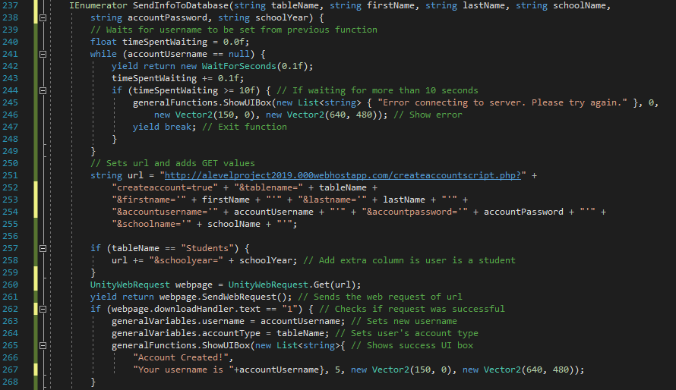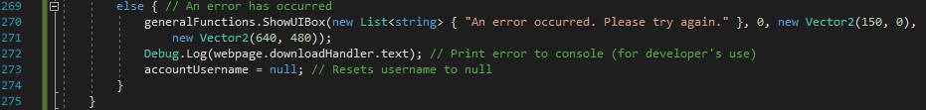

Figure 166 - Code for SendInfoToDatabase

*SendInfoToDatabase* actually sends off the data to the server to finalise the creation of the account. However, it first needs to wait for *GetNameCount* to finish running. The while loop at the beginning of the function waits for a new username to be created (which would indicate that *GetNameCount* is finished). If nothing is received after 10 seconds, a server response error appears and the function ends. Assuming there is connection and a username is created, the PHP script is requested using GET requests to store user inputs. The PHP script will add the account to the database and return a value. A ‘1’ indicates a successful request. If a ‘1’ is received by the C# script, the new username is stored in *GeneralVariables* as is the account type and a success message is shown. That success message, when clicked, will call the function *GoToNextScene*. This occurs as I’ve added the relevant line to *functionsToCall* at index value 5. If a ‘1’ is not received then an error message appears and the username is reset to *null*.

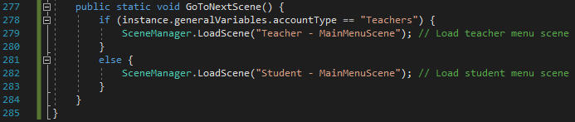

Figure 167 - Code for GoToNextScene and end of script

When *GoToNextScene* is called, the program will move to the Main Menu scene. This is either student-specific or teacher-specific depending on the user’s account type and this is checked using an if statement of the *accountType* variable.

#### PHP – CreateAccountScript

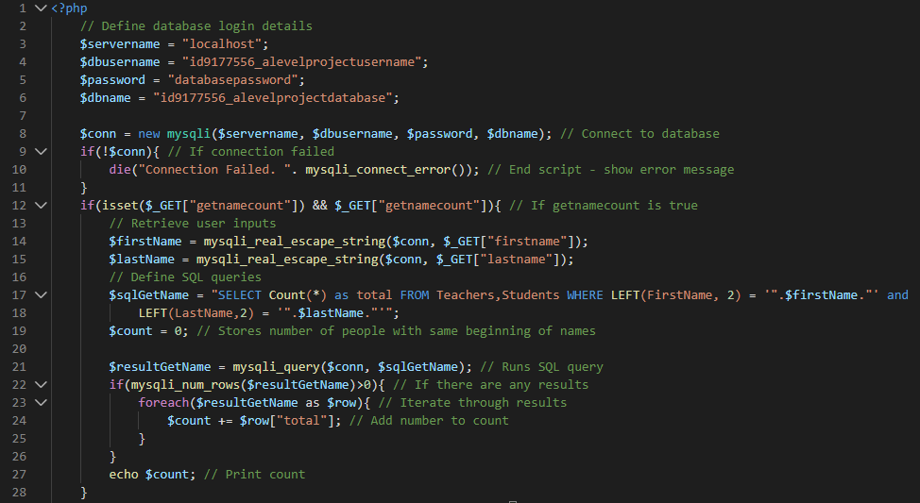

Figure 168 - Code for createaccountscript (#1)

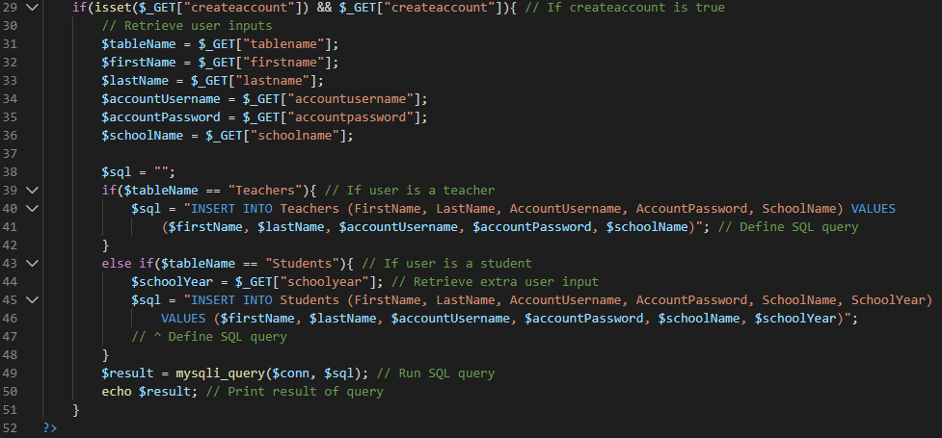

Figure 169 - Code for createaccountscript (#2)

This script is split into two sections: the *getnamecount* section and the *createaccount* section. In the C# script, both are called as part of creating the account. The former is used for developing an automatically-generated username and the latter is used for storing the newly-created account on the database.

The script begins with defining the login details to the and attempting a connection to the database– as always. If the URL includes *getnamecount=true*, then the if statement on line 12 will evaluate to true and the code inside will be executed. This code retrieves the first and last names from the user input and creates an SQL query, requesting the number of people with the same first two characters of both names. The query is then run and the results are iterated through, adding to *count*. The value of *count* is then printed to be retrieved in the C# script.

If *createaccount=true* is in the URL, then the user inputs are retrieved and, if the table name variable is set to ‘Teachers’, the SQL query is for inserting the account details to the *Teachers* table and similarly, if the table name variable is set to ‘Students’, the SQL query is for inserting the account details to the *Students* table. The query is then run and the result is returned (‘1’ for a successful query execution).

#### Testing

The testing for this section will need to be fairly strong since it uses a lot of user input (the most out of any scene, in fact). Therefore, I will test every input field and toggle click with plausible and implausible inputs to make sure the right response occurs. All tests will be made with all other input fields taking valid inputs, to ensure the response is purely based on the input field in question.

|  |  |  |  |
| --- | --- | --- | --- |
| General Tests | | | |
| Test | **Expected Output** | **Output** | **Correct?** |
| Click back button | Program goes previous scene | Program goes back to Start scene | Yes |
| Click submit button (with valid inputs) | New account is created – success bar appears |  | Yes |
| Clicks on success UI box | Error message appears saying scene hasn’t been created yet |  | Yes |

|  |  |  |  |
| --- | --- | --- | --- |
| Toggle Fields | | | |
| Test | **Expected Output** | **Output** | **Correct?** |
| Click on Teacher toggle | Teacher toggle tick should appear | Teacher toggle appears | Yes |
| Click on Student toggle | Student toggle tick should appear, extra field should appear | Student tick and extra text and input field appear | Yes |
| 1. Click on Teacher toggle 2. Click on Student toggle | 1. Teacher tick should appear 2. Teacher tick should disappear, student tick should appear, extra field should appear | 1. Teacher tick appears 2. Teacher tick disappears, student tick and extra field appear | Yes |
| 1. Click on Student toggle 2. Click on Teacher toggle | 1. Student tick should appear, extra field should appear 2. Student tick should disappear, teacher tick should appear, extra field should disappear | 1. Student tick and extra field appear 2. Student tick and extra field disappear, teacher tick appears | Yes |
| 1. Click on Teacher toggle 2. Click on Teacher toggle | 1. Teacher tick should appear 2. Teacher tick should disappear | 1. Teacher tick appears 2. Teacher tick disappears | Yes |
| 1. Click on Student toggle 2. Click on Student toggle | 1. Student tick should appear, extra field should appear 2. Student tick should disappear, extra field should disappear | 1. Student tick and extra field appear 2. Student tick and extra field disappear | Yes |

|  |  |  |  |  |
| --- | --- | --- | --- | --- |
| Input Field #1 (First Name) | | | | |
| Test | **Test input** | **Expected Output** | **Output** | **Correct?** |
| Enter nothing |  | Error message when submitted |  | Yes |
| Enter integer value | 15 | Won’t be permitted to enter integers. | Not permitted to enter integers. Nothing would appear in input field when integers were entered. | Yes |
| Enter string (1 character) | ‘L’ | Error message when submitted |  | Yes |
| Enter string (more than 2 but less than 40 characters) | ‘Dan’ | No error message – account should be made |  | Yes |
| Enter string (more than 40 characters[6]) | ‘aaaaaaaaaaaaaaaaaaa  aaaaaaaaaaaaaaaaaaa  aaaaaaaaaaaaaaaaaaa  aaaaaaaaaaaaaaaaaaa’ | Won’t allow more than 40 characters | Input field only permits up to 40 characters. Extra characters didn’t appear in the input field. | Yes |
| Enter string (more than one word) | ‘Dan Leb’ | Won’t allow space | Input field didn’t permit space to be added. | Yes |
| Enter symbols inside string | ‘Dan£$%()>?|\/~#@[]{}’ | Won’t be permitted to enter symbols | Input field didn’t accept the characters after ‘Dan’. | Yes |
| Enter function keys (including print screen, tab etc) | ‘Dan’ + pressing function keys | Nothing will happen | Nothing. Except when the *Home* and *End* keys were clicked. When that happened, the cursor moved to the beginning and end of the input text respectively (like in most texts). Pressing the *Escape* key removed the cursor from the input box. | Yes. Although the exceptions weren’t expected, they are welcome. |

|  |  |  |  |  |
| --- | --- | --- | --- | --- |
| Input Field #2 (Last Name) | | | | |
| Test | **Test input** | **Expected Output** | **Output** | **Correct?** |
| Enter nothing |  | Error message when submitted |  | Yes |
| Enter integer value | 42 | Won’t be permitted to enter integers. | Not permitted to enter integers. Nothing would appear in input field when integers were entered. | Yes |
| Enter string (1 character) | ‘F’ | Error message when submitted |  | Yes |
| Enter string (more than 1 but less than 40 characters) | ‘Leb’ | No error message – account should be made |  | Yes.  The fact that the username created is ‘DaLe2’ shows that the system of generating unique usernames is working properly. |
| Enter string (more than 40 characters) | ‘aaaaaaaaaaaaaaaaaaa  aaaaaaaaaaaaaaaaaaa  aaaaaaaaaaaaaaaaaaa  aaaaaaaaaaaaaaaaaaa’ | Won’t allow more than 40 characters | Input field only permits up to 40 characters. Extra characters didn’t appear in the input field. | Yes |
| Enter string (more than one word) | ‘Dan Leb’ | Won’t allow space | Input field didn’t permit space to be added. | Yes |
| Enter symbols inside string | ‘Leb)(*&^%$£’ | Won’t be permitted to enter symbols | Input field didn’t accept the characters after ‘Leb’. | Yes |
| Enter function keys (including print screen, tab etc) | ‘Leb’ + pressing function keys | Nothing will happen | Nothing. Except when the *Home* and *End* keys were clicked. When that happened, the cursor moved to the beginning and end of the input text respectively (like in most texts). Pressing the *Escape* key removed the cursor from the input box. | Yes. Although the exceptions weren’t expected, they are welcome. |

|  |  |  |  |  |
| --- | --- | --- | --- | --- |
| Input Field #3 (School Name) | | | | |
| Test | **Test input** | **Expected Output** | **Output** | **Correct?** |
| Enter nothing |  | Error message when submitted |  | Yes |
| Enter integer value | 42 | Won’t be permitted to enter integers. | Not permitted to enter integers. Nothing would appear in input field when integers were entered. | Yes |
| Enter string (1 character) | ‘W’ | Error message when submitted |  | No. (Error #1) |
| Enter string (more than 1 but less than 40 characters) | ‘JFS’ | No error message – account should be made |  | Yes. |
| Enter string (more than 40 characters) | ‘aaaaaaaaaaaaaaaaaaa  aaaaaaaaaaaaaaaaaaa  aaaaaaaaaaaaaaaaaaa  aaaaaaaaaaaaaaaaaaa’ | Won’t allow more than 40 characters | Input field only permits up to 40 characters. Extra characters didn’t appear in the input field. | Yes |
| Enter string (more than one word) | ‘JFS School’ | Won’t allow space | Input field didn’t permit space to be added. | Yes |
| Enter symbols inside string | ‘JFS)£$%^$£’ | Won’t be permitted to enter symbols | Input field didn’t accept the characters after ‘JFS’. | Yes |
| Enter function keys (including print screen, tab etc) | ‘JFS’ + pressing function keys | Nothing will happen | Nothing. Except when the *Home* and *End* keys were clicked. When that happened, the cursor moved to the beginning and end of the input text respectively (like in most texts). Pressing the *Escape* key removed the cursor from the input box. | Yes. Although the exceptions weren’t expected, they are welcome. |

|  |  |  |  |  |
| --- | --- | --- | --- | --- |
| Input Field #4 (Account Password) | | | | |
| Test | **Test input** | **Expected Output** | **Output** | **Correct?** |
| Enter nothing |  | Error message when submitted |  | Yes |
| Enter integer value | 424265181 | No error message – account should be made |  | Yes |
| Enter string (1 character) | ‘O’ | Error message when submitted |  | Yes |
| Enter string (more than 1 but less than 7 characters) | ‘Word’ | Error message when submitted |  | Yes |
| Enter string (7 characters) | ‘Word123’ | Error message when submitted |  | Yes |
| Enter string (8 characters) | ‘Password’ | No error message – account should be made |  | Yes |
| Enter string (more than 8 characters) | ‘TestPassword123’ | No error message – account should be made |  |  |
| Enter string (more than one word) | ‘Test Password’ | No error message – account should be made |  | Yes |
| Enter symbols inside string | ‘Password)£$%^$£’ | No error message – account should be made |  | Yes |
| Enter function keys (including print screen, tab etc) | ‘Password’ + pressing function keys | Nothing will happen | Nothing. Except when the *Home* and *End* keys were clicked. When that happened, the cursor moved to the beginning and end of the input text respectively (like in most texts). Pressing the *Escape* key removed the cursor from the input box. | Yes. Although the exceptions weren’t expected, they are welcome. |

|  |  |  |  |  |
| --- | --- | --- | --- | --- |
| Input Field #5 (School Year) | | | | |
| Test | **Test input** | **Expected Output** | **Output** | **Correct?** |
| Enter nothing |  | Error message when submitted |  | Yes |
| Enter string value | ‘Hello’ | Won’t allow letters | Letters weren’t permitted and weren’t added to the input field when typed. | Yes |
| Enter integer (negative) | -4 | Error message when submitted |  | Yes |
| Enter integer | 0 | Error message when submitted |  | Yes |
| Enter integer | 1 | No error message – account should be made |  | Yes |
| Enter integer | 5 | No error message – account should be made |  | Yes |
| Enter integer | 15 | No error message – account should be made |  | Yes |
| Enter integer | 16 | Error message when submitted |  | Yes |
| Enter symbols inside string | ‘14%^&’ | Symbols won’t be permitted | Input field accepted the digits but not the symbols. The symbols were not added to the input field text when typed. | Yes |
| Enter function keys (including print screen, tab etc) | ‘11’ + pressing function keys | Nothing will happen | Nothing. Except when the *Home* and *End* keys were clicked. When that happened, the cursor moved to the beginning and end of the input text respectively (like in most texts). Pressing the *Escape* key removed the cursor from the input box. | Yes. Although the exceptions weren’t expected, they are welcome. |

##### Error #1

The error occurred with the *School Name* field when testing for single character inputs. It accepted the input when it should have provided a length error. I have realised that I missed out the check for length so I have added it in, as shown below:

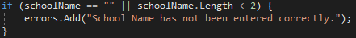

Figure 170 - Corrected code for ValidateInputs function

When rerunning the test which failed with the updated code, the input of ‘W’ did come up with an error message and therefore, I can conclude the error has been fixed. Since all of the tests which have produced accounts did so correctly, I can conclude the functions *GetNameCount*, *CreateAccount* and *SendInfoToDatabase* must be working correctly too. In addition, *GoToNextScene* is working since, when I click on the success UI box, the error below appears (which is what I expect).

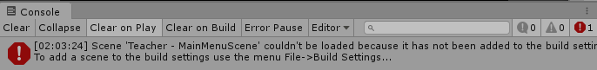

Figure 171 - Console output

As well as that, I can see that the successfully created accounts (in terms of the user inputs) were indeed created successfully by the PHP script and the database, as shown in the below images of the database as it stands after the earlier tests were run.

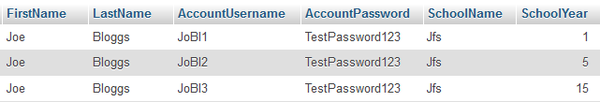

Figure 172 - Students table

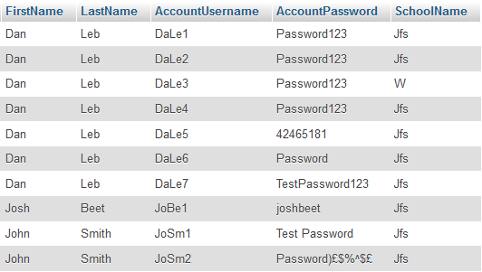

Figure 173 - Teachers table

#### Review

##### Content of Section

In this section, I have created the Create Account scene, which enables the user to create an account for the program. It has a validation system which prevents incorrect inputs and sends the user’s information to the database to be stored as a new account.

##### Testing

Testing for this section was very stringent since it involves a significant amount of user input. I have tested the toggles and each of the input fields for all possible inputs and insured the outputs were as expected.

##### Meeting Success Criteria

This ticks off one of the most important success criteria which states the user should be able to create an account that is stored on the online database.

##### Summary of the Program at this Stage

At this stage, the Loading Scene, Start Scene and Create Account Scene have been created. As of now, the only useful thing the user can do on the program is to create an account.

##### Changes from Design

No changes have been made to the design of the actual scene itself, neither in terms of the page design nor the algorithm design.

## Stage #7 – Login Scene

#### C# - LoginSceneScript

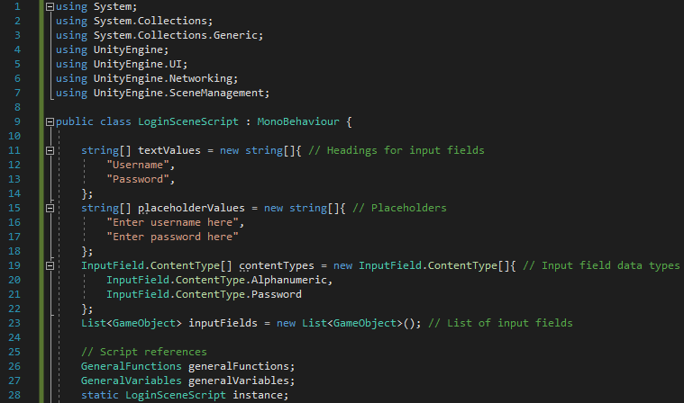

Figure 174 - Code for beginning of LoginSceneScript

As with previous C# scripts, it begins with the *using* statements and the creation of *generalFunctions*, *generalVariables* and *instance*. Other than that, variables in this section are *textValues* (defining the headings for the input fields), *placeholderValues* (the text that will be shown in the input fields), *contentTypes* (defining the data types permitted for the input fields) and a list for the input fields.

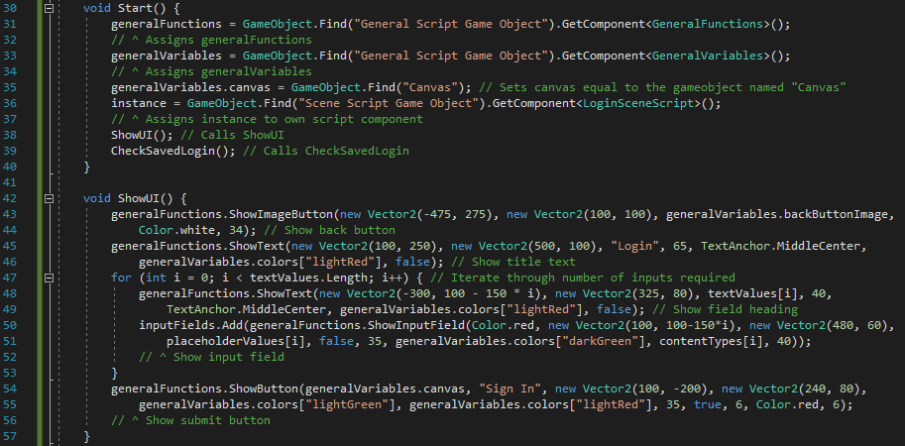

Figure 175 - Start and ShowUI functions

The *Start* function does the exact same things as in the previous C# scripts with the exception of calling *CheckSavedLogin* at the end. In *ShowUI*, the back button, title text, input field headings, input fields and submit button are shown. The input field and its headings are created by iterating through the length of the list of text values and creating one input field and one heading for each index of the list.

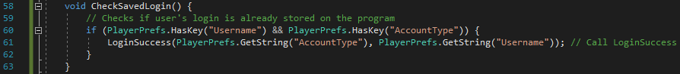

Figure 176 - Code for CheckSavedLogin

This function contributes to a new feature which I have decided to add since the design. The feature is an automatic login system. If the user has logged in to an account on the device before, then opening the login screen again will lead to the program recognising that the user has already logged in previously and log them in automatically. Essentially, it works the same way that most saved login systems work on websites (where the login would be stored as a cookie and checked when the website loads). The function works by simply checking if the username and account type variables have been stored as PlayerPrefs[7]. If they have, then *LoginSuccess* is called, taking the values stored offline as the function’s arguments.

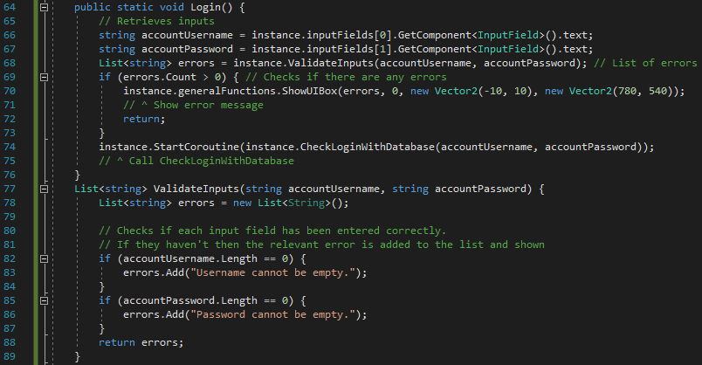

Figure 177 - Code for Login and ValidateInputs

The *Login* function is called when the ‘Login’ button is clicked. It first takes in the inputs for username and password and stores them as variables. It then calls *ValidateInputs* and sends the inputs as arguments. If the returned set of errors is not empty then an error message is shown and the function ends. If it is empty, then there is nothing wrong with the inputs and *CheckLoginWithDatabase* is called.

The *ValidateInputs* function is fairly sparse here in comparison to the same function in other scripts. The reason for this is I don’t want to restrict their login inputs. If they enter something which logically can’t be the username or password, I can still allow it because the login will just be rejected as incorrect login details. So, the only checks I make are that the values can’t be empty. If they are then an error message will be added to the list *errors* and returned.

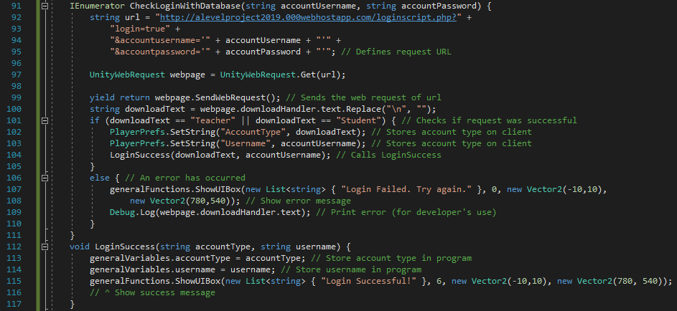

Figure 178 - Code for CheckLoginWithDatabase and LoginSuccess

The login details need to be checked by the database. The details are sent in the IEnumerator *CheckLoginWithDatabase*. The URL is defined and the web request is sent to the PHP script. If the login is successful, the PHP script will print either ‘Teacher’ or ‘Student’ referring to the account type of the logged-in user. So, the if statement on line 101 acts as a checker for if the login request was successful. If it was then the account type and username are set offline as PlayerPrefs and *LoginSuccess* is called. The *LoginSuccess* functions stores the account type and username in their respective variables in *GeneralVariables* and shows a success message.

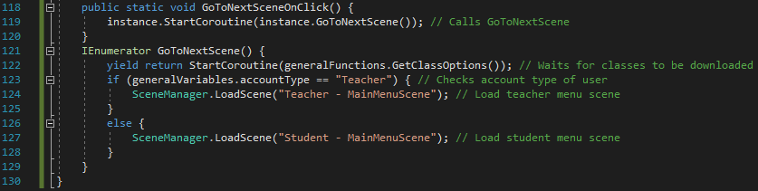

Figure 179 - Code for GoToNextSceneOnClick, GoToNextScene and end of script

The function *GoToNextSceneOnClick* is called when the successful login message is clicked on. It is required for IEnumerators cannot be called from other scripts[8] so I have created this function which will simply call the IEnumerator *GoToNextScene*. *GoToNextScene* is an IEnumerator simply because of its first line. Since the user has just logged in, the user’s class details need to be downloaded to the program. Line 122 calls *GetClassOptions* which does just that, whilst waiting for the function to finish running. After that, it either loads the Teacher Main Menu scene or the Student Main Menu scene, depending on the account type of the user.

#### PHP – LoginScript

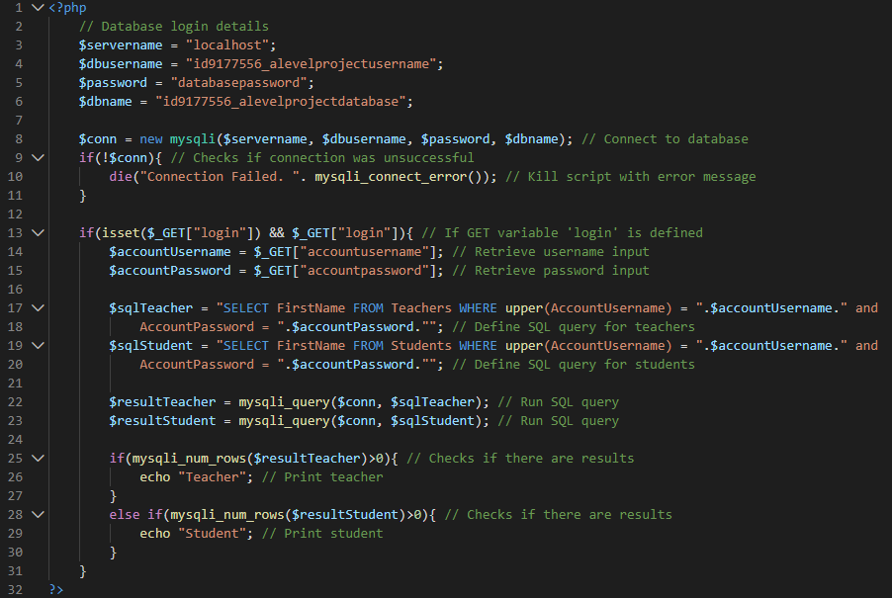

Figure 180 - Code for LoginScript

First, the login details are defined and the connection is attempted. If the connection to the database is unsuccessful, an error message is printed and the script stops running (like previous PHP scripts). Assuming the connection was successful, line 13 checks to make sure there is a GET variable called *login* that is defined[9]. Then, the user’s inputs are retrieved from the URL and stored as variables. After that, the SQL queries are defined and executed. If there are more than 0 rows in the results of the first SQL query, then the user is a teacher and so ‘Teacher’ is printed. Similarly, if there are more than 0 rows in the results of the second SQL query, then the user is a student and so ‘Student’ is printed.

#### Testing

The testing for this section will simply include testing the input fields and button.

|  |  |  |  |
| --- | --- | --- | --- |
| General Tests | | | |
| Test | **Expected Output** | **Output** | **Correct?** |
| Click back button | Program goes to previous scene |  | Yes |
| Click submit button (with valid inputs) | New account is created – success bar appears |  | Yes |
| Clicks on success UI box | UI box disappears. Error message in console saying scene hasn’t been created yet |  | No. (Error #1) |
| Click submit button (with invalid inputs) | Error message appears |  | Yes |
| Clicks on error message | Error message goes away |  | Yes |
| Enters Login scene having previously been logged in | Logged in message should appear immediately without any user action. | The above image appeared immediately after going onto the Login scene | Yes |

|  |  |  |  |
| --- | --- | --- | --- |
| Input Field #1 (Username) | | | |
| Test | **Expected Output** | **Output** | **Correct?** |
| Empty string | Error message when submitted |  | Yes |
| String of letters | No error – should attempt login when submitted | No error message appeared. Login was attempted when the submit button was clicked. | Yes |
| String of digits | No error – should attempt login when submitted | No error message appeared. Login was attempted when the submit button was clicked. | Yes |
| Alphanumeric string | No error – should attempt login when submitted | No error message appeared. Login was attempted when the submit button was clicked. | Yes |
| Symbols | Symbols shouldn’t be permitted by input field | I wasn’t able to enter symbols into the input field. | Yes |
| Function keys | Symbols shouldn’t be permitted by input field (other than the effects of the keys mentioned in earlier tests) | No effect on input field when function keys were typed. | Yes |

|  |  |  |  |
| --- | --- | --- | --- |
| Input Field #2 (Password) | | | |
| Test | **Expected Output** | **Output** | **Correct?** |
| Empty string | Error message when submitted |  | Yes |
| Integer value | No error – should attempt login when submitted | No error message appeared. Login was attempted when the submit button was clicked. | Yes |
| Enter string | No error – should attempt login when submitted | No error message appeared. Login was attempted when the submit button was clicked. | Yes |
| Enter string (multiple words) | No error – should attempt login when submitted. Space should be added to input when typed. | Space was added to input when spacebar was typed. No error message appeared. Login was attempted when the submit button was clicked. | Yes |
| Enter symbols | No error – should attempt login when submitted | No error message appeared. Login was attempted when the submit button was clicked. | Yes |
| Function keys | Symbols shouldn’t be permitted by input field (other than the effects of the keys mentioned in earlier tests) | No effect on input field when function keys were typed. | Yes |

##### Error #1

The error occurred when clicking on the successful UI box. The expected result was for the box to go away and for an error to come up in the console saying the next scene hasn’t been created yet. In actual fact, the UI box disappeared then appeared again and no error came up in the console. I discovered that is because the wrong value was given in the line below from *LoginSuccess*.



Figure 181 – Error-causing code

The parameter for the function to call next is given as ‘6’ here but the sixth index of *functionsToCall* is to login. Therefore, as it stands, every time the user clicks on the box telling them their login was successful, the program attempts to log them in again. I have therefore changed that parameter to ‘7’ as that then calls *GoToNextSceneOnClick* as expected.

After making that change, when the successful UI box is clicked on, it now disappears and an error message appears in the console saying the new scene hasn’t yet been created, as shown below.

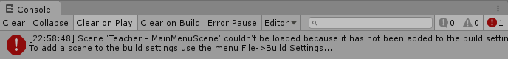

Figure 182 - Console response to test

#### Review

##### Content of Section

In this section, I have created the Login feature of the program. It allows users (who have previously created an account) to log in to the program. In addition to that, I have implemented an automatic sign-in section which allows users who have previously been logged in to that device

##### Testing

The testing in this section consisted of testing the input fields with various data types and symbols, in addition to the usual checking of things like the back button and the submit button.

##### Meeting Success Criteria

This section fulfils the success criterion that users should be able to log in to the program with their accounts. As mentioned numerous times already, this criterion is very important as it is the basis of the program, allowing features like classes, homeworks and leaderboards to exist.

##### Summary of the Program at this Stage

At this stage, the user is able to create an account and log in to their account.

##### Changes from Design

A few minor changes have been made with regards to the algorithm involved in making the Login scene. This includes things like removing unnecessary variables and introducing the sequence-based method of positioning lists (as described in a footnote earlier). However, a more major change is the addition of the automatic sign-in system which allows previously logged-in users to log in without having to enter their details again.

## Stage #8 – Teacher Main Menu Scene

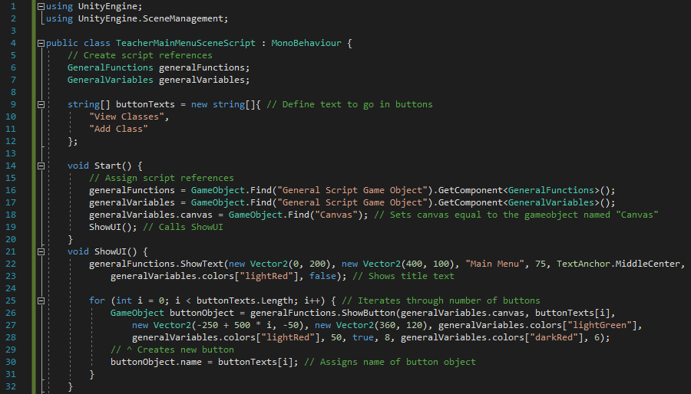

Figure 183 - Code for beginning of TeacherMainMenuSceneScript and Start and ShowUI functions

The script begins in the same way as all other – with the *using* keywords to define used modules and by creating the script references. In this script, *instance* isn’t defined because there is nowhere in the script where it needs to be used. The only other variable defined in this script (globally) is the list of strings called *buttonTexts* which defines what the text inside each button should be. The *Start* function simply does the same thing as in previous scripts (assigns script references and canvas and calls *ShowUI*). *ShowUI* first creates the title text before iterating through the number of values in *buttonTexts* and creating a new button for each one. The object’s name is then defined as its text so that it can be identified in *GoToNextScene*.

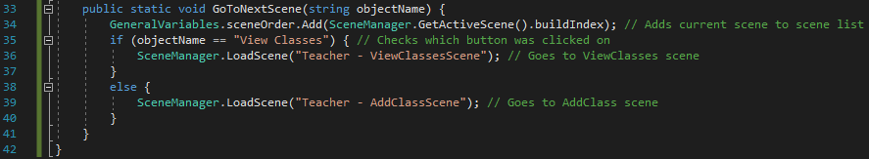

Figure 184 - Code for GoToNextScene and end of script

When one of the buttons is clicked, *GoToNextScene* is called (the relevant line of code has been added to the *functionsToCall* list in *GeneralFunctions*). The function takes a parameter which will be the name of the object. The function then adds the current scene to the scene order list before checking if the button that was clicked on was “View Classes” or “Add Class”. Depending on that, the program will load and go to the relevant scene.

#### Testing

Testing for this section will simply include testing for clicking the two buttons.

|  |  |  |  |
| --- | --- | --- | --- |
| Test | Expected Output | Output | Correct? |
| Retest from previous scene. Enter scene from create account | Scene should load | The scene loaded successfully and as expected. | Yes |
| Retest from previous scene. Enter scene from create account | Scene should load | The scene loaded successfully and as expected. | Yes |
| N/A | UI should all appear with right attributes |  | Yes |
| Click on View Classes button | Error message in console saying scene not created yet |  | Yes |
| Click on Add Class button | Error message in console saying scene not created yet |  | Yes |

#### Review

##### Content of Section

In this section, I’ve created the main menu scene for teachers. They’ll see it straight after they log in or create an account and it provides them with the options going forward.

##### Testing

The testing for this section was basic. In addition, to checking that moving to the Main Menu scene from previous scene now works (previously led to an error saying the scene hasn’t been created yet), I have checked that clicking the buttons lead to the correctly anticipated outcome.

##### Meeting Success Criteria

This scene is similar to the Start scene in terms of the success criteria is achieves. It doesn’t directly achieve any of them but helps to achieve the criterion to do with making the program easily navigable for the user (given the scene is essentially a navigation scene).

##### Summary of the Program at this Stage

The program as it stands allows users to create accounts, login and allows teachers to view their main menu.

##### Changes from Design

I have made one change in the code for the scene. I have applied the sequential method of positioning UI elements (specifically positioning the buttons) instead of storing the values in a list.

## Stage #9 – Teacher Add Class Scene

#### C# - TeacherAddClassSceneScript

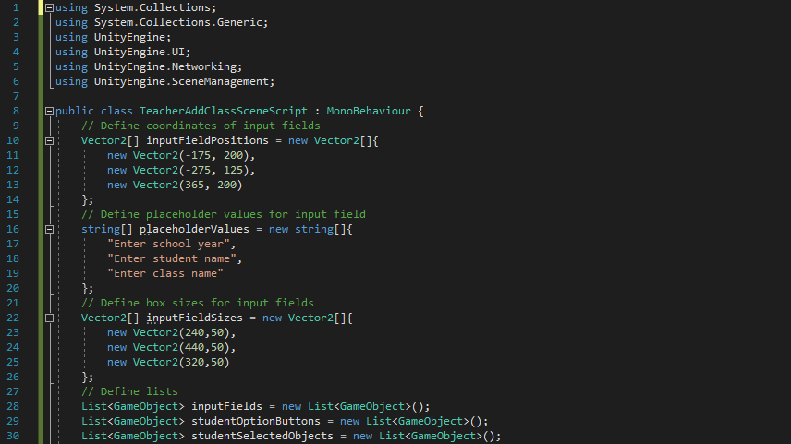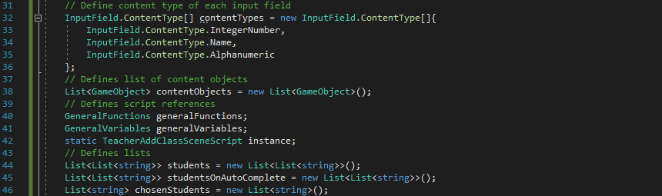

Figure 185 - Code for beginning of TeacherAddClassSceneScript and variable creation

This script has a large number of variables because there are lots of components in the foreground in addition to a lot of computation being done in the background. The input field positions and sizes are defined using arrays of Vector2s[10]. There are various lists that are defined. These are for the input fields and various lists of students that are required[11]. In addition to that, there is a list for the permitted data types of the input fields and the usual script references that appear in all other scripts too.

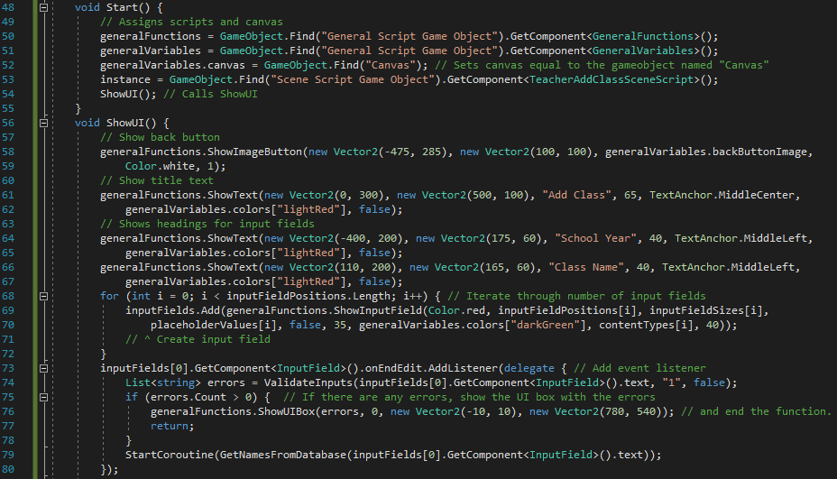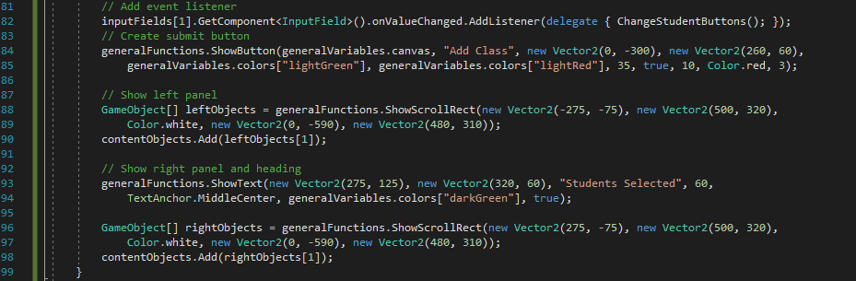

Figure 186 - Code for Start and ShowUI

The *Start* function achieves nothing other than its general purpose of defining the script references, defining *canvas* and calling *ShowUI*. *ShowUI* has a lot of UI elements to show (as shown in the page design of this scene). The function shows the elements methodically, beginning with the back button, title text and headings for the input fields. Then, the input fields are created and their event listeners are defined. The event listener for the school year input field is *OnEndEdit* (calls the delegate function when the user clicks out of the input field) and checks for input errors before calling *GetNamesFromDatabase*. The event listener for the ‘Enter student name’ input field is *OnValueChanged* (calls the delegate function when the user changes the value inside the input field) and calls *ChangeStudentButtons*. Then the submit button is created before the two panels are created by making scroll rects and (in the case of the right-hand panel) a heading text is created.

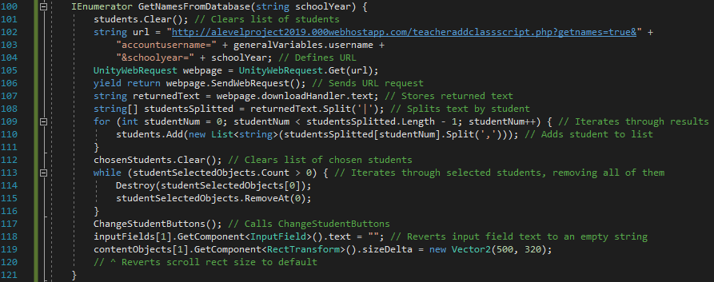

Figure 187 - Code for GetNamesFromDatabase

*GetNamesFromDatabase* is the IEnumerator that makes a request to the PHP script and returns with a list of students which are can be added since they are in the right school and year group. First, the current list of students is cleared since a new list of students is about to be created. Next, the URL is defined and the web request is sent. The result is stored and split by ‘|’ (splitting the text by student since ‘|’ is the separator between students). Then, the program iterates through the results, adding each student to *students*. Then, since a new year group has been defined, any selected students are no longer valid students so they are removed. This is done by iterating through the list of selected objects, destroying the objects and removing them from the list. Finally, *ChangeStudentButtons* is called and the input field and scroll rect are reset to their default attributes.

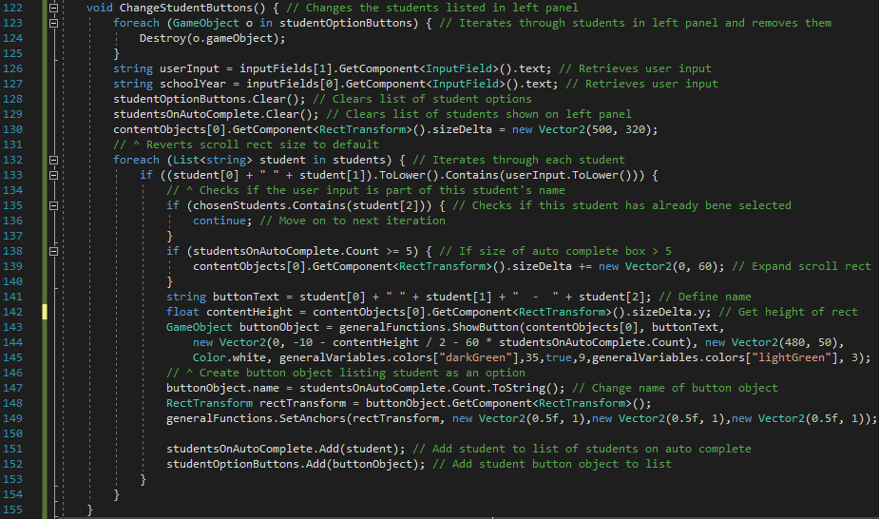

Figure 188 - Code for ChangeStudentButtons

*ChangeStudentButtons* will remove the students in the left-hand panel and replace them with the new list of possible students (based off of the user’s current input for student name). First, lines 123-125 remove the student list by iterating through the list of options and destroying each one. Then, the user’s inputs are retrieved, the student lists are cleared and the size of the scroll rect is reverted to its default. The program then iterates through the list of students. Line 133 is an if statement which checks if the user’s current input forms part of the that student’s name. If that’s the case, then the student is a possible option and the code from lines 134 to 152 will be executed.

First, I check if that student has already been selected (i.e. if the student is on the right-hand panel). If they are, then there’s no need for them to appear on the left-panel as a new option so I end that iteration. Lines 138-140 expand the scroll rect if necessary, allowing for more options to be available. Then, the name of the student is defined (by concatenating the first name, a space and the surname) and the button is created. The name of the object is set to an integer based on its index in the list *studentsOnAutoComplete*. Finally, the student and student text object are appended to the lists *studentsOnAutoComplete* and *studentOptionButtons* respectively.

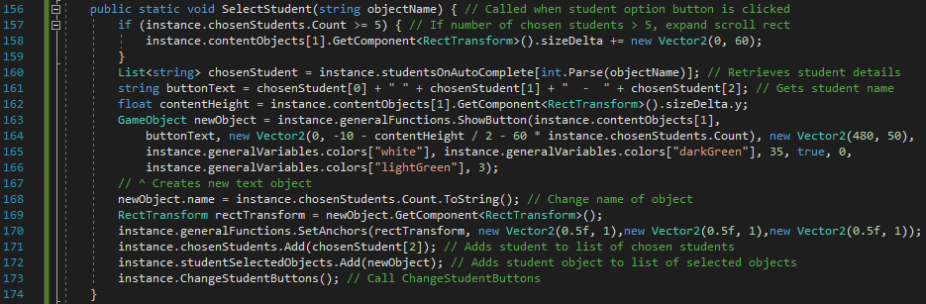

Figure 189 - Code for SelectStudent

*SelectStudent* is the function which is called when the teacher clicks on one of the student text options in the left-hand panel. The purpose of this function is to add a text object of the added student to the right-hand panela and to ‘recalculate’ the options on the left-hand panel. First, the size of the scroll rect needs to be expanded (if there are more than five chosen students) to allow for more students to be added to the list. After that, the student’s details are retrieved (line 160) and a new button is created for the student in the right-hand panel (lines 163-166)[12]. Then the student and student objects are added to *chosenStudents* and *studentSelectedObjects* respectively. Finally, *ChangeStudentButtons* is called to redo the left-hand panel now that the selected student should no longer feature on that panel[13].

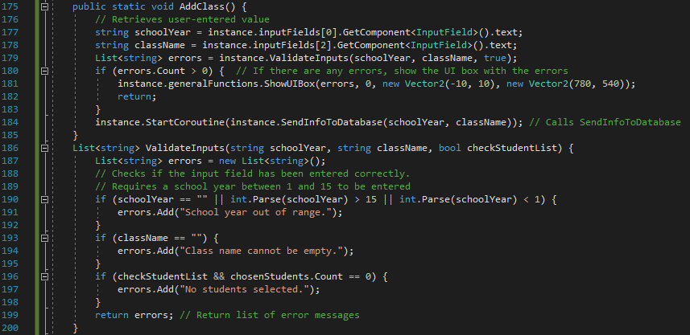

Figure 190 - Code for AddClass and ValidateInputs

*AddClass* is the function that’s called when the teacher clicks the submit button at the bottom of the screen. It first retrieves the user input and validates them by calling *ValidateInputs*. This function checks all of the user inputs in the same way as in previous scripts and returns a list of error messages[14]. If there are any errors, an error box will show and the function will end. If there are no errors then *SendInfoToDatabase* is called.

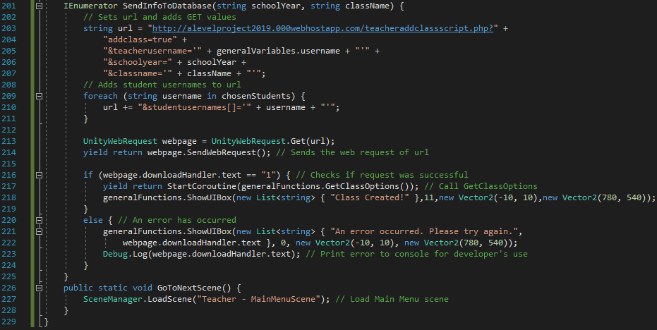

Figure 191 - Code for SendInfoToDatabase, GoToNextScene and end of script

*SendInfoToDatabase* does a very similar job to its respective function in other scripts. It simply sends the request to a PHP script and ensures the response from the PHP script is correct. First, it defines the request URL and adds the user’s inputs to it as GET requests. It then iterates through the chosen students, adding each of them to the URL and combining to make a list of students in the URL. The request is then sent to the PHP script and a value is returned. If the response is ‘1’ then the request was successful. In that case, the program will call *GetClassOptions* (since the classes of the user has now changed), wait for a response before a success UI box is shown. If there’s an error however (indicated by any response other than ‘1’), then an error box is shown and the specific error message is shown to the user. The reason it’s shown to the user is because there is a potential error which may occur which I have coded for in the PHP script and this will need to be shown to the user in the form of an error message.

When the user clicks on the success box, *GoToNextScene* is called (the relevant lines for this script have been added to the *functionsToCall* list). This simply loads the Teacher Main Menu scene since that seems the most logical scene to go back to after having made the class.

#### PHP – TeacherAddClassScript

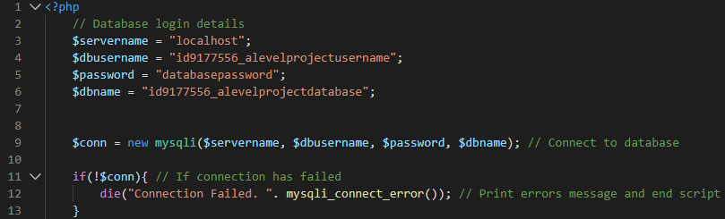

Figure 192 - Code for beginning of teacheraddclassscript

First, as with all of my PHP scripts (excluding *CheckInternetConnection* for obvious reasons), the database login details are defined and the script connects to the database. Again, as per usual, if the connection has failed then an error message appears and the script ends.

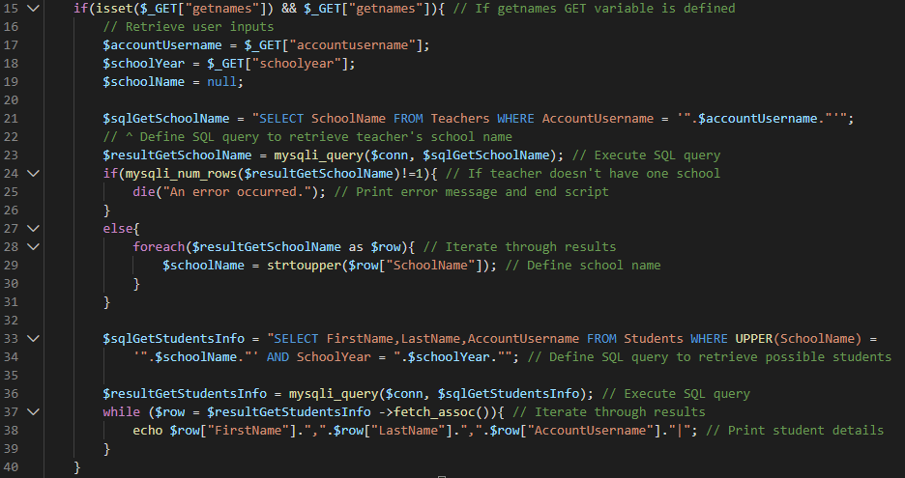

Figure 193 - Code for getnames section

If the GET variable *getnames* is defined in the URL, then the inner block of this if statement is executed. The purpose of this section is to retrieve all possible students given the teacher’s username and the inputted school year. First, the user inputs are retrieved. Then, an SQL query is executed to retrieve the name of the teacher’s school using their username. After that, another SQL query is executed, this time retrieving a list of students with the right attributes. I then iterate through these students and print them out in a friendly format (using ‘|’ to separate the students and ‘,’ to separate each variable for each student).

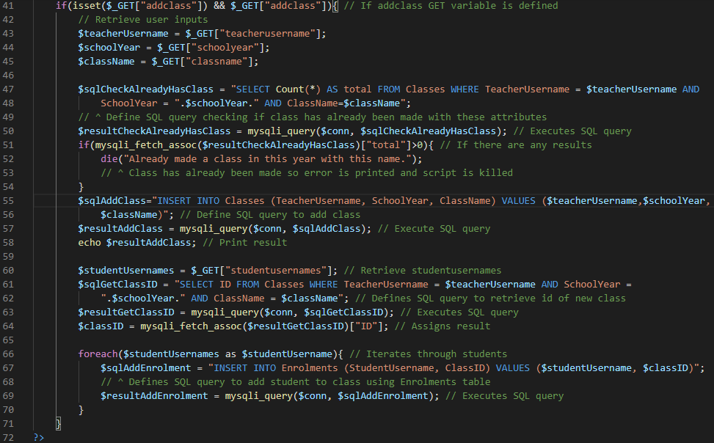

Figure 194 - Code for addclass section and end of script

If the GET variable *addclass* is defined, then the submit button has been clicked, the inputs have been deemed valid and the new class needs to now be added to the database. First, the user inputs are retrieved. Then, I define and execute an SQL query which checks if a class has already been made by the same teacher with the same class name and school year. If that’s the case, then an error message will show saying a class with the same attributes has already been created and the script will end. If that’s not the case, then lines 55-57 define and execute the SQL query which actually adds the class to the *Classes* table.

However, that’s not the end of the script because each student needs to be individually added to the class by creating a connection in the *Enrolments* table. First, the ID of the new class needs to be found. That’s done by using another SQL query (lines 61-64) to retrieve the ID of the row with the user-inputted data. Then, I iterate through the list of students which are to be added to the class (as given in the GET variable *studentUsernames*), defining and executing a new SQL query for each one which creates a new row in *Enrolments* with the student username and the new class ID as the values.

#### Testing

As with previous scripts, when I test a certain aspect of the scene, it will be supplemented by valid inputs in all other places to ensure any effects are caused by the one feature I’m testing.

|  |  |  |  |
| --- | --- | --- | --- |
| General Tests | | | |
| Test | **Expected Output** | **Output** | **Correct?** |
| Retest. Enter scene from Main Menu | Scene opens | Scene opens without errors | Yes |
| N/A | All UI looks correct and in right place |  | Yes |
| Click back button | Goes to Teacher Main Menu scene | Scene changes to Teacher Main Menu scene | Yes |
| Click Add Class button | Submits class |  | Yes |
| Click success UI box | Goes to Teacher Main Menu scene | Scene changes to Teacher Main Menu scene | Yes |

|  |  |  |  |
| --- | --- | --- | --- |
| Input Field #1 (School Year) | | | |
| Test | **Expected Output** | **Output** | **Correct?** |
| Empty string | Error message when clicked out of input field |  | Yes |
| String of letters | User shouldn’t be able to enter letters | I wasn’t able to enter any letters in the input field. | Yes |
| String of digits | No error – should generate left-hand panel properly |  | Yes |
| Alphanumeric string | User should only be able to type the integer parts of the string | Only the integer parts of the string entered was permitted and was typed on the input field. | Yes |
| Symbols | Symbols shouldn’t be permitted by input field | Symbols weren’t permitted and didn’t show in the input field. | Yes |
| Function keys | Symbols shouldn’t be permitted by input field (other than the effects of the keys mentioned in earlier tests) | Symbols didn’t have any effect on the input field. | Yes |

|  |  |  |  |
| --- | --- | --- | --- |
| Input Field #2 (Class Name) | | | |
| Test | **Expected Output** | **Output** | **Correct?** |
| Empty string | Error message when submitted |  | Yes |
| String of letters | No error – should attempt to create class when submitted | No error message appeared. Class was created when the submit button was clicked. | Yes |
| String of digits | No error – should attempt to create class when submitted | No error message appeared. Class was created when the submit button was clicked. | Yes |
| Multi-word string | No error – should attempt to create class when submitted | I wasn’t able to enter the space into the input field.  “New Class” was entered into the input field as “NewClass” | No. (Error #1) |
| Alphanumeric string | No error – should attempt login when submitted | No error message appeared. Class was created when the submit button was clicked. | Yes |
| Symbols | Symbols shouldn’t be permitted by input field | I wasn’t able to enter symbols into the input field. | Yes |
| Function keys | Symbols shouldn’t be permitted by input field (other than the effects of the keys mentioned in earlier tests) | No effect on input field when function keys were typed. | Yes |

|  |  |  |  |
| --- | --- | --- | --- |
| Input Field #3 (Student Name) | | | |
| Test | **Expected Output** | **Output** | **Correct?** |
| Empty string | Nothing should happen. Left-hand panel should show all name options. | Nothing happens. Left-hand panel shows all possible names. | Yes |
| String of letters | No error. Left-hand panel should only show names which the user input forms part of | Only names which my input formed part of came up as options. (This was updated after every key press.) | Yes |
| String of digits | Shouldn’t be permitted | I was unable to enter digits into the input field. | Yes |
| Multi-word string | No error. Left-hand panel should only show names which the user input forms part of | Works in the same way as the ‘String of letters’ test. Only names which included my input came up as options (where the space also had to be in the name). | Yes |
| Alphanumeric string | Only letters should show in input field. Left-hand panel should only show names which the user input forms part of | Only the letters were permitted in the input field. Then, the panel showed only the names that were part of the (letters-only) input. | Yes |
| Symbols | Shouldn’t be permitted | I was unable to enter symbols into the input field. | Yes |
| Function keys | Symbols shouldn’t be permitted by input field (other than the effects of the keys mentioned in earlier tests) | No effect on input field when function keys were typed. | Yes |

##### Error #1

The issue here is that the class name wasn’t permitting multiple words in its input field when there isn’t anything wrong with it. (In fact, it is probably preferable in most situations to have a space.) The problem was that in *contentTypes*, I set this input field as ‘Alphanumeric’ which means no spaces are permitted. Unfortunately, there are no settings which allows letters, spaces and digits but not symbols. So, I have switched the setting to ‘Standard’, which allows letters, digits, spaces and symbols. Then, in *ValidateInputs*, I have added a test to see if there are any symbols in the input, adding an error message if there is. The appended code to *ValidateInputs* is shown below:



Figure 195 - Appended code to ValidateInputs

If there are any characters in the input field which are not letters, digits or spaces, then the if statement will evaluate to true (since the ‘!’ is taken as the *NOT* logical operator). If that’s the case, then an error message is added to the list *errors*.

Since this solution to the problem has changed the whole mechanics of that input field, I will run all of the tests for that input field again (even the ones which succeeded).

|  |  |  |  |
| --- | --- | --- | --- |
| Input Field #2 (Class Name) | | | |
| Test | **Expected Output** | **Output** | **Correct?** |
| Empty string | Error message when submitted |  | Yes |
| String of letters | No error – should attempt to create class when submitted | No error message appeared. Class was created when the submit button was clicked. | Yes |
| String of digits | No error – should attempt to create class when submitted | No error message appeared. Class was created when the submit button was clicked. | Yes |
| Multi-word string | No error – should attempt to create class when submitted | No error message appeared. Class was created when the submit button was clicked. | Yes |
| Alphanumeric string | No error – should attempt login when submitted | No error message appeared. Class was created when the submit button was clicked. | Yes |
| Symbols | Symbols shouldn’t be permitted by input field | I wasn’t able to enter symbols into the input field. | Yes |
| Function keys | Symbols shouldn’t be permitted by input field (other than the effects of the keys mentioned in earlier tests) | No effect on input field when function keys were typed. | Yes |

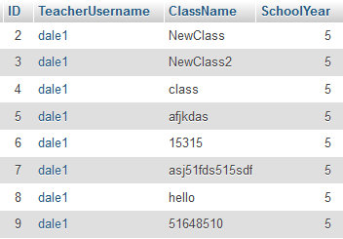

Figure 196 - Classes table in database

As shown in the image above, all of the classes have been added properly to the database[15].

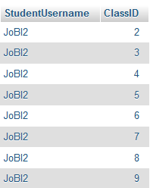

Figure 197 - Enrolments table in database

The above image shows that the Enrolments table also works properly. (The same student name is simply because I used the same student in my tests.) In addition to that, the fact that all of the input tests have passed and the classes and enrolments have been added successfully to the database, I can safely say that the PHP scripts are working properly.

#### Review

##### Content of Section

In this section, I have created the Add Class scene. This allows teachers to create classes and, crucially, add specific students to it. The selection can be done using the autocomplete feature or by using the drag-down on the panel.

##### Testing

The testing for this section came in two parts: general testing and testing of the input fields. The general testing consisted of things like checking and ensuring certain features were working like the back button, submit button etc. The input field tests involved similar things to previous scripts, with testing of different data types, using symbols or spaces etc.

##### Meeting Success Criteria

This section fulfils the criterion that students should be able to be added to classes (although the scene has been created from the point of view of a teacher adding the student to classes, not students adding themselves to classes). The idea of classes is fundamental in the program and it’s integral for features such as leaderboards (to know who students are competing against) and homeworks (to know which teacher is setting which homework for which students). Now, the basis for these features have been made with the creation of the Add Class scene.

##### Summary of the Program at this Stage

At this stage, both teachers and students are able to create accounts and log in to their accounts. Although students aren’t able to do more than that for now, teachers are also able to create classes and assign specific students to those classes.

##### Changes from Design

The only change from the design has come about from the error I discovered during the testing of the Class Name input field. To solve this, I had to change a small part of the C# script. Other than that, everything is the same as what was designed (especially the design of the page which I’ve left unchanged).

## Success Criteria Update

|  |
| --- |
| Success Criterion |
| A login system where people can either login as a student or a teacher. |
| The ability to create an account, either as a student or a teacher. |
| The student can be added to a class. |
| The student can play maths games. |
| The student’s score is displayed on a separate leaderboard for each class and each game. |
| The teachers and students can (only) view the leaderboards which apply to their account. |
| The teachers can set specific homeworks based on time spent on the program. |
| The teachers can view specific homeworks and see how much time each student has spent on it. |
| The students can view their current homeworks. |
| Simple and clear – it has a layout which is easy to understand and is pleasing to the eye. |
| Easily Navigated – it should be easy to move from scene to scene without being confused about how to reach a certain scene |
| Data is not lost when the user exits the program. The data and accounts are retrievable. |

At this stage, I am happy with the progress being made. Three of the success criteria have been completely fulfilled while three are criteria which are generic for the whole program (and have so far been fulfilled).

## Stakeholder Update

I have had a meeting with Mrs Mistry to show her the progress made so far. We have gone through each of the scenes created so far and she has given her opinions on each one. The meeting was recorded and a summary of what was said is displayed below.

### Stakeholder Update Interview

**Q:We have just looked at the Loading Scene as it progresses to the Start Scene. The aim of the Loading Scene is to download essential components of the program from the online server, which need to be downloaded before the program begins. What are your opinions of the scene?**

I don’t fully understand what data it is that is being downloaded by I’m sure it is necessary. Although the scene is very bare with just one piece of text, I don’t think it needs any changing because it quickly moves to the start menu anyway. I also really like the fact that the full stops increase in number to make it feel more like an animation.

**Q: The Start Scene is a simple menu with a title, a few images and a few buttons to indicate where to go next. Are you happy with the current design?**

Yes. This looks very similar to the design we agreed on during the design process and I’m happy with the images chosen and the colour scheme selected.

**Q: Looking at the Create Account Scene, I have a few questions. First, are you happy with the layout and functionality of it all. Second, do you feel there are any more pieces of information which should be entered in order to create an account?**

I’m happy with the layout as it follows the design we’ve agreed on. The functionality also looks good but I would just ask that you move the message saying ‘>= 8 characters’ from the placeholder to the heading on the left of the box. Also, it would be nice if you could replace ‘>=’ with ‘ $≥$’ as that would look nicer. In terms of extra pieces of information, I don’t think the user would need to enter anything else.

**Q: On the Login Scene, is there anything you wish to comment on? It is a fairly basic scene so I have just incorporated the aspects we talked about previously.**

As you said, there isn’t much going on in this scene and it all seems fine so I wouldn’t wish to change anything.

**Q: Is there anything with the Teacher Main Menu Scene that you would like changed?**

No, it’s a very simple scene and I don’t see the need to change anything.

**Q: Looking at the Add Class Scene now, this is a lot more complicated than the scenes we’ve looked at so far. What are your opinions of the scene and is there anything you would want me to change about it?**

First, I really like the auto-complete feature that you have with the students. The rest of the scene looks good but I would ask if it is possible to upload a document with a list of all students I want to add and have the program automatically add students to the class from that document.

**Q: Thank you for our meeting. Are there any other comments you wish to make about the program so far?**

No, the program looks like it’s coming around quite nicely. I look forward to meeting you again to discuss more of it.

### Response to Stakeholder Update Interview

Mrs Mistry was happy with most of the program so far but requested two changes: one in the Create Account Scene and one in the Add Class Scene. I have talked to her in response to her request to use a documented list and have explained that there are certain issues with this idea that I don’t think can be resolved. The issues involve the program not necessarily knowing whether the account with a certain name reflects the person from the document. They may have the same name but that doesn’t mean they’re the same person. In my database, the primary key for students is their username which wouldn’t be known by the teachers so can’t be put in the database anyway. At the end of our conversation, my stakeholder accepted that this change would not be possible.

For the change to Create Account script, it is entirely feasible so I have made these changes. First, I have moved the text ‘(>= 8 letters)’ from the fourth string in *placeholderValues* to the fourth string in *textValues*. Since that text is now quite large, a few changes have to be made to the heading on the left side of the input fields. First, the x-coordinate of the headings have been switched from $-300$ to $-350$. I have also changed the size of the text objects in the x direction from $325$ to $400$. In addition, I have changed ‘>=’ to the Unicode equivalent which will express it as ‘ $≥$’ in the program. The final change I have had to make is the font size; I have set *bestFit* to *true* which will allow all of the password heading to show properly.

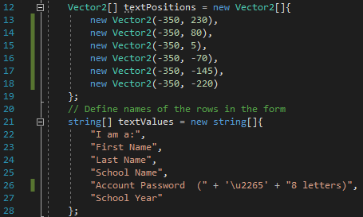

Figure 198 - Updated definitions for textPositions and textValues

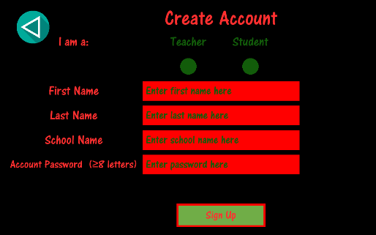

Figure 199 - New layout for Create Account Scene

Above is the new layout for the Create Account Scene. I have shown this to my stakeholder and Mrs Mistry has replied saying that she is happy with the changes made. I will now continue the development of the program, in the order stated in the ‘Order of Development’ section.

## Stage #10 – Student Main Menu Scene

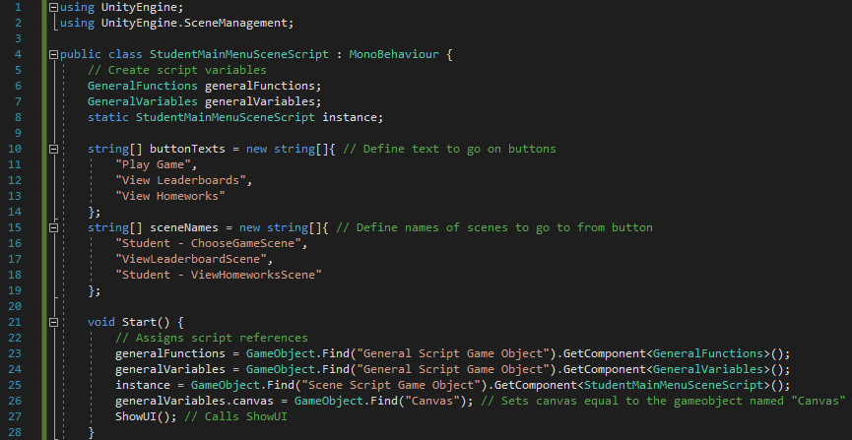

Figure 200 - Code for beginning of StudentMainMenuSceneScript and Start function

The script begins in the usual way, by importing used modules and defining the variables. In this script, as well as the usual script variables, I have defined two arrays: *buttonTexts* and *sceneNames*. *buttonTexts* defines the text which should be show in each button and *sceneNames* defines which scene each button should lead to. The *Start* function, called automatically by Unity3D upon loading the script, assigns the scripts and canvas (in the usual way) before calling *ShowUI*.

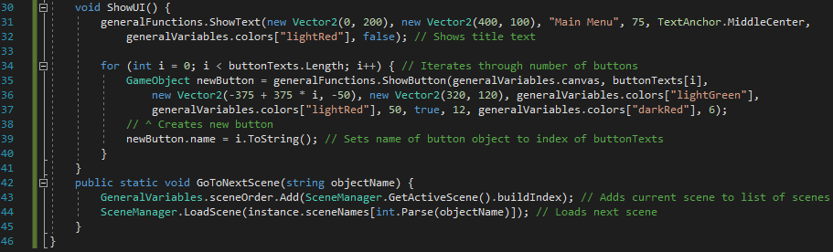

Figure 201 - Code for ShowUI, GoToNextScene and end of script

*ShowUI*, as is its purpose in all scripts in the program, displays all of the UI elements in the scene. It first shows the title text before iterating through the values in the array *buttonTexts* and assigning the object’s name to the button’s index in *buttonTexts*. The reason for this is so that, when the button is clicked, I can tell which scene the button is mean to go to.

*GoToNextScene* is called when one of the buttons is clicked (the relevant line has been added to the *functionsToCall* list in *GeneralFunctions*). First, the current scene is added to the list of scenes (for use with back buttons) before the new scene is loaded. As explained above, the scene that is loaded is determined by the name of the button object (when cast to an integer).

#### Testing

There isn’t a lot that needs to be tested in this section. The only things that need to be tested are that the UI elements appear correctly and that the clicking on the buttons has the expected effect.

|  |  |  |
| --- | --- | --- |
| Expected Feature | Output | Correct? |
| Retest – Running program to see if the Main Menu scene now loads after login/create account. | Loads Student Main Menu scene | Yes |
| Title text appears with correct attributes |  | Yes |
| Buttons appear with correct position, size, colour, text etc. |  | Yes |
| Buttons run correct response when clicked on (errors saying the scenes haven’t been created yet) |  | Yes. This console response is a result of me clicking the three buttons in order from left to right. |

All of these tests have passed so I’m happy to move on to the next section as I’m satisfied with the result of this section.

#### Review

##### Content of Section

In this section, I have created the main menu for student users. They will have the option to play a game, view various leaderboards for their classes or view their outstanding homeworks.

##### Testing

Testing, as explained above, was fairly short for this section given the limited content. However, all of the UI was checked and the effect of clicking the buttons was tested to make sure they linked to the right scenes. (Although they gave an error, it was expected and the specific error it gave shows that the buttons will link to the right scenes once those scenes are created.)

##### Meeting Success Criteria

As with other menu scenes, this section helps with fulfilling the success criterion that the program should be easily navigable for the user. This scene provides the student user with three distinct possibilities and it is easy for the user to understand where to go next.

##### Summary of the Program at this Stage

At this stage, both students and teachers are able to create accounts and log in to their accounts, in addition to accessing their respective main menus. As well as that, teachers are able to create classes and add students to those classes.

##### Changes from Design

The only change from the design is with the sequence-based positioning of the buttons which I have added whereas they were previously positioned using an array of Vector2s unnecessarily. Other than that, this section follows its page design and algorithm design.

## Stage #11 – Student Choose Game Scene

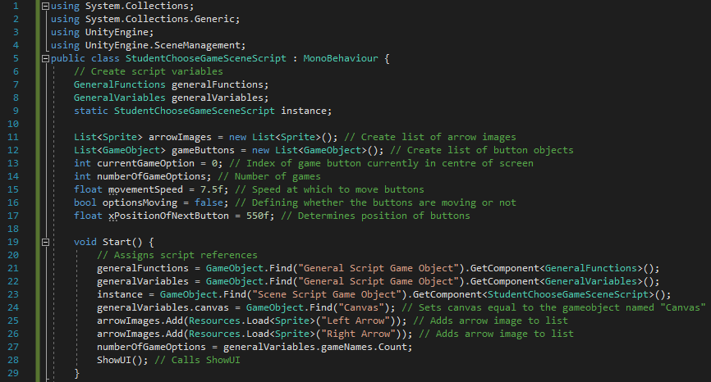

Figure 202 - Code for beginning of StudentChooseGameSceneScript and Start function

First, the required modules are imported and the general scripts are defined. Then lists for the arrow images and for the button GameObjects are defined. After that, a series of variables are defined which help with the movement of the buttons. These are: *currentGameOption* (defining which game option is currently in the centre of the screen), *numberOfGameOptions* (defining the number of games there are[16]), *movementSpeed* (multiplier to help adjust how quickly the buttons move), *optionsMoving* (Boolean value defining whether the buttons are currently moving or not) and *xPositionOfNextButton* (defining where the outer buttons need to be placed). The *Start* function assigns the script references and canvas in addition to loading and appending the arrow images to *arrowImages* before assigning a value to *numberOfGameOptions* and calling *ShowUI*.

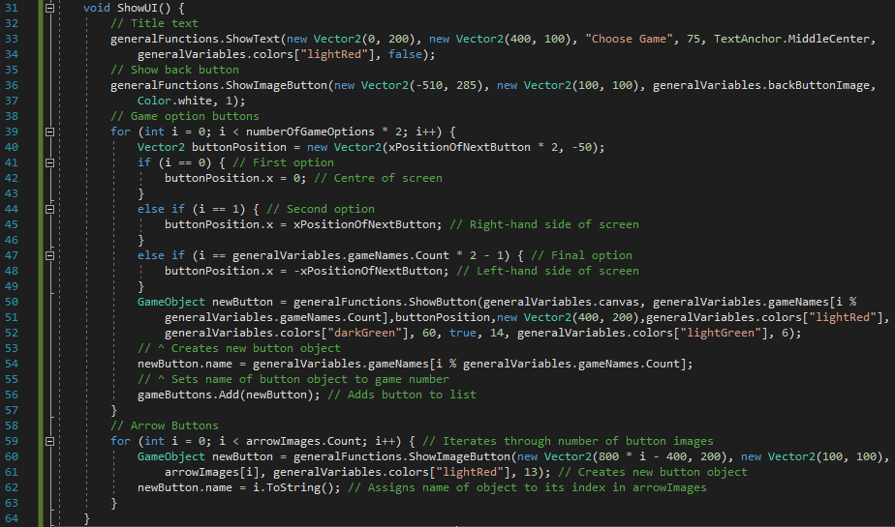

Figure 203 - Code for ShowUI

*ShowUI* first shows the title text and the back button in the usual way. It then iterates through twice the number of games[17] and creates a new button for each one. As default, the first game option will be in the centre of the screen, the first option will be on the right-hand side and the final option will be on the left-hand side. The buttons are then added to the list of button objects. Finally, I iterate through the list of arrowImages and display each one as a button.

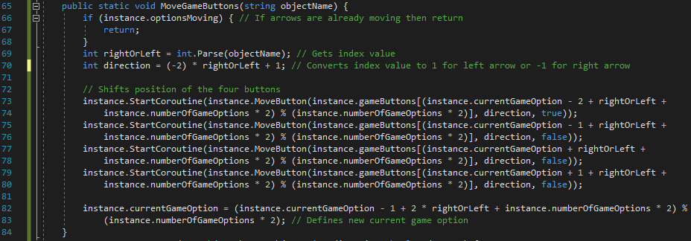

Figure 204 - Code for MoveGameOptions

First, if the buttons are already moving, then executing this function is going to cause problems because variables will be overwriting themselves. Therefore, if the buttons are moving, I end the function. I then define two variables: *rightOrLeft* is the name of the GameObject when integer-casted (0 for left arrow and 1 for right arrow) and *direction* is the short arithmetic manipulation of *rightOrLeft* which will leave the variable as either 1 (for left arrow) or -1 (for right arrow). This is a better form for the directions since I can now just multiply the translation by *direction* which will automatically make the buttons move the way I want it to (without having to write the code twice, once for each direction). Then, for each of the four buttons which need to be moved, *MoveButton* is called taking in the button object, its direction and whether it’s the final button or not as arguments. Finally, *currentGameOption* is redefined as the new button in the centre of the screen.

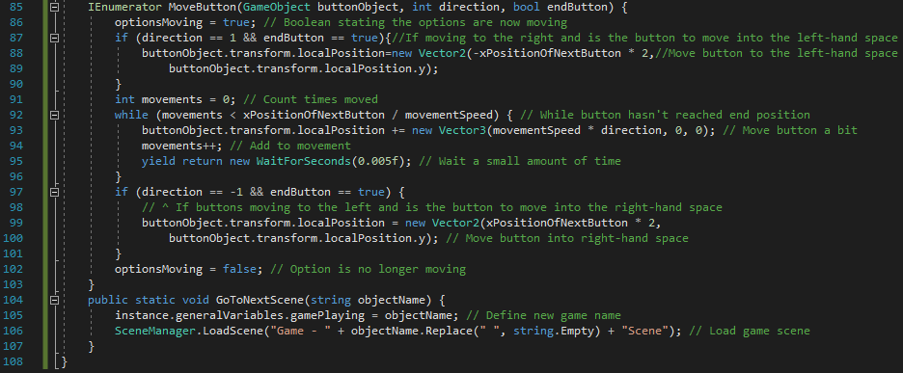

Figure 205 - Code for MoveButton, GoToNextScene and end of script

First, the variable *optionsMoving* is set to *true* so that the buttons can’t be made to move whilst they’re already moving. Then, if the buttons are moving to the right (when the left arrow is clicked) and the button defined is the final button, then it is moved to beyond the left-hand side of the screen so that it can move to the right towards the left-hand side of the screen. Then, a while loop continuously moves the button object in the right direction until it reaches its final position (which will be *xPositionOfNextButton* further in a certain direction than its original position). Finally, similar to before, if the buttons are moving to the left (when the right arrow is clicked) and the button defined is the final button, then it is moved to beyond the right-hand side of the screen so that it can move to the left towards the right-hand side of the screen. Last, *optionsMoving* is set to *false* so that the buttons can move once more.

When one of the buttons is selected, *GoToNextScene* is called. First, the game that is about to be loaded is set as the value of *gamePlaying* in *generalVariables*. Then, the new game scene is loaded where the name of the scene is laid out in the form written on line 186.

#### Testing

|  |  |  |  |
| --- | --- | --- | --- |
| Test | Expected Output | Output | Correct? |
| Retest from previous scene. Enter scene from student main menu | Scene should load | The scene loaded successfully and as expected. | Yes |
| N/A | All UI elements in right place with right attributes |  | Yes |
| Click back button | Student Main Menu scene should load | Program moves to Student Main Menu scene | Yes |
| Click right arrow (after loading the scene) | All buttons should shift to the left. ‘Algebra Millionaire’ should now appear on the right |  | Yes |
| Click left arrow (after loading the scene) | All buttons should shift to the right. ‘Speed maths’ should now appear on the left |  | Yes |
| Click ‘Linear Spaceship Wars’ button when in centre of screen | Error saying ‘Linear Spaceship Wars’ game scene not created |  | Yes |
| Click ‘Linear Spaceship Wars’ button when in side of screen | Error saying ‘Linear Spaceship Wars’ game scene not created |  | Yes |
| Click ‘Speed Maths’ button when in centre of screen | Error saying ‘Speed Maths’ game scene not created |  | Yes |
| Click ‘Speed Maths’ button when in side of screen | Error saying ‘Speed Maths’ game scene not created |  | Yes |
| Click ‘Algebra Millionaire’ button when in centre of screen | Error saying ‘Algebra Millionaire’ game scene not created |  | Yes |
| Click ‘Algebra Millionaire’ button when in side of screen | Error saying ‘Algebra Millionaire’ game scene not created |  | Yes |

From the above tests, I am happy with this scene and will move onto a review of the section before moving onto the next section.

#### Review

##### Content of Section

This section involved the creation of the Choose Game scene and *StudentChooseGameSceneScript*. It allows student users to pick a game and move on to actually play the game. As opposed to having a simple list of games to choose from, I have opted for a more interactive, more dynamic conveyor-belt system, where the user can move across the options like a roulette wheel turns. Using the ‘modulo’ function in my code has allowed me to return the list back to the beginning once the user reaches the last item.

##### Testing

In terms of testing, this section has a limited number of factors with regards to user input. Other than checking that the UI elements are in their correct places with right attributes (size, colour etc), I have tested that the back button works and that all of the buttons to play a new game have the expected outcome by providing an error saying the game scene hasn’t been created yet.

##### Meeting Success Criteria

This scene performs the basis of fulfilling the success criterion that the user should be able to play games since this section provides the options of which game to play.

##### Summary of the Program at this Stage

At this stage, both students and teachers are able to create account, log in to their accounts and access their respective main menus. Teachers are also able to add new classes and students are able to reach *Student Choose Game Scene* at which point they decide which game to play.

##### Changes from Design

In this section, I haven’t drifted away from neither the page design nor the algorithm design.

## Stage #12 – General Game Script

The *GeneralGameScript* is, as shown in my algorithm design, going to include functions which are going to be used in all of my games. Those, for now[18], are starting (and running) a countdown and the *EndGame* function, in addition to keeping the score and timer GameObject variables.

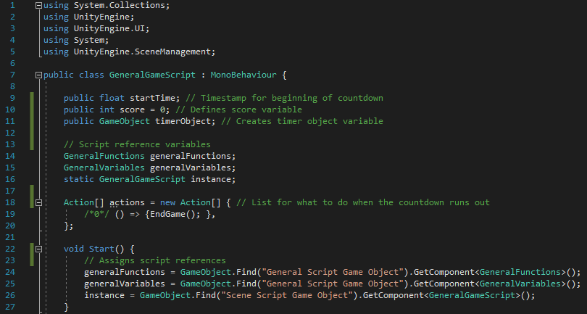

Figure 206 - Code for beginning of GeneralGameScript, Start and ShowUI functions

First, the global variables are defined. As well as the usual script reference variables, I have variables defining the start time of the countdown, the current user score of the game and a reference to the timer object shown on the screen. In addition to that, at the end of the countdown, there are different things which might happen so I have created an array of actions (using the same idea as *functionsToCall* in *GeneralFunctions*) where one of those actions will be called when the countdown reaches zero. The *Start* function, automatically called once the script loads, simply assigns the script references. It doesn’t call any functions because the other functions in this script will be called from each specific game script when required.

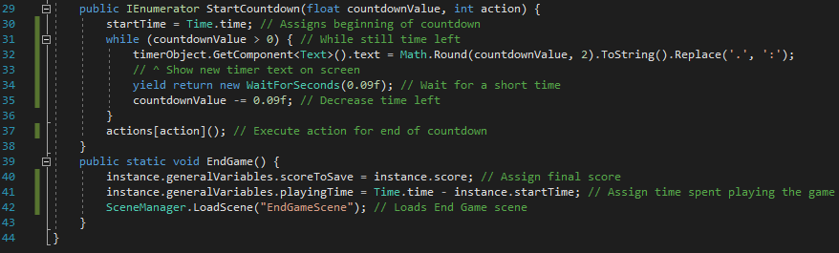

Figure 207 - Code for StartCountdown, EndGame and end of script

There are two functions, that I can think of at the moment, which will be useful in most (if not all) of the games designed. These are *StartCountdown* and *EndGame*. *StartCountdown* runs a countdown for the game (or one round of the game in the case of ‘Algebra Millionaire’). First, it assigns a start time (by taking the value built-in to Unity3D called *Time.time*) and uses the parameter *countdownValue* to define how much time is left on the countdown (the value initially passed as an argument is how the long the countdown should last). I have then used a while loop to iteratively update the timer object, wait for a short period of time and decrease the amount of time left (by decreasing *countdownValue*) until *countdownValue* is not greater than 0 (at which point the countdown is over). When the countdown finishes, one of the values from *actions* will be executed. The index of the list used is passed as an argument to the function (the integer parameter, *action*).

One of the possible outcomes of the countdown finishing is that the user’s game has now ended. If that’s the case then *EndGame* will be called (as shown in the zeroth index of *actions*). The function stores the user’s score and the length of time they spent playing before loading the End Game scene.

#### Testing

Testing for this section is fairly difficult, given I haven’t made any games yet, and these functions are all used in games. What I have done is made a new scene called ‘Test Scene’, set it up in the usual way (by adding ‘Scene Script Game Object’, ‘General Script Game Object’, ‘Main Camera’, ‘Canvas’ and ‘EventSystem’) and added *GeneralGameScript* to ‘Scene Script Game Object’. In *GeneralGameScript*, I have created a new function called *RunTests* (as shown below) which is called at the end of the *Start* function. It first assigns the *canvas* variable before creating a new timer (by creating a text object) and calling *StartCountdown*. There is no explicit test for *EndGame* because I am calling *StartCountdown* with the argument *action* being 0, meaning *EndGame* should be called at the end of the countdown. That way, both functions are fully tested through one test. I also haven’t tested *score* and *instance* but, since they are variables, I can assume they will work.

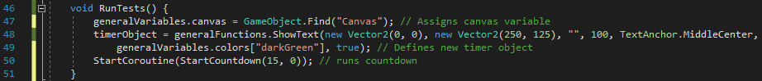

Figure 208 - Code for RunTests

|  |  |  |
| --- | --- | --- |
| Expected Output | Output | Correct? |
| Timer object shows (with right attributes) |  | Yes |
| Timer object decreases (along with real time) |  | Yes |
| Timer object stops decreasing when it reaches zero |  | Yes[19]. |
| Error message saying ‘End Scene not created’ when timer object reaches zero |  | Yes |

All of the tests have passed so I’m happy with this script and will now review it before moving on to the next section.

#### Review

##### Content of Section

In this section, I have created the *GeneralGameScript* which is similar to *GeneralFunctions* but specifically for the game scenes. It contains functions (two for now) which are going to be used in most, if not all, of the games and so should be developed once and called from all game scenes.

##### Testing

The testing for this section consisted of creating a test scene, test function in *GeneralGameScript* and running a timer. I then checked to make sure everything outputted was as expected.

##### Meeting Success Criteria

As with Student Choose Game Scene, this script doesn’t do anything o explicitly fulfil any of the success criteria. However, *GeneralGameScript* plays an important role in all of the games and so this section helps to fulfil the criterion that the students are able to play the games.

##### Summary of the Program at this Stage

At this stage, nothing has changed in terms of what the user can do since the last section. As with before, both teachers and students can create accounts, login and access their respective main menus whilst teachers can add classes and students can choose a game (but not yet play them).

##### Changes from Design

No changes have been made from the design (except that the variable for the countdown timer is passed as an argument to the function rather than set inside the function).

## Stage #13 – Linear Spaceship Wars Scene

In this section, I will create the first of the games. ‘Linear Spaceship Wars’ will involve the user inputting gradients and y-intercepts which will be the equation of a laser which is meant to be aimed at enemy spaceships (full details of which were written in the design of this scene).

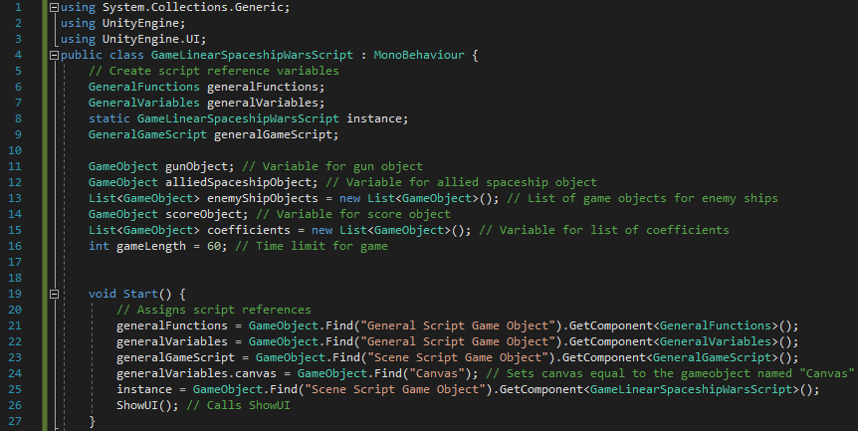

Figure 209 - Code for beginning of script and Start

The script begins by defining all of the variables required for the game to run. Of course, there are the script reference variables (which includes *GeneralGameScript*). In addition, there is the GameObject *gunObject* (storing the gun object), *alliedSpaceshipObject* (storing the object for the allied spaceship), *enemyShipObjects* (a list of objects storing the enemy ships), *scoreObject* (storing the text object showing the user’s score), *coefficients* (storing the objects which hold the input fields for the equation coefficients) and *gameLength* (defining how long the game should last, in seconds). The *Start* function simply does its usual job of assigning all of the script references and the canvas before calling *ShowUI*.

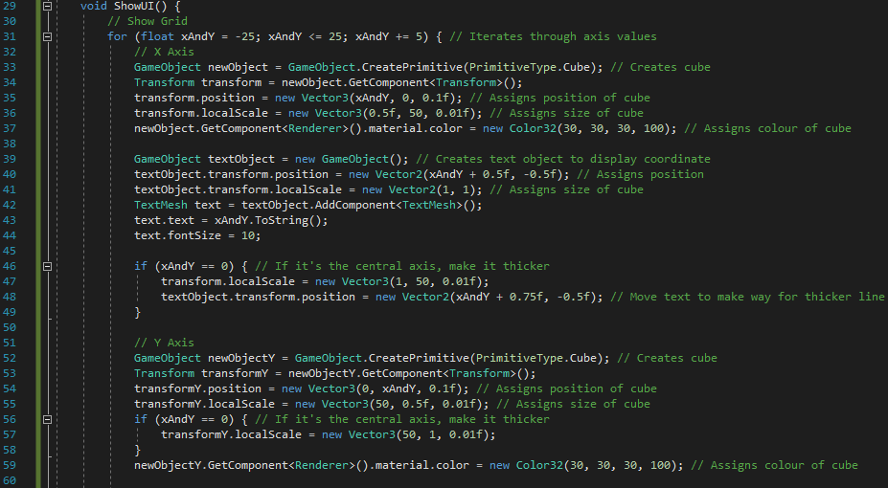

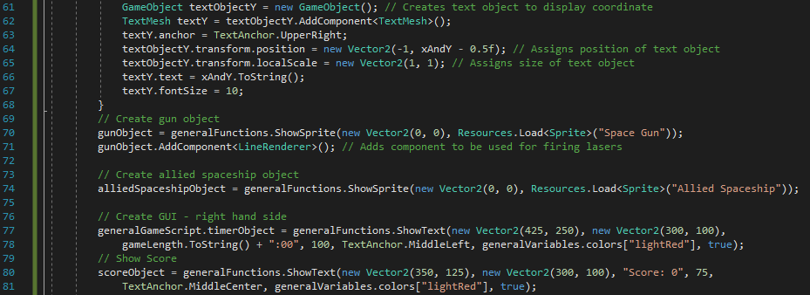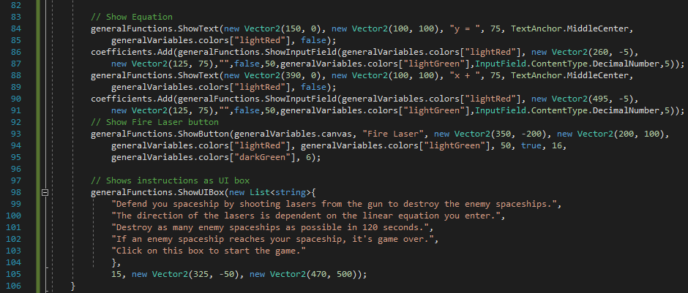

Figure 210 - Code for ShowUI

The *ShowUI* function is fairly long, as shown in the images above, because there is a lot of setting up required in this scene. First, the grid is created[20]. The gridlines will be at five-unit intervals from each other (between -25 and 25 on each axis), so I first iterate between -25 and 25 going up by five each iteration. In each iteration, a new Cube object is created (3d object as opposed to the 2d UI elements)[21] for a constant x-position. I then create the text object (which again is 3D instead of part of the UI), which shows the co-ordinate of that line along the x-axis. Lines 46-49 then check if the gridline being drawn is the y-axis. If it is, then the gridline is made slightly thicker (to indicate a major axis) and the text is shifted slightly to make way for the extra thickness of the line. Lines 51-67 then run the same code but with keeping the y-position constant (creating perpendicular lines to the first set).

After the grid, the gun and allied spaceship objects are created, in addition to the timer object and score object. Lines 84-91 create the equation. The reason why it takes so many lines is because it involves two text objects and two input fields (for the gradient and y-intercept). Finally, I create the button to fire the laser and show the instructions in the form of a UI box.

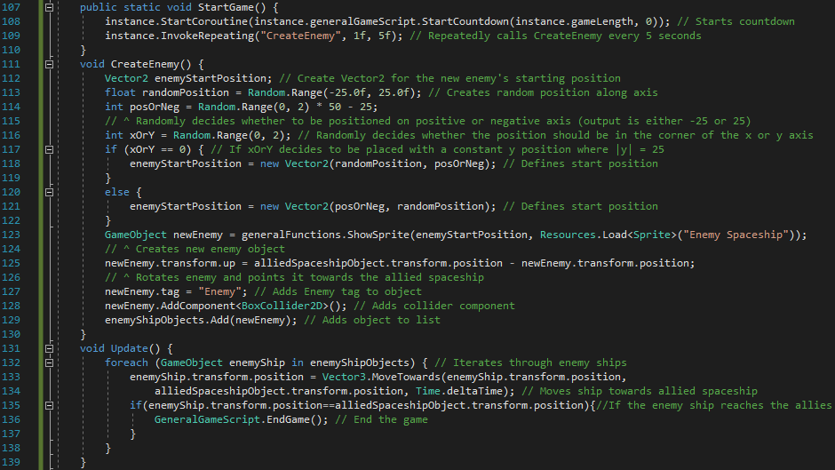

Figure 211 - Code for StartGame, CreateEnemy and Update

*StartGame* is the function that is called when the student clicks on the instructions (to say they have finished reading them and are ready to start playing). The function calls two functions. First, it calls *StartCountdown*, which starts running the countdown and the timer object will start to decrease on the screen. Second, *CreateEnemy* is repeatedly called every five seconds (except the first call which will occur after one second).

*CreateEnemy* is the function that creates a new enemy ship that the user needs to try and destroy. It first creates a Vector2 (so it can be defined later) and generates three random numbers. The first (*randomPosition*) defines where along the side-length of a square the new enemy should be placed. The second (*posOrNeg*) defines whether the new enemy should be positioned on the positive or negative axis and the third (*xOrY*) defines whether the new enemy should be positioned on the right or left-hand sides or the top or bottom sides of the square. After deciding on the enemy’s position, I create the sprite and rotate the object towards the allied spaceship (this adds to the idea that the enemy ships are going towards the allied spaceship). Finally, I add the ‘Enemy’ tag to the object (so it can be easily identified as an enemy), add a *BoxCollider2D* component (which will allow collisions to work with it) and add the new enemy object to the list of enemy objects, *enemyShipObjects*.

The *Update* function is similar to *Start* in the sense that it is automatically called in Unity3D. The difference being that *Start* is executed upon loading the script whereas *Update* is executed every frame. The function is used in this script to continuously move each of the enemy ships a little bit closer to the allied spaceship. It begins by iterating through the list of enemy spaceship objects. In each iteration it uses a Unity3D function called *MoveTowards* to make the enemy ship move towards the allied spaceship by a small amount. I then check if the enemy ship and allied ship have the same position. If that’s the case then the two ships have collided, meaning the enemy ship has attacked the allied spaceship and the user has lost the game. Therefore, if the if statement is *true*, then *EndGame* is called.

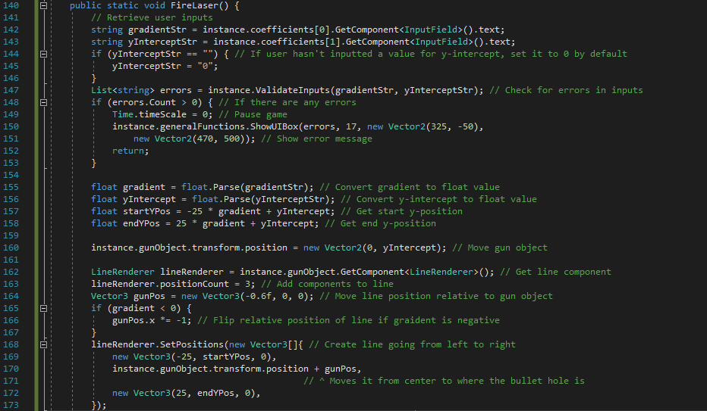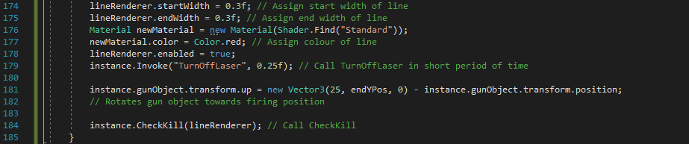

Figure 212 - Code for FireLaser

The *FireLaser* function will visually fire a laser from the gun object in a linear line in the direction dictated by the user’s inputted equation. First, the user’s inputs are retrieved from their text objects and, if the y-intercept value is not set by the user, then it is automatically set by default to 0. I then call *ValidateInputs*, sending it the user inputs as arguments. If there are any errors, then the game is paused (using *Time.timeScale=0*) and an error message is shown. If there are no errors, the line is created. This is done by first defining certain pieces of information about the line which can be gathered from the user inputs (lines 155-158) before adding a *LineRenderer* component to the gun object. Lines 168-173 define three points along the line which is enough to create an accurate linear line. Lines 174-178 define attributes related to the line, such as the width and colour of the line. The gun object is then rotated in the direction of the line, *TurnOffLaser* is invoked after a quarter of a second, and *CheckKill* is called.

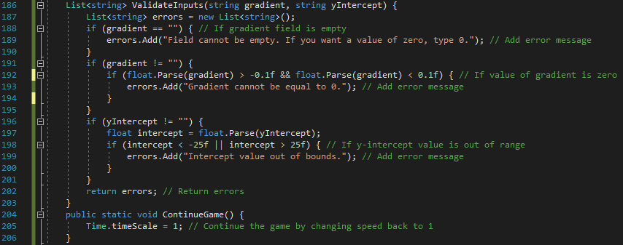

Figure 213 - Code for ValidateInputs

*ValidateInputs* has the same function as in other scripts – to check that all of the user inputs follow the correct format. In this game, the gradient field cannot be left empty so its value is checked. The gradient’s absolute (positive) value cannot be less than 0.1. The reason for this is that it becomes a very easy game as you can just move the y-intercept to the right place and add a gradient of 0. Therefore, I have checked for small gradients and invalidated them. Finally, the y-intercept’s absolute value cannot be greater than 25. If that was the case, then the gun object would be off the screen and I don’t want that to be possible so I’m invalidating those values as well. I then return the list of error messages.

If there’s an error, then an error message shows and the game is paused. When the error message is clicked on, *ContinueGame* will be called, which reverts the game speed back to 1, making the game continue.

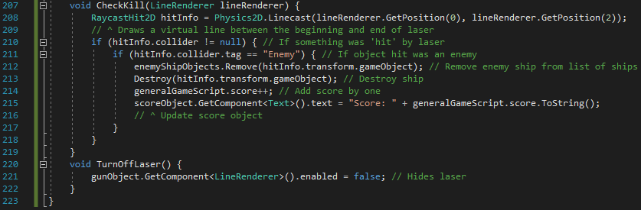

Figure 214 - Code for CheckKill and TurnOffLaser

*CheckKill* is called from *FireLaser* and checks if the laser that is shot collides with any of the enemy ships. It does this using Unity3D functions called *LineCast* and *Raycast*. These two functions draw a virtual line (which follows the same path as the laser line) and checks what it collides with respectively. I then check if the line has collided with an object and, if it is, I check if the object hit by the line is an enemy. If an enemy is hit, I remove the enemy from the list of enemy ships, destroy the enemy ship object, increment the user’s score by one and updates the score object on the screen to display the new score. If the line either doesn’t hit any object or hits an object that isn’t an enemy, nothing will happen because the laser should only have an effect on enemy objects.

When the user fires the laser, it’s only a short burst so it needs to be turned off after a small amount of time. Line 179 invokes *TurnOffLaser* a quarter of a second after the laser is created. The function simply disables the *LineRenderer* component of the gun object using the attribute *enabled*.

#### Testing

|  |  |  |  |
| --- | --- | --- | --- |
| General Tests | | | |
| Test | **Expected Output** | **Output (only relevant parts of screen have been screenshotted)** | **Correct?** |
| Retest from Student Choose Game Scene | Game scene loads |  | Yes |
| N/A | Gridlines in correct place |  | Yes |
| N/A | X-axis and Y-axis gridlines are thicker than the others | Shown in above image | Yes |
| N/A | Timer object shows correctly |  | No. (Error #1) |
| N/A | Instructions show correctly |  | Yes |
| N/A | Gun object and allied spaceship show |  | Yes. They are overlapping because they are both set to (0,0) by default. |
| Click on instructions box | Instructions box disappears and game begins |  | Yes |
| N/A | Score object appears with right attributes | Shown in image above | Yes |
| N/A | Equation objects appear with right attributes | Shown in image above | Yes |
| N/A | ‘Fire Laser’ button appears with right attributes | Shown in image above | Yes |

|  |  |  |  |
| --- | --- | --- | --- |
| Gameplay Tests | | | |
| Test | **Expected Output** | **Output (only relevant parts of screen have been screenshotted)** | **Correct?** |
| N/A | Enemy objects appear every five seconds (except first one which should appear after one second) |  | Yes. First one appeared with 59 seconds to go and second one appeared with 54 seconds to go. |
| Click ‘Fire Laser’ button (with valid inputs) | 1. Gun object moves to y-intercept 2. Laser is fired from gun object 3. Laser fired with right equation 4. Laser disappears after a quarter of a second. | 1 second later: | Yes. I was unable to screenshot the program twice in such a short space of time but it did disappear after 0.25 seconds. |
| Click ‘Fire Laser’ button with inputs which should hit an enemy | 1. Enemy ship disappears 2. Score object increases value by 1 |  | Yes |
| Enemy ship reaches allied spaceship | Error saying End Game Scene not created yet |  | Yes. The error occurred many times because the moving to the End Game Scene was called every frame in *Update*. This isn’t an issue as it will only be called once when the new scene is made. |
| Time runs out | Error saying End Game Scene not created yet |  | Yes |

|  |  |  |  |
| --- | --- | --- | --- |
| Input Field #1 (Gradient) | | | |
| Test | **Expected Output** | **Output** | **Correct?** |
| Empty string | Error message when ‘Fire Laser’ is clicked |  | Yes |
| String of letters | User shouldn’t be able to enter letters | I was unable to enter letters | Yes |
| Float where $gradient<-0.1$ | No error – should fire laser when button is clicked |  | Yes |
| Float where $-0.1< gradient<0$ | Error message when ‘Fire Laser’ is clicked. Timer pauses |  | Yes |
| Float where $0<gradient<0.1$ | Error message when ‘Fire Laser’ is clicked. Timer pauses |  | Yes |
| Float where $gradient>0.1$ | No error – should fire laser when button is clicked |  | Yes |
| Symbols | Symbols shouldn’t be permitted by input field | Symbols were not permitted by the input field and couldn’t be entered. | Yes |
| Function keys | Symbols shouldn’t be permitted by input field (other than the effects of the keys mentioned in earlier tests) | Symbols didn’t have any effect on the input field. | Yes |

|  |  |  |  |
| --- | --- | --- | --- |
| Input Field #2 ($y-intercept$) | | | |
| Test | **Expected Output** | **Output** | **Correct?** |
| Empty string | No error – should fire laser when button is clicked with a $y-intercept$ of 0. |  | The gun object is at $(0,0)$ when firing the laser, as expected. |
| String of letters | User shouldn’t be able to enter letters | I was unable to enter letters. | Yes |
| Float | No error – should fire laser when button is clicked |  | Yes. The gun object moves to $(0, 7.2)$ as expected. |
| Symbols | Symbols shouldn’t be permitted by input field | I was unable to enter symbols into the input field. | Yes |
| Function keys | Symbols shouldn’t be permitted by input field (other than the effects of the keys mentioned in earlier tests) | Symbols didn’t have any effect on the input field. | Yes |

##### Error #1



Figure 215 - Erroneous test

This was an error because the timer object didn’t feature in the centre of that section of the screen when it was meant to. To fix this, I have tested difference values for the x-position of the timer object and I have changed it to $400$ (compared to $425$ originally). After checking this, it now features in the centre of that section of the screen, as shown in the image below.



Figure 216 - Output for adjusted position

#### Review

##### Content of Section

In this section, the first game has been created. It allows students to shoot lasers to destroy enemy ships by entering a linear equation which determines the direction and position of the laser. The game lasts for 60 seconds and the user’s score is based on how many enemies they can destroy within the time limit. But, if any of the enemy ships reach the allied spaceship (situated at the origin), then the game ends as the user has lost.

##### Testing

For the input fields, the usual testing of different data types took place. For the gradient function, however, I checked float values from a variety of difference intervals because they were meant to have different effects on the program.

For the other objects and features (such as the submit button and back button functionalities), I checked that they did their function when required, as well as retesting the test from a previous scene that this scene will load. In addition, I made sure all UI elements were in the right place with the right attributes (position, size, colour etc).

##### Meeting Success Criteria

This met possibly the most important success criteria of all: the user can play games. Since this program revolves around the games, this marks the first part of the project which directly involves the aim of the program and so, this section has achieved the success criterion that the students should be able to play games.

##### Summary of the Program at this Stage

At this stage, both teachers and students can login, create accounts and access their respective menu scenes. Teachers are also able to add classes while students are able to reach the Choose Game scene, as well as play a game.

##### Changes from Design

From the design, the only noteworthy change from the design is the minor adjustment to the position of the timer object, as described earlier. Other than that, the development has mostly followed the plan outlined in the design.

## Stage #14 – End Game Scene

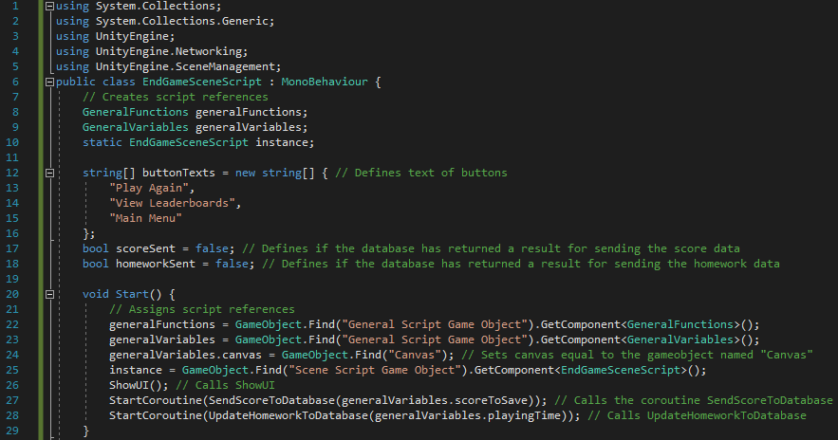

Figure 217 - Code for beginning of EndGameSceneScript and Start function

In addition to the usual features of importing modules and creating the script references, I have created three variables. *buttonTexts* is a list of strings containing the text that will go in each button while *scoreSent* and *homeworkSent* are Booleans which define if the server has returned a result for sending the respective information. In the *Start* function, I assign the script references and canvas before calling *ShowUI*. I also call the IEnumerators *SendScoreToDatabase* and *UpdateHomeworkToDatabase*.

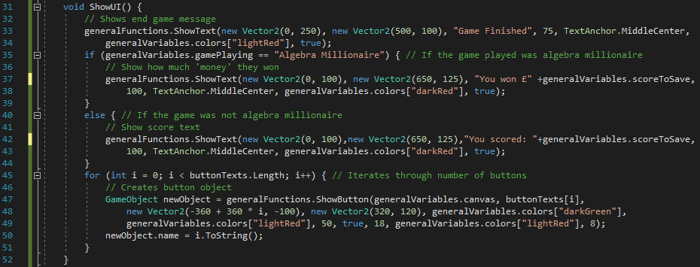

Figure 218 - Code for ShowUI

*ShowUI*, as with other scripts, shows the UI elements in the scene. It first shows the main message, telling the user that the game is over. It then shows the user’s score, either as a score or as an amount of money (in the case of ‘Algebra Millionaire’). I then iterate through the number of buttons and create a new button object for each one. The image below shows the line I have added to *functionsToCall*, which will be executed when one of the buttons is clicked on.



Figure 219 - Appended code to functionsToCall

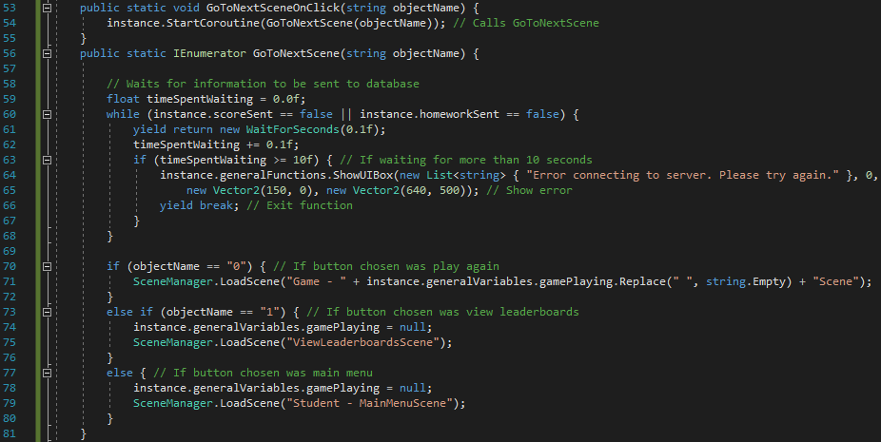

Figure 220 - Code for GoToNextSceneOnClick and GoToNextScene

*GoToNextSceneOnClick* is required for the same reason it is required in *LoginSceneScript*. An IEnumerator cannot be called from another script so it cannot be called from *functionsToCall*. Therefore, *GoToNextSceneOnClick* will be executed when one of the buttons is clicked and this function will simply call the IEnumerator *GoToNextScene*. It is an IEnumerator because of the lines 59-68. These lines wait for the score and homework information to be sent to the database. It first sets a variable for the amount of time that’s been spent waiting. Then, while the results haven’t been received, wait for a small amount of time and show an error if it is taking too long. Assuming a response has been received from the server, the function will continue. It checks the name of the clicked button object and loads a new scene dependent on the name.

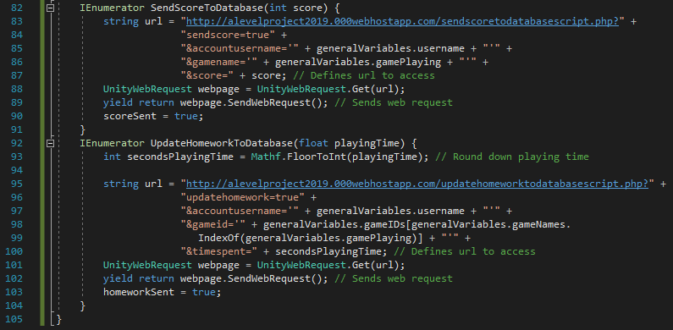

Figure 221 - Code for SendScoreToDatabase and UpdateHomeworkToDatabase and end of script

The two functions above do almost the same thing. They both define a URL to try and access before sending the web request and waiting for a response to come (using the *yield* keyword). When a response is received, the relevant Boolean value is set to *true*, which then allows *GoToNextScene* to proceed.

#### Testing

|  |  |  |  |
| --- | --- | --- | --- |
| Test | Expected Output | Output | Correct? |
| Retest – Play Linear Spaceship Wars and wait for timer to end | End Game scene should load. | Loads End Game scene | Yes |
| Retest – Play Linear Spaceship Wars and wait for the enemy ship to hit the allied spaceship | End Game scene should load | Loads End Game scene | Yes |
| N/A | All text appears with correct attributes |  | Yes |
| N/A | Buttons appear with correct position, size, colour, text etc. |  | Yes |
| Click ‘Play Again’ button | Linear Spaceship Wars scene should load | Linear Spaceship Wars game restarted | Yes |
| Click ‘View Leaderboards’ button | Error saying scene not created |  | Yes |
| Click ‘Main Menu’ button | Student Main Menu scene should load | Student Main Menu scene loaded | Yes |

All tests passed so I will review this section and move on to the next section.

#### Review

##### Content of Section

In this section, I have created the screen which students will see when any of their games end. It provides them with the options of either playing the same game again, viewing the leaderboards or returning to the main menu.

##### Testing

Testing in this section consisted of making sure all of the UI elements were positioned correctly with the right attributes as well as testing what happens when I click the buttons in the screen, making sure the screens that the buttons link to are correct.

##### Meeting Success Criteria

This section, as with many others, is a scene which helps with the overall layout of the program and makes the program easily navigable (which is one of the success criteria). It also helps to fulfil the criterium that students should be able to play games since the end game scene is a useful part of any game.

##### Summary of the Program at this Stage

As of now, both students and teachers are able to create accounts, login to those accounts and view their main menus. Teachers can also add classes while students can play games and view the end game scene.

##### Changes from Design

The only significant change from the design came when developing the event for when one of the buttons is clicked. In my algorithm design, I had a different function being called depending on which button is clicked. However, I considered that to be excessive and unnecessary so I put all three events into the same function where an if statement uses the name of the button object to determine which scene to move on to.

## Stage #15 – Teacher View Classes Scene

This scene has been placed here in the order because I want to now make the View Leaderboards Scene. To access that scene, students can already do it from their menu but teachers need to go via the View Classes scene so I will make this scene now and move on to the leaderboards after.

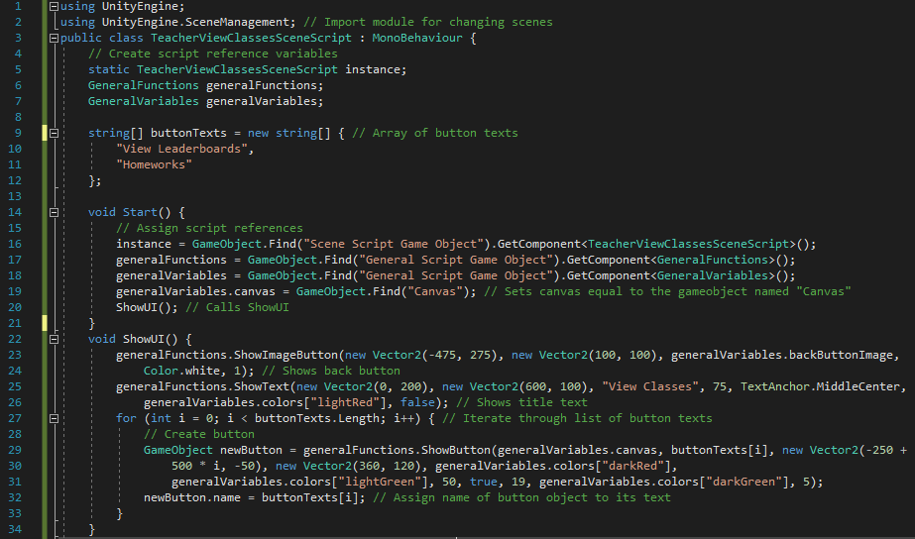

Figure 222 - Code for beginning of TeacherViewClassesSceneScript and Start and ShowUI functions

First, the imported modules are defined and the script reference variables are created in the same way as previous scripts. I have one other variable which is an array of strings defining the text that will go on each button (similar to previously-made menus). The *Start* function does its usual job of assigning the script references, assigning the *canvas* variable and calling *ShowUI*. *ShowUI* also does its usual job of showing all of the UI elements. It creates the back-button image before showing the title text and iterating through the array of texts, creating a new button for each one. The x-coordinate of the buttons has been determined using an arithmetic sequence in the same way as previously in this project. The names of the button objects are set to their text values so that I can determine which one is clicked on.

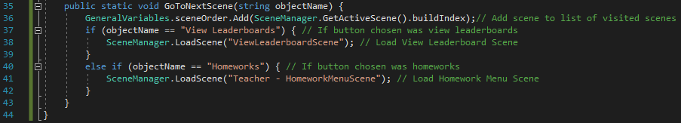

Figure 223 - Code for GoToNextScene and end of script

*GoToNextScene* works in the same way as functions in previous scripts which have done the same job. It is automatically called when one of the buttons is clicked (as I have added the relevant line of code to the *functionsToCall* list in *GeneralFunctions*). First, it adds the current scene index to the list of visited scenes before checking which button was clicked and loading the relevant scene. I have used *else if* instead of *else* for the ‘Homeworks’ checking because there may be more buttons in the future which I want to prepare for. Using *else* would limit the program to two buttons whereas *else if* allows an infinite number.

#### Testing

|  |  |  |  |
| --- | --- | --- | --- |
| Test | Expected Output | Output | Correct? |
| Re-test. Click View Classes button from teacher main menu | View Classes Scene loads | View Classes Scene loads. | Yes |
| Click back button | Teacher Main Menu Scene loads | Teacher Main Menu Scene loads. | Yes |
| N/A | All UI appears correctly |  | Yes |
| Click view leaderboards button | Error message should appear saying scene not created yet. |  | Yes |
| Click homeworks button | Error message should appear saying scene not created yet. |  | Yes |

All of the above tests have passed, so I’m happy to continue with the next section of the program.

#### Review

##### Content of Section

In this section, I have created a menu for teachers which allows them to choose between viewing leaderboards or going to the homeworks menu.

##### Testing

I have tested this section in the same way as previously-made menu scenes, by checking that clicking the buttons result in the desired effect and clicking the back button goes to the previous scene.

##### Meeting Success Criteria

This, as with other menu scenes, doesn’t in itself meet any of the criteria but helps with the overall navigable nature of the program.

##### Summary of the Program at this Stage

At this stage, all users can create accounts and login while students can play one game and teachers can add classes.

##### Changes from Design

In terms of page design, I have inverted the colour of the button and its outline since I think it looks better this way. In terms of the code, I have used a sequence-based method of showing the buttons (also used in previous menu scenes) and this involved creating a string array of button texts.

## Stage #16 – View Leaderboards Scene

#### C# - ViewLeaderboardSceneScript

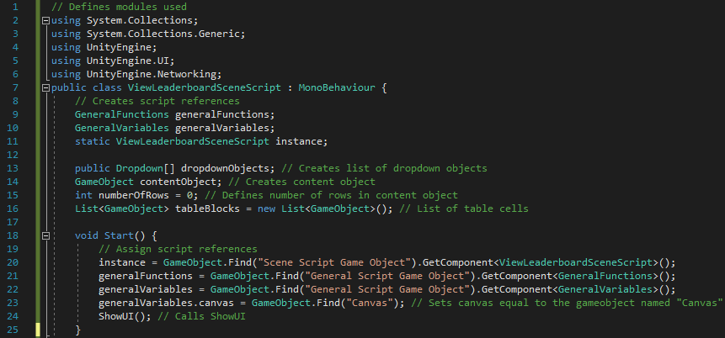

Figure 224 - Code for beginning of ViewLeaderboardSceneScript and Start function

First, the modules that are used in this script are defined. Then, the script references are created and the list of dropdown objects is created, in addition to a content object, an integer for the number of rows in the content object and a list of table cells. In the *Start* function, the script references are assigned, the canvas is assigned and *ShowUI* is called.

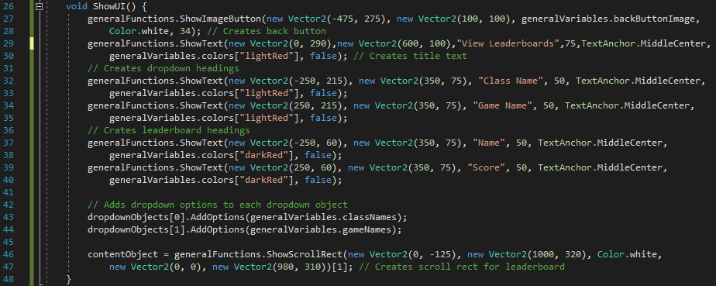

Figure 225 - Code for ShowUI function

*ShowUI*, like in other scripts, shows all of the UI elements. It first displays the back button and title text before showing the dropdown headings and leaderboard headings. Finally, the options for each dropdown object is added before a scroll rect is shown (which will contain the leaderboard itself). The dropdown objects haven’t been created in this script because they have been made in the Unity editor instead[22].

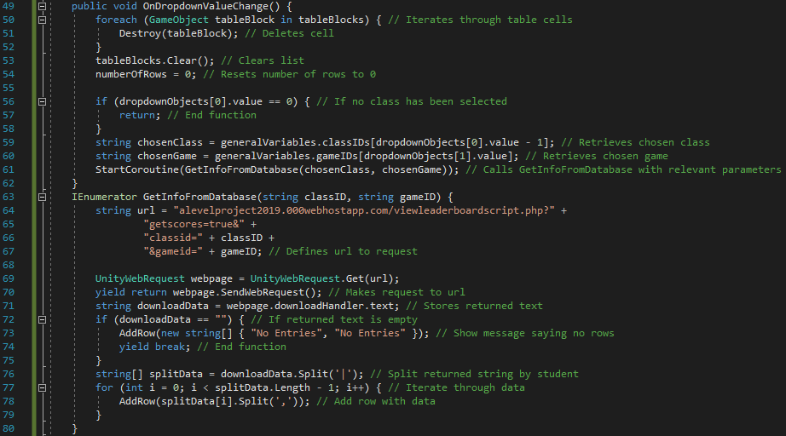

Figure 226 - Code for OnDropdownValueChange and GetInfoFromDatabase

When the user picks a new option on one of the dropdowns, *OnDropdownValueChange* is called. Lines 50-54 wipes all of the data which is being stored for the previous dropdown selections. It destroys all of the table cells in the scroll rect, clears the list of table blocks and sets the number of rows to 0. I then check if the user has picked the first class. This class is simply empty so, in this case, I just return from the function. Assuming one of the user’s classes has been selected, the chosen classes are retrieved and *GetInfoFromDatabase* is called with the chosen class and game sent as arguments.

*GetInfoFromDatabase* defines a URL and sends a web request to that URL. The data that’s returned is stored as *downloadData*. If it is an empty string, then there are no entries, the appropriate message is shown and the function ends. If it is not empty, then *downloadData* is split by student and I iterate through the pieces of data, adding a new row to the table for each piece of data by calling *AddRow*.

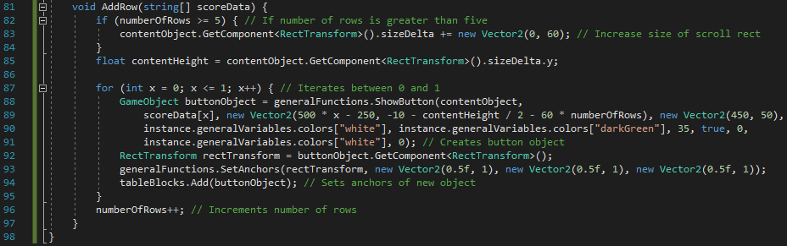

Figure 227 - Code for AddRow and end of script

First, if the number of rows is at least five, then the size of the scroll rect needs to be increased and this is done at the beginning of *AddRow*. After that, I iterate between 0 and 1, creating a new button object for each piece of data (name and score)[23]. Finally, the new objects are added to *tableBlocks* and *numberOfRows* is incremented by one as a new row has just been added.

#### PHP – ViewLeaderboardScript

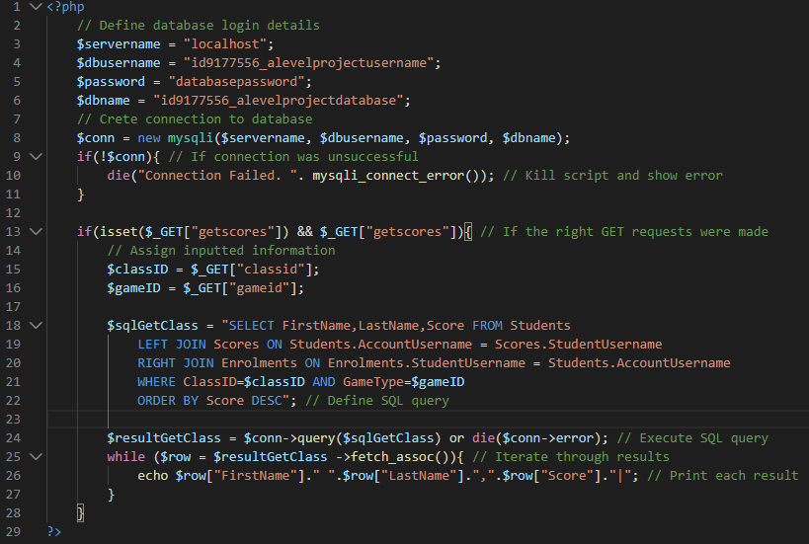

Figure 228 - Code for ViewLeaderboardScript

As with other PHP scripts, *ViewLeaderboardScript* begins by defining the login details for the database. It then attempts to connect to the database with these login details, showing an error and killing the script in the case of an unsuccessful connection. The script will then check to make sure the *getscores* GET request is defined (line 13) before storing the inputted data (class ID and game ID) as variables. The SQL query is then defined and executed; the results are iterated through and each result is printed.

#### Testing

|  |  |  |  |
| --- | --- | --- | --- |
| Test | Expected Output | Output | Correct? |
| Re-test. Click on view leaderboards from student main menu | View Leaderboard Scene should load | View Leaderboard Scene loads | Yes |
| Re-test. Click on view leaderboards from view classes scene. | View Leaderboard Scene should load | View Leaderboard Scene loads | Yes |
| N/A | All UI elements show correctly |  | Yes |
| Click on class dropdown | 1. Class names show  2. Can use scrollbar to scroll through list | After dragging scrollbar down: | Yes. All options shown on dropdown are classes that the student (from the login I used) is in. |
| Click on game dropdown | Game list appears |  | Yes. |
| Click on new class option | 1. Selected option should show in box.  2. Entries should appear in white box. |  | Yes.[24] |
| Click on new game option | 1. Selected option should show in box.  2. Entries should appear in white box. |  | Yes.[25] |
| Click back button (student). | Student Main Menu scene loads |  | No. (Error #1) |
| Click back button (teacher). | View Classes scene loads |  | No. (Error #1 – it appears the two errors are the same) |

##### Error #1

The error occurred when I clicked on the back button. The error message states that the index was out of range and that the error came from the *ShowImageButton* function in *GeneralFunctions*. Initially, it seemed like the error was with *OnBackButtonClick*. The way this function works is by simply going to the scene of which its index is the last in the *sceneOrder* list. Therefore, there shouldn’t be an issue with accessing that scene. An answer to the problem would be that the list is empty but I have added a check in there for that where the function should just end if that’s the case. (In addition, I put a breakpoint inside the if statement to see if that branch is reached and it wasn’t, so the list isn’t empty.) Finally, I discovered I had accidentally entered the wrong value into the parameter for *callFunctionNum* when creating the button. After changing the argument to 1 (the index for the *OnBackButtonClick* event), the functionality now works and clicking the back button leads to the Student Main Menu scene being loaded for students and the View Classes scene loads for teachers.

#### Review

##### Content of Section

In this section, I have created the View Leaderboards Scene which allows both teachers and students to view the leaderboards for each game for each of their classes. It is automatically ordered in descending order of score so the top score will be at the top and the scores will decrease as the user scrolls down using the scrolling functionality.

##### Testing

I have tested the dropdown fields, back buttons and ensured that the right values come up when each button is clicked. I also checked to make sure the right event occurs when a class and game is chosen but there are no results in that leaderboard yet.

##### Meeting Success Criteria

This scene meets one of Mrs Mistry’s most important criteria for this program – leaderboards. As stated previously, leaderboards has been a central part of this program as it allows students to be competitive which will convince them to play more of the games and learn more maths. When creating the End Game Scene, I implemented the functionality to submit scores and store them, while this section displays the leaderboards for the users. Therefore, this fundamental criterion has now been met.

##### Summary of the Program at this Stage

At this stage, students and teachers are both able to login, create accounts and view their respective main menus. Students are also able to choose a game and play one game, as well as view leaderboards. Teachers are able to create classes and add students to those classes[26].

##### Changes from Design

There haven’t been any notable changes from the design, either algorithmically or graphically.

## Success Criteria Update

|  |
| --- |
| Success Criterion |
| A login system where people can either login as a student or a teacher. |
| The ability to create an account, either as a student or a teacher. |
| The student can be added to a class. |
| The student can play maths games. |
| The student’s score is displayed on a separate leaderboard for each class and each game. |
| The teachers and students can (only) view the leaderboards which apply to their account. |
| The teachers can set specific homeworks based on time spent on the program. |
| The teachers can view specific homeworks and see how much time each student has spent on it. |
| The students can view their current homeworks. |
| Simple and clear – it has a layout which is easy to understand and is pleasing to the eye. |
| Easily Navigated – it should be easy to move from scene to scene without being confused about how to reach a certain scene |
| Data is not lost when the user exits the program. The data and accounts are retrievable. |

In the seven sections completed since the last success criteria update, three of them have been menu scenes and one is a section for back-end development (*GeneralGameScript*) and so doesn’t fulfil any of the criteria. Therefore, even though I have completed seven sections since the last update, only two more criteria have been fully fulfilled (while one is now partially fulfilled). Nevertheless, I will still hold a meeting with Mrs Mistry to discuss the progress.

## Stakeholder Update

### Stakeholder Update Interview

**Q: I have just shown you the three menu scenes created since I last discussed the program with you. These are the Student Main Menu Scene, the Student Choose Game Scene and the Teacher View Classes Scene. What are your opinions of these scenes?**

For the Student Main Menu Scene and the Teacher View Classes Scene, they both have very little functionality with just a few buttons so I have no issue with how they are at the moment. The Student Choose Game Scene, however, seems more complicated but I really like the idea that it’s rotating between the different options. I’m not sure it’s entirely necessary but I like it. The rest of the scene is again just fairly simple so I don’t have anything to comment on.

**Q: Looking at the gameplay for Linear Spaceship Wars, do you think it is at the right level mathematically for the students in KS3?**

I feel that the maths is probably at the right level, yes. However, in the game, there is one thing I’d like to change. From a mathematical point of view, I think there’s a way of cheating the game because you can enter a very basic equation (like $y=x$) and regardless of where the enemy spaceships are coming from, that equation will hit the spaceship if it gets close enough. So, maybe it would be a good idea to have one enemy on the screen at a time which doesn’t move towards the centre. Then a new enemy spaceship would appear in a random location immediately when a laser kills an enemy. Other than that, I’m happy with the game – it’s quite fun to play!

**Q: Do you have any comments about the End Game Scene?**

As with before, this is basically a menu so there’s not much to comment on. One thing I’d like to say is I like the fact you can play the game again directly from here and not have to go back to the Choose Game Scene.

**Q: What are your opinions of the View Leaderboards Scene?**

I like the fact you can select exactly which class and which game the leaderboard shows for and I like the fact that it’s automatically in descending order of score. It would be nice, however, to be able to order the leaderboard by other categories such as date completed, for example. Other than that, this scene looks like it will be really useful for me to track the progress of my students.

### Response to Stakeholder Update Interview

I’m happy to say Mrs Mistry is happy with the majority of the progress made. With regards to the comments about the End Game Scene, I have responded to my stakeholder telling her I have added it to the extra features I can add at the end of the project as an extension if there is the time for that.

For the changes to Linear Spaceship Wars, I have spent a bit of time testing her ‘cheat’ and can confirm she is correct. It is very easy to get correct answers (albeit not many within the time limit) by just waiting for each enemy to get close and shooting a generic equation that doesn’t necessarily hit the enemy in the middle but has a very high chance of hitting it – enough to destroy it. So, I have decided to take on the changes suggested by Mrs Mistry and luckily it doesn’t require much restructuring.



Figure 229 - Removed line of code

First, the line above has been removed and replaced with the below line as I only want to create one enemy at the beginning of the game as opposed to continuously calling the function *CreateEnemy* every five seconds.



Figure 230 - Amended code for when game begins

The next change is that I was previously creating the enemy at some point on the outskirt of the grid but this is now not necessary. I will now allow the enemy to be placed anywhere in the grid as long as it’s at least five units away from the centre. The updated code for *CreateEnemy* is shown below:

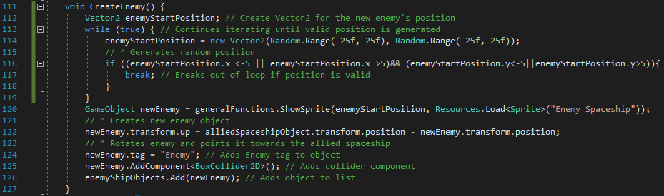

Figure 231 - Updated code for CreateEnemy

Next, the *Update* function is now unnecessary as its only function is to move each enemy ship towards the centre and check if it has reached the centre. Since I don’t want that as a feature anymore, I have removed that function. The final thing required is for me to call *CreateEnemy* when an enemy is shot, so I have added the following line of code to *CheckKill* inside the if statement branch where the ship is hit:



Figure 232 - Code added to CheckKill

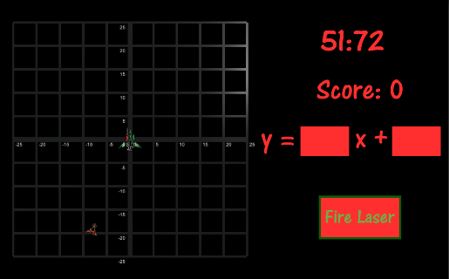

Figure 233 - Screen during Linear Spaceship Wars

Now, when playing the game, only one enemy ship is on the screen at any given time (as shown in the screenshot above) and it’s not moving. In addition, the enemy ship can now appear nearly anywhere in the grid and a new enemy appears when the enemy is hit with the laser. The changes made have therefore been a success and the ‘cheat’ found by Mrs Mistry no longer works.

I have shown the new version of the game to Mrs Mistry and she approves of the game, so I will now move on with my development to the Teacher Homework Menu Scene.

## Stage #17 – Teacher Homework Menu Scene

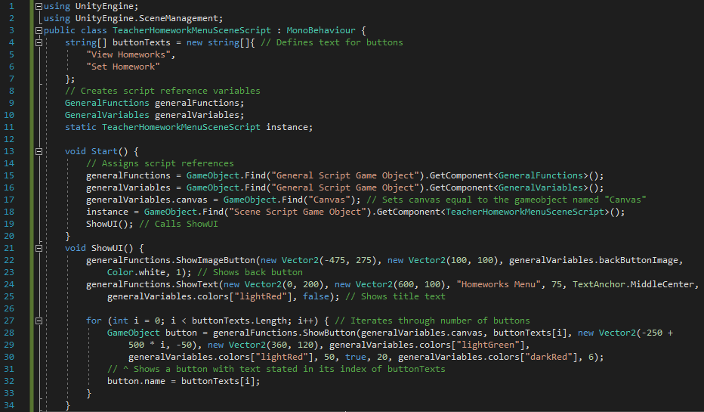

Figure 234 - Code for beginning of TeacherHomeworkMenuSceneScript and Start and ShowUI functions

This code is similar to previous menu scenes. First, modules used in the script are defined and script references are created, in addition to *buttonTexts* which is an array of strings listing the texts to go in the buttons. *Start* does its usual job of assigning the script references, assigning the *canvas* variable and calling *ShowUI*. *ShowUI* shows the back button and title text before iterating through the indices of *buttonTexts*, creating a new button for each text value. The new button’s object name is renamed to its text value, like in other menus, so the clicked button can be worked out.

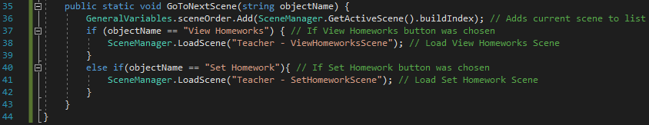

Figure 235 - Code for GoToNextScene and end of script

*GoToNextScene* is called when one of the buttons is called (as I have added the relevant line to *functionsToCall* in *GeneralFunctions*). First, the current scene index is added to the list of visited scenes (for use in the back-button functionality). Then, I check which button has been clicked and go to the scene chosen.

#### Testing

|  |  |  |  |
| --- | --- | --- | --- |
| Test | Expected Output | Output | Correct? |
| Re-test. Click Homework button from view classes | Homework Menu Scene loads | Homework Menu Scene loads. | Yes |
| Click back button | View Classes Scene loads | View Classes Scene loads. | Yes |
| N/A | All UI appears correctly |  | Yes |
| Click view homeworks button | Error message should appear saying scene not created yet. |  | Yes |
| Click set homework button | Error message should appear saying scene not created yet. |  | Yes |

All of these tests have passed successfully so I will review this section and move on to setting new homeworks.

#### Review

##### Content of Section

In this section, I have created another menu scene, this time for teachers wanting to interact with the homework functionality of the program. It gives them the option of either viewing their current homeworks (that have been previously set) or setting a new homework.

##### Testing

Testing for this scene was fairly short as there isn’t much functionality to test. I checked that the UI elements appeared correctly and that the three buttons do their jobs correctly and the program moves on in the right way once clicked.

##### Meeting Success Criteria

As with other menu scenes, this section helps to make the program overall more easily navigable for teachers but doesn’t in itself meet any of the success criteria.

##### Summary of the Program at this Stage

At this stage, all users can create accounts, login and access their main menus in addition to the ability to view leaderboards. Students can also play one of the games and teachers can create classes.

##### Changes from Design

There haven’t been any notable changes for this section since the design.

## Stage #18 – Teacher Set Homework Scene

#### C# - TeacherSetHomeworkSceneScript

As with View Leaderboards Scene, the dropdowns have been created in the Unity Editor, as opposed to in the code, due to complications with Unity3D.

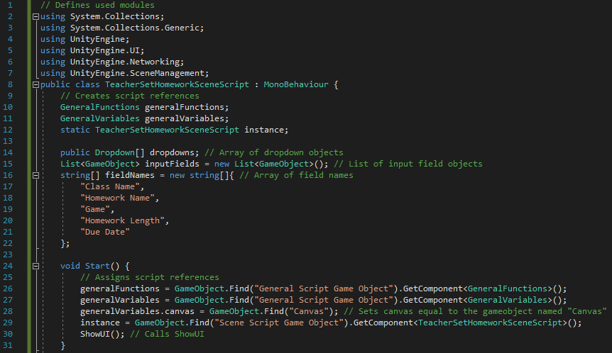

Figure 236 - Code for beginning of TeacherSetHomeworkSceneScript and Start function

First, the used modules are defined and the script reference variables are created. Then, I have created three additional variables: *dropdowns* to store the dropdown objects, *inputFields* to store the input field objects and *fieldNames* to store the heading names for the input fields. The *Start* function does its usual job of assigning the script references, assigning the *canvas* variable and calling *ShowUI*.

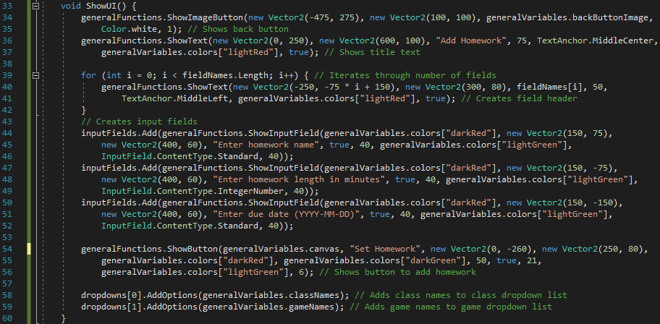

Figure 237 - Code for ShowUI

First, *ShowUI* displays the usual UI elements of the back button and the title text. Lines 39-42 then display the field headings by iterating through the list of strings defining the headings’ text values. Lines 44-52 display the three input fields (the other two fields being dropdowns) individually[27]. A submit button is then created before the class names and game names are added as options to their respective dropdown fields.

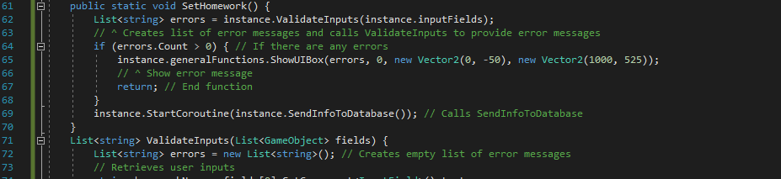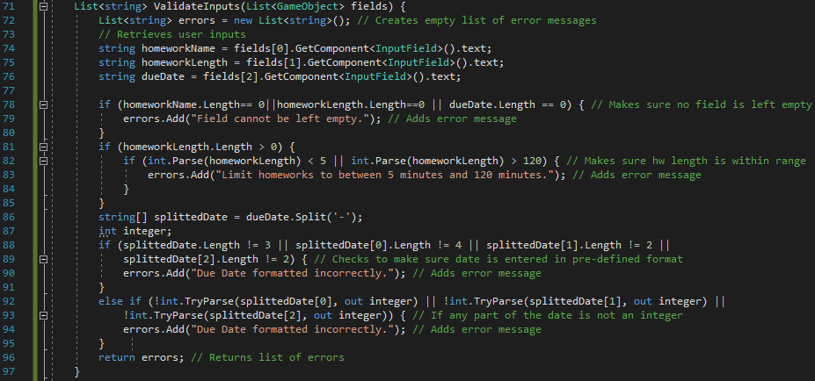

Figure 238 - Code for SetHomework and ValidateInputs functions

When the ‘Set Homework’ button is clicked, *SetHomework* is called (the relevant line has been added to *functionsToCall* in *GeneralFunctions*). The function calls *ValidateInputs* passing the list of input fields as an argument. (The dropdown objects don’t need to be validated as I have already determined which options are available so any selection is guaranteed to be valid.) I then check if the length of the error messages list is greater than zero. If it is, then there is at least one error and the function will stop after an error box appears displaying the error messages.

*ValidateInputs* checks all of the user inputs and determines if they are valid or not. First, an empty list of string is created to store error messages, the user inputs are retrieved and stored as string variables. The first if statement checks to make sure none of the fields have been left empty. I then check that the length of the homework is reasonable (which I have set to between 5 and 120 minutes). Lines 86-95 check the formatting of the due date field. The first if statement checks to make sure the right number of values are in each part of the date. There must be three values (year, month, day) and they must be four, two and two characters respectively. Assuming the formatting is correct, I then check to make sure all three values are integers but returning the list of error messages.

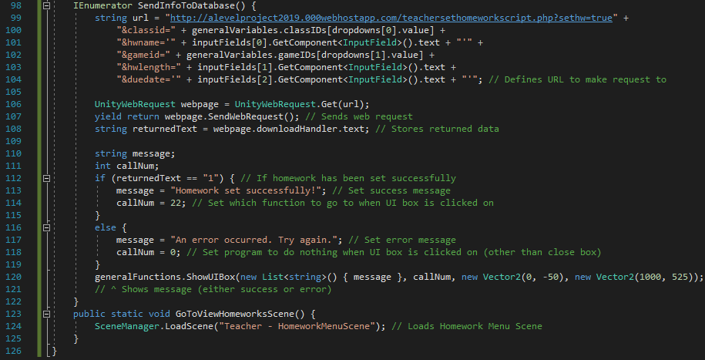

Figure 239 - Code for SendInfoToDatabase, GoToViewHomeworksScene and end of script

The purpose of *SendInfoToDatabase* is to call the PHP script and tell it to set a new homework. To do this, the URL to be requested is first defined with the user’s inputs given as GET requests. After the web request is sent, its returned data is stored as a string and checked. If it is “1”, then that implies the homework has been set successfully and so the message and function to call are set accordingly. Similarly, it the returned value is not “1”, then there has been an error and an error message will show. Either way, a UI box is shown with the defined message and function to call.

*GoToViewHomeworksScene* is called when a success message UI box is clicked on. It will simply load the Homework Menu Scene, as it seems that is the most logical scene for the teacher to go to after setting a homework (as it allows them to either go back or to view the homework they have just set).

#### PHP – TeacherSetHomeworkScript

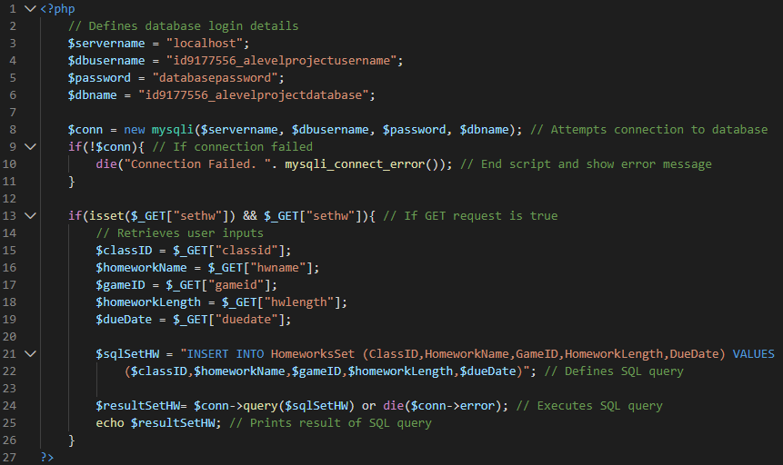

Figure 240 - Code for TeacherSetHomeworkScript

First, the database login details are defined and a database connection is attempted. If it fails, then an error is printed and the script ends. If the connection was successful, then I check that the correct GET request is in the URL and it is set to *true* before retrieving the user’s inputs and defining the SQL query to insert the new homework into the table *HomeworksSet* which contain all homeworks. Finally, I execute the query and either “1” is printed (if the query was successful) or an error message will be printed.

#### Testing

|  |  |  |  |
| --- | --- | --- | --- |
| General Tests | | | |
| Test | **Expected Output** | **Output** | **Correct?** |
| Re-test. Click set homework button from homework menu | Set Homework Scene should load | Set Homework Scene loads. | Yes |
| N/A | All UI elements appear correctly |  | Yes |
| Click back button | Homework Menu Scene should load | Homework Menu Scene loads. | Yes |
| Click Set Homework button (with valid inputs) | 1. Success UI box should show.  2. Should load Homework Menu Scene when UI box is clicked on. | Homework Menu Scene loaded when I clicked on the green box above. | Yes |
| Click class dropdown list | Dropdown options show |  | Yes |
| Select option in class dropdown | Option now becomes selected in class field | (after clicking on ‘Year 7 Class’) | Yes |
| Click game dropdown list | Dropdown options show |  | Yes |
| Select option in game dropdown | Option chosen becomes selected in game field | (after clicking on ‘Algebra Millionaire’) | Yes |

|  |  |  |  |
| --- | --- | --- | --- |
| Input Field #1 (Homework Name) | | | |
| Test | **Expected Output** | **Output** | **Correct?** |
| Enter nothing | Error message when submitted | Error occurred when submitted. It said “Field cannot be left empty” | Yes |
| Enter integer value | No error - should set homework when submitted | Homework was set successfully when submitted. | Yes |
| Enter string (1 character) | No error - should set homework when submitted | Homework was set successfully when submitted. | Yes |
| Enter string (more than 2 but less than 40 characters) | No error message – should set homework when submitted | Homework was set successfully when submitted. | Yes |
| Enter string (more than 40 characters) | Won’t allow more than 40 characters | Wasn’t able to type more than 40 characters. | Yes |
| Enter string (more than one word) | No error – should set homework when submitted | Homework was set successfully when submitted. | Yes |
| Enter symbols inside string | No error – should set homework when submitted | Homework was set successfully when submitted. | Yes |
| Enter function keys (including print screen, tab etc) | Nothing will happen | Nothing. Except when the *Home* and *End* keys were clicked. When that happened, the cursor moved to the beginning and end of the input text respectively (like in most texts). Pressing the *Escape* key removed the cursor from the input box. | Yes |

|  |  |  |  |
| --- | --- | --- | --- |
| Input Field #2 (Homework Length) | | | |
| Test | **Expected Output** | **Output** | **Correct?** |
| Enter nothing | Error message when submitted | Error message when submitted saying “Field cannot be left empty” | Yes |
| Enter integer value ($n<0$) | Error message when submitted – value out of range | Error message when submitted saying “Limit homeworks to between 5 minutes and 120 minutes”. | Yes |
| Enter integer value () | Error message when submitted – value out of range | Error message when submitted saying “Limit homeworks to between 5 minutes and 120 minutes”. | Yes |
| Enter integer value () | Error message when submitted – value out of range | Error message when submitted saying “Limit homeworks to between 5 minutes and 120 minutes”. | Yes |
| Enter integer value ($n=5$) | No error – should set homework when submitted | Homework was set successfully when submitted. | Yes |
| Enter integer value () | No error – should set homework when submitted | Homework was set successfully when submitted. | Yes |
| Enter integer value () | No error – should set homework when submitted | Homework was set successfully when submitted. | Yes |
| Enter integer value ($n>120$) | Error message when submitted – value out of range | Error message when submitted saying “Limit homeworks to between 5 minutes and 120 minutes”. | Yes |
| Enter string | Shouldn’t be able to type string letters | I wasn’t able to enter letters into the input field. | Yes |
| Enter symbols inside string | Shouldn’t be able to type symbols | I wasn’t able to enter symbols into the input field. | Yes |
| Enter function keys (including print screen, tab etc) | Nothing will happen | Nothing. Except when the *Home* and *End* keys were clicked. When that happened, the cursor moved to the beginning and end of the input text respectively (like in most texts). Pressing the *Escape* key removed the cursor from the input box. | Yes |

|  |  |  |  |
| --- | --- | --- | --- |
| Input Field #3 (Due Date) | | | |
| Test | **Expected Output** | **Output** | **Correct?** |
| Enter nothing | Error message when submitted | Two error messages showed when I tried to submit. The first said “Field cannot be left empty” and the second said “Due Date formatted incorrectly”. | Yes. Both errors are correct. |
| Enter integer | Error message when submitted – value out of range | Error message when submitted saying “Due Date formatted incorrectly”. | Yes |
| Enter string | Error message when submitted | Error message when submitted saying “Due Date formatted incorrectly”. | Yes |
| Enter date with correct format | No error – homework should be set when submitted | Homework was set successfully when submitted. | Yes |
| Enter date with four values.  E.g. 2019-12-13-04 | Error message when submitted | Error message when submitted saying “Due Date formatted incorrectly”. | Yes |
| Enter date with separation being ‘/’.  E.g. 2019/12/13 | Error message when submitted  (wrong separator) | Error message when submitted saying “Due Date formatted incorrectly”. | Yes |
| Enter date with non-integer components.  E.g. 2019-hi-13 | Error message when submitted | Error message when submitted saying “Due Date formatted incorrectly”. | Yes |
| Enter date with wrong number of characters in first column  E.g. 201-12-13 | Error message when submitted | Error message when submitted saying “Due Date formatted incorrectly”. | Yes |
| Enter date with wrong number of characters in second column.  E.g. 2019-123-13 | Error message when submitted | Error message when submitted saying “Due Date formatted incorrectly”. | Yes |
| Enter date with wrong number of characters in third column.  E.g. 2019-12-133 | Error message when submitted | Error message when submitted saying “Due Date formatted incorrectly”. | Yes |
| Enter symbols (not ‘-’) inside string | Error message when submitted | Error message when submitted saying “Due Date formatted incorrectly”. | Yes |
| Enter function keys (including print screen, tab etc) | Nothing will happen | Nothing. Except when the *Home* and *End* keys were clicked. When that happened, the cursor moved to the beginning and end of the input text respectively (like in most texts). Pressing the *Escape* key removed the cursor from the input box. | Yes |

All tests here have passed so I will review the section and move on. The fact that all of these tests have passed implies that the PHP script is running properly and is doing its job. To confirm this, I have manually checked the database to make sure

#### Review

##### Content of Section

In this section, I have created the scene which allows teachers to set a homework for a class to play a specific game for a certain amount of time by a deadline. It is similar to the Create Account Scene in the sense that the scene is essentially just made of input fields and dropdowns as that’s all that is required for the user to create a homework.

##### Testing

As this scene has three input fields, two dropdown fields and two buttons, there was a fairly significant amount of testing done to make sure there is no way of breaking the system. For the dropdowns, that simply involved making sure the right options came up and that an option became selected when I clicked on one of them. For the buttons, it simply involved clicking them and making sure the intended outcome occurred. Finally, for the input fields, I tested lots of different data types and lengths to enter into the fields to make sure the intended outcome occurred for each one.

##### Meeting Success Criteria

This section fulfils part of one of the more important criteria: the ability for teachers to be able to create homeworks for their classes based on the amount of time they spend on a specific game.

##### Summary of the Program at this Stage

At this stage, all users are able to create accounts and log in to them in addition to view their respective menus and view leaderboards. As well as that, students can play one of the games and teachers can add classes and set homeworks.

##### Changes from Design

There haven’t been any notable changes from the design.

## Stage #19 – Teacher View Homeworks Scene

#### C# - TeacherViewHomeworksSceneScript

As with previous scenes with dropdown fields, I have created the dropdown field in the Unity Editor due to complications with creating dropdowns in code.

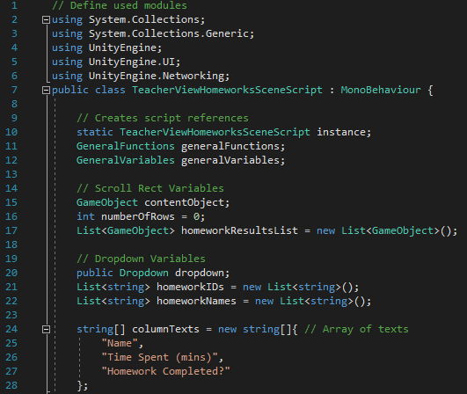

Figure 241 - Code for beginning of TeacherViewHomeworksSceneScript and definition of variables

First, I define the modules I will be using in the script below then I define my variables. These are split into four sections. First, I have the usual ‘script reference variables’ which are created and assigned later in the *Start* function. The ‘scroll rect variables’ consist of *contentObject* (defining the object of the scroll rect which will feature the homework values), *numberOfRows* (defining the number of rows in the scroll rect) and *homeworkResultsList* (a list of objects, each of which will represent one cell in the scroll rect table). The ‘dropdown variables’ represent variables which are related to the dropdown objects. These are: *dropdown* (defining the dropdown object for the homework to be viewed), *homeworkIDs* (a list of strings for the IDs of homeworks which are available for the teacher to view) and *homeworkNames* (similarly a list of strings for the names of homeworks which are available for the teacher to view). Finally, I have an array *columnTexts* which defines the text of the column headings for the scroll rect table.

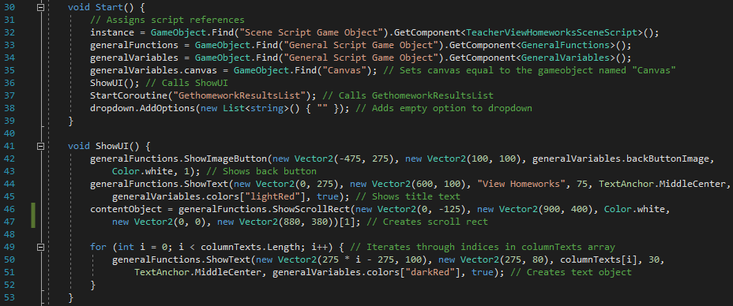

Figure 242 - Code for Start and ShowUI functions

The *Start* function assigns the script references, assigns the *canvas* variable and calls *ShowUI* like the *Start* function in other scripts. In addition to this, *GetHomeworkResultsList* is called and an empty option is added to the dropdown field (allowing a default value of no homework to be chosen). In *ShowUI*, the back button, title text and scroll rect are shown before I iterate through the number of columns in the scroll rect, creating a heading above each column. (The position of the column texts is defined using a sequence-based approach like in previous scripts.)

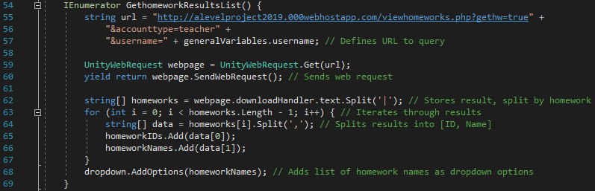

Figure 243 - Code for GetHomeworkResultsList

The aim of this function is to download the names of the teacher’s homeworks and add them as options to the dropdown field. To do this, a URL is defined and a request is made to the webpage. Line 62 stores the response from the webpage, split by homework. I then iterate through that set of results adding the ID of the homeworks to the list *homeworkIDs* and the name of the homeworks to the list *homeworkNames*. After the for loop, I then add the list of homework names as options for the dropdown list.

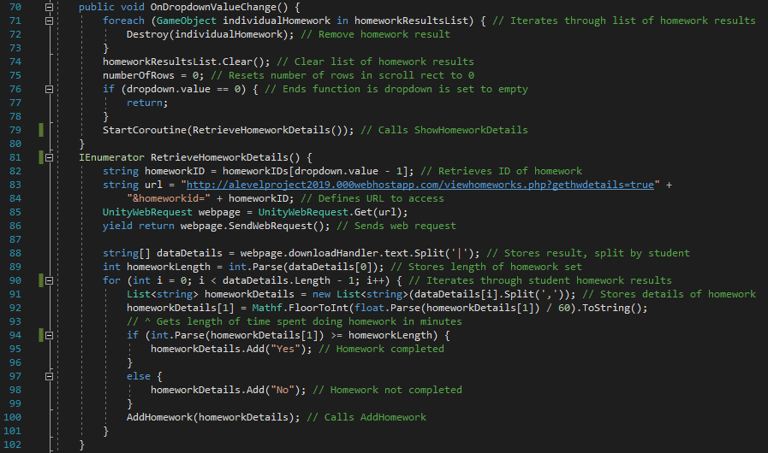

Figure 244 - Code for OnDropdownValueChange and RetrieveHomeworkDetails

The function *OnDropdownValueChange* is called whenever the value selected form the dropdown field is changed. When this happens, I want to clear my current list of homework results and re-download them for the new homework. I do this by iterating through *homeworkResultsList* and destroying each object stored there. Since doing this only destroys the object (the value is technically still stored in the list), I then clear the list so it is now empty. I then reset the number of rows to 0 and, if the dropdown has not been set to the empty default value, I call *RetrieveHomeworkDetails* to download the details of the newly-selected homework.

First, in *RetrieveHomeworkDetails*, I retrieve the ID of the selected homework (using the in-built variable *dropdown.value* defines the index of the dropdown value selected by the user). I then define the URL to access and make the web request to that webpage. The returned result is split, by student, into an array. The first value in the array denotes the length of the homework so I convert that to an integer and store it as the variable *homeworkLength*. I then iterate through the list of results. The student’s homework information is split into a list of strings which will contain their name and how long they’ve spent doing the homework. The third column in the scroll bar table is whether the student has completed the homework or not. This is determined by convert the value for time spent into a float and dividing it by 60 (since it was originally in minutes). I then check if that value is greater than the length of the homework or not. If it is, then the third column is ‘Yes’ or else the third column is ‘No’. At this point, I have the information required for the scroll rect table so I call *AddHomework*, at the end of each iteration, which takes the list of information as a parameter.

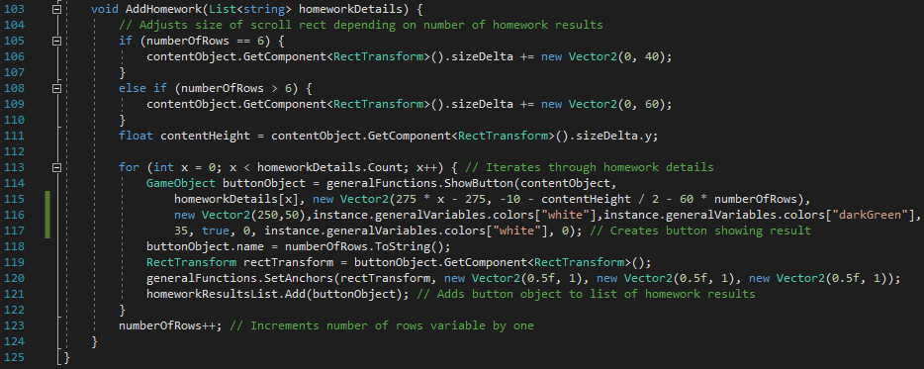

Figure 245 - Code for AddHomework and end of script

*AddHomework* works in a similar way to functions in other scripts where scroll rect tables are created (such as View Leaderboards Scene). First, I need to adjust the size of the scroll rect so that the user can scroll the right amount depending on how many homework results there are. I then iterate through *homeworkDetails* and create a new button for each detail (which corresponds to each column)[28]. When each button is created, it is added to the list of homework results and, when each student’s result has been added, the *numberOfRows* variable increases as an extra row has just been added.

#### PHP – ViewHomeworks

The *ViewHomeworks* script does multiple different things. First, it retrieves a list of homeworks which the teacher has set and returns it to the client. Second, given a selected homework, it retrieves a list of students with pieces of information about their work on that specific homework. In addition to that, this script will also handle the students’ viewing of the homeworks but I will add that code in the next section when I make the Student View Homeworks Scene.

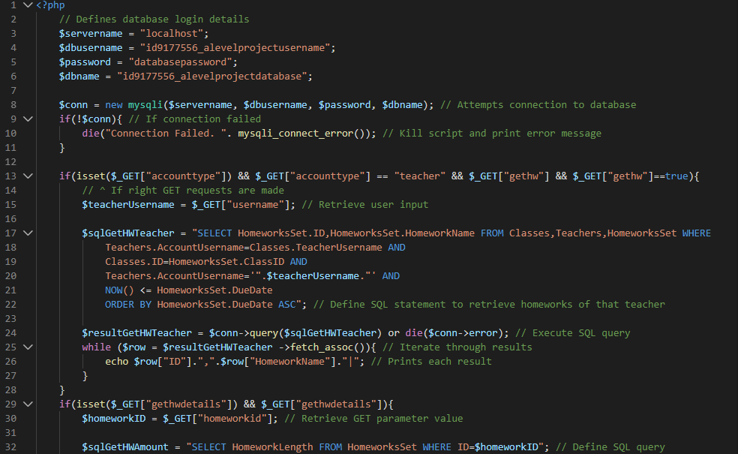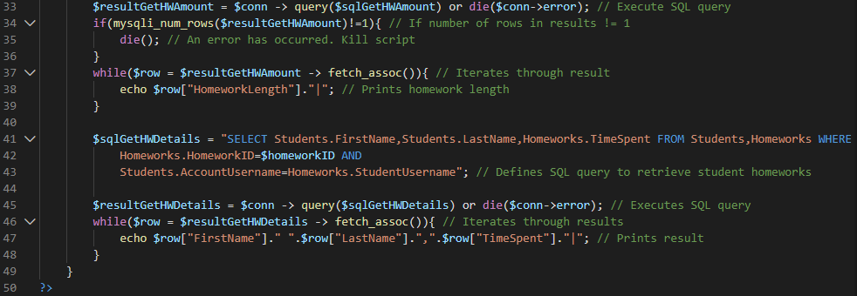

Figure 246 - Code for ViewHomeworks

First, I define the database login details, attempt a connection to the database and handle unsuccessful attempts, in the same way as in previous PHP scripts. Unlike other PHP scripts created earlier, this script will have multiple functions (as stated above) so I have used branching to determine which piece of code to run. As shown in the C# variables for the URLs, they have different parameters. The GET variables *gethw* and *gethwdetails* determine which branch to take. The first branch is for the beginning of the scene when I want to get the options for the dropdown field. The SQL query selects the homework ID and homework name for all homeworks where the user is the teacher that set the homework and when the due date hasn’t passed yet (since I will hopefully be able to implement an e-mailing service for after the due date, as stated in the analysis section). I then execute that SQL query and iterate through the results, printing each one.

The other branch is for when a new dropdown value is selected and I need to retrieve the results for that specific homework. In this case, there are two SQL queries made: one to retrieve the length of the homework that was set and one to retrieve each student’s result. The first query is made by simply selecting the *HomeworkLength* field from the table *HomeworksSet* for the selected homework. I execute the query, check that there is only one row of results (since there should only be one homework length as there should only be one homework with that ID) before printing that result. The second SQL query then retrieves the homework details for any student which has a record with the specified homework ID. I iterate through the results, printing the first name, last name and time spent on the homework for each result.

#### Testing

|  |  |  |  |
| --- | --- | --- | --- |
| Test | Expected Output | Output | Correct? |
| Re-test. Click View Homeworks button from Homework Menu Scene | Teacher View Homeworks Scene should load | Teacher View Homework Scene loads | Yes |
| Click back button | Homework Menu Scene should load | Homework Menu Scene loads | Yes |
| N/A | All UI appears correctly |  | Yes |
| Click on dropdown field | Correct options appear in dropdown list |  | Yes |
| Select new dropdown value | 1. New dropdown value appears in dropdown field  2. Homework results appear correctly  3. Dropdown list disappears |  | 1. Yes  2. No (entries don’t appear)  3. Yes  There is an error in the console. (Error #1) |
| Select empty (default) dropdown value | 1. Dropdown field should become empty  2. Homework results table should become empty |  | Yes |

##### Error #1

The error screenshotted above says “Index was out of range. Must be non-negative and less than the size of the collection” and it is from the *RetrieveHomeworkDetails* function in the C# script. Since it involves a list or array, the issue must arise from me referencing the index of an array or list. So, the issue is either on line 82, 89, 91, 92 or 94. To determine which error the line has come from, I will use the idea that the code in the section follows ‘selection’, meaning each line of code follows the previous line. I will use print statements (printing the relevant variable at each stage) after each of the lines which could be causing the error. From this, I should be able to determine which part of the function is causing the error and why.

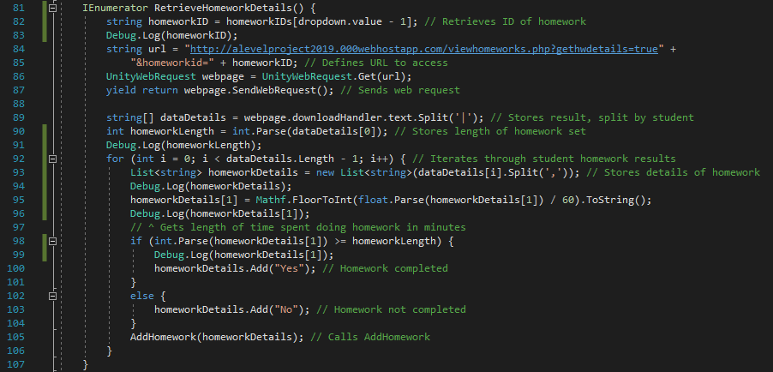

Figure 247 - Temporarily updated code for testing. Added debug lines are lines 83, 91, 94, 96 and 99

After running the program and selecting a new dropdown value again, the following image is the output from the console.

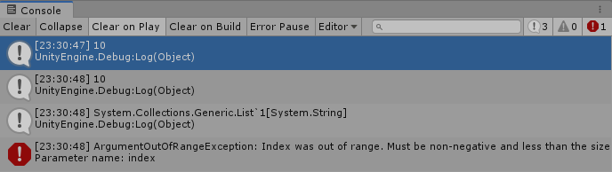

Figure 248 – Test output in console

The first three print statements show that the first list/array references are definitely working properly as ‘10’ is the expected value for both lines (manually checking the database showed me that *homeworkID* and *homeworkLength* were both 10 for the homework I selected). The third printed value is a list of strings (Unity3D doesn’t allow the printing of the contents of a list in the console); this was expected so I can assume it’s correct. I then get an error before the fourth comment so the error must be regarding line 91 (from the original code). This line splits *dataDetails[i]* by comma. I have added the following line of code to print *dataDetails[i]* just before the erroneous line.



Figure 249 - Test print statement

After running the program again and re-doing the same test, the following image is the output from the console.

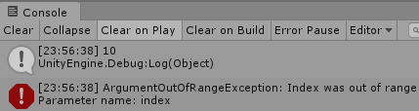

Figure 250 - Test output in console

From this test, I have noticed the problem. Earlier, I stated that the first value in *dataDetails* refers to the homework length then all values after that will be per student. The for loop on line 90 starts at *i=0* (which means it includes the homework length) when it should be starting at *i=1*. After changing the starting position of the variable *i*, I have rerun the test again with the following result.

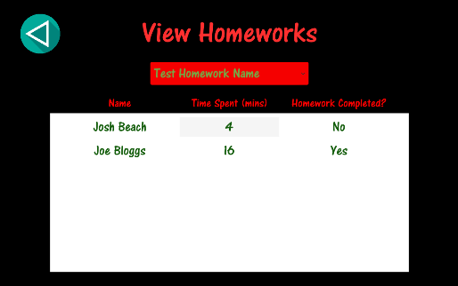

Figure 251 - Test output on screen

As shown above, the function now runs correctly and the students are listed with the columns correctly[29]. In addition, the console now shows no errors so I am happy to review this section and move on to the next section – Student View Homeworks Scene. As well as this, the tests all being successful implies that the PHP script is running correctly as it is outputting the correct values.

#### Review

##### Content of Section

In this section, I have implemented the functionality for teachers to be able to view the results of their students for a specific homework of their choosing. It will list each student, how many minutes they have spent on the homework and whether they have completed the homework or not.

##### Testing

Testing for this section involved checking that the UI looked correct, checking that clicking each button had the intended effect and checking the effect of selecting various values on the dropdown field.

##### Meeting Success Criteria

This section fully fulfils the success criterion stating that teachers should be able to view homeworks and see how much time students have spent on them. That is the intended use of this scene so I will consider the success criterion completed.

##### Summary of the Program at this Stage

At this stage, all users can create accounts, login to those accounts, view their main menus and view their classes’ leaderboards. In addition to that, students are able to play one of the games while teachers are able to add classes, set homeworks and view the results of those homeworks.

##### Changes from Design

There haven’t been any notable changes since the design section of this section.

## Stage #20 – Student View Homeworks Scene

#### C# - StudentViewHomeworksSceneScript

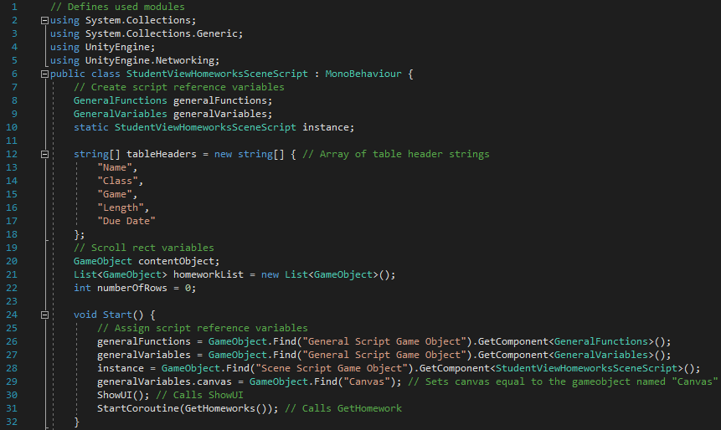

Figure 252 - Code for beginning of StudentViewHomeworksSceneScript and Start function

This script follows a similar plan to the *TeacherViewHomeworksSceneScript* since they both have very similar functions. First, the modules which are used in the script are defined and I create the script reference variables. I then create an array of strings which define the names of the columns for the list in addition to three variables used with regards to the scroll rect. These are: *contentObject* (which stores the actual scroll rect object itself), *homeworkList* (storing all of the homework cell objects) and *numberOfRows* (which defines the number of rows in the scroll rect at the current point in time). In the *Start* function (called upon the loading of the script), the script reference variables are assigned and *canvas* is assigned (like in previous scripts), in addition to *ShowUI* and *GetHomeworks* being called, similar to in *TeacherViewHomeworksSceneScript*.

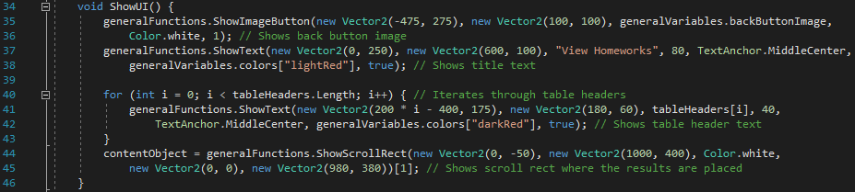

Figure 253 - Code for ShowUI

In *ShowUI*, I first show the back-button image and the title text like in most scenes. I then iterate through the table headers, creating a new text object for each one and placing them in a header position above the appropriate column in the scroll rect. Finally, the scroll rect is created and stored in *contentObject*.

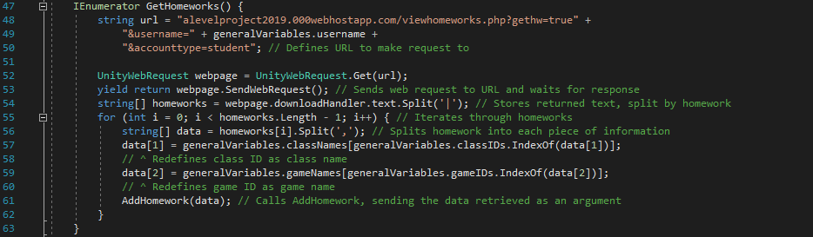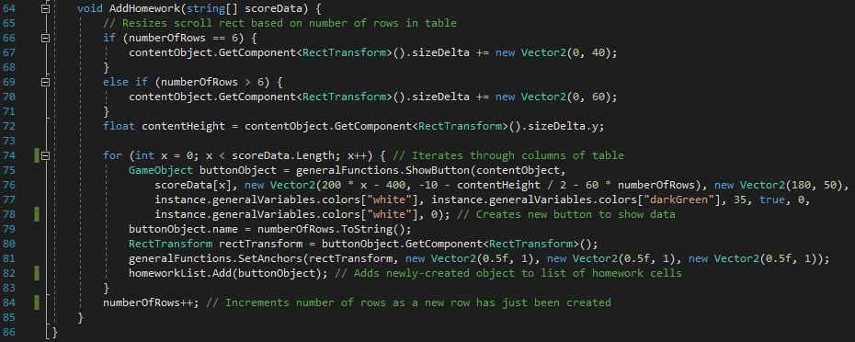

Figure 254 - Code for GetHomeworks, AddHomework and end of script

*GetHomeworks* is called from the *Start* function so is run, without any user interaction, when the scene first loads. Its function is to retrieve the list of homeworks from the database and send each one to *AddHomework* which will add it to the scroll rect for the user to see. As with most functions that make a request to a PHP script, a URL is first defined and the function (specifically an IEnumerator) waits for the PHP script to return a value from the request. Again, similar to the *TeacherViewHomeworksSceneScript*, the returned value is stored split by homework. I then iterate through the homework results, redefining the class IDs and game IDs to their respective names[30] before calling *AddHomework*, which takes *data* as an argument.

*AddHomework* adds the data, passed into it from *GetHomeworks*, to the scroll rect for the student to view as a homework they need to complete. First, as with all scroll rect-managing functions, a check needs to be made for how many rows there are and adjust the size of the scroll rect accordingly[31]. I then iterate through the columns of the table, creating a new button object which displays the text for that column. Again, like *TeacherViewHomeworksSceneScript*, I add the objects to the list of homework cells and increment the variable for the number of rows, as I have just created a new row of values (corresponding to one new homework).

#### PHP – ViewHomeworks

In addition to the code already written for *ViewHomeworks*, the following piece of code has been added which specifically applies to the student part of viewing homeworks.

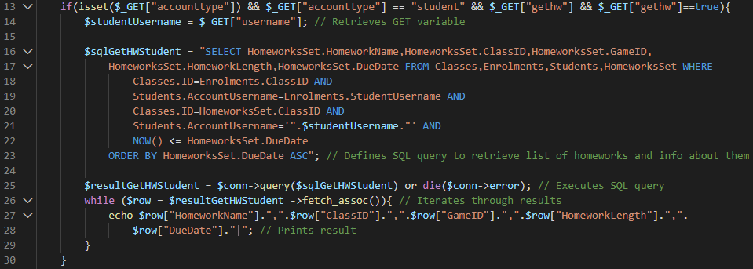

Figure 255 - Code for student branching of GetHomeworks

If the account type is ‘student’ and the *gethw* GET variable is equated to *true*, then the branch between lines 14 and 29 will be run. First, the student’s username is retrieved from its GET variable. Then, a long SQL query is defined (as it links together four tables in the database) which retrieves homework information about all homeworks which are currently outstanding for the student. Line 23 orders the results by its due date in ascending order, meaning the homeworks with closer deadlines will appear first when presented to the user in the table. I then execute the query and iterate through the results, printing each column separated by a comma (and adding a ‘|’ at the end of the print statement to split each homework).

#### Testing

|  |  |  |  |
| --- | --- | --- | --- |
| Test | Expected Output | Output | Correct? |
| Re-test. Click View Homeworks button from Student Main Menu Scene | Student View Homeworks Scene should load | Student View Homeworks Scene loads | Yes |
| Click back button | Student Main Menu Scene should load | Student Main Menu Scene loads | Yes |
| N/A | 1. All UI appears correctly  2. Correct homework information should appear |  | Yes |
| N/A | Homeworks should be sorted by date | The homeworks are sorted by date in ascending order. (See image above.) | Yes |
| Drag down on scroll rect | Scroll rect should ‘move down’ and rows lower down in the list should be viewable | Scroll rect moves down in a smooth manner and shows lower rows. | Yes |
| Drag down on scroll rect beyond last row | I shouldn’t be able to scroll past the final row of the homeworks list. | I can scroll beyond the final row (shown in above image) but, as soon as I let go of the drag, the scroll rect snaps back into place (shown in the image below). | Yes[32] |
| Drag up on scroll rect above first row | I shouldn’t be able to drag the scroll rect past the first row. | Similar to the previous test, I am able to scroll above the first row (as shown in the above image) but, as soon as I let go of the drag, the scroll rect snaps into the correct position (shown in the below image) | Yes[33] |

All of these tests have passed (see footnote below for explanation of why the final test is a success) and I can assume the PHP script is working properly as the homeworks are successfully downloaded (and I have manually checked the database to make sure the right homeworks have been downloaded), so I will review the section and move onto the second program.

#### Review

##### Content of Section

In this section, I have created the Student View Homeworks Scene which allows students to view information about all of their outstanding homeworks (name of homework, class name, game name, length of homework and due date). It is sorted by due date (in ascending order), so the user will see the most ‘pressing’ homeworks first in the list. Potentially, in a future release, an update could be made so that this scene can be sorted by other factors such as homework length.

##### Testing

Testing for this scene was fairly limited as there is very little user interaction. The only things the student can do in this scene is click the back button and drag on the scroll rect, both of which are tested to make sure the right outcome occurs when the event happens (including what happens when the scroll rect is dragged beyond its limits). Other than user interaction, I have checked to make sure all of the UI elements show correctly and that the homeworks download.

##### Meeting Success Criteria

This section fully fulfils the success criterion stating that students should be able to view their current homeworks. That is the aim of this section and it allows students to do exactly that, not just to view their homeworks but also specific information about the homeworks.

##### Summary of the Program at this Stage

At this stage, all users are able to create accounts, login to those accounts, view their homeworks (the ones they’ve set if the user is a teacher or the ones they’ve been set if they’re a student) and the view leaderboards (of each of their classes for each game). In addition, students can play one of the games while teacher can add classes and set homeworks.

Now, all of the functionality of the program has been created. There are games, homeworks, classes and leaderboards. So, the only thing left to develop is additional games (which will be the final two sections of development).

##### Changes from Design

There haven’t been any notable changes since the design of this section.

## Stage #21 – Speed Maths Scene

In this section, I am going to create the second game: Speed Maths. It involves the user answering fairly basic mathematical problems which use the basic concepts of addition, subtraction, multiplication, division, exponents and factorials. They will select the answer by tapping on one of nine options, listed out in a three-by-three grid in a panel object.

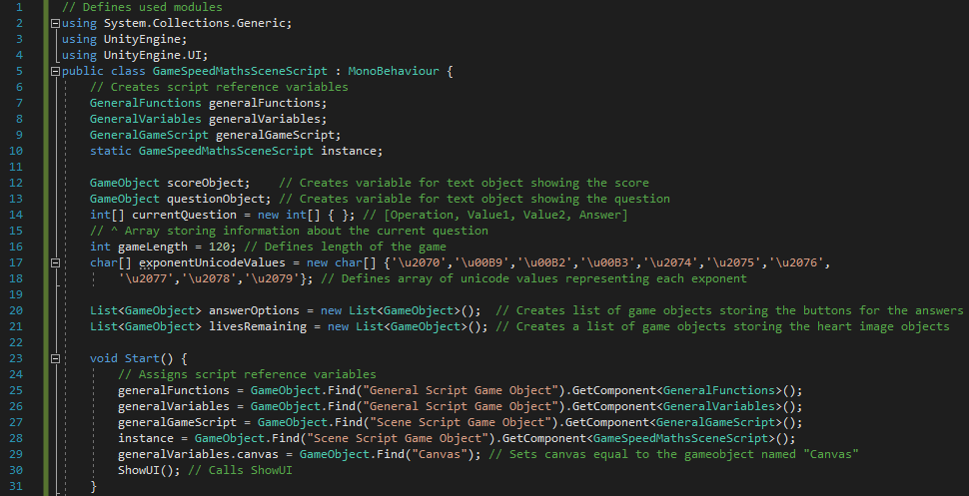

Figure 256 - Code for beginning of GameSpeedMathsSceneScript and Start function

First, as with all of my C# scripts, the used modules are defined and the script reference variables are created (including a *GeneralGameScript* reference since this is one of the games). In addition to that, I have created the following variables:

|  |  |  |
| --- | --- | --- |
| Variable | Data Type | Use |
| *scoreObject* | GameObject | This stores the text object which will show the current score to the user. |
| *questionObject* | GameObject | This stores the text object which will show the current question to the user. |
| *currentQuestion* | Array of integers | This stores an array of values which relate to the current question being shown to the user. The array will be in the form $[operation, value1, value2, answer]$. An example could be $\left[3, 24, 4, 6\right]$ (division operation where the values are $24$ and $4$, meaning the answer is $6$). |
| *gameLength* | Integer | An integer defining how long the game should last. It is a constant but could be changed in future updates if things like different difficulties were made. |
| *exponentUnicodeValues* | Array of characters | The exponent questions will involve a squared sign, cubed sign etc. This can’t be typed in superscript in Unity3D so I have to use their Unicode representation. To do this, *exponentUnicodeValues* stores the Unicode values for ten superscripted integers (between 0 and 9) in order so I will be able to add the symbol by referencing the right index of the array. |
| *answerOptions* | List of GameObjects | This is a list of GameObjects which will store the nine answer buttons in the grid. |
| *livesRemaining* | List of GameObjects | This is a list of GameObjects which will store the three life images. This list has a double use as I will also use it to simply determine how many lives the player has left (hence the name of the variable) by checking the length of the list. |

In the *Start* function, there is nothing special I have written other than what is done in the *Start* function of every other C# script (with the added fact that there is a script reference for *GeneralGameScript*); the script reference variables are assigned, *canvas* is assigned and *ShowUI* is called.

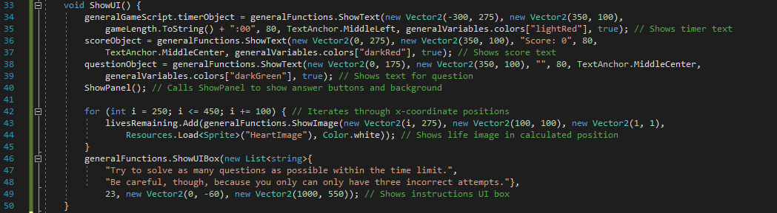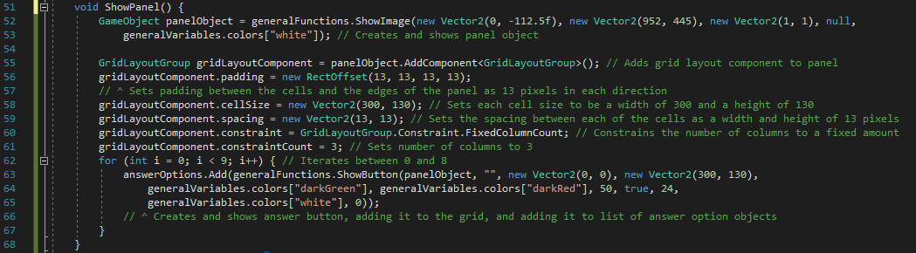

Figure 257 - Code for ShowUI and ShowPanel

*ShowUI* displays all of the UI elements on the screen other than the panel and the answer buttons on the panel. Since it requires quite a few lines of code to create the panel and its buttons, I thought it would make more sense to have it as its own function (simply to split up the code and make it more readable) which is called from *ShowUI*. *ShowUI* starts by showing the timer text object (which, as stated in Stage #12, is stored in *GeneralGameScript*), the score object (set to a default text of “Score: 0”) and the question object (which is set to a default text value of an empty string). I then call *ShowPanel* (which will create the background panel and answer buttons). After that, I iterate through x-coordinates between 250 and 450 inclusive (incrementing the value by 100 each time), creating a new image GameObject showing a heart image at that x-coordinate (each image representing one life). Finally, I show a UI box which displays the instructions to the user. When they click on the box, index *24* will be referenced from *functionsToCall* in *GeneralFunctions*. This line will call *StartGame* which will start the game and provide the first question to the user.

In *ShowPanel*, lines 52-61 create and setup the panel object while lines 63-68 create the answer button objects. First, the basic panel object is created (without all of its ‘panel’ attributes set) by calling *ShowImage*, since the panel is essentially just a large block-coloured image. I then add a *GridLayoutComponent* to the panel object which means the children of the panel object will now be set out in a gridded fashion. The *padding* attribute defines how many pixels from the edges of the panel object the grid should be, *cellSize* defines the size of each individual cell in the grid (each cell will be an answer object) and *spacing* defines the number of pixels between each row and column in the grid. Finally, *constraint* is set to the enumerated value of *FixedColumnCount*, meaning there is a fixed number of columns in the grid. The line below that then defines the number of columns permitted which is 3 (since it is a three-by-three) grid. Finally, I iterate between 0 and 9, creating a new button object in each iteration, which will create a three-by-three grid of answer buttons[34].

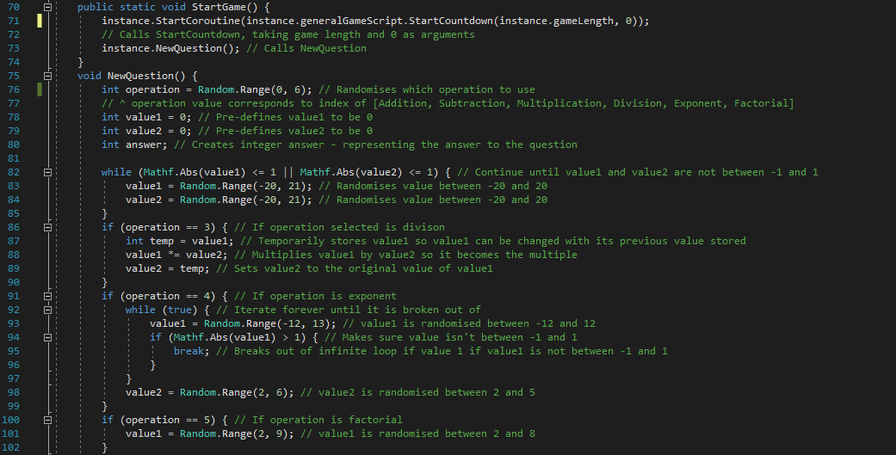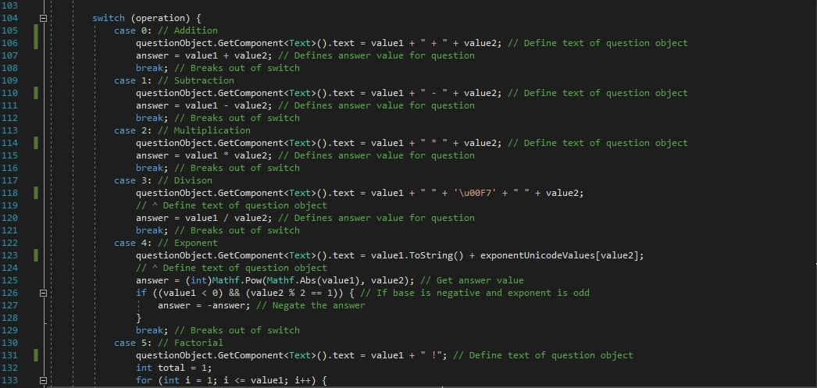

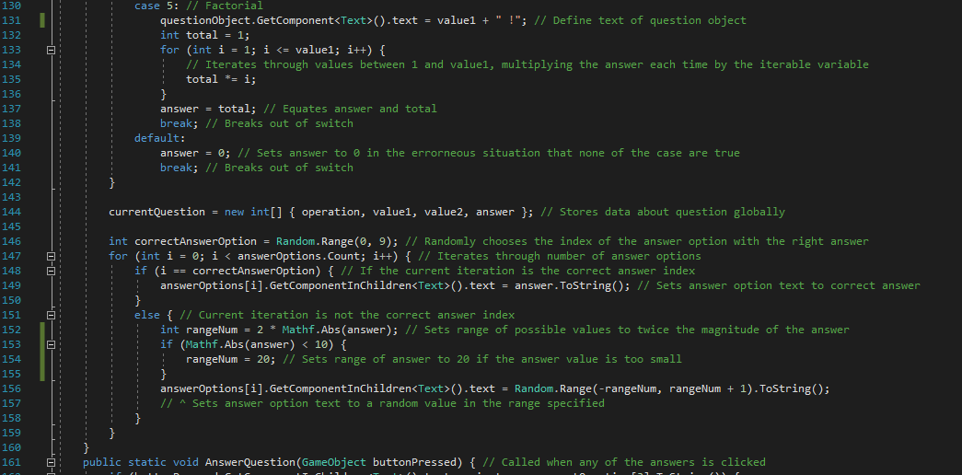

Figure 258 - Code for StartGame and NewQuestion

*StartGame* is called when the instructions UI box is clicked on, indicating that the user is ready to start. The function simply calls two functions: *StartCountdown* in *GeneralGameScript* (which begins the countdown by using an IEnumerator to decrease a counter variable slowly over time) and *NewQuestion* (which randomly creates a new question and displays it to the user along with randomly-defined answers).

There are three parts to this function: determining the operation of the question, determining the values to be used in the question (and thus also the answer to the question) and the possible answers to the question. First, the operation value is randomly selected (with each operation being considered by a value between zero and five) and stored in the variable *operation*. In addition, I initially create the variables for the three values used in the program: the two values used to make the calculation (*value1* and *value2*) and the answer which will be the result of that calculation (*answer*). I then randomly generate values for *value1* and *value2* between -20 and 20. However, since I don’t want to be very easy questions, I don’t want to allow the values to be between -1 and 1. To do this, I have used a while loop; the two values will both be repeatedly redefined randomly until such a time as both values are outside of the range between -1 and 1.

I then have a few special cases to make sure questions don’t get too difficult. First, I have a condition for when the operation is division (operation 3). I want the answer to be a whole number and there are two ways of doing this. One would be to repeatedly redefine the values randomly until the second value divides the first (which would use a similar idea to that used to ensure the values are not between -1 and 1). However, I have decided to use the second approach which changes the function of the value variables. I have made *value2* essentially become the answer, while making the two values in the calculation *value1*value2* and *value1* (thus essentially making the question $\frac{value1*value2}{value1}$ and the user would have to work out the answer (which would be $value2$). This method makes more sense to me as it requires less computation. The chances that two randomly generated values will divide each other cleanly is fairly unlikely, whereas this method will work first try every time (since multiply two integers together will always be an integer but dividing two integers isn’t always an integer).

The second special case occurs when the operation is exponentiation (operation 4). I want to limit the possible values of the base to between -12 and 12 for these questions since larger values will cause the questions to be too difficult (an example being ${19}^{12}$ which is highly unfeasible for students to have to work out in their heads). The base is determined by repeatedly redefining the value until it is not between -1 and 1, at which point the while loop is broken out of. I have also restricted the exponent (this time to between two and five inclusive). I don’t want the exponent to be negative because it will cause the answer to be a fraction (which would make the question too complicated), and I have restricted the maximum value to be five again because it would otherwise cause the question to become too difficult to answer. Finally, the last special case is when the operation is a factorial (operation 5). It has been restricted to between two and eight. It cannot be negative because negative factorials are not well-defined in mathematics and I have set a maximum of eight because the answer increases very quickly with factorials so anything more than that will result in a very large answer which would be too difficult for the user to answer.

Next in the function is the showing of the question text (on the question object) to the user and the assigning of the *answer* value. Since the operations are different, the question text will be different and the way the answer is assigned is different. To do this, I have used a switch statement using cases for each of the operations. For each case, I define the new question object text component and calculate the answer to the question, storing it as *answer[35]*. I then break out of the switch section (a required part of every case statement) which prevents other cases of the switch section being run. Another requirement in switches is to have a default case; this should never happen as *operation* should only ever be between zero and five. But if the default case was reached, I have just set the answer to zero and I break.

On line 144, I redefine the *currentQuestion* array with the data regarding the new question, in the order described earlier. Lines146-159 then create the random answers and show them to the user. I first randomly select the index (between zero and eight) of the answer buttons which the correct answer will be placed in. I then iterate through each of the values between zero and eight inclusive. If the iterated value *i* is equal to the index for the correct answer, then the text value of that answer object is set to the correct answer (casted to a string). If that’s not the case (which will be for eight of the nine values), then I create a random number with a range between the negative of twice the absolute value of the answer and twice the absolute value of the answer. (Except, if the correct answer has an absolute value less than 20, I set the *rangeNum* value to 20 to make sure there is sufficient variation in the answer options.) I then set the text of the answer object to the random number chosen.

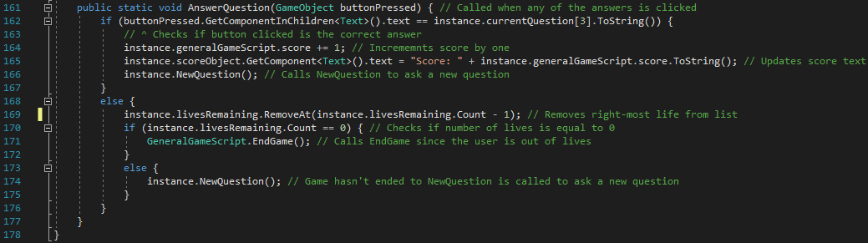

Figure 259 - Code for AnswerQuestion and end of script

*AnswerQuestion* is called (from *functionsToCall* in *GeneralFunctions*) whenever one of the answer buttons is clicked on. It takes a GameObject called *buttonPressed* as a parameter. Unlike other ‘on click’ event functions which may take the name of the clicked GameObject as a parameter to determine the button clicked, in this case, the whole GameObject clicked is passed as a parameter. This allows me to access the text value of the object’s children and see if it is the correct answer[36]. If the answer selected is correct, the user’s score increases by one, the score object text is updated and *NewQuestion* is called for a new question to be generated and shown to the user. If the answer is incorrect, the right-most life is removed from the list *livesRemaining*. Then, I check the length of *livesRemaining*, determining that the game can continue if the length is greater than zero and the game is over if the list is empty. If the game can continue, then *NewQuestion* is called but, if the game is over, then *EndGame* is called.

#### Testing

|  |  |  |  |
| --- | --- | --- | --- |
| General Tests | | | |
| Test | **Expected Output** | **Output** | **Correct?** |
| Re-test. Click Speed Maths button from Choose Game Scene | Speed Maths Scene should load | Speed Maths Scene loads. | Yes |
| N/A | 1. All UI elements appear correctly.  2. Instructions appear over question and answer area. |  | Yes |
| Click on instruction box | 1. Instructions box should disappear  2. UI elements should appear correctly  3. Question should appear.  4. Answers should appear in three-by-three layout (with at least one correct answer)  5. Timer starts to count down | 1. Instructions box disappeared.  2. All UI elements appear to be in the correct place with correct colours, size etc.  3. Question appears in correct position.  4. Answers are laid out in a three-by-three layout. $-2$ is the correct answer and that value is one of the options.  5. Countdown begins. | Yes |
| Click on correct answer | 1. Score should increase by one  2. New question should appear  3. Possible answers should change | 1. Score increases to become one.  2. New question has been generated.  3. New answers have been generated (the answer, $-1$ is one of the options, in the bottom left option) | Yes |
| Click on incorrect answer | 1. Score should remain at current score  2. One heart image should disappear  3. New question should appear  4. New answers should appear | 1. Score has remained at zero (score was zero before I clicked the incorrect answer).  2. There are still three heart images on the screen.  3. A new question has appeared.  4. New answers have appeared. | No. (Error #1) |
| Click on third incorrect answer | 1. End Game Scene should load  2. Correct score should show | 1. End Game Scene immediately loads.  2. Correct final score shows | Yes |
| Timer runs out | End Game Scene should load |  | Yes |

|  |  |  |  |  |
| --- | --- | --- | --- | --- |
| Question Generation | | | | |
|  |  | **Output (Each run 10 times)** | |  |
| Test | **Expected Output** | **Question** | **Valid question?** | **Correct?** |
| Wait for addition question | Question should appear in the form $x+y$. Values can be any integer within range | $-17+9$ $14+-2$ $-14+14$ $2+-17$ $-19+20$ $8+-17$ $-2+13$ $-2+-14$ $8+3$ $-20+13$ | Yes  No  Yes  No  Yes  No  Yes  No  Yes  Yes | No. (Error #2) |
| Wait for subtraction question | Question should appear in the form $x-y$. Values can be any integer within range | $10--3$ $19-11$ $18-7$ $-12-15$ $2--3$ $15--3$ $-5--10$ $-11-4$ $-18-15$ $11-16$ | No  Yes  Yes  Yes  No  No  No  Yes  Yes  Yes | No. (Error #3) |
| Wait for multiplication question | Question should appear in the form $x*y$. Values can be any integer within range | $-8*-9$ $-8*-18$ $-9*-9$ $-6*6$ $10*-18$ $-10*8$ $20*7$ $-13*10$ $10*-7$ $17*-13$ | Yes  Yes  Yes  Yes  Yes  Yes  Yes  Yes  Yes  Yes | Yes |
| Wait for division question | Question should appear in the form $x/y$. $x$ must divide $y$ | $-78/13$ $77/-7$ $-112/7$ $16/2$ $70/7$ $56/7$ $120/-6$ $-45/-15$ $-216/-12$ $18/-9$ | Yes  Yes  Yes  Yes  Yes  Yes  Yes  Yes  Yes  Yes | Yes |
| Wait for exponential question | Question should appear in the form $x^{y}$. $x$ and $y$ must be integers where $-12≤x≤12, x∉\{-1,0,1\}$ and $2≤y≤5$ | $-5^{3}$ $-{11}^{5}$ $-5^{5}$ $4^{2}$ $-9^{5}$ $-{12}^{4}$ $4^{3}$ $7^{2}$ $-{10}^{2}$ $-9^{4}$ | No  No  No  Yes  No  No  Yes  Yes  No  No | No. (Error #4) |
| Wait for factorial question | Question should appear in the form $x!$, where $2≤x≤8$. | $2!$ $6!$ $7!$ $2!$ $2!$ $5!$ $3!$ $4!$ $6!$ $3!$ | Yes  Yes  Yes  Yes  Yes  Yes  Yes  Yes  Yes  Yes | Yes |

##### Error #1

The first error discovered was that the image of the heart doesn’t disappear when a wrong answer is entered. This is a peculiar result since the test straight after that (entering three incorrect answers and checking if the game ends) was successful. I have discovered the reason for this is because line 169 simply removes the object from the list, but it doesn’t actually destroy the object itself. So, the second test succeeded because I check how many lives are left based on the length of the list (which does decrease when an incorrect answer is given), but the image object still remains. To fix this, I have added the following line of code, to the branch of code where line 169 is situated, which will destroy the heart object so it will disappear from the screen.



Figure 260 - Updated code to fix Error #1

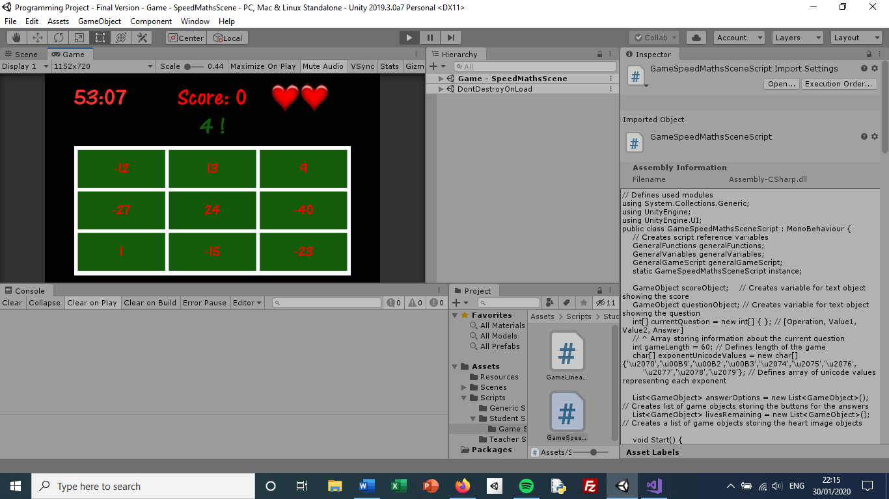

Figure 261 - Re-test: Screenshot of screen after clicking on an incorrect answer

As shown in the screenshot above, the right-most heart image disappears when I select an incorrect answer. Therefore, this error has been fixed (and I also re-tested clicking three incorrect answers to make sure the right outcome still occurred – it did).

##### Error #2

The second error occurs when the selected operation is addition. It isn’t an error as such but more something which doesn’t look right and I would like to change. The issue occurs when *value2* is negative. When this happens, the question will be something like $5+-4$. Although mathematically valid, I would rather this shows $5-4$ as it is simpler and less confusing for the user. To do this, I have added an if statement in the addition case branch checking if *value2* is positive or negative. If it is positive, then the code is unchanged from before. However, if it is negative, then I switch the operation sign to a minus sign and show the absolute value of *value2*, as opposed to its true value. The updated code for the addition case branch is shown below:

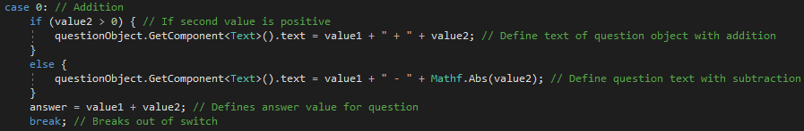

Figure 262 - Updated code for addition case

|  |  |
| --- | --- |
| Re-test for addition questions | |
| Question | Valid? |
| $$19+17$$ | Yes |
| $$-8+6$$ | Yes |
| $$-6-13$$ | Yes |
| $$-2+5$$ | Yes |
| $$12-7$$ | Yes |
| $$16+12$$ | Yes |
| $$-10-3$$ | Yes |
| $$12+19$$ | Yes |
| $$-9-5$$ | Yes |
| $$18-3$$ | Yes |

The above test involves questions where *value1* and *value2* are positive, where *value1* is positive and *value2* is negative, where *value1* is negative and *value2* is positive, and where both *value1* and *value2* are negative (therefore testing all possible scenarios with regards to the sign of the values). All of the tests made are valid as they now appear in the format that I want[37].

##### Error #3

The third error is essentially the same as the second error but with the subtraction operation instead of addition. When *value2* is negative, the question will show two minus signs next to each (e.g. $4--5$). Like error #2, although it’s mathematically valid, I would rather just show a plus sign instead as it’s clearer for the user and less confusing.

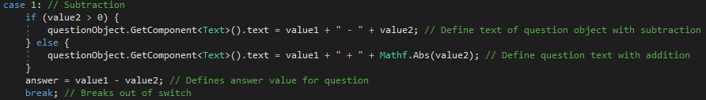

Figure 263 - Updated code for subtraction case

The code I have changed is very similar to the fix for error #2. I check using an if statement if *value2* is positive or negative. If positive, then the text set to the question object is unchanged. But if it is negative, then I switch the operator to a plus sign and I show the absolute value of *value2* (because the minus sign has ‘gone into the minus sign’). The rest of the case is unchanged – the answer is set to the difference between the values and I break out of the switch section.

|  |  |
| --- | --- |
| Re-test for subtraction questions | |
| Question | Valid? |
| $$-8-13$$ | Yes |
| $$18+13$$ | Yes |
| $$-3+8$$ | Yes |
| $$17-9$$ | Yes |
| $$4-6$$ | Yes |
| $$20+14$$ | Yes |
| $$7-20$$ | Yes |
| $$-19-14$$ | Yes |
| $$-5-20$$ | Yes |
| $$18-7$$ | Yes |

As with the second re-test, these tests cover all four possibilities with regards to the sign of *value1* and *value2*. In all of the tests, the question appeared in the format that I want so I’m satisfied that this has been solved.

##### Error #4

The fourth error has occurred when the operation is an exponent. The issue I have with this is again when the base value is negative. A question shown as $-5^{2}$ would have an answer calculated in my program of $25$ whereas the mathematical answer to a question written as $-5^{2}$ is $-25$. I have realised that the way the question should have been written is ${\left(-5\right)}^{2}$ which means that the value $-5$ is squared not just $5$.

To solve this, I have updated the case branch to check if *value1* is positive or negative. If it is positive, then the question object text remains unchanged (like in errors two and three). However, if it is negative, then I added parentheses around *value1* to make sure the question is mathematically valid. The code for the updated case statement is shown below:

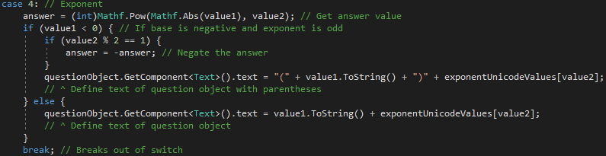

Figure 264 - Updated code for exponent case

|  |  |
| --- | --- |
| Re-test for exponentiation questions | |
| Question | Valid? |
| $$3^{2}$$ | Yes |
| $$3^{2}$$ | Yes |
| $${\left(-5\right)}^{4}$$ | Yes |
| $${\left(-12\right)}^{4}$$ | Yes |
| $${\left(-8\right)}^{4}$$ | Yes |
| $${\left(-2\right)}^{5}$$ | Yes |
| $$4^{3}$$ | Yes |
| $${\left(-11\right)}^{5}$$ | Yes |
| $${\left(-8\right)}^{5}$$ | Yes |
| $$3^{3}$$ | Yes |

All of the questions in the re-test have given valid questions (with both positive and negative bases, with both odd and even exponents). So, I am happy with this solution.

#### Review

##### Content of Section

In this section, I have created the second of the three games for the program. It is called ‘Speed Maths’ and involves students answering maths questions which use basic mathematical operations. The aim of the game is not to improve mathematical ability (as the questions are to a large extent simple) but to improve the speed at which students answer such questions. The student will be permitted three incorrect answers before the game ends.

##### Testing

I have tested each aspect of the section in a different way. For the buttons, I made sure the event that occurred after clicking on it was correct. For the questions, I tested that the questions which were produced were valid and made sense when displayed to the user. To do this, I had to test each operation multiple times (at least 10 each) to ensure all possible generated values were covered.

##### Meeting Success Criteria

This section fulfils the success criterion that the user should be able to play games. It is the main content of the program as it is where the students improve mathematically, which is the whole point of the program. Other than that, this also indirectly helps to fulfil success criteria such as having leaderboards and homeworks since creating a game allows leaderboards to exist and for homeworks to be set on this game.

##### Summary of the Program at this Stage

|  |  |
| --- | --- |
| Students | Teachers |
| Create account | Create account |
| Login | Login |
| View leaderboards | View leaderboards |
| Play two of the games | Set homeworks |
|  | View Homeworks |
|  | Add Classes |

##### Changes from Design

The only notable changes have been from the fixes made due to the errors found during testing. This involved adding parentheses to the exponent questions when the base is negative and switching the plus and minus signs when *value2* is negative.

## Stage #22 – Algebra Millionaire Scene

In this final section, I will create, develop and test the third and final game in the program, ‘Algebra Millionaire’. It involves playing a game very similar to the popular TV programme, ‘Who Wants to be a Millionaire’, with the exception that the questions will all be algebra related. Like the TV equivalent, the questions will get harder as the game progresses. There will be three stages: linear equations, linear equations with an additional constant multiplier and a quadratic equation (I will make sure that all solutions are integers). The aim for the student will be to reach £1 million, which is reached by answering 15 questions correctly in a row. Again, like the TV programme, I will implement the three classic lifelines (‘50/50’, ‘Phone a Friend’ and ‘Ask the Audience’). To add an extra level of complexity for the user, I will add a countdown for each question (which is not a feature currently on the TV show).

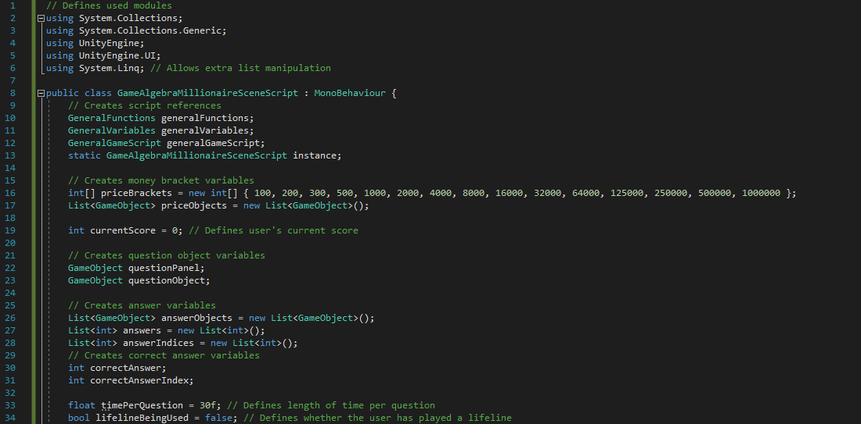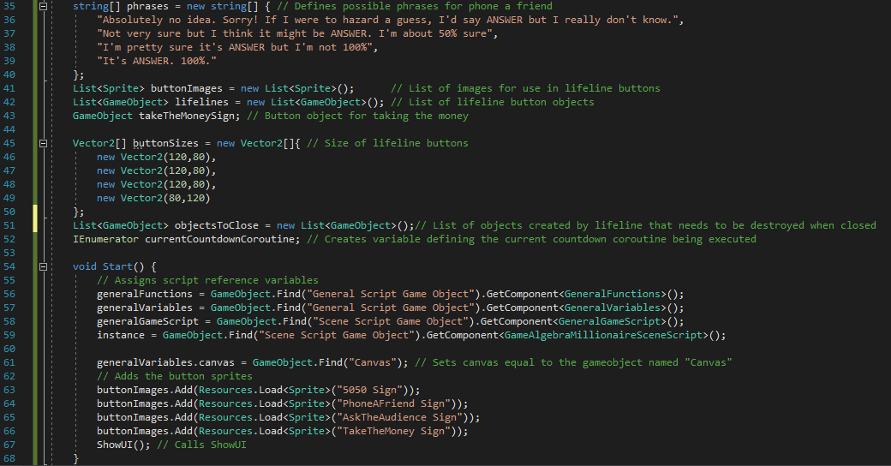

Figure 265 - Code for beginning of GameAlgebraMillionaireSceneScript and Start function

First, as with all scripts, the used modules are defined and the script reference variables are created. *System.Linq* is used as a module because it provides additional functions with regards to using lists such as finding the total sum of an integer list (which will be used in the ‘Ask the Audience’ lifeline), which isn’t a function available in *System*. In addition to the usual script reference variables, I have created the following variables:

|  |  |  |
| --- | --- | --- |
| Variable | Data Type | Use |
| *priceBrackets* | Array of integers | This defines the monetary progression of the user’s ‘winnings’ depending on the number of questions the user has answered correctly. It progresses in the same fashion as in the TV show. |
| *priceObjects* | List of GameObjects | This is a list of the GameObjects which will show on the grid on the right-hand side of the screen to show the price brackets mentioned above. |
| *currentScore* | Integer | This defines the user’s current score in integer terms (how many questions they have answered correctly, not how much money they have won so far). |
| *questionPanel* | GameObject | This variable will hold the background panel which will show the question and answers. |
| *questionObject* | GameObject | This variable will hold the GameObject which will show the text of the question. |
| *answerObjects* | List of GameObjects | This is a list of GameObjects which will show the answer buttons. |
| *answers* | List of integers | This is a list of integers which will represent the four possible answers, in the order in which they appear in *answerObjects*. (I.e. the first zeroth value in *answers* will be the same as the text value showing in the zeroth value of *answerObjects*). |
| *answerIndices* | List of integers | This is a list of integers which will represent the indices of *answerObjects* which are still shown to the user. For most of the times, this will simply be the values zero to three. But, when the ‘50/50’ lifeline is played, two of the items will be removed. |
| *correctAnswer* | Integer | This integer variable will simply hold the value of the correct answer. |
| *correctAnswerIndex* | Integer | This variable will simply hold the index of the answer option which holds the correct answer. |
| *timePerQuestion* | Float | This float value defines how much time is permitted to the user per question. |
| *lifelineBeingUsed* | Boolean | This Boolean value defines whether a lifeline is currently in use or not. The reason for this is I don’t want something like ‘Phone a Friend’ to be clicked on whilst the bar chart for ‘Ask the Audience’ is already being displayed.  I’ll still allow multiple lifelines in the same question, but they cannot be selected when there is already one showing on the screen (‘50/50’ isn’t an issue here as it simply removes two options and doesn’t actually take up any additional space on the screen.) |
| *phrases* | Array of strings | This defines a series of phrases which I have written that will be the responses in the ‘Phone a Friend’ lifeline. Each of them has the word ‘ANSWER’ in the string. I will replace this with an appropriate answer in the *PhoneAFriend* function. |
| *buttonImages* | List of sprites | This represents a list of sprites which are going to be used either as lifelines or for the ‘Take the Money’ sign. |
| *lifelines* | List of GameObjects | This is a list of GameObjects which are the lifeline buttons. When one of the buttons is clicked, the appropriate lifeline will be used. |
| *takeTheMoneySign* | GameObject | This is a GameObject which is for the ‘Take the Money’ sign. When the button is clicked, the game will end and the money won so far is ‘secured’. |
| *buttonSizes* | Array of Vector2s | This is an array of Vector2s which represents the sizes of the lifelines and ‘Take the Money’ sign. Their indices reflect that of *buttonImages*. |
| *objectsToClose* | List of GameObjects | When either the ‘Phone a Friend’ or ‘Ask the Audience’ lifelines are used, additional GameObjects are created to display the outcome of the lifeline. These are all added to *objectsToClose* so that, when the user clicks to close the lifeline response, I can iterate through *objectsToClose* and destroy all of the GameObjects in there. |
| *currentCountdownCoroutine* | IEnumerator | This variable stores the IEnumerator currently being run. This will be used for the countdowns and so that I am able to stop the countdowns when the user gets a correct answer. (I won’t be able to simply reset the time value to the beginning because, for each question, the coroutine will be executed individually.) |

In *Start*, as well as doing its usual job of assigning the script reference variables and assigning the canvas, I load each of the lifeline sprites and add them to *buttonImages*. Finally, I call *ShowUI* to display all of the UI.

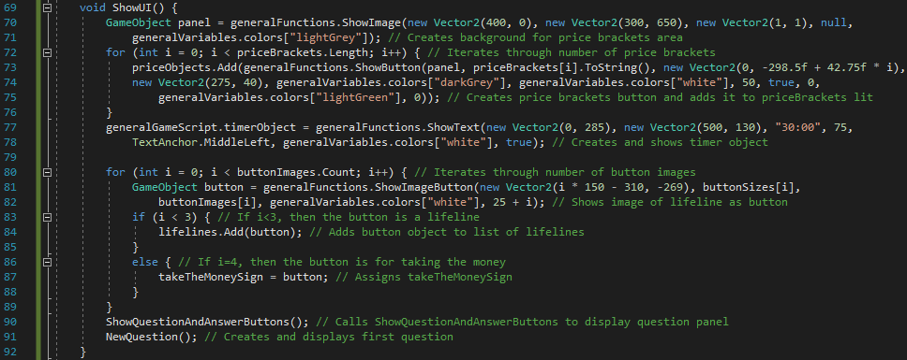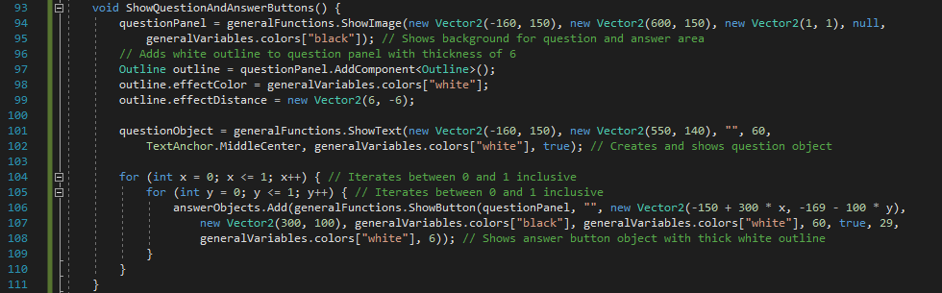

Figure 266 - Code for ShowUI

For the displaying of the UI, I have set it up into two sections. One section will contain the showing of the question and answers panel while the other section will display everything else. Showing the question and answer panel will be in its own function because it is a fairly large piece of code and I want it to be clear where that section is. In *ShowUI*, I first create the grid on the right-hand side of the screen which displays the price brackets, first by creating a light grey background panel before iterating through the array of price brackets and displaying a piece of text for each one. I then create the timer object (the variable for which is in *GeneralGameScript*) before iterating through the recently-loaded list of images and creating a button for each one, placing it below where the question panel will be. Finally, *ShowQuestionAndAnswerButtons* and *NewQuestion* are called.

There are three things to be displayed in *ShowQuestionAndAnswerButtons*: the background panel, the question object and the answer objects. The background panel is created first with a white-coloured thick outline. Then, the question object is created with its text initially set to an empty string as no question has been created yet. Finally, I iterate between zero and one with two embedded for loops to create a two-by-two grid of answer buttons (using a sequence-based method for positioning the buttons on the x-axis and y-axis).

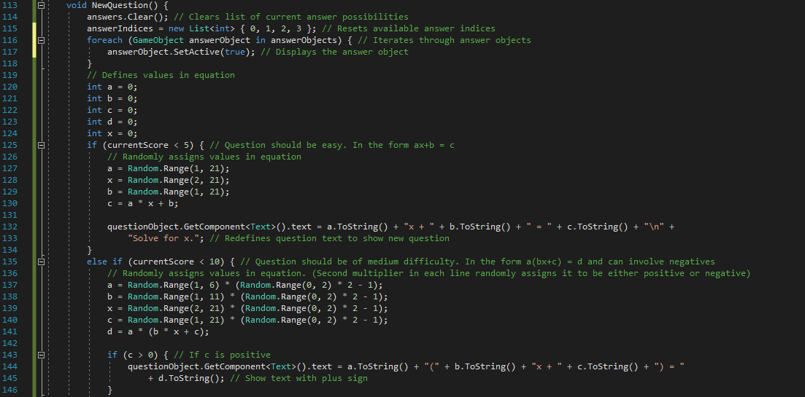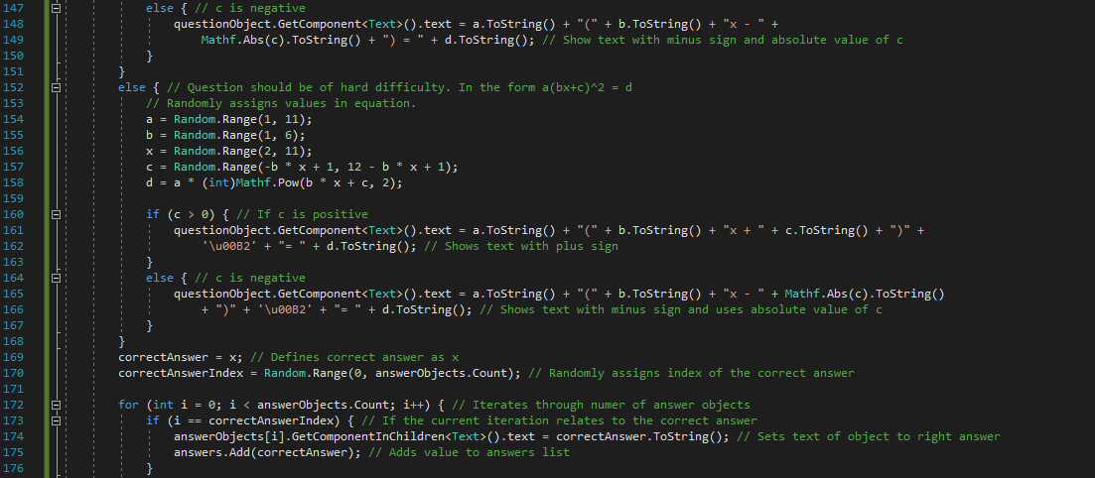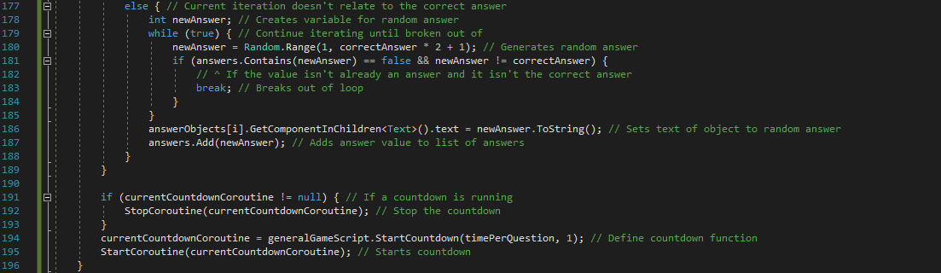

Figure 267 - Code for NewQuestion

*NewQuestion* generates a new question and displays it to the user, in addition to generating random answers and resetting the countdown timer. First, I reset everything that might have been changed in the last question. The list, *answers*, needs to be reset because it currently has all of the answers from the previous question. *answers.clear()* removes every item in the list and leaves it empty so it can be added with the answers for the new question. I also reset the list *answerIndices* to show all four values again and I iterate through the answer objects, displaying each one. I then define the local variables *a*, *b*, *c*, *d* and *x* which will represent the four constant values in the question and the variable, which will be the answer. There are then three different situations: when the user has got under five correct answers (under £1000), when the user has got over five but under 10 correct answers (between £1000 and £16000) and when the user has got over ten but under 15 correct answers (between £32000 and £500000).

If the user has got under five questions correct so far, the question will be shown in the form $ax+b=c$. I randomly generate values for *a*, *x* and *b* before calculating *c* for the generated values[38]. The question object is then updated to show the question. I then do the same thing for the other two formats of question ( $a\left(bx+c\right)=d$ if the number of answered questions is less than 10 or $a{\left(bx+c\right)}^{2}$ if the number of answered questions is greater than nine). The only difference arises with the fact that I allow negative values for the second and third types of question – to add an extra level of difficulty. The way I do this is by creating second random value, this time between zero and one. I multiply the value by two and take away one leaving either one or negative one. I multiply this value to the original value for the constant, making it either positive or negative. However, negative values create the same issue found in the previous section – displaying negatives will show both a plus and minus sign. To combat this, I have used the same solution used in the Speed Maths Scene. I check if the value is positive or negative; if it is positive then I leave it as it is and display it normally. But, if it is negative, then I display a negative sign instead and show the absolute of the negative value. Also, for the final type of question, it involves the squared sign, for which I have used its Unicode representation (seen on lines 162 and 166) as that is permitted in C#.

To generate the answers, I first set the global variable, *correctAnswer*, equal to the local variable, *x*, since *x* is the value that the user is meant to work out. I also assign *correctAnswerIndex* a random value between zero and the number of answer objects subtract one[39], to determine the answer box which will contain the correct answer. I then iterate through the number of answer objects. If the current iterative variable is equal to *correctAnswerIndex*, then the correct answer is added to *answers* and the text of that answer box is edited to now show the correct answer. If the current iterative variable is not equal to *correctAnswerIndex*, then I need to generate a random incorrect answer to show. This randomly-generated value has a condition though: it must not be a duplicate answer. So, I use a while true loop to keep generating values until one the value is not already in the list *answers* and it isn’t equal to *correctAnswer* (the second check is necessary because *answers* may not contain *correctAnswer* at the time of checking). When this happens, I break out of the while true loop and append the randomly-generated value to *answers* while updating the text of the answer object.

Finally, since a new question and random answers have been generated, the countdown timer needs to be reset. To do this, I end the current countdown by stopping the coroutine running the countdown (only if such a coroutine exists – it should exist for all questions other than the first), defining the new coroutine and finally starting the newly-defined coroutine.



Figure 268 - Code for CountdownFinished

This function will be called from *GeneralGameScript* (hence why the *static* keyword is required) when the countdown ends. It simply calls *EndGame* since the countdown ending means the user has lost the game. I do this using the *instance* variable to reference it because *EndGame* is a non-static function (which is also the reason why I cannot simply call *EndGame* from *GeneralGameScript*).

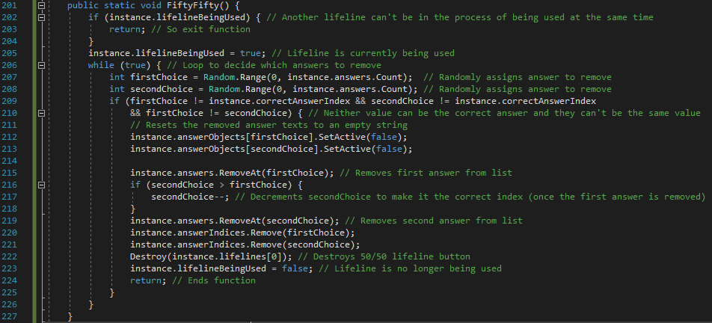

Figure 269 - Code for FiftyFifty

*FiftyFifty* is the function that is called when the ‘50/50’ image button is clicked on during a question. First, I check that the no other lifelines are currently being processed (as stated earlier in the variable definitions, I do allow multiple lifelines for the same question but they cannot be executed whilst another one is being processed). If another lifeline is being processed, the function simply ends. Assuming there are no other lifelines being processed at the time, *lifelineBeingUsed* is immediately set to *true* to prevent other lifelines from being used. I have then wrapped the rest of the function in a while true loop. The reason for this is to make sure the two answers that are removed are both incorrect answers and also not the same answer. So, I randomly generate two indices for answers to be removed and check if they fulfil the criteria stated above. If they don’t, then nothing will happen and it will move onto the next iteration to generate new values. If they do fulfil the criteria, then the two answer objects are set to not be displayed to the user and the two answers are removed from the list *answers*, in addition to the two answer indices being removed from the list *answerIndices*. Finally, the ‘50/50’ lifeline button is removed, *lifelineBeingUsed* is set to *false* (paving the way for another lifeline to be used if required) and I return to end the function.

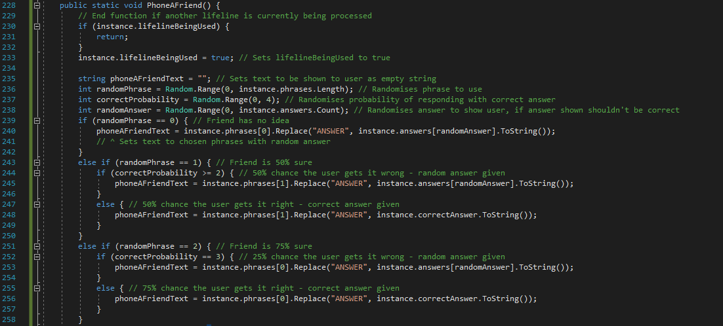

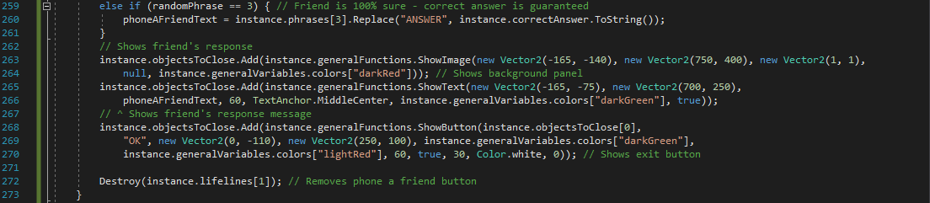

Figure 270 - Code for PhoneAFriend

Obviously, I have not incorporated a literal ‘Phone a Friend’ feature because, although it’s possible for mobile devices, it wouldn’t work for PCs or tablets and it would cause issues with the person answering the call and timing the call etc. Instead, I have created four set responses which will be made at random. The responses have a 25% chance, 50% chance, 75% chance and 100% chance of getting the right answer and each response has an equal chance of coming up.

First, I prevent the function from executing if one of the lifelines is currently being executed (by checking the Boolean variable *lifelineBeingUsed*). I then set *lifelineBeingUsed* to *true* and create a few local variables for use in the function. *phoneAFriendText* defines the string which will be shown to the user as the friend’s response. *randomPhrase* determines which of the preset phrases should be shown while *correctProbability* is used to determine the probability that the correct answer is provided. Finally, *randomAnswer* determines which of the answers to display at random (but the variable is only used if the correct answer isn’t going to be provided).

*randomPhrase* will be a value between zero and three (assuming the current number of phrases). If *randomPhrase* is zero, then the user has a 25% chance of being shown the right answer because the ‘friend’ has no idea so the answer chosen is completely random. This is done by setting *phoneAFriendText* equal to *phrases[0]* with the word ‘ANSWER’ replaced with the random answer chosen. If *randomPhrase* is one, then the user has a 50% chance of showing the correct answer. I use *correctProbability* to determine if the answer given should be correct or not. If *correctProbability>1* (either two or three), then I set *phoneAFriendText* equal to *phrases[1]* again with the word ‘ANSWER’ replaced with the random answer chosen. But, if *correctProbability* is either zero or one, then the answer given should be correct so I instead replace ‘ANSWER’ with the correct answer value. I then do the same for if *randomPhrase* is two, giving a random answer if *correctProbability>2* and giving the right answer if *correctProbability<=2* (giving a 75% chance of showing the correct answer). Finally, if *randomPhrase* is equal to three, then the correct answer is guaranteed so I just output the relevant phrase with ‘ANSWER’ replaced with the correct answer.

Now that the friend’s response text has been defined, I show it to the user. I do this by creating a background panel, text object (to show the message) and a button (to exit the message). These created objects are added to *objectsToClose*, so that the objects will be removed from the screen when the exit message is clicked on. Finally, the lifeline button for ‘Phone a Friend’ is destroyed so that the user can’t use the same lifeline again. At the end of the function, I have not set *lifelineBeingUsed* to *true* like I did in *FiftyFifty*. The reason for this is the panel with the friend’s message is still being shown so I will set *lifelineBeingUsed* to *true* when the exit button is clicked and the added objects are removed.

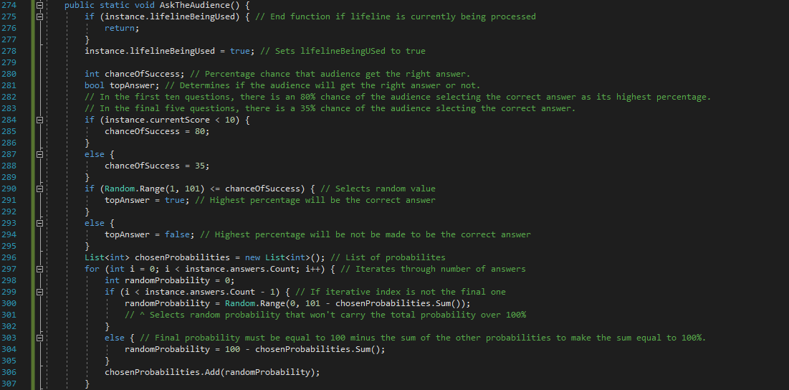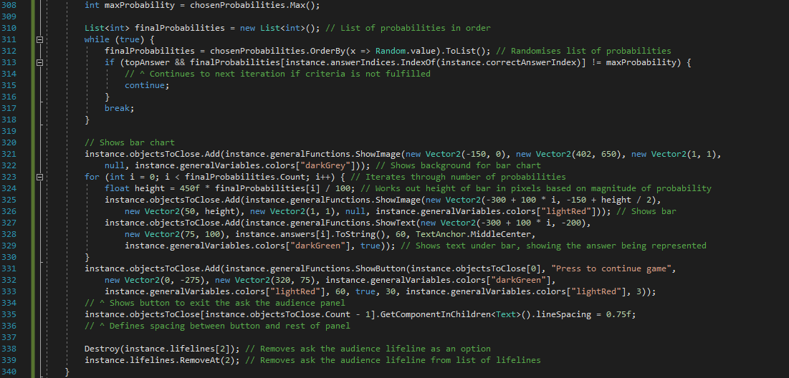

Figure 271 - Code for AskTheAudience

First, as with the previous lifeline functions, I ensure the function doesn’t execute if another lifeline is currently being used. As with *PhoneAFriend*, there are multiple local variables used in this function. *chanceOfSuccess* is the percentage probability that the audience are going to give the right answer as its top result. Having checked the statistics online, I found that in the first 10 questions, the audience have a 95% chance of giving the right answer in the TV show[40]. However, this seems too high for my game so I’ve changed that to 80% to make it a little more difficult for the user. For the final five questions, I couldn’t find any statistics online about the TV show, so I have arbitrarily set a probability of 30%. *chanceOfSuccess* is set by simply checking the value of *currentScore* and assigning *chanceOfSuccess* to either 80 or 30 based on whether *currentScore* was less than 10 or not respectively. However, *chanceOfSuccess* doesn’t itself determine if the right answer should be provided or not. For that, I have created the Boolean *topAnswer* which will be *true* if the correct answer should be shown top and *false* otherwise. To work out the value of *topAnswer*, I create a random integer between one and 100 and, if it is less than or equal to the value of *chanceOfSuccess*, then *topAnswer* is set to *true*. If not, then *topAnswer* is set to *false*.

Lines 290-301 randomly-generate four probabilities that have a sum of 100%[41]. I do this by iterating through the number of values in *answers* and generating a random probability for each one, adding it to *chosenProbabilities*, which will store the list of probabilities. However, when the current iterated value is the final one in the list *answers*, I don’t set it randomly and in fact set it to 100 subtract the current sum of the *chosenProbabilities* list. This ensures that the total sum of the list will be 100 at the end of the loop. I then create a variable called *maxProbability* which will store the largest percentage in *chosenProbabilities*.

*chosenProbabilities* gives the list of probabilities but it isn’t necessarily in the order I want. To order the list the way I want it, I simply shuffle the list continuously until the correct answer is in the index I want (only required if *topAnswer* is *true*). Although this method isn’t computationally the best, the low number of values in *chosenProbabilities* means the expected number of iterations is fairly low and so the code shouldn’t take long to run. I break out of the while true loop when the criterion is fulfilled.

Finally, I need to display the audience’s results to the user and I do this in the form of a bar chart. I first create a background panel before iterating through *finalProbabilities*, displaying a vertical rectangle for each one, where the height of the rectangle reflects the percentage of the audience that has voted for that answer[42]. I also show a piece of text under each rectangle which states which answer the bar represents. Finally, I create an exit button (which will call *CloseObjects* when clicked), the line spacing is defined as 0.75 and the lifeline for ‘Ask the Audience’ is removed from the list and its object is destroyed, so the user can’t use the lifeline again.

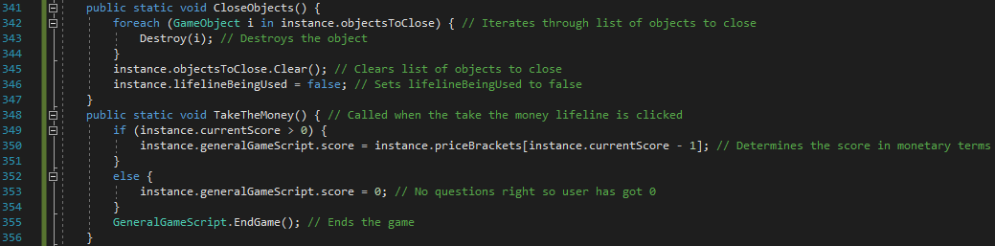

Figure 272 - Code for CloseObjects and TakeTheMoney functions

*CloseObjects* is called when the exit button for ‘Phone a Friend’ or ‘Ask the Audience’ is clicked. It simply has the job of removing all of the objects which were created in the execution of that lifeline. This is done by iterating through the list *objectsToClose* and destroying each object before clearing the list. Finally, *lifelineBeingUsed* is set to *false* so that another lifeline can be used if required.

*TakeTheMoney* is called when the ‘Take the Money’ button is clicked. At this point, the game ends but the score needs to be set to its monetary equivalent. If the user has got at least one question correct, then their score is set to the value of the price bracket they’ve reached most recently. If they haven’t got any answers right then their score is zero. I then call *EndGame* in *GeneralGameScript* as the game is now over.

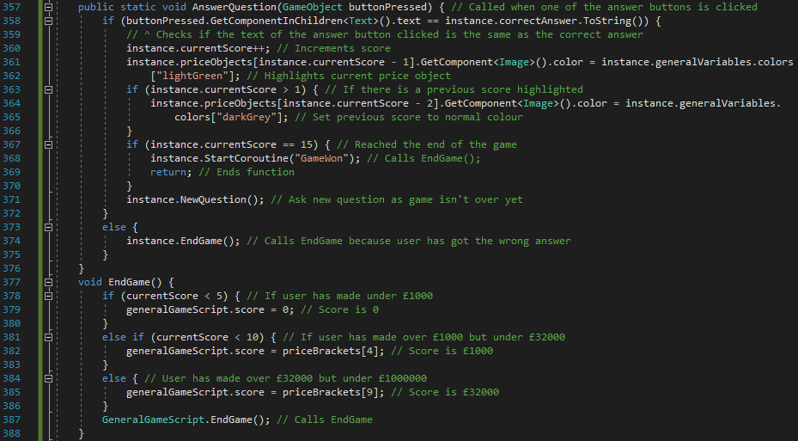

Figure 273 - Code for AnswerQuestion and EndGame

*AnswerQuestion* is called when one of the answers is clicked. The function takes a GameObject parameter which allows me to determine which answer was clicked on. The first thing that needs to be checked is if the answer clicked is correct or not. I do this by checking if the text component of the GameObject, *buttonPressed*, is equal to the correct answer. If it is correct then a number of things happen. First, the user’s score increments by one. Then, I highlight the newly-reached price bracket green on the panel on the right-hand side of the screen, while also undoing the highlighting of the previously-highlighted price bracket. I then need to check if the game has been won or not. If it has been won (indicated by a *currentScore* value of 15), then *GameWon* is called and the function ends. If not, then *NewQuestion* is called to continue the game. If, however, the answer chosen is not correct, then *EndGame* is called.

The job of *EndGame* is to convert the user’s score into its monetary equivalent before calling *EndGame* in *GeneralGameScript*. As per the TV show’s rules, the user’s winning is £0 if they get under five questions correct. It is otherwise £1000 if the user gets under 10 questions correct and, they ‘receive’ £32000 if they get at least 10 questions correct (they can’t have got 15 correct as *EndGame* wouldn’t have been called in that scenario). Finally, *EndGame* in *GeneralGameScript* is called to move onto the End Game Scene and upload results to the database.

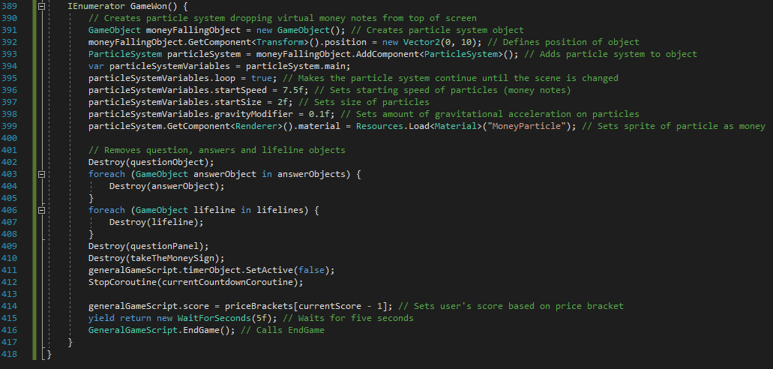

Figure 274 - Code for GameWon and end of script

If the user completes the game and wins £1000000, I didn’t want them to simply get a message saying they’ve won a million pounds because that seems a bit anti-climactic. Instead, I decided it would be nice to have monetary notes ‘fall’ from the top of the screen for a few seconds. Unity3D has a feature called ‘Particle Systems’ which allows me to do just that. I first create a new GameObject, position it above the screen and add a Particle System component to it. The variables set below that define different aspects of the system. *loop* being set to *true* means that the system will continue forever (until I go to the End Game Scene), *startSpeed* defines the original speed of the notes, *startSize* defines the size of the notes and *gravityModifier* defines how strong (if at all) the gravitational acceleration should be on the notes. This is set to 0.1 (chosen using trial and error) to make sure the notes fall at a reasonable rate. To make the notes falling more prominent, I remove all of the objects relating to the question, answers and lifelines. I also remove the timer text and stop the current countdown before updating the user’s score. Finally, the program waits for five seconds (to allow the user time to admire the falling notes) before calling *EndGame* in *GeneralGameScript* to upload the score to the database and move onto the End Game Scene.

#### Testing

For a lot of these tests, although I haven’t shown them all in the form of screenshots, I have tested them multiple times (up to 20 times in the case of the testing of the lifeline functionality).

|  |  |  |  |
| --- | --- | --- | --- |
| General Tests | | | |
| Test | **Expected Output** | **Output** | **Correct?** |
| Re-test. Click Algebra Millionaire button from Choose Game Scene | Algebra Millionaire Scene should load | Algebra Millionaire Scene loads. | Yes |
| N/A | All UI should look correct |  | Yes |
| N/A | First question should appear – in valid format | Question appears in the format $ax+b=c$ which is the correct format. The constants used $16$ and $16$ are in the range expected. | Yes |
| N/A | Four answers should appear – within permitted range | The correct answer here is $15$. The other answers are all within the range of $-2*answer≤x≤2*answer$. | Yes |
| N/A | Timer should start counting down from 30 seconds | As shown, the countdown object counts down from 30 seconds when the game starts. | Yes |
| Click on correct answer | 1. New question should show.  2. New answers should show.  3. New price bracket should be highlighted green.  4. Old price bracket should no longer be highlighted | Before click:    After click:    1. A new question has been generated.  2. New answers have been generated.  3. New price bracket (£100) is highlighted green.  4. No previous bracket to de-highlight.  After another click on right answer:    1. A new question has been generated.  2. New answers have been generated.  3. New price bracket (£200) is highlighted green.  4. Old price bracket (£100) has been reset to a grey background again. | Yes |
| Timer reaches zero (no correct answers) | End Game Scene should load. £0 should be won. |  | Yes |
| Timer reaches zero (between one and four correct answers) | End Game Scene should load. £0 should be won. |  | Yes |
| Timer reaches zero (five correct answers) | End Game Scene should load. £1000 should be won. |  | Yes |
| Timer reaches zero (between six and nine correct answers) | End Game Scene should load. £1000 should be won. |  | Yes |
| Timer reaches zero (10 correct answers) | End Game Scene should load. £32000 should be won. |  | Yes |
| Timer reaches zero (between 11 and 13 correct answers) | End Game Scene should load. £32000 should be won. |  | Yes |
| Timer reaches zero (14 correct answers) | End Game Scene should load. £32000 should be won. |  | Yes |
| Incorrect answer given (no correct answers) | End Game Scene should load. £0 should be won. |  | Yes |
| Incorrect answer given (between one and four correct answers) | End Game Scene should load. £0 should be won. |  | Yes |
| Incorrect answer given (five correct answers) | End Game Scene should load. £1000 should be won. |  | Yes |
| Incorrect answer given (between six and nine correct answers) | End Game Scene should load. £1000 should be won. |  | Yes |
| Incorrect answer given (10 correct answers) | End Game Scene should load. £32000 should be won. |  | Yes |
| Incorrect answer given (between 11 and 13 correct answers) | End Game Scene should load. £32000 should be won. |  | Yes |
| Incorrect answer given (14 correct answers) | End Game Scene should load. £32000 should be won. |  | Yes |
| Get 15 correct answers. | 1. Question, answers, lifeline buttons and timer text should disappear.  2. Money should fall from the top of the screen.  3. After five seconds, End Game Scene should load and £1000000 should be won. | After about five seconds: | Yes[43] |

|  |  |  |  |
| --- | --- | --- | --- |
| Lifelines | | | |
| Test | **Expected Output** | **Output** | **Correct?** |
| Click on ‘50/50’ button | 1. Two incorrect answers disappear.  2. ‘50/50’ image button should disappear. | The correct answer, 3, is still an option. | Yes |
| Click on ‘Phone a Friend’ button | Message appears showing friend’s response with an attempt to answer the question. | (In this question, $12$ was one of the possible answers.) | Yes |
| Click on ‘OK’ button on ‘Phone a Friend’ response | 1. Whole message should disappear.  2. ‘Phone a Friend’ image button should have disappeared. |  | Yes |
| Click on ‘Ask the Audience button’ | A bar chart appears showing percentages for each option. |  | No. (Error #1) |
| Click on exit button on ‘Ask the Audience’ panel | 1. ‘Ask the Audience’ panel should disappear.  2. ‘Ask the Audience’ image button should disappear. |  | Yes |
| Click on ‘Take the Money’ button. (After 3 correct answers) | End Game Scene should load. User should have won £300. |  | Yes |
| Click on ‘Take the Money’ button. (After 7 correct answers) | End Game Scene should load. User should have won £4000. |  | Yes |
| Click on ‘Take the Money’ button. (After 13 correct answers) | End Game Scene should load. User should have won £250000. |  | Yes |
| Click on ‘Phone a Friend’ having already used ‘50/50’ in the same question | Should work in the same way as before. The answer given by the friend should be one of the two remaining options. | After playing ‘50/50’:    After playing ‘Phone a Friend’:    (15 is one of the two options still available.) | Yes |
| Click on ‘Ask the Audience’ having already used ‘50/50’ in the same question. | Should work in the same way as before. Bars should only appear for the two remaining answers (but the two bars should still look like they add to make 100%). | After playing ‘50/50’:    After playing ‘Ask the Audience’, there was no change on the screen and the following error appeared in the console: | No[44]. (Error #2) |

##### Error #1

This issue isn’t really an error but it is something I noticed during testing that I didn’t want to happen. When I use the ‘Ask the Audience’ lifeline, the bar chart appears in the centre of the screen. It is covering up the countdown timer text so the user can’t tell how much time is remaining (since the timer still counts down even when a lifeline is being used). To combat this, I have made changes to the position and height of the bar chart panel (and, therefore, the position and height of the bars). I have changed the position of the whole panel by moving it down by 50 units and I have changed the height by decreasing it by 75 units. I have also moved the relative position of the exit button up by 50 units (as it’s now further up relative to the panel). The final change made was decreasing the maximum height of each bar (in the case of it representing 100%) from 450 pixels to 350 pixels. The updated code is shown below:

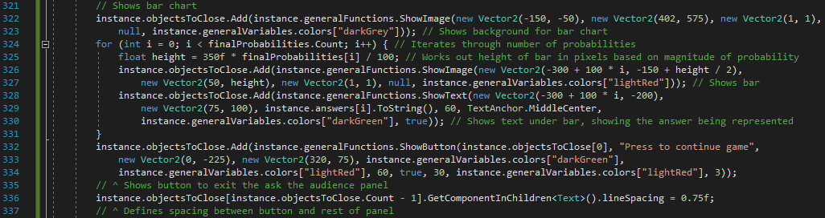

Figure 275 - Updated code for displaying bar chart

The values that I’ve changed in the screenshot above have been decided using trial and error so I know the output is now how I want it. Below is a screenshot of what happens when I use the ‘Ask the Audience’ lifeline with the changes above:

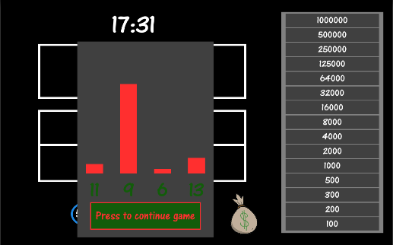

Figure 276 - Screenshot of 'Ask the Audience' lifeline after updating code

As shown, the timer object is now clearly visible even when the ‘Ask the Audience’ lifeline is in use. So, I’m happy to conclude this issue has been fixed.

##### Error #2

The second error has occurred as a result of the ‘50/50’ and ‘Ask the Audience’ lifelines being used in succession when answering the same question. The error states that “Index was out of range” and is referencing line 341 in *GameAlgebraMillionaireSceneScript*. This tells me that the error is occurring somewhere in the function, *AskTheAudience*. Since the error only occurs after the ‘50/50’ lifeline has been used, the error must be because the number of answers available is two as opposed to four. However, I have checked through the whole function and it appears that everything is developed dependent on the size of the lists *answers* and *answerIndices* which means it should all be working. In addition, I have commented out individual parts of the function (white-box testing) to determine where specifically the error is occurring in the function. I have narrowed the error down to line 313. On this line, the only variables used which relate to the number of answers available are *answerIndices* and *correctAnswerIndex*. *correctAnswerIndex* is simply displaying the index of the correct answer and I don’t want it to change if the ‘50/50’ lifeline is used. I have checked the *FiftyFifty* function and can confirm that *correctAnswerIndex* isn’t changed in that function. Therefore, the error must be to do with the variable *correctAnswerIndex*.

I have rerun the program and printing the list *answerIndices* to the console. As stated before, the error was only occurring around 50% of the time. From rerunning the program, I have noticed that, when there is an error, there are three values left in *answerIndices* instead of two (as shown in the screenshot below), while there are the correct number of values when the code executes as expected.

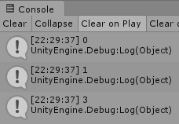

Figure 277 - Erroneous output

I have finally realised the reason for this. When I remove the two values from *answers*, I have made an adjustment to the value of *secondChoice* to allow the right index to be removed. However, for *answerIndices*, that adjustment shouldn’t be used because I have used the *Remove* function as opposed to the *RemoveAt* function, used for removing the values from *answers*. To fix this, I have placed the lines that remove the values from *answerIndices* before I adjust the value of *secondChoice*. The updated code is shown below:

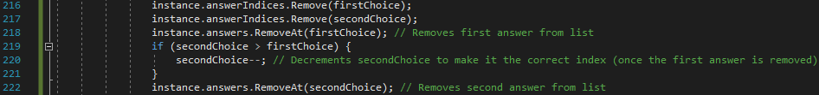

Figure 278 - Updated code to fix error in FiftyFifty

After fixing the code, I have run another 20 tests of using both ‘50/50’ and ‘Ask the Audience’ in the same question, and the expected output has occurred every time. One of these tests has been screenshotted below:

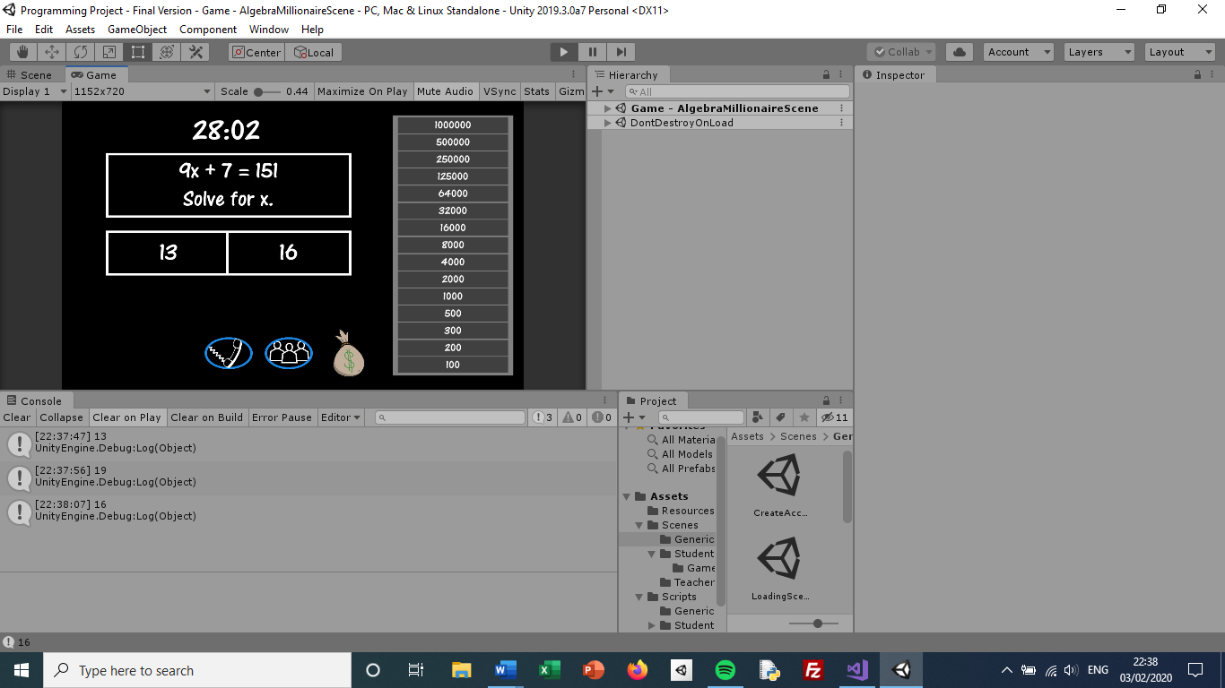

Figure 279 - Screen after '50/50' lifeline is used

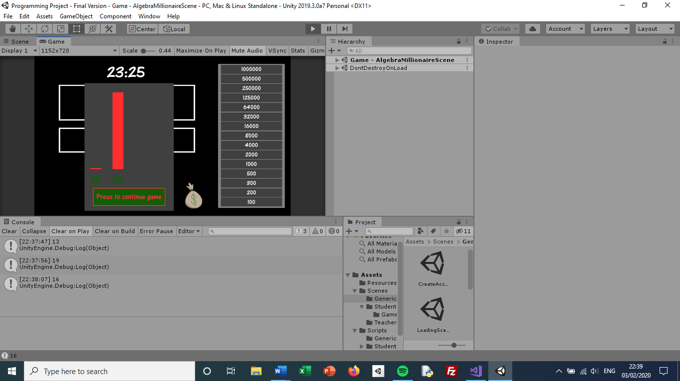

Figure 280 - Screen after 'Ask the Audience' lifeline is used

#### Review

##### Content of Section

In this section, I have created the ‘Who Wants to be an Algebra Millionaire’ game for students to play. It starts with basic algebra and progresses to more complex questions with the addition of negative numbers (including negative numbers) and squared numbers. I have tried to make it as similar to the game show as possible (to increase its authentic look) by implementing the feature of having lifelines. I have created the same three lifelines as in the TV show (although they obviously work in a different way). I have also implemented a ‘Take the Money’ feature which allows the student to end the game whenever they want, if they don’t know the answer to a question and they don’t want to risk what they’ve already won.

##### Testing

Testing for this scene came in two sections. First were the general tests which examined what happened when things like correct answers were given or what happened when the scene first loaded. For these tests, I made sure that the expected output happened when I triggered the relevant event. The second type of test was with regards to the lifelines. I made sure the result of using the lifelines were shown correct when each one was selected and I also made sure the result of using the lifelines disappeared when the exit button was clicked.

##### Meeting Success Criteria

As with the other two game scenes, this section has helped to fulfil the success criterion that students should be able to play games. The result of each games is also uploaded to the database which helps to fulfil the criteria for having leaderboards and homeworks.

##### Summary of the Program at this Stage

This is the final stage of the program so all of the features have now been implemented. The things the users can do are listed below:

|  |  |
| --- | --- |
| Students | Teachers |
| Create account | Create account |
| Login | Login |
| View leaderboards | View leaderboards |
| Play all three of the games | Set homeworks |
|  | View Homeworks |
|  | Add Classes |

##### Changes from Design

Only the basic design of the scene was originally made so a lot of extra features have been designed by me since then (checking that my stakeholder is happy with how it looks at each stage). But, out of the things which were originally designed, the screen looks more or less the same as how it was designed. With regards to the algorithm design, the code follows the basic layout of the original flowchart but (as expected), it was simply a basic design and the code has inevitably become more complex and I have discovered during development that a few extra functions were required.

## Success Criteria Update

|  |
| --- |
| Success Criterion |
| A login system where people can either login as a student or a teacher. |
| The ability to create an account, either as a student or a teacher. |
| The student can be added to a class. |
| The student can play maths games. |
| The student’s score is displayed on a separate leaderboard for each class and each game. |
| The teachers and students can (only) view the leaderboards which apply to their account. |
| The teachers can set specific homeworks based on time spent on the program. |
| The teachers can view specific homeworks and see how much time each student has spent on it. |
| The students can view their current homeworks. |
| Simple and clear – it has a layout which is easy to understand and is pleasing to the eye. |
| Easily Navigated – it should be easy to move from scene to scene without being confused about how to reach a certain scene |
| Data is not lost when the user exits the program. The data and accounts are retrievable. |

Now that the development of the program is complete, I am happy to say I have fulfilled all of the success criteria. However, I have left two of the criteria as partially completed. The reason for this is, unlike the other criteria where I can distinctly say whether it has been completed or not, these criteria require approval from Mrs Mistry as I feel it should be the opinion of my stakeholder for the matters of being clear and easily navigable.

## Stakeholder Update

As I have now completed the development of the program, I have had a meeting with Mrs Mistry to discuss the program and any changes she wants me to make. Below is a summary of the interview we had.

### Stakeholder Update Interview

**Q: Are there any changes you would like me to make to the Teacher Homework Menu Scene?**

No, the scene is very basic and does its job in giving the options to go to other areas in the program. There’s nothing else I want it to do.

**Q: One of the fundamental parts of your requested program is the ability to set homeworks. Are you satisfied the with functionality provided in the Teacher Set Homework Scene?**

As we said in early discussions for this program, the homework would simply be to spend a certain amount of time playing the games. I like the fact that you have taken that a step further and allowed teachers to set the homework for a specific game. The other pieces of information required is fine and I don’t think there’s anything else required in the section. One thing I’d ask is if you could move the format example for the due date from the placeholder to the heading on the left side of the input field.

**Q: What are your opinions on the Teacher View Homeworks Scene and the Student View Homeworks Scene?**

First, in the Student View Homeworks Scene, the students just need to see what their homeworks are and I think that’s been done in a perfectly good fashion – it displays all of the information that teachers would enter when setting the homework. For the Teacher View Homeworks Scene, I like that it not only tells you how long each student has spent on the homework but also whether they have completed the homework or not. However, I would like for it to order it based on whether they have completed the homework or not (all completed homeworks at the top/bottom of the list).

**Q: We have just played the second game, Speed Maths. What are your opinions of it in terms of its difficulty and gameplay features? Are there any changes you would like me to make?**

Firstly, I can see the game isn’t a very complex one but it is very fun to play and it even gets my competitive side out (even without other people to compete against)! The gameplay is completely fine and I like the idea of having three lives. The only thing I’d say is students in KS3 may not understand the symbol ‘*’. I understand that that is the symbol for multiplication in computing but students may not know that so I would rather the multiplication questions to use the basic mathematical multiplication symbol ‘X’ instead (or some variation of that).

**Q: Having played Who Wants to be an Algebra Millionaire and tried out all of the lifelines, what are your opinions on the game?**

I’ve been a fan of the TV show for a long time so it was really fun for me to play this maths version. I especially like how you’ve incorporated the lifelines even though two of the three lifelines usually involve responses from humans! I think the later questions are quite difficult for KS3 students but that’s ok because I want it to be a real push to get £1 million. However, although it is used in the TV version, I would rather there wasn’t a time limit for each question. I understand why it’s needed in the other two games but I don’t want to put the students under too much pressure. So, I would like you to remove the time limit for the questions. Other than that, I like this game very much.

### Response to Stakeholder Update Interview

Firstly, for Mrs Mistry’s comments regarding the Teacher View Homeworks Scene, I have informed her that (as with similar comments for the View Leaderboards Scene), this request will be something I look into as an extension if I have the time as I don’t feel it’s of major importance to the program. The other three changes, however, I will make as requested.

#### Change 1

The first change requested by Mrs Mistry is in the Teacher Set Homework Scene where she requested the example of the due date format to be moved to the heading from the placeholder. To do this, I have first updated *fieldNames*, as shown below, to include the example format in the final heading. In addition, I have removed the same text from the placeholder for the due date.

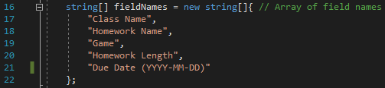

Figure 281 - Updated definition for fieldNames

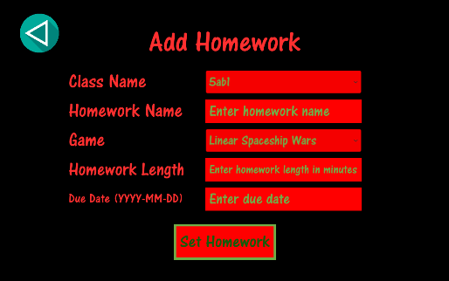

Figure 282 - Screen for Teacher Set Homework Scene

Since the code creating the text headings already had the argument *bestFit* set to *true*, the heading has automatically resized to make it fit properly. As such, the scene now looks good and, after sending her a picture of the updated scene, Mrs Mistry has given her approval.

#### Change 2

The second change requested by Mrs Mistry is in the Speed Maths game. Her request is that I use a mathematical multiplication symbol as opposed to the computational symbol I have been using so far. I have checked online and have found a Unicode symbol which represents a multiplication sign. So, in *GameSpeedMathsSceneScript*, I have simply changed the line:



Figure 283 - Old code to display multiplication question

To:



Figure 284 - New code to display multiplication question

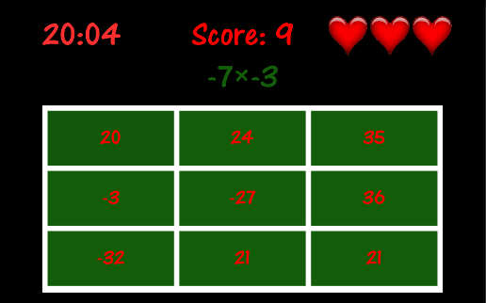

Figure 285 - Screen for Speed Maths game

For multiplication questions, the question now shows a mathematical multiplication sign. When showing this to Mrs Mistry, she requested that I add a space on either side of the multiplication sign so I have done so. The line of code now reads:



Figure 286 - Updated code for displaying multiplication question

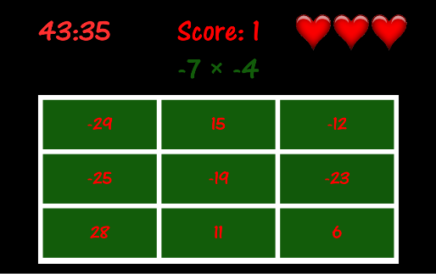

Figure 287 - Screen for Speed Maths game with updated code

As shown in the image above, there is now more space between the multiplication symbol and the surrounding characters. I have sent an image of the new program running to my stakeholder and Mrs Mistry has replied saying she is happy with the change.

#### Change 3

The final change that Mrs Mistry asked for is to remove the countdown timer for the Algebra Millionaire game. Since I am removing a piece of functionality in this situation, the changes I need to make is simply removing pieces of code related to that functionality.



Figure 288 - Removed line of code - originally created countdown text



Figure 289 - Removed piece of code - was called when the countdown ended and sent the program to the EndGame function



Figure 290 - Removed variable as it was storing the function instance running the countdown timer

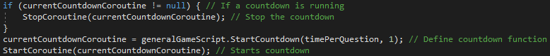

Figure 291 - Removed piece of code which was updating the countdown timer function every time a new question was asked



Figure 292 - Removed line of code in actions array in GeneralGameScript

Since I have removed the above line from *actions* in *GeneralGameScript*, there is now only one action whichever occurs when the countdown ends in any of the games (whereas before I required *actions* to store two different possible events depending on the situation). Therefore, I could remove *actions* and the parameter *action* in *StartCountdown* before hard-coding an event into the countdown function. But I have decided to keep the code as it is for the reason that its soft-coded nature allows future versions of the program to have different types of countdowns in a much easier manner than if I changed the code to the hard-coded idea mentioned above.

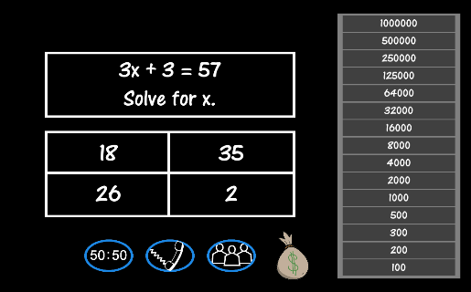

Figure 293 - Screen for Algebra Millionaire game without countdown timer

As shown in the image above, the timer object no longer appears as all references to it (and, of course, its creation) has been removed from the code. To confirm, I waited without entering any values for over 30 seconds and nothing happened, proving that the countdown timer isn’t running in the background as well as it not showing in the foreground. I have showed the result to Mrs Mistry and she is happy with the change made.

As I have now completed the development of the whole program (with my stakeholder’s approval of the design and functionality), I will now move onto doing tests which are fundamental to the program as a whole before evaluating the project.

# Testing

As stated in my design of the testing process, I have completed the testing in the iterative development section which handles how the gameplay itself works. I now need to test fundamental components which aren’t necessarily related to any particular part of the program but need to be tested for the program as a whole. As stated earlier, these are the tests I will carry out:

|  |  |  |
| --- | --- | --- |
| Test Number | Test action | Expected Response |
| 1 | SQL injection into input fields in Create Account Scene, Login Scene and Add Class Scene (all of the scenes where the result of an input field is sent to the database). | The system should handle input without any error being displayed to the user. (Of course, the SQL injected statement shouldn’t pass.) |
| 2 | Running multiple instances of the application on the same PC. | Both applications should run fine without errors. |
| 3 | Running multiple instances of the application on different devices at the same time. | Both applications should run fine without errors. |
| 4 | Making multiple connections to the database (including accessing the same tables) concurrently. | All accesses to the database should be handled and the program should run properly on all instances of the program. |
| 5 | Internet connection drops out during the program (after *LoadingScene*). | Error saying ‘No Internet Connection’ should show when connection to database is attempted. |

## Test 1 – SQL Injection

There are certain statements which, when entered in an input field, will cause catastrophic effects on the database. In this test, I will enter various different statements, which are meant to cause damage to the database, in different input fields. However, I will only enter the statements in input fields where symbols are permitted. This is because most SQL injection statements use symbols and I have already checked that symbols aren’t allowed in things like integer fields in the iterative development section. The SQL statements also require spaces so the only input fields where SQL injection could occur is with input fields where symbols are permitted and spaces are permitted. The input fields where this could happen are: the ‘Password’ fields in Create Account Scene and Login Scene and the ‘Homework Name’ field in Set Homework Scene.

To prepare for the fact that something could happen to the database as a result of these tests, I have taken a backup of the whole database and stored it offline. In addition to that, to ensure I understand the full effect of each test, I will check the result on both the client’s program and I will manually check the database.

|  |  |  |  |
| --- | --- | --- | --- |
| Test Number | SQL Statement Added[45] | Input Field Entered Into | Effect |
| 1 | ” or ““=” | ‘Password’ field in Create Account Scene | Client: Message saying account was created successfully.  Database: Account is created successfully. |
| 2 | “Test Name; DROP TABLE Teachers” | ‘Password’ field in Login Scene | Client: Message saying login failed.  Database: Teachers table still exists and hasn’t been cleared. |
| 3 | or 1=1 | ‘Homework Name’ field in Set Homework Scene | Client: Message saying an error occurred.    Database: There has been no effect on the database. |

#### Comment on Tests

For tests one and three, the SQL statement used with the inputs is an *INSERT INTO* query. SQL injection is typically used with *SELECT* queries as it allows the hackers to retrieve the information. They wouldn’t be able to retrieve the information from an *INSERT INTO* query as they don’t return any value. I believe that is the reason why these tests have succeeded. However, for the second test, it is a *select* statement but the type of query is irrelevant because the injection is to add another line that tells the database to delete the *Teachers* table. The tests were all successful (as the *Teachers* table wasn’t deleted when the test was run) so I am happy to say the program should be safe against SQL injection. (I don’t feel the need to check input fields which don’t allow either symbols or spaces because every example of an SQL injection statement uses at least one of these). Therefore, I don’t need to test SQL injection for fields like ‘School Year’ in Create Account Scene because there is nothing a hacker would be able to enter with only integers that would threaten the integrity of the database.

## Test 2 – Concurrent Use (Single Device)

For this test, I will run the program concurrently in two separate instances of the program on the same device. To do this, I have compiled the program into a Windows build so it can be run multiple times as an executable program.

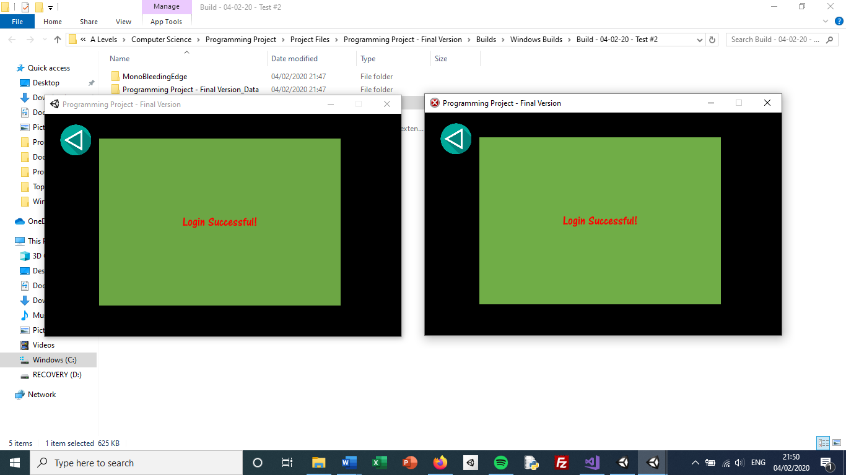

Figure 294 - Login Scene for both instances of the program[46]

As shown in the screenshot above, both instances of the program are able to run at the same time. In addition, I was able to login to different accounts on each instance. I had a worry that the login of the second instance would override the login of the first instance and that the two programs will both have the login for the second account. However, as shown in the screenshot below, that is not the case and the two accounts do successfully remain active in their respective instances of the program.

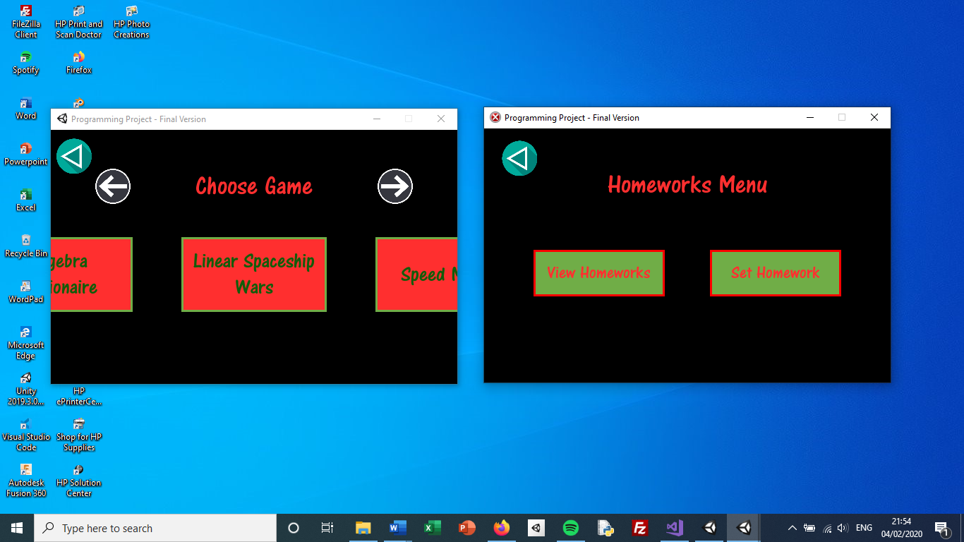

Figure 295 - Screenshot displaying the two instances of the program in different scenes

The above image shows the left image in a student scene and the right image in a teacher scene (as I logged into a student account on the left instance of the program and a teacher account on the right instance) which shows that the two accounts do remain with the instances and that the logging in on the second instance doesn’t override the first instance.

## Test 3 – Concurrent Use (Multiple Devices)

In this test, I am going to run the compiled executable program on two different devices at the same time. Like Test 2, I will first check that I can use both instances of the program before checking to make sure the accounts are retained on each one.

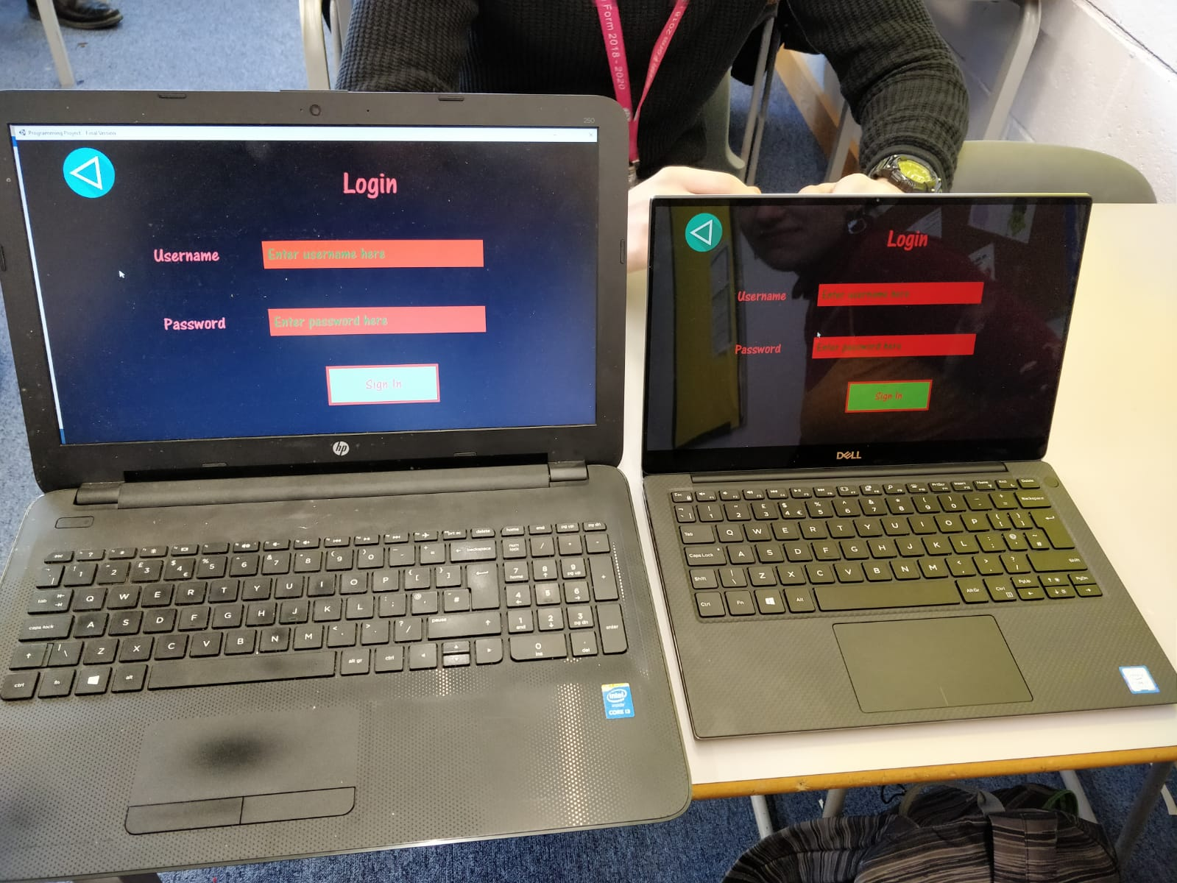

Figure 296 - Image of program running on two devices

As shown in the image above, the program does still work when there are two instances on different devices. In addition, the image below shows that the two programs retain their accounts (and the second login does not override the first login). The left image displays the Choose Game Scene which only appears for students (which is correct as I logged in as a student on the left laptop) while the right image displays the Add Class Scene which only appears for teachers (also correct as I logged in as a teacher on the right computer).

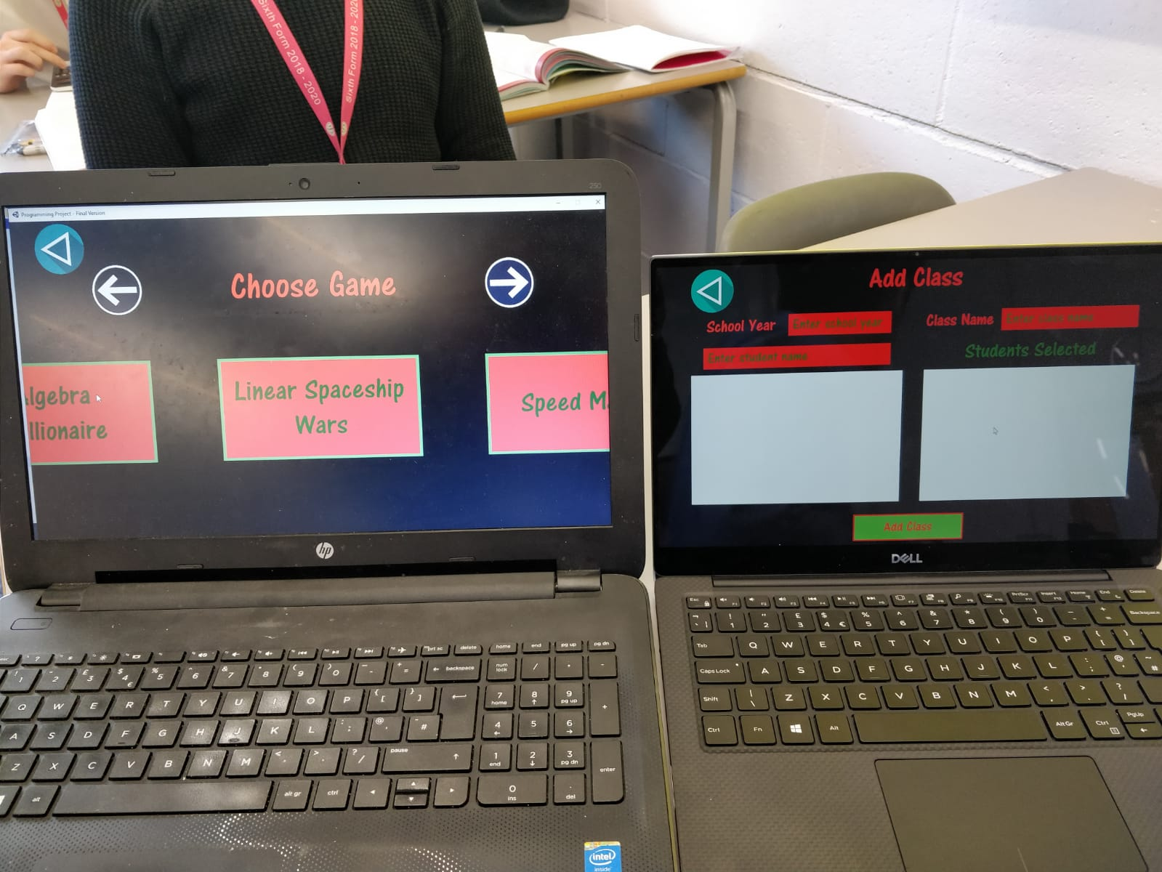

Figure 297 - Image showing account retention in program

Since both of these tests have passed, I will now continue to the next test.

## Test 4 – Concurrent Database Requests

Tests 2&3 checked if the program ran successfully when the program itself was being run at the same time (on the same computer and different computers respectively). However, those tests haven’t checked for concurrent database requests. Although the programs are open at the same time, I haven’t made the database requests at the same time. So, in this test, I will run two instances of the program at the same time and I will click a button making a request to the database at the exact same time. Since the database is stored online, it shouldn’t make a difference if the two instances of the program are on the same device or not. I have decided to run the two instances on different devices as it is more likely the two requests are made at the same time if they are on two different devices (since I would have to change tabs to switch between windows if they were on the same device, which would take up time).

On each device, my friend and I clicked (with valid data entered) the login button to send the login information to the database. I have recorded the results of two tests: when the login information was the same and when they were different. Both of them should be permitted as I want to allow multiple instances of the same account at the same time.

|  |  |  |
| --- | --- | --- |
| Before submit button was clicked | After submit button was clicked | Correct? |
|  |  | Yes |
|  |  | Yes |

In the first test, my friend and I tried to login to the same account at the exact same time (we sent the request at the same time but the response came at slightly different times). As shown in the right-hand image of the first test, both logins were successful and so the test passed, as both database requests were handled successfully. In the second test, my friend and I tried to login to different accounts at the exact same time (again the requests were made at the same time but response arrived slightly later for the computer on the right). As shown in the right-hand image of the second test, both logins were successful and so the test passed. Therefore, the program can handle concurrent database requests successfully[47].

## Test 5 – Losing Internet Connection

Although I have already got a check for the internet connection at the beginning of the program, I have not tested what happens when the internet connection is lost during the running of the program. I will turn off my Wi-Fi connection at various stages where a request to the database is made. After turning off the Wi-Fi connection, I will make the request to the database and check what happens.

|  |  |  |  |
| --- | --- | --- | --- |
| Test[48] | Expected Output | Output | Correct? |
| Turn off Wi-Fi and click Create Account button | Error message saying no internet connection and to try again. |  | Yes |
| Turn off Wi-Fi and click Login button | Error message saying no internet connection and to try again. |  | No[49] |
| Turn off Wi-Fi and enter school year in Add Class Scene | Error message saying no internet connection and to try again. | No students appeared in the left-hand panel (because they couldn’t be downloaded from the database) but no error message was given. Nothing happened when the school year was entered. | No |
| Turn off Wi-Fi and click View Leaderboards class dropdown | Error message saying no internet connection and to try again. |  | No |
| Turn off Wi-Fi and click Set Homework button | Error message saying an error occurred and to try again. |  | Yes |
| Turn off Wi-Fi and go to View Homeworks Scene | Error message saying no internet connection and to try again. | The dropdown didn’t have any options because the homeworks couldn’t been downloaded from the database. | No |
| Turn off Wi-Fi and play a game | Game should run fine. An error should appear saying there is no internet connection when the End Game Scene loads. | The game runs normally and the End Game Scene appears normally without displaying any error (although the score obviously hasn’t been uploaded to the database). | No |

In the above tests, some of them passed whilst some unfortunately failed. For all of the failed tests, the issue lied with the fact that I didn’t show an error message if there is no internet connection (apart from the Login Scene as explained in the footnote on the previous page). I already have a function which checks if there is internet connection so I have moved that to *GeneralFunctions* and added an extra piece of code to each function where I access the database, to allow me to check if there is internet connection just before I make a request to the database each time. The idea is I use the *CheckInternetConnection* function every time and update a newly-created Boolean variable in *GeneralVariables* called *hasInternetConnection* depending on what happens in *CheckInternetConnection*. At the beginning of each function where I make a request to the database, I first call *CheckInternetConnection* and wait for a response before checking the value of *hasInternetConnection*. I then show an error and end the function if there is no internet. Some of the changed code is shown below (the code added to each function accessing the database is essentially the same so I have only shown one example):



Figure 298 - Variable added to GeneralVariables

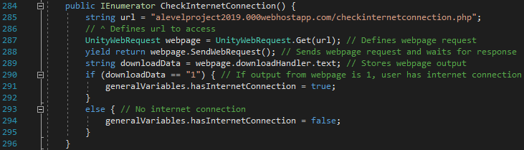

Figure 299 - Updated CheckInternetConnection function moved to GeneralFunctions

Like when it was in *LoadingSceneScript*, *CheckInternetConnection* makes a request to *checkinternetconnection.php* and determines if the user has access to the internet or not. Unlike before, I now simply change the variable *hasInternetConnection* based on that.

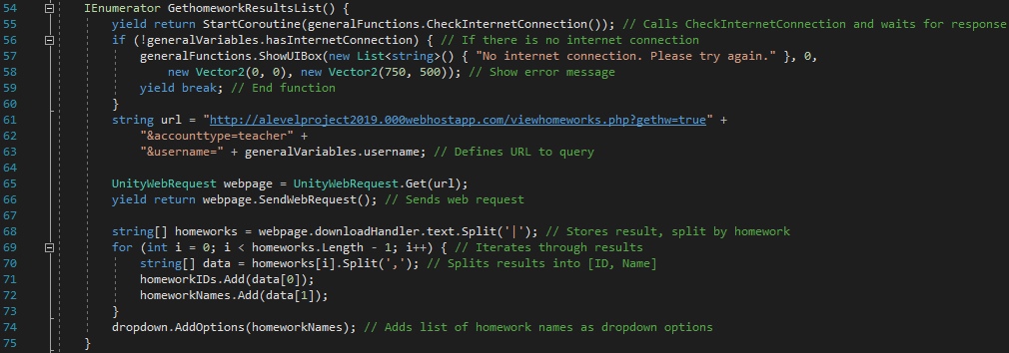

Figure 300 - Updated code for GetHomeworkResultsList in Teacher View Homeworks Scene. Added code are lines 55-60

In the screenshot directly above, lines 55-60 are very similar to the additions made in other scripts so I have only screenshotted it here. I first call *CheckInternetConnection* and wait for the function to end (thanks to the *yield* keyword). I then check *hasInternetConnection* and act based on its value. In most scripts, I continue the function if there is internet connection but show an error message and end the function if there is no internet connection. Below are the same tests as before, now that *CheckInternetConnection* is called more often.

|  |  |  |  |
| --- | --- | --- | --- |
| Test[50] | Expected Output | Output | Correct? |
| Turn off Wi-Fi and click Create Account button | Error message saying no internet connection and to try again. |  | Yes |
| Turn off Wi-Fi and click Login button | Error message saying no internet connection and to try again. |  | Yes |
| Turn off Wi-Fi and enter school year in Add Class Scene | Error message saying no internet connection and to try again. |  | Yes |
| Turn off Wi-Fi and click View Leaderboards class dropdown | Error message saying no internet connection and to try again. |  | Yes |
| Turn off Wi-Fi and click Set Homework button | Error message saying an error occurred and to try again. |  | Yes |
| Turn off Wi-Fi and go to View Homeworks Scene | Error message saying no internet connection and to try again. |  | Yes |
| Turn off Wi-Fi and play a game | Game should run fine. An error should appear saying there is no internet connection when the End Game Scene loads. | The game ran normally. The below image is what happened as soon as the game ended.    When I clicked on the error message, the End Game Scene appeared normally (as expected). | Yes |

All of these tests have passed so I have now fixed the issue where an error message doesn’t necessarily appear when there is no internet.

As all of the tests have now been completed with success, I will move onto the evaluation of the whole project.

# Evaluation

I am now going to go through each of my success criteria and discuss how they have been met, if they have been met.

## Evaluation of Success Criteria

### Essential Features

#### Success Criterion – Having a Login System

The first criterion was to have a login system where people can login into both student and teacher accounts. The images below show how the Login Scene looks and what happens when I enter valid details into the input fields and submit.

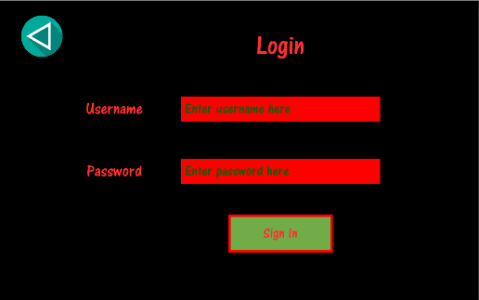

Figure 301 - Login Scene

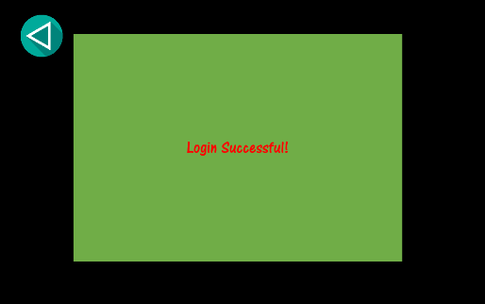

Figure 302 - Result of successful login attempt

The Login Scene fulfils this success criterion as it enables users to log in using their assigned usernames and their passwords. To make things cleaner and simpler for the user, the Login Scene is the same for both students and teachers (unlike some other educational programs). The database also helps to fulfil this criterion as I have tables for Teacher and Student accounts which store the login information for all users. This table is then accessed to check if the entered login details are correct for anyone.

**Scripts that help to fulfil this criterion**

* *LoginSceneScript.cs*
* *loginscript.php*

#### Success Criterion – Having a Create Account System

To be able to login to accounts, the users must of course have accounts in the first place. This success criterion states that users should have the ability to create either a student or a teacher account. To fulfil this, I have created the Create Account Scene and implemented two tables in my database (*Teachers* and *Students*) which are dedicated to storing account information.

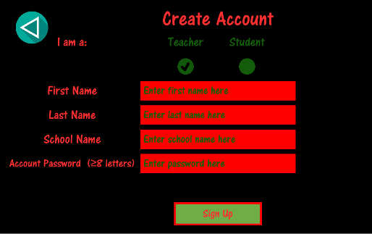

Figure 303 - Create Account Scene for teachers

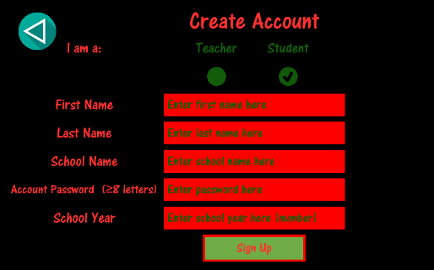

Figure 304 - Create Account Scene for students

As with the Login Scene, the Create Account Scene fulfils this criterion as it allows the user to fill in a form, providing information required to make an account, and to send the data to the server where a new account will be created with the user-inputted details. Like the Login Scene, an important aspect of the scene for me is the fact that the student and teacher versions of the form feature on the same scene and that I don’t require separate scenes for the two types of users. This is thanks to the green toggles at the top of the scene and the dynamic nature of the implementation for the ‘School Year’ field.

**Scripts that help to fulfil this criterion**

* *CreateAccountSceneScript.cs*
* *loginscript.php*

#### Success Criterion – Adding Students to Classes

The criterion here mentions the ability for teachers to add students to classes. I have implemented this feature in the *TeacherAddClassSceneScript*, a scene which allows teachers to create classes and add students to the class, as long as every student is from the teacher’s school and is in the school year stipulated in the ‘School Year’ input field that the teacher has entered.

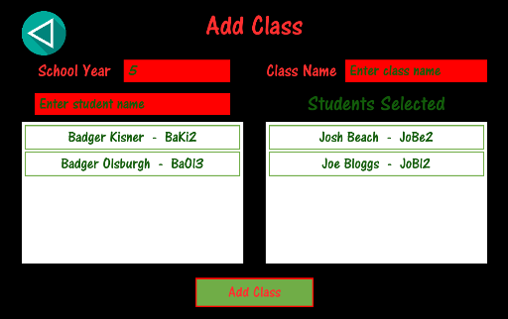

Figure 305 - Screen for Teacher Add Class Scene showing students being added to a new class

This fulfils the criterium because it allows teachers to create classes and add individual students to those classes. When the ‘Add Class’ button is clicked, the entered data is sent to the server and a new class is created in the database (while enrolments are made where each student is linked to each class). However, as it stands, in this project, teachers are only able to add students to a class when the class is first created. It would be nice (as an update in the future) for it to be possible for teachers to add students to a class which already exists. In reality, this is unlikely to matter too much since the majority of classes do not gain or lose students during the course of the academic year (especially in KS3 which is the target audience), but it is an additional feature which could have been implemented.

**Scripts that help to fulfil this criterion**

* *TeacherAddClassSceneScript.cs*
* *teacheraddclassscript.php*

#### Success Criterion – Students playing maths games

This is quite clearly the most fundamental success criterion of them all – the requirement that users must be able to play maths games – since the whole purpose of the program is for students to be able to play maths games and compete against each other.

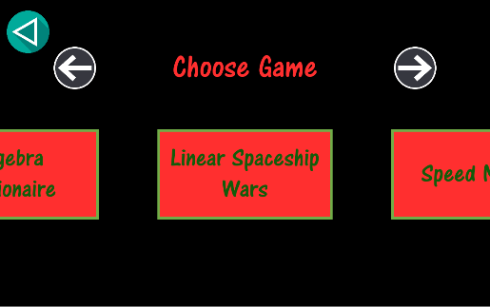

Figure 306 - Screen for Student Choose Game Scene

The first section related to this criterion is the Student Choose Game Scene. Since I have three games in the program, there needs to be some way for the student to decide which one to play. This scene provides that functionality using a simplistic approach but using a moving menu to allow a theoretically infinite number of games to be played.

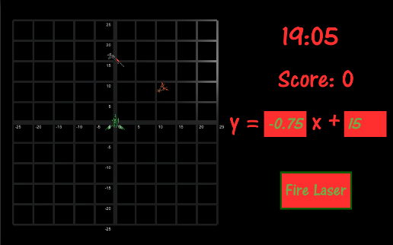

Figure 307 - Screen for Linear Spaceship Wars Scene

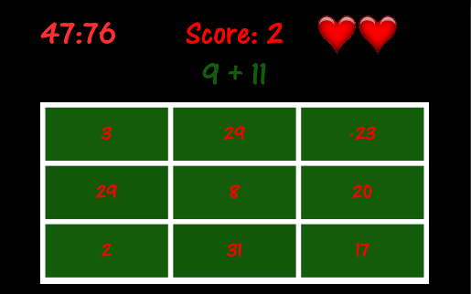

Figure 308 - Screen for Speed Maths Scene

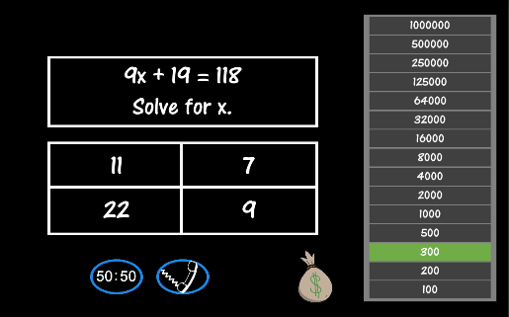

Figure 309 - Screen for Who Wants to be an Algebra Millionaire Scene

The three images above show screenshots from each of the three games I have developed for the program. These games are essentially what the program is all about and they are what ultimately fulfil this criterion that students should be able to play maths games.

In addition to the games themselves, the *GameTypes* table in the database forms a fundamental basis for many parts of the program. Scores, leaderboards and homeworks (in addition to the Choose Game Scene) rely on *GameTypes* to know what games are available. Moreover, the fact that the game names are stored in the database means that adding new games (or removing games in the case of maintenance of a game) will be very easy as adding the name of the game to the *GameTypes* table would simply add it to the options in Choose Game Scene (meaning students can now select that game), add it to the list of games that a homework can be set for and add it to the list of games that the leaderboard can be viewed for. Essentially, changing the games will automatically cause all other aspects of the program to follow suit.

**Scripts that help to fulfil this criterion**

* *StudentChooseGameSceneScript.cs*
* *GeneralGameScript.cs*
* *GameLinearSpaceshipWarsScript.cs*
* *GameSpeedMathsScript.cs*
* *EndGameSceneScript.cs[51]*

#### Success Criterion – Displaying of leaderboards

In this section, I have merged the criteria of students’ scores being displayed on different leaderboards for each game and class, and the criterium that teachers and students can only view the leaderboards that apply to their class. The reason for this is the same piece of code (and same scene) fulfils both criteria.

These criteria are important because the leaderboard functionality is something that makes this program stand out from some alternative programs that are available online. I have fulfilled these criteria by using dropdown fields in the View Leaderboards Scene: one for choosing which class to view and one for choosing which game to view. This allows users to view different leaderboards depending on the class and game they want to view (thus fulfilling the first criterium). In addition, the only classes which are available on the dropdown field are classes that the student is part of (or that the user is the teacher of, in the case of teachers viewing the leaderboards). This is done using a PHP script which only selects classes where the teacher username is equal to that of the account username that is logged in to the program.

Again, as with previous scenes, something good about the leaderboards is that the scene is the same for both teachers and students. This is important from a maintenance point of view as it means only one scene needs to be changed to update the viewing of the leaderboards. The images below show the functionality of the View Leaderboards Scene, as described above.

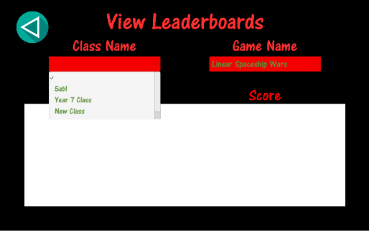

Figure 310 - Screenshot showing class name dropdown field in View Leaderboards Scene

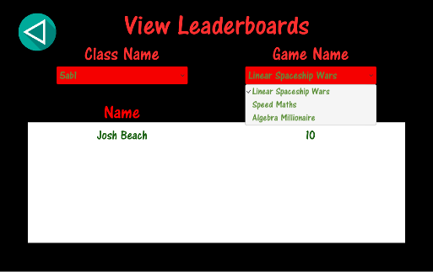

Figure 311 - Screenshot showing game name dropdown in View Leaderboards Scene

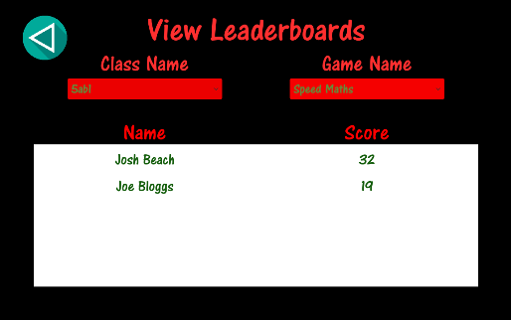

Figure 312 - Screenshot showing leaderboard for one specific class playing one specific game

**Scripts that help to fulfil this criterion**

* *ViewLeaderboardSceneScript.cs*
* *viewleaderboardscript.php*
* *EndGameSceneScript.cs* (the scores are sent to the PHP script to be uploaded in this script)
* *sendscoretodatabasescript.php* (uploads the score to the *Scores* table in the database)

#### Success Criterion – Setting specific homeworks

This success criterion states that teachers should be able to set homeworks on specific games for specific classes, where they must play the game for a specified amount of time before a specified due date. Since the teacher needs to enter lots of information (as I want to provide as much customisation of homeworks as possible), I have created the Teacher Set Homework Scene which is essentially a form like Create Account Scene or Login Scene. It allows teachers to specify the class, game type, homework length and due date of a homework in addition to giving the homework a name. When the ‘Set Homework’ button is clicked, the information entered in the form is sent to a PHP script which uses an SQL query to add the new homework to the database, adding it to the *HomeworksSet* table so it can be viewed by both the teachers and their students. The image below shows the Teacher Set Homework Scene, displaying the form that teachers fill out to set a homework.

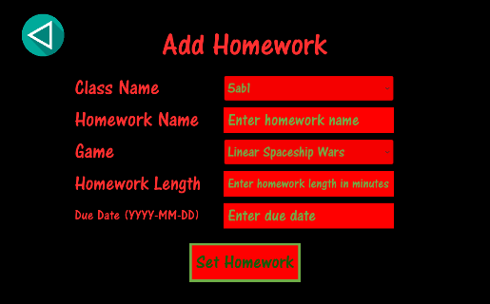

Figure 313 - Screen for Teacher Set Homework Scene

**Scripts that help to fulfil this criterion**

* *TeacherSetHomeworkSceneScript.cs*
* *teachersethomeworkscript.php*

#### Success Criterion – Viewing homeworks (Teacher)

This success criterion states that teachers should be able to view the specific homeworks they have set and see how much time each student in that class has spent on that homework. I have fulfilled this criterion by creating the Teacher View Homeworks Scene which allows teachers to do exactly as specified in the criterion. In fact, I have added an extra feature (albeit a minor one) which takes the time each student has spent on the homework and, based on that, creates a third column which states whether they have completed the homework or not. Although it’s a fairly basic feature to implement (simply checking if the time spent is greater or less than the homework length), I feel it is quite useful as it allow the teacher to just look at the first and third columns without having to do a calculation for each and every student. The teacher decides which homework to view by selecting a homework from a dropdown field which will only have homeworks which the teacher has set as an option. An example of how the Teacher View Homeworks Scene would look for a certain teacher and a certain homework is shown below:

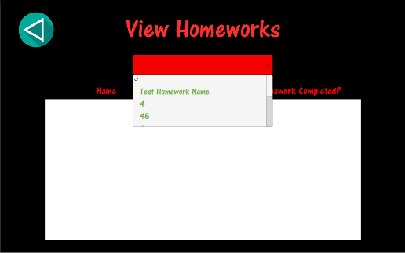

Figure 314 - Screenshot showing dropdown field and list of homework options to choose from

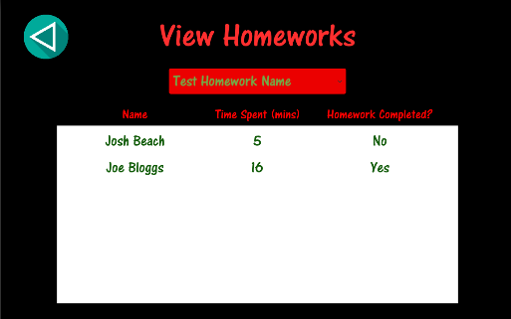

Figure 315 - Screen of Teacher View Homeworks Scene for specific homework (in this situation, the homework length is 15 minutes)

**Scripts that help to fulfil this criterion**

* *TeacherViewHomeworksSceneScript.cs*
* *viewhomeworks.php*

#### Success Criterion – Viewing Homeworks (Student)

This success criterion states that students should be able to view all of their homeworks for which the due date has not yet passed. I have done in this a very similar way to the viewing of homeworks for teachers. I have created a Student View Homeworks Scene which displays all of the student’s current homeworks. However, there are two differences between Student View Homeworks Scene and Teacher View Homeworks Scene. First, there is no need for the student to need to select anything; they just need to be able to view all of their current homeworks. Therefore, unlike in Teacher View Homework Scene, I don’t have a dropdown field for the students to select a value. The second difference is the columns of the table. For teachers, they simply need to know the student name, the amount of time they’ve spent on the homework and whether they have completed the homework or not. For students, they require all of the information about the homework. So, there are five columns: homework name, class name, game name, homework length and due date. An image displaying how the Student View Homeworks Scene works is shown below:

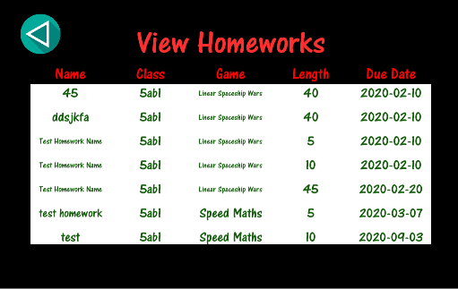

Figure 316 - Screen for Student View Homeworks Scene

**Scripts that help to fulfil this criterion**

* *StudentViewHomeworksSceneScript.cs*
* *viewhomeworks.php*

#### Success Criterion – Simple and clear layout

This is a generic criterion which is relevant in all of the front-end of the program. I was told by my stakeholder that the program should be simple and not include unnecessary details – she wanted a fairly minimalistic design. As shown in all of the previous screenshots, I have only included features that are relevant to the program’s function and there are no unnecessary details (with the exception of the images on the Start Scene, which was agreed upon) in the program.

I have discussed this success criterion with my stakeholder as it is a criterion that I don’t feel I can confirm has been fulfilled myself. As I have gone through the whole program with Mrs Mistry, she has an understanding of the layout of the program. She has told me that she feels the layout is indeed simple and clear and that she feels the developed program fulfils the original objective with regards to the layout.

#### Success Criterion – Easily navigable program

Another important, generic criterion is that the program should be easily navigable. This ties in with the previous criterion about having a simple and clear layout since a clear layout will lead to the program being more easily navigable. But this criterion involves having large buttons which clearly indicate the effect of clicking on them. Unlike buttons on some programs (which simply use symbols without any explanation as to what those symbols mean), all of the buttons in this program (with the exception of the back button and the arrows in Choose Game Scene) include text inside it which states the effect of clicking the button in a fool-proof manner.

As with the previous criterion, I have asked Mrs Mistry about her opinion on the navigability of the program. She agrees with me that the text on buttons makes it clear where the program would lead and therefore makes the program easily navigable. She also mentioned the fact that the program includes lots of menus as a positive (in the sense that the user can make small steps towards the scene they are looking for instead of choosing it from a large menu) but also a negative (in the sense that the user may get a little bit lost about where the program is). Therefore, Mrs Mistry and I have concluded that this success criterion has been partially fulfilled because, although there are aspects of the program that makes it easily navigable, the large number of menus could confuse users which makes it harder to navigate the program.

#### Success Criterion – Retrievable data

This success criterion states that data should not be lost when the user exits the program and that all data and accounts should be retrievable. This criterion is all about storing data in an online server. I have done this by creating an online relational database with eight intertwined tables and connecting my C# scripts (on the client) to PHP scripts (on the server) which use SQL queries to make changes to the database. By doing this, all accounts, scores, homeworks and classes are stored forever on the database and the storing of the data is not dependent on anything like the size of the client’s storage space. I tested this in various ways such as logging into the same account from two completely independent devices (in which the accounts were logged into successfully, meaning the account must have been stored online successfully) and closing and re-opening the program to see if any data has been deleted.

#### Success Criterion – Easily Navigable, Games are Fun to Play

For these two criteria, I was hoping to run a survey with around 30 KS3 students so I could check that these two criteria were successfully achieved. Unfortunately, whilst organising a meeting of these students (would have been during a maths class with one of my stakeholder’s classes), the Covid-19 outbreak progressed to the point where it was no longer possible to have this survey. Outside of that scope, I have no access to KS3 students and I have therefore been unable to run this survey. However, I have gone through all parts of the program with my stakeholder and she has said that they are easily navigable and fun to play. Although not ideal, I plan to run the survey with one of my stakeholder’s maths classes after school has resumed so I can make any alterations that are required.

### Desirable Features

#### Different difficulty levels

The first request was to have different levels of difficulty for the games. For Linear Spaceship Wars, I cannot think of a situation where different difficulty levels can be implemented (except potentially having multiple enemy ships and having to shoot a laser through both) so I have not implemented difficulty levels for that. With regards to the Algebra Millionaire game, there are essentially three levels of difficulty in the game with the first five questions being easy, the second set of five being of medium difficulty whereas the final five are fairly tough.

However, with the Speed Maths game, I have unfortunately not been able to implement different difficulty due to time constraints but there is the potential for it to be added in a theoretical future update. I would have implemented some kind of settings area (either as its own scene or in the top corner of the game scene) which would allow the student to select the difficulty level. The level selected would then be reflected in either what values are used in the question (perhaps between -10 and 10 in easy mode but between -20 and 20 in tough mode) or what operations are used (perhaps only addition and subtraction in easy mode while tough mode would include operations like multiplication, division and exponentials). I would then save the difficulty level selected as a *PlayerPref* (offline storage on the client; like a cookie in a browser) which would allow the program to automatically set the game to that difficulty level when the program is run again at a different time.

#### Website/Mobile Application

As with the different difficulties, time constraints mean I have been able to implement neither a website nor a mobile application but I have planned for how both of these would work. The website would be a fairly basic website using HTML (for displaying the content of the website), CSS (for applying styles and a design to the website) and a small amount of JavaScript (to handle client interaction with the website). Unity3D allows developers to compile programs to a number of different formats, one of which is ‘WebGL’ which is a JavaScript API used for rendering graphics (hence its use in Unity3D projects) and is enabled on most web browsers (including Google Chrome, Mozilla Firefox, Safari, Microsoft Edge and Opera). The plan was to create a simple HTML webpage (perhaps with some information about the program and some other relevant information for the user) and have the program (compiled to WebGL) embedded into the webpage and showing in the centre of the page. The website would have been hosted on 000webhost.com which is the same website I have used to host the program’s database. This would allow for more integration between the website and the program, which could have paved the way for more integrated online features.

For mobile applications, I wouldn’t have been able to create an app for iOS because, although it is possible to create an iOS compatible program in Unity3D, I do not have access to any Apple desktops or iPhones which means I cannot compile the program into an iOS compatible file or test the application respectively. For android however, no specialist device is required to compile to an Android-compatible file type and I have access to Android phones. Like the WebGL version, it is very simple to compile to an Android-compatible version of the program as Unity3D allows integration between platforms in the program very easily. However, the issue would lie with the changes and testing that would be required to make the program suitable for phones. For example, for the input fields, it would be quite weird for the user to enter data on a keyboard because the application would be running in landscape mode (meaning the keyboard would take up essentially the whole screen whilst typing). There are minor issues like this that would require refining specifically for Android devices and unfortunately, I have not had enough time to complete this desirable feature.

#### Automatic e-mails to teachers

As with the previous two desired features, I have been restricted by the time constraints of this project and have been unable to implement this. The idea was to have an e-mail be sent automatically to a teacher on the due date of a homework which would have a list of students in the e-mail, stating which students have completed the homework and who hasn’t. Like the other two desirable features, although I have not implemented it, I have researched how the feature could have been implemented. The idea for the automatic e-mails was to use ‘Cron Jobs’. Cron Jobs are functions or subroutines which would be run at a certain point in time. 000webhost has a feature allowing developers to use Cron Jobs.

I would create a new PHP script which would be specialised in sending these automatic e-mails. Using the Cron Job feature on 000webhost, I would call the new PHP script at a set time every day (probably in the evening as that would allow the students to finish the homework on the due date itself). The PHP script would then run multiple SQL queries to retrieve the relevant data. The first SQL query would retrieve a list of homeworks (including data about the homeworks like teacher username) for which the due date is the current date. I would then iterate through each of those homeworks, executing another SQL query which would retrieve a list of students for that homework and work out if each user has completed the homework or not. The PHP script would then send an e-mail to the teacher for each homework listing which students have completed/not completed the homework. The e-mail would be sent using the *mail* function which is built-in to the PHP language[52]. It would easily allow me to send e-mails by just listing the receiver address, subject of the message, the message, additional headers (probably wouldn’t be required) and any additional parameters (also probably not required).

For this to work, I would require the e-mail address of every teacher. I would therefore have to change the setup of the database by adding an extra field in the *Teachers* table and I would also have to change the design of the Create Account Scene to provide an extra input field for entering an e-mail address. This wouldn’t be very difficult to implement as I have already implemented an almost identical feature for only providing the ‘School Year’ input field when the Student toggle is selected.

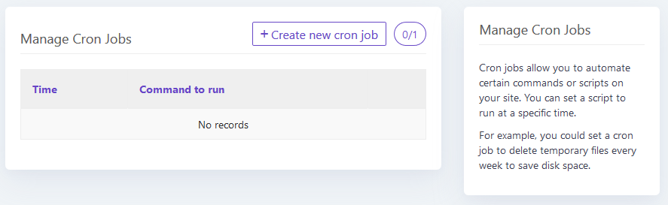

Figure 317 - Cron Job feature section on 000webhost.com

## System Maintenance

The program is, in general, fairly low maintenance. As the program will be compiled, there shouldn’t be any issue with the client’s program as long as no changes are made to it. The main cause of concern would be with regards to the database, especially as the database is stored online and vulnerable to both external threats and down-time. As my database is stored on a hosting service, 000webhost.com handle all maintenance of the database, including things like bringing the database back online if the server goes down for a few minutes. Unfortunately, as I have been using the free version of the database, 000webhost.com does not take backups of the database. It would be recommended that, for maintenance reasons, a backup be made of the program on a frequent basis as all accounts, scores, classes and homeworks would be eternally lost if an error occurred on the database and no backup had been made. Luckily, the file size of the database backup is very small (a backup of the current database is only 10KB), so a backup can be taken very frequently (once a day would be often enough) without a significant amount of storage being taken up. If a specialist 1TB hard drive was bought with the purpose of storing these backups, the hard drive would become full after over 273,000 years. Therefore, there is no risk whatsoever of the hard drive running out of space in the near future.

Another maintenance issue would be if users forgot their usernames and/or passwords. Unfortunately, I haven’t implemented the functionality which allows users to change settings or reset their passwords etc. The only way it can be done at the moment would be to login to PHPmyadmin on 000webhost and to manually change the login details. This wouldn’t be very difficult because PHPmyadmin is user-friendly and it is easy to make these changes. The same solution would also apply to situations where a user wants to delete their account or the situation discussed in an earlier section where a teacher wants to add a student to a class which has already been created.

## Accessibility

For users who may struggle with their eyesight (with difficulty viewing small items), I have intentionally made the program full-screen as it allows me to increase the size of all features – especially text. The font on all scenes is as large as seems normal which would hopefully make it easier for users who have difficulty reading small text to use the program. An example of a scene where the text is larger is shown below:

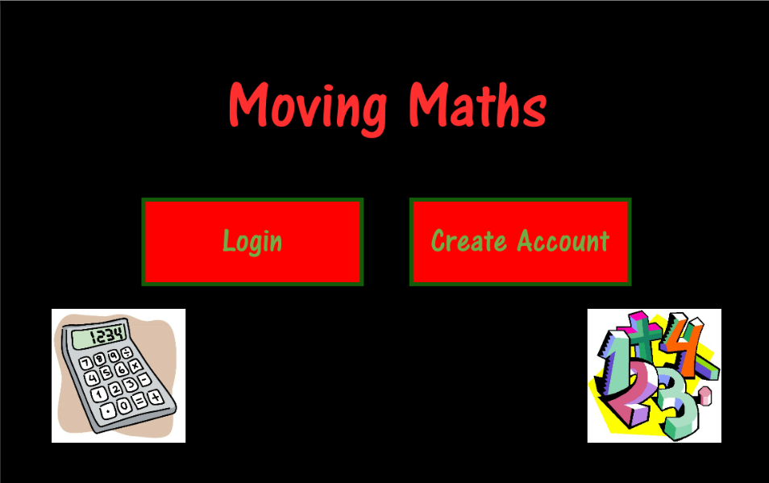

Figure 318 - Screenshot of Start Scene, showing relative size of text

For users who may be deaf or struggling with hearing, I have not implemented any audio components to the program (such as mental maths questions said out loud) meaning there shouldn’t be any difficulty for users with difficulty hearing.

## Reflection on Program

Thinking about the program I have created in this project, there are a number of things I would change if I were able to do this project again. First, I think the idea that an e-mail is sent to teachers on the due date of homeworks with a list of non-compliant students is a great idea and I would invest more time in completing that (even though it is a non-essential feature of the program). In addition, I would try to include other additional features such as account settings and, crucially, the ability for teachers to add students to previously-created classes.

From a programming point of view, I have also noticed minor changes that could have been made which would have made the overall code more efficient. For example, like how I have created general functions for things like showing text or images, I could create a similar thing with menu scenes. I have multiple menu scenes which are all identical apart from the text that appears in the heading and buttons. So, a general menu scene could be made which would simply create a title text and some buttons while parameters would be passed into the scene-creating function that would determine customised things like how many buttons there are, what the text values are and whether the back button should appear in that scene or not.

Another change that I would make if I were to redo the project is the method in which I transfer the data from the C# script to the PHP script. I have used GET parameters but, after having done the development and testing, I have discovered that POST is generally a more secure method of transferring data. In addition, I haven’t done any encryption or hashing of passwords in this project. That is something I would have done if I were to complete the project again.

## General Comments

In general, I have completed and fulfilled all of the success criteria and requirements set out by my stakeholder, Mrs Mistry, at the very beginning of this project. It provides all of the essential features of the program: accounts, maths games, classes, leaderboards and homeworks. All of the data is stored on an online database, meaning the program can be used properly from anywhere in the world as long as there is an internet connection. In addition, as the program has been compiled as an executable file for Windows desktops, the program can be easily run by any client without confusion about how to open the file and how to see the output (questions which the users could be asking had the program been written in a language like Python which is, at least partly, interpreted).

After the development and testing of the program was completed, I compiled it to an executable file, uploaded it to our school servers and showed the final product to Mrs Mistry. Unfortunately, the school was closed (due to the Covid-19 outbreak) before Mrs Mistry was able to use the program in a lesson with KS3 students. Therefore, I have been unable to fulfil a proper user test. However, my client and stakeholder, Mrs Mistry, has responded that she is completely happy with all aspects of the program, as amended since our last discussion. Mrs Mistry has said she plans on using the program with her classes in the future and will be introducing the program to the other maths teachers at the school as well.

# Bibliography

Access "Left", "Right", "Top" and "Bottom" of RectTransform via script. (2015, January 28). Retrieved from https://answers.unity.com/questions/888257/access-left-right-top-and-bottom-of-recttransform.html

Auto-complete Text Field. (2012, July 3). Retrieved from https://forum.unity.com/threads/auto-complete-text-field.142181/

Call to a member function fetch_assoc() on boolean in. (2016, February 27). Retrieved from https://stackoverflow.com/questions/35669088/call-to-a-member-function-fetch-assoc-on-boolean-in-path

Clever way to shuffle a List in one line of C# code. (2014, April 16). Retrieved from https://forum.unity.com/threads/clever-way-to-shuffle-a-list-t-in-one-line-of-c-code.241052/

Getting a Code to Run at a Specific Time of Day Even if App is Off. (2015, August 26). Retrieved from https://answers.unity.com/questions/1035803/getting-a-code-to-run-at-a-specific-time-of-day-ev.html

How to insert data into a foreign key in a table in Sql. (2018, June 12). Retrieved from https://www.quora.com/How-do-I-insert-data-into-a-foreign-key-in-a-table-in-Sql

How to replace a char in string with an Empty character in C#.NET. (2011, June 16). Retrieved from https://stackoverflow.com/questions/6373315/how-to-replace-a-char-in-string-with-an-empty-character-in-c-net

How to Send Mail From Unity. (2018, November 8). Retrieved from https://forum.unity.com/threads/how-to-send-mail-from-unity.580639/

InputField autocomplete. (2017, September 11). Retrieved from https://gamedev.stackexchange.com/questions/148246/inputfield-autocomplete

PHP mail() Function. (n.d.). Retrieved from https://www.w3schools.com/php/func_mail_mail.asp

Retrieve built-in UI sprites via code. (2017, December 4). Retrieved from https://stackoverflow.com/questions/47638453/retrieve-built-in-ui-sprites-via-code

Search in Dropdown options. (2018, November 8). Retrieved from https://answers.unity.com/questions/1569855/search-in-dropdown-options.html

SQL join three or more tables based on a parent-child relationship. (2019, November 9). Retrieved December 3, 2019, from https://www.w3resource.com/sql/joins/using-a-where-cluase-to-join-three-or-more-tables-based-on-a-parent-child-relationship.php

Store functions in List or Array in Unity3D. (2013, June 23). Retrieved from https://stackoverflow.com/questions/17265436/store-functions-in-list-or-array-in-unity3d

Unicode Character 'MULTIPLICATION SIGN' (U+00D7). (n.d.). Retrieved from https://www.fileformat.info/info/unicode/char/00d7/index.htm

Unicode subscripts and superscripts. (2005, July 2). Retrieved December 19, 2019, from https://en.wikipedia.org/wiki/Unicode_subscripts_and_superscripts

# Final Code

## C# Scripts (in order of development)

#### GeneralVariables.cs

using UnityEngine;

using System.Collections.Generic;

public class GeneralVariables : MonoBehaviour {

    public GameObject canvas; // Canvas (area for all UI elements)

    public string username = null; // Username set to null

    public Font arcenaFont; // Font

    public Sprite backButtonImage; // Image of back button

    public Dictionary<string, Color32> colors = new Dictionary<string, Color32>(){

        {"lightGreen", new Color32(112,173,71,255)},

        {"darkGreen", new Color32(18,92,10,255)},     // Defines the rgb values of commonly used

        {"lightRed", new Color32(255,47,47,255)},      // colours in the program. This will be

        {"darkRed", new Color32(255,0,0,255)},         // added to over time if new colours are used

        {"lightGrey",new Color32(128,128,128,255)},

        {"darkGrey",new Color32(64,64,64,255)},

        {"white", new Color32(255,255,255,255)},

        {"black",new Color32(0,0,0,255)}

    };

    public List<string> gameIDs = new List<string>();   // List of game ids

    public List<string> gameNames = new List<string>(); // List of game names

    public string accountType; // Account type variable (student or teacher)

    public List<string> classIDs = new List<string>();   // List of class ids

    public List<string> classNames = new List<string>(); // List of class names

// List for order of scenes viewed (for use with back button)

    // Only allows accepted scenes (no game scenes, start scene)

    public static List<int> sceneOrder = new List<int>();

    public bool hasInternetConnection = false; // Defines if the user has internet connection or not

    //Only Student variables - Begin

    public string gamePlaying; // Most recently played game

    public int scoreToSave; // Score value to save

    public float playingTime; // Time spent by the student on the game

    // Only Student variables – End

    void Start() {

        arcenaFont = Resources.Load<Font>("ARCENA");

        backButtonImage = Resources.Load<Sprite>("BackButton");

    }

}

#### GeneralFunctions.cs

using System.Collections;

using System.Collections.Generic;

using UnityEngine;

using UnityEngine.UI;                 // Imported modules

using UnityEngine.EventSystems;

using UnityEngine.SceneManagement;

using UnityEngine.Networking;

public class GeneralFunctions : MonoBehaviour {

    System.Action[] functionsToCall = new System.Action[]{ // List of functions to be called

        /* 0*/() => { },

        /* 1*/() => {OnBackButtonClick();},

        /* 2*/() => {LoadingSceneScript.CloseApplication(); },

        /* 3*/() => {StartSceneScript.GoToNextScene(EventSystem.current.currentSelectedGameObject.name); },

        /* 4*/() => {CreateAccountSceneScript.CreateAccount(); },

        /* 5*/() => {CreateAccountSceneScript.GoToNextScene(); },

        /* 6*/() => {LoginSceneScript.Login(); },

        /* 7*/() => {LoginSceneScript.GoToNextSceneOnClick(); },

        /* 8*/() => {TeacherMainMenuSceneScript.GoToNextScene(EventSystem.current.currentSelectedGameObject.name); },

        /* 9*/() => {TeacherAddClassSceneScript.SelectStudent(EventSystem.current.currentSelectedGameObject.name); },

        /*10*/() => {TeacherAddClassSceneScript.AddClass(); },

        /*11*/() => {TeacherAddClassSceneScript.GoToNextScene(); },

        /*12*/() => {StudentMainMenuSceneScript.GoToNextScene(EventSystem.current.currentSelectedGameObject.name); },

        /*13*/() => {StudentChooseGameSceneScript.MoveGameButtons(EventSystem.current.currentSelectedGameObject.name); },

        /*14*/() => {StudentChooseGameSceneScript.GoToNextScene(EventSystem.current.currentSelectedGameObject.name); },

        /*15*/() => {GameLinearSpaceshipWarsScript.StartGame(); },

        /*16*/() => {GameLinearSpaceshipWarsScript.FireLaser(); },

        /*17*/() => {GameLinearSpaceshipWarsScript.ContinueGame(); },

        /*18*/() => {EndGameSceneScript.GoToNextSceneOnClick(EventSystem.current.currentSelectedGameObject.name); },

        /*19*/() => {TeacherViewClassesSceneScript.GoToNextScene(EventSystem.current.currentSelectedGameObject.name); },

        /*20*/() => {TeacherHomeworkMenuSceneScript.GoToNextScene(EventSystem.current.currentSelectedGameObject.name); },

        /*21*/() => {TeacherSetHomeworkSceneScript.SetHomework(); },

        /*22*/() => {TeacherSetHomeworkSceneScript.GoToViewHomeworksScene(); },

        /*23*/() => {GameSpeedMathsSceneScript.StartGame(); },

        /*24*/() => {GameSpeedMathsSceneScript.AnswerQuestion(EventSystem.current.currentSelectedGameObject); },

        /*25*/() => {GameAlgebraMillionaireSceneScript.FiftyFifty(); },

        /*26*/() => {GameAlgebraMillionaireSceneScript.PhoneAFriend(); },

        /*27*/() => {GameAlgebraMillionaireSceneScript.AskTheAudience(); },

        /*28*/() => {GameAlgebraMillionaireSceneScript.TakeTheMoney(); },

        /*29*/() => {GameAlgebraMillionaireSceneScript.AnswerQuestion(EventSystem.current.currentSelectedGameObject); },

        /*30*/() => {GameAlgebraMillionaireSceneScript.CloseObjects(); },

    };

    GeneralVariables generalVariables; // Link to general variables script

    void Start() {

        generalVariables = transform.GetComponent<GeneralVariables>();

    }

    public IEnumerator GetClassOptions() {

        string url; // The url to make request to

        generalVariables.classIDs.Clear();   // Clears list of classes

        generalVariables.classNames.Clear(); //          ^

        if (generalVariables.accountType == "Teacher") { // Checks if user is a teacher

            url = "alevelproject2019.000webhostapp.com/getclassesscript.php?" +

                "getclassesteacher=true&" +

                "teacherusername=" + generalVariables.username;  // Defines teacher-specific url

        }

        else {

            url = "alevelproject2019.000webhostapp.com/getclassesscript.php?" +

                "getclassesstudent=true&" +

                "studentusername=" + generalVariables.username; // Defines student-specific url

        }

        UnityWebRequest webpage = UnityWebRequest.Get(url);

        yield return webpage.SendWebRequest(); // Makes request to webpage. Waits for response

        string downloadData = webpage.downloadHandler.text; // Data retrieved from website

        string[] splitData = downloadData.Split('|');       // Data retrieved, split by class

        for (int i = 0; i < splitData.Length - 1; i++) { // Iterate through class data

            generalVariables.classIDs.Add(splitData[i].Split(',')[0]);   // Add id to list of class ids

            generalVariables.classNames.Add(splitData[i].Split(',')[1]); // Add name to list of class names

        }

    }

    public static void OnBackButtonClick() {

        if (GeneralVariables.sceneOrder.Count == 0) {

            return;

        }

        if (GameObject.Find("UI Box")) {

            return;

        }

        int sceneToGoTo = GeneralVariables.sceneOrder[GeneralVariables.sceneOrder.Count - 1];

        // ^ Defines which scene to move to

        GeneralVariables.sceneOrder.RemoveAt(GeneralVariables.sceneOrder.Count - 1);

        // ^ Removes scene that the program is about to go to from sceneOrder

        SceneManager.LoadScene(sceneToGoTo); // Loads new scene

    }

    public GameObject ShowText(Vector2 textPosition, Vector2 textBoxSize, string text, int fontSize, TextAnchor alignment,

        Color32 textColor, bool bestFit) {

        GameObject textObject = new GameObject(); // Creates text object

        textObject.transform.SetParent(generalVariables.canvas.transform); // Sets the canvas as a parent of the text

        Text textComponent = textObject.AddComponent<Text>(); // Adds a text component

        RectTransform rectTransform = textObject.GetComponent<RectTransform>();

        // ^ Gets RectTransform component of textObject

        SetRectTransformValues(rectTransform, textPosition, textBoxSize, new Vector2(1, 1));

        // ^ Calls SetRectTransformValues which sets the position, size and scale of the text object

        SetTextValues(textComponent, text, generalVariables.arcenaFont, fontSize, alignment, textColor, bestFit);

        // ^ Calls SetTextValues which sets the text, font, font size, alignment and colour of the text

        textObject.layer = 5;

        return textObject;

    }

    public GameObject ShowInputField(Color32 boxColor, Vector2 inputFieldPosition, Vector2 inputFieldSize,

            string placeholderTextValue, bool bestFit, int fontSize, Color32 textColor, InputField.ContentType contentType,

            int characterLimit) {

        // Create input field object

        GameObject inputField = new GameObject();

        inputField.transform.SetParent(generalVariables.canvas.transform);

        inputField.layer = 5;

        Image inputFieldImage = inputField.AddComponent<Image>();

        inputFieldImage.color = boxColor;

        RectTransform inputFieldTransform = inputField.GetComponent<RectTransform>();

        SetRectTransformValues(inputFieldTransform, inputFieldPosition, inputFieldSize, new Vector2(1, 1));

        // Create placeholder child of input field

        GameObject placeholder = new GameObject();

        placeholder.transform.SetParent(inputField.transform);

        placeholder.layer = 5;

        RectTransform placeholderTransform = placeholder.AddComponent<RectTransform>();

        SetRectTransformValues(placeholderTransform, new Vector2(0, 0), inputFieldSize - new Vector2(20, 5),

            new Vector2(1, 1));

        Text placeholderText = placeholder.AddComponent<Text>();

        SetTextValues(placeholderText, placeholderTextValue, generalVariables.arcenaFont, fontSize, TextAnchor.MiddleLeft,

            textColor, bestFit);

        // Create text child of input field

        GameObject userTextObject = new GameObject();

        userTextObject.transform.SetParent(inputField.transform);

        userTextObject.layer = 5;

        RectTransform userTextTransform = userTextObject.AddComponent<RectTransform>();

        SetRectTransformValues(userTextTransform, new Vector2(0, 0), inputFieldSize - new Vector2(20, 5), new Vector2(1, 1));

        Text userText = userTextObject.AddComponent<Text>();

        SetTextValues(userText, "", generalVariables.arcenaFont, fontSize, TextAnchor.MiddleLeft, textColor, bestFit);

        userText.fontStyle = FontStyle.Italic;

        // Create input field component of input field object

        InputField inputFieldComponent = inputField.AddComponent<InputField>();

        inputFieldComponent.targetGraphic = inputFieldImage; // Sets input field image

        inputFieldComponent.textComponent = userText;        // Sets input field text

        inputFieldComponent.placeholder = placeholderText;   // Sets placeholder text

        inputFieldComponent.contentType = contentType;       // Sets input field type

        inputFieldComponent.characterLimit = characterLimit; // Sets max character limit

        return inputField;

    }

    public GameObject ShowImage(Vector2 position, Vector2 sizeDelta, Vector2 scale, Sprite sprite, Color32 color) {

        GameObject image = new GameObject();

        image.transform.SetParent(generalVariables.canvas.transform);

        RectTransform rectTransform = image.AddComponent<RectTransform>();

        SetRectTransformValues(rectTransform, position, sizeDelta, scale);

        Image imageComponent = image.AddComponent<Image>();

        if (sprite != null) { // Checks if the parameter sprite has a value

            imageComponent.sprite = sprite; // Asigns the sprite attribute

        }

        else {

            imageComponent.color = color; // Assigns the color attribute

        }

        return image;

    }

    public GameObject ShowUIBox(List<string> messages, int callFunctionNum, Vector2 position, Vector2 size) {

        if (GameObject.Find("UI Box")) { // Checks if a UI box already exists

            return GameObject.Find("UI Box");

        }

        // Create UI box object

        GameObject uiBox = ShowImage(position, size, new Vector2(1, 1), null, generalVariables.colors["lightGreen"]);

        uiBox.name = "UI Box";

        // Create text child of UI box

        GameObject textChild = ShowText(position,size,string.Join("\n",messages),40,TextAnchor.MiddleCenter,

            generalVariables.colors["darkRed"],true);

        textChild.transform.SetParent(uiBox.transform);

        // Create button component of UI box

        Button button = uiBox.AddComponent<Button>();

        button.targetGraphic = uiBox.GetComponent<Image>();

        button.onClick.AddListener(delegate () { // Creates an event listener for when the box is clicked on

            Destroy(uiBox); // Destroys the UI box object

            functionsToCall[callFunctionNum]();

        });

        return uiBox;

    }

    public GameObject ShowButton(GameObject parent, string buttonText, Vector2 buttonPosition, Vector2 buttonSize,

                Color32 buttonColor, Color32 textColor, int fontSize, bool bestFit, int callFunctionNum,

                Color32 outlineColor, int outlineThickness) {

        // Create button object

        GameObject buttonObject = ShowImage(new Vector2(0,0), buttonSize, new Vector2(1, 1), null, buttonColor);

        buttonObject.transform.SetParent(parent.transform);

        buttonObject.GetComponent<RectTransform>().localPosition = buttonPosition;

        // Creates button text object

        GameObject buttonTextObject = ShowText(new Vector2(0,0), buttonSize - new Vector2(20, 5), buttonText, fontSize,

            TextAnchor.MiddleCenter, textColor, true);

        buttonTextObject.transform.SetParent(buttonObject.transform);

        buttonTextObject.GetComponent<RectTransform>().localPosition = new Vector2(0, 0);

        // Creates button component

        Button buttonComponent = buttonObject.AddComponent<Button>();

        buttonComponent.targetGraphic = buttonObject.GetComponent<Image>();

        buttonComponent.onClick.AddListener(delegate {  // Defines event listener for when button is clicked

            functionsToCall[callFunctionNum]();

        });

        // Creates outline component

        Outline buttonOutline = buttonObject.AddComponent<Outline>();

        buttonOutline.effectColor = outlineColor;

        buttonOutline.effectDistance = new Vector2(outlineThickness, -outlineThickness);

        return buttonObject;

    }

    public GameObject ShowSprite(Vector2 position, Sprite sprite) {

        GameObject spriteObject = new GameObject();

        spriteObject.transform.position = new Vector3(position.x, position.y, 0);

        SpriteRenderer spriteRenderer = spriteObject.AddComponent<SpriteRenderer>(); // Add sprite renderer component

        spriteRenderer.sprite = sprite; // Set sprite

        return spriteObject;

    }

    public void SetRectTransformValues(RectTransform rectTransform, Vector2 localPosition, Vector2 sizeDelta,

        Vector2 localScale) {

        rectTransform.localPosition = localPosition; // changes local position of object

        rectTransform.sizeDelta = sizeDelta; // changes width and height of object

        rectTransform.localScale = localScale; // changes scale relative to the object's parent

    }

    public void SetAnchors(RectTransform rectTransform, Vector2 minAnchor, Vector2 maxAnchor, Vector2 pivot) {

        rectTransform.anchorMin = minAnchor; //

        rectTransform.anchorMax = maxAnchor; // Set anchors and pivot of object

        rectTransform.pivot = pivot;         //

    }

    public void SetTextValues(Text textObject, string text, Font font, int fontSize, TextAnchor alignment, Color32 color,

        bool bestFit) {

        textObject.text = text; // sets text of object

        textObject.font = font; // sets font of text

        textObject.fontSize = fontSize; // sets font size of text

        textObject.alignment = alignment; // sets alignment value of text

        textObject.color = color; // sets colour of the text

        if (bestFit) { // Checks if the boolean parameter bestFit is true

            textObject.resizeTextForBestFit = true;

            textObject.resizeTextMinSize = 10;

            textObject.resizeTextMaxSize = fontSize;

        }

    }

    public GameObject[] ShowScrollRect(Vector2 panelPosition, Vector2 panelSize, Color32 color, Vector2 contentPosition,

        Vector2 contentSize) {

        // Create panel object

        GameObject panelObject = ShowImage(panelPosition, panelSize, new Vector2(1, 1), null, color);

        panelObject.layer = 5;

        // Create content object

        GameObject contentObject = new GameObject();

        contentObject.layer = 5;

        contentObject.transform.SetParent(panelObject.transform);

        RectTransform contentObjectTransform = contentObject.AddComponent<RectTransform>();

        SetRectTransformValues(contentObjectTransform, contentPosition, contentSize, new Vector2(1, 1));

        SetAnchors(contentObjectTransform, new Vector2(0.5f, 1), new Vector2(0.5f, 1), new Vector2(0.5f, 1));

        // Add scroll rect to panel

        ScrollRect scrollRect = panelObject.AddComponent<ScrollRect>();

        scrollRect.content = contentObjectTransform; // Sets content to content object

        scrollRect.horizontal = false; // Prevents horizontal scrolling

        scrollRect.vertical = true; // Allows vertical scrolling

        // Mask the panel

        panelObject.AddComponent<Mask>();

        return new GameObject[] { panelObject, contentObject };

    }

    public GameObject ShowImageButton(Vector2 imagePosition, Vector2 imageSize, Sprite sprite, Color32 color,

        int callFunctionNum) {

        // Create image object

        GameObject imageObject = ShowImage(imagePosition, imageSize, new Vector2(1, 1), sprite, color);

        imageObject.layer = 5;

        Button buttonComponent = imageObject.AddComponent<Button>();

        buttonComponent.targetGraphic = imageObject.GetComponent<Image>();

        buttonComponent.onClick.AddListener(delegate {

            functionsToCall[callFunctionNum]();

        });

        return imageObject;

    }

    public IEnumerator CheckInternetConnection() {

        string url = "alevelproject2019.000webhostapp.com/checkinternetconnection.php";

        // ^ Defines url to access

        UnityWebRequest webpage = UnityWebRequest.Get(url); // Defines webpage request

        yield return webpage.SendWebRequest(); // Sends webpage request and waits for response

        string downloadData = webpage.downloadHandler.text; // Stores webpage output

        if (downloadData == "1") { // If output from webpage is 1, user has internet connection

            generalVariables.hasInternetConnection = true;

        }

        else { // No internet connection

            generalVariables.hasInternetConnection = false;

        }

    }

}

#### LoadingSceneScript.cs

using System.Collections.Generic;

using System.Collections;

using UnityEngine;                    // Imports relevant modules

using UnityEngine.UI;

using UnityEngine.SceneManagement;

using UnityEngine.Networking;

public class LoadingSceneScript : MonoBehaviour {

    GeneralFunctions generalFunctions; // Reference to General Functions script

    GeneralVariables generalVariables; // Reference to General Variables script

    static LoadingSceneScript instance; // Static reference to its own script

    GameObject loadingText; // Loading text object

    void Start() {

        DontDestroyOnLoad(GameObject.Find("General Script Game Object").gameObject);

        // ^ Keeps General Script Game Object in all future scenes

        generalFunctions = GameObject.Find("General Script Game Object").GetComponent<GeneralFunctions>();

        // ^ Assigns generalFunctions

        generalVariables = GameObject.Find("General Script Game Object").GetComponent<GeneralVariables>();

        // ^ Assigns generalVariables

        generalVariables.canvas = GameObject.Find("Canvas"); // Sets canvas equal to the gameobject named "Canvas"

        instance = GameObject.Find("Scene Script Game Object").GetComponent<LoadingSceneScript>();

        // ^ Assigns instance to its own script component in the Scene Script Game Object

        ShowUI(); // Calls ShowUI function to display UI elements

        StartCoroutine("CheckInternetConnection"); // Calls CheckInternetConnection to check if user has connection

        InvokeRepeating("ChangeLoadingText", 0.3f, 0.3f); // Repeatedly calls ChangeLoadingText every 0.3 seconds

    }

    IEnumerator CheckInternetConnection() {

        yield return StartCoroutine(generalFunctions.CheckInternetConnection()); // Calls CheckInternetConnection and waits for response

        if (generalVariables.hasInternetConnection) { // If there is no internet connection

            StartCoroutine("GetGameNames");

        }

        else {

            generalFunctions.ShowUIBox(new List<string>() { "No internet connection. Tap to close application" }, 2,

                new Vector2(0, 0), new Vector2(750, 500)); // Show error message

        }

    }

    void ShowUI() {

        loadingText = generalFunctions.ShowText(new Vector2(0, 50), new Vector2(250, 100), "Loading", 75,

        TextAnchor.MiddleLeft, generalVariables.colors["lightRed"], true);

        // ^ Shows loading text

    }

    IEnumerator GetGameNames() {

        string url = "alevelproject2019.000webhostapp.com/getgamenamesscript.php?getgamenames=true";

        // ^ Defines url to access

        UnityWebRequest webpage = UnityWebRequest.Get(url); // Defines webpage request

        yield return webpage.SendWebRequest(); // Sends webpage request and waits for response

        string downloadData = webpage.downloadHandler.text; // Stores webpage output

        string[] splitData = downloadData.Split('|'); // Splits output into separate games

        for (int i = 0; i < splitData.Length - 1; i++) { // Iterates through list of games

            generalVariables.gameIDs.Add(splitData[i].Split(',')[0]); // Adds game id to list

            generalVariables.gameNames.Add(splitData[i].Split(',')[1]); // Adds game name to list

        }

        SceneManager.LoadScene("StartScene"); // Go to start scene

    }

    void ChangeLoadingText() {

        string str = loadingText.GetComponent<Text>().text; // Define current string

        string dots = new string('.', (str.Split('g')[1].Length + 1) % 4); // Add full stop

        loadingText.GetComponent<Text>().text = "Loading" + dots; // Set new string to text object

    }

    public static void CloseApplication() {

        Application.Quit(); // Close the application

    }

}

#### StartSceneScript.cs

using System.Collections.Generic;

using UnityEngine;

using UnityEngine.SceneManagement;

public class StartSceneScript : MonoBehaviour {

    GeneralFunctions generalFunctions; // Reference to script

    GeneralVariables generalVariables; // Reference to script

    static StartSceneScript instance; // Reference to own script

    List<Sprite> images = new List<Sprite>(); // List of images to be shown

    string[] buttonTexts = new string[]{ // List of names for buttons

        "Login",

        "Create Account"

    };

    void Start() { // Function runs automatically when the script loads

        generalFunctions = GameObject.Find("General Script Game Object").GetComponent<GeneralFunctions>();

        // ^ Defines reference to script

        generalVariables = GameObject.Find("General Script Game Object").GetComponent<GeneralVariables>();

        // ^ Defines reference to script

        instance = GameObject.Find("Scene Script Game Object").GetComponent<StartSceneScript>();

        // ^ Defines reference to own script

        generalVariables.canvas = GameObject.Find("Canvas"); // Sets canvas equal to the gameobject named "Canvas"

        images.Add(Resources.Load<Sprite>("Home Screen Image 1")); // Retrieves image and adds to list of images

        images.Add(Resources.Load<Sprite>("Home Screen Image 2")); // Retrieves image and adds to list of images

        ShowUI(); // Calls ShowUI function

    }

    void ShowUI() {

        generalFunctions.ShowText(new Vector2(0, 200), new Vector2(700, 125), "Moving Maths", 100,

            TextAnchor.MiddleCenter, generalVariables.colors["lightRed"], false);

        // ^ Shows title text

        for (int i = 0; i < buttonTexts.Length; i++) { // Iterates through list of buttons

            GameObject button = generalFunctions.ShowButton(generalVariables.canvas, buttonTexts[i],

                new Vector2(-200 + 400 * i, 0), new Vector2(320, 120), generalVariables.colors["darkRed"],

                generalVariables.colors["lightGreen"], 50, true, 3, generalVariables.colors["darkGreen"], 6);

            // ^ Create button

            button.name = buttonTexts[i]; // Assigns name of button object

        }

        for (int i = 0; i < images.Count; i++) { // Iterates through list of images

            generalFunctions.ShowImage(new Vector2(800 * i - 400, -200), new Vector2(200, 200), new Vector2(1, 1), images[i],

                Color.white);

            // ^ Shows image

        }

    }

    public static void GoToNextScene(string objectName) { // Function which loads the next scene

        GeneralVariables.sceneOrder.Add(SceneManager.GetActiveScene().buildIndex);

        // ^ Add current scene to scene list

        if (objectName == "Login") { // If button clicked was login

            SceneManager.LoadScene("LoginScene"); // Load login scene

        }

        else {

            SceneManager.LoadScene("CreateAccountScene"); // Load create account scene

        }

    }

}

#### CreateAccountSceneScript.cs

using System;

using System.Collections;

using System.Collections.Generic;

using UnityEngine;

using UnityEngine.UI;

using UnityEngine.Networking;

using UnityEngine.SceneManagement;

public class CreateAccountSceneScript : MonoBehaviour {

    // Define coordinates for text

    Vector2[] textPositions = new Vector2[]{

        new Vector2(-350, 230),

        new Vector2(-350, 80),

        new Vector2(-350, 5),

        new Vector2(-350, -70),

        new Vector2(-350, -145),

        new Vector2(-350, -220)

    };

    // Define names of the rows in the form

    string[] textValues = new string[]{

        "I am a:",

        "First Name",

        "Last Name",

        "School Name",

        "Account Password  (" + '\u2265' + "8 letters)",

        "School Year"

    };

    // List of input field objects

    List<GameObject> inputFields = new List<GameObject>();

    // Define coordinates of input fields

    Vector2[] inputFieldPositions = new Vector2[]{

        new Vector2(100, 80),

        new Vector2(100, 5),

        new Vector2(100, -70),

        new Vector2(100, -145),

        new Vector2(100, -220)

    };

    // Define placeholder values for input fields

    string[] placeholderValues = new string[]{

        "Enter first name here",

        "Enter last name here",

        "Enter school name here",

        "Enter password here",

        "Enter school year here (number)"

    };

    // Create list for toggle objects

    List<GameObject> toggles = new List<GameObject>();

    // Define toggle text values

    string[] toggleTextValues = new string[]{

        "Teacher",

        "Student"

    };

    // List of input text objects

    List<GameObject> textObjects = new List<GameObject>();

    // Defines possible input types for each input field

    InputField.ContentType[] contentTypes = new InputField.ContentType[]{

        InputField.ContentType.Name,

        InputField.ContentType.Name,

        InputField.ContentType.Name,

        InputField.ContentType.Password,

        InputField.ContentType.IntegerNumber

    };

    string accountUsername; // Username variable

    GeneralFunctions generalFunctions;

    GeneralVariables generalVariables;

    static CreateAccountSceneScript instance;

    void Start() { // Retrieves script references and calls ShowUI

        generalFunctions = GameObject.Find("General Script Game Object").GetComponent<GeneralFunctions>();

        // ^ Assigns reference to General Functions script

        generalVariables = GameObject.Find("General Script Game Object").GetComponent<GeneralVariables>();

        // ^ Assigns reference to General Variables script

        generalVariables.canvas = GameObject.Find("Canvas"); // Sets canvas equal to the gameobject named "Canvas"

        instance = GameObject.Find("Scene Script Game Object").GetComponent<CreateAccountSceneScript>();

        // ^ Assign reference to its own script

        ShowUI();

    }

    void ShowUI() {

        // Show title text

        generalFunctions.ShowText(new Vector2(100, 300),new Vector2(500, 100),"Create Account",65,TextAnchor.MiddleCenter,

            generalVariables.colors["lightRed"], false);

        AddToggles(); // Show toggles

        for (int i = 0; i < textValues.Length; i++) { // Iterate through list of text positions

            textObjects.Add(generalFunctions.ShowText(textPositions[i], new Vector2(400, 80), textValues[i], 40,

                TextAnchor.MiddleCenter, generalVariables.colors["lightRed"], true)); // Show text object

        }

        for (int i = 0; i < inputFieldPositions.Length; i++) { // Iterate through input fields

            inputFields.Add(generalFunctions.ShowInputField(Color.red, inputFieldPositions[i], new Vector2(480, 60),

                placeholderValues[i], false, 35, generalVariables.colors["darkGreen"], contentTypes[i], 40));

            // ^ Show input field

        }

        FlipExtraField(false); // Call FlipExtraField with parameter false. Means set to teacher account

        generalFunctions.ShowImageButton(new Vector2(-475, 275), new Vector2(100, 100), generalVariables.backButtonImage,

            Color.white, 1); // Show back button

        generalFunctions.ShowButton(generalVariables.canvas, "Sign Up", new Vector2(100, -300), new Vector2(260, 60),

            generalVariables.colors["lightGreen"], generalVariables.colors["lightRed"], 35, true, 4, Color.red, 6);

        // ^ Show sign up button

    }

    void AddToggles() {

        for (int i = 0; i < toggleTextValues.Length; i++) { // Iterate through number of toggles

            // Create toggle object

            GameObject newToggle = new GameObject();

            toggles.Add(newToggle);

            toggles[i].transform.SetParent(generalVariables.canvas.transform);

            RectTransform rectTransform = toggles[i].AddComponent<RectTransform>();

            generalFunctions.SetRectTransformValues(rectTransform, new Vector2(190 * i, 155), new Vector2(150, 150),

                new Vector2(1, 1));

            // Create text child

            GameObject textChild = new GameObject();

            textChild.transform.SetParent(toggles[i].transform);

            Text textComponent = textChild.AddComponent<Text>();

            generalFunctions.SetTextValues(textComponent, toggleTextValues[i], generalVariables.arcenaFont, 40,

                TextAnchor.MiddleCenter, generalVariables.colors["darkGreen"], false);

            RectTransform textRectTransform = textChild.GetComponent<RectTransform>();

            generalFunctions.SetRectTransformValues(textRectTransform, new Vector2(0, 75), new Vector2(120, 100),

                new Vector2(1, 1));

            // Create image child as background

            GameObject imageChild = new GameObject();

            imageChild.transform.SetParent(toggles[i].transform);

            Image imageComponent = imageChild.AddComponent<Image>();

            imageComponent.color = generalVariables.colors["darkGreen"];

            RectTransform imageRectTransform = imageChild.GetComponent<RectTransform>();

            generalFunctions.SetRectTransformValues(imageRectTransform, new Vector2(0,0), new Vector2(50, 50),

                new Vector2(1, 1));

            imageComponent.sprite = Resources.Load<Sprite>("ToggleSprite");

            imageComponent.useSpriteMesh = true;

            // Create tick object as child of background image

            GameObject tickChild = new GameObject();

            tickChild.transform.SetParent(imageChild.transform);

            Image tickImageComponent = tickChild.AddComponent<Image>();

            tickImageComponent.sprite = Resources.Load<Sprite>("TickIcon");

            RectTransform tickRectTransform = tickChild.GetComponent<RectTransform>();

            generalFunctions.SetRectTransformValues(tickRectTransform, new Vector2(0, 0), new Vector2(50, 50),

                new Vector2(1, 1));

            // Create toggle component

            Toggle toggleComponent = toggles[i].AddComponent<Toggle>();

            toggleComponent.targetGraphic = imageComponent;

            toggleComponent.graphic = tickImageComponent;

            toggleComponent.onValueChanged.AddListener(delegate {

                ChangeToggle(toggles.IndexOf(newToggle));

            });

        }

    }

    void ChangeToggle(int toggleIndex) { // Switch toggle from student to teacher and vice versa

        if (toggles[toggleIndex].GetComponent<Toggle>().isOn && toggles[(toggleIndex+1)%2].GetComponent<Toggle>().isOn){

            // Toggle has been switched -> Turn off other toggle

            toggles[(toggleIndex + 1) % 2].GetComponent<Toggle>().isOn = false;

        }

        FlipExtraField(toggles[1].GetComponent<Toggle>().isOn); // Call FlipExtraField

    }

    void FlipExtraField(bool isStudent) { // Shows/hides final input field and text object

        inputFields[inputFields.Count - 1].SetActive(isStudent); // Makes SchoolYear input field visible

        textObjects[textObjects.Count - 1].SetActive(isStudent); // Makes SchoolYear text visible

    }

    public static void CreateAccount() {

        if (GameObject.Find("UI Box")) { // Ends function is UI box is on screen

            return;

        }

        // Retrieves user-entered values

        string firstName = instance.inputFields[0].GetComponent<InputField>().text;

        string lastName = instance.inputFields[1].GetComponent<InputField>().text;

        string schoolName = instance.inputFields[2].GetComponent<InputField>().text;

        string accountPassword = instance.inputFields[3].GetComponent<InputField>().text;

        string schoolYear = instance.inputFields[4].GetComponent<InputField>().text;

        string tableName;

        instance.accountUsername = null; // Nullifies the username

        List<string> errors = instance.ValidateInputs(firstName, lastName, schoolName, accountPassword, schoolYear);

        if (errors.Count > 0) {  // If there are any errors, show the UI box with the errors

            instance.generalFunctions.ShowUIBox(errors, 0, new Vector2(150, 0), new Vector2(640, 500));

            return;

        }

        if (instance.toggles[0].GetComponent<Toggle>().isOn) { // Checks which toggle is chosen

            tableName = "Teachers";

        }

        else {

            tableName = "Students";

        }

        instance.StartCoroutine(instance.GetNameCount(firstName, lastName)); // Calls GetNameCount

        instance.StartCoroutine(instance.SendInfoToDatabase( // Calls SendInfoToDatabase

            tableName, firstName, lastName, schoolName, accountPassword, schoolYear));

    }

    bool ValidateName(string value) { // Validates name inputs

        return value.Split(' ').Length == 1 && value.Length >= 2; // Checks if the name is one word

    }

    List<string> ValidateInputs(string firstName, string lastName, string schoolName, string accountPassword,

        string schoolYear) {

        List<string> errors = new List<string>(); // Creates list of errors

        // Checks if each input field has been entered correctly.

        // If they haven't then the relevant error is added to the list and shown

        if (!toggles[0].GetComponent<Toggle>().isOn && !toggles[1].GetComponent<Toggle>().isOn) {

            errors.Add("Account type not specified.");

        }

        if (!ValidateName(firstName)) {

            errors.Add("First Name has not been entered correctly.");

        }

        if (!ValidateName(lastName)) {

            errors.Add("Last Name has not been entered correctly.");

        }

        if (schoolName == "" || schoolName.Length < 2) {

            errors.Add("School Name has not been entered correctly.");

        }

        if (accountPassword.Length < 8) {

            errors.Add("Password not long enough.");

        }

        // check school year

        if (toggles[1].GetComponent<Toggle>().isOn) {

            // Requires a school year between 1 and 15 to be entered

            if (schoolYear == "" || int.Parse(schoolYear) > 15 || int.Parse(schoolYear) < 1) {

                errors.Add("School year out of range.");

            }

        }

        return errors;

    }

    IEnumerator GetNameCount(string firstName, string lastName) {

        /*yield return StartCoroutine(generalFunctions.CheckInternetConnection()); // Calls CheckInternetConnection and waits for response

        if (!generalVariables.hasInternetConnection) { // If there is no internet connection

            generalFunctions.ShowUIBox(new List<string>() { "No internet connection. Please try again." }, 0,

                new Vector2(150, 0), new Vector2(640, 500)); // Show error message

            yield break; // End function

        }*/

        string url = "http://alevelproject2019.000webhostapp.com/createaccountscript.php?" +

                     "getnamecount=true" +

                     "&firstname=" + firstName.Substring(0, 2) +

                     "&lastname=" + lastName.Substring(0, 2); // Defines url to access

        UnityWebRequest webpage = UnityWebRequest.Get(url);

        yield return webpage.SendWebRequest(); // Sends request

        Debug.Log(webpage.downloadHandler.text);

        accountUsername = firstName.Substring(0, 2) + lastName.Substring(0, 2) +

            (int.Parse(webpage.downloadHandler.text) + 1).ToString(); // Create new username

    }

    IEnumerator SendInfoToDatabase(string tableName, string firstName, string lastName, string schoolName,

        string accountPassword, string schoolYear) {

        // Waits for username to be set from previous function

        float timeSpentWaiting = 0.0f;

        while (accountUsername == null) {

            yield return new WaitForSeconds(0.1f);

            timeSpentWaiting += 0.1f;

            if (timeSpentWaiting >= 10f) { // If waiting for more than 10 seconds

                generalFunctions.ShowUIBox(new List<string> { "Error connecting to server. Please try again." }, 0,

                    new Vector2(150, 0), new Vector2(640, 500)); // Show error

                yield break; // Exit function

            }

        }

        // Sets url and adds GET values

        string url = "http://alevelproject2019.000webhostapp.com/createaccountscript.php?" +

            "createaccount=true" + "&tablename=" + tableName +

            "&firstname='" + firstName + "'" + "&lastname='" + lastName + "'" +

            "&accountusername='" + accountUsername + "'" + "&accountpassword='" + accountPassword + "'" +

            "&schoolname='" + schoolName + "'";

        if (tableName == "Students") {

            url += "&schoolyear=" + schoolYear; // Add extra column is user is a student

        }

        UnityWebRequest webpage = UnityWebRequest.Get(url);

        yield return webpage.SendWebRequest(); // Sends the web request of url

        if (webpage.downloadHandler.text == "1") { // Checks if request was successful

            generalVariables.username = accountUsername; // Sets new username

            generalVariables.accountType = tableName; // Sets user's account type

            generalFunctions.ShowUIBox(new List<string>{ // Shows success UI box

                "Account Created!",

                "Your username is "+accountUsername}, 5, new Vector2(150, 0), new Vector2(640, 500));

        }

        else { // An error has occurred

            generalFunctions.ShowUIBox(new List<string> { "An error occurred. Please try again." }, 0, new Vector2(150, 0),

                new Vector2(640, 500));

            Debug.Log(webpage.downloadHandler.text); // Print error to console (for developer's use)

            accountUsername = null; // Resets username to null

        }

    }

    public static void GoToNextScene() {

        if (instance.generalVariables.accountType == "Teachers") {

            SceneManager.LoadScene("Teacher - MainMenuScene"); // Load teacher menu scene

        }

        else {

            SceneManager.LoadScene("Student - MainMenuScene"); // Load student menu scene

        }

    }

}

#### LoginSceneScript.cs

using System;

using System.Collections;

using System.Collections.Generic;

using UnityEngine;

using UnityEngine.UI;

using UnityEngine.Networking;

using UnityEngine.SceneManagement;

public class LoginSceneScript : MonoBehaviour {

    string[] textValues = new string[]{ // Headings for input fields

        "Username",

        "Password",

    };

    string[] placeholderValues = new string[]{ // Placeholders

        "Enter username here",

        "Enter password here"

    };

    InputField.ContentType[] contentTypes = new InputField.ContentType[]{ // Input field data types

        InputField.ContentType.Alphanumeric,

        InputField.ContentType.Password

    };

    List<GameObject> inputFields = new List<GameObject>(); // List of input fields

    // Script references

    GeneralFunctions generalFunctions;

    GeneralVariables generalVariables;

    static LoginSceneScript instance;

    void Start() {

        generalFunctions = GameObject.Find("General Script Game Object").GetComponent<GeneralFunctions>();

        // ^ Assigns generalFunctions

        generalVariables = GameObject.Find("General Script Game Object").GetComponent<GeneralVariables>();

        // ^ Assigns generalVariables

        generalVariables.canvas = GameObject.Find("Canvas"); // Sets canvas equal to the gameobject named "Canvas"

        instance = GameObject.Find("Scene Script Game Object").GetComponent<LoginSceneScript>();

        // ^ Assigns instance to own script component

        ShowUI(); // Calls ShowUI

        CheckSavedLogin(); // Calls CheckSavedLogin

    }

    void ShowUI() {

        generalFunctions.ShowImageButton(new Vector2(-475, 275), new Vector2(100, 100), generalVariables.backButtonImage,

            Color.white, 1); // Show back button

        generalFunctions.ShowText(new Vector2(100, 250), new Vector2(500, 100), "Login", 65, TextAnchor.MiddleCenter,

            generalVariables.colors["lightRed"], false); // Show title text

        for (int i = 0; i < textValues.Length; i++) { // Iterate through number of inputs required

            generalFunctions.ShowText(new Vector2(-300, 100 - 150 * i), new Vector2(325, 80), textValues[i], 40,

                TextAnchor.MiddleCenter, generalVariables.colors["lightRed"], false); // Show field heading

            inputFields.Add(generalFunctions.ShowInputField(Color.red, new Vector2(100, 100-150*i), new Vector2(480, 60),

                placeholderValues[i], false, 35, generalVariables.colors["darkGreen"], contentTypes[i], 40));

            // ^ Show input field

        }

        generalFunctions.ShowButton(generalVariables.canvas, "Sign In", new Vector2(100, -200), new Vector2(240, 80),

            generalVariables.colors["lightGreen"], generalVariables.colors["lightRed"], 35, true, 6, Color.red, 6);

        // ^ Show submit button

    }

    void CheckSavedLogin() {

        // Checks if user's login is already stored on the program

        if (PlayerPrefs.HasKey("Username") && PlayerPrefs.HasKey("AccountType")) {

            LoginSuccess(PlayerPrefs.GetString("AccountType"), PlayerPrefs.GetString("Username")); // Call LoginSuccess

        }

    }

    public static void Login() {

        // Retrieves inputs

        string accountUsername = instance.inputFields[0].GetComponent<InputField>().text;

        string accountPassword = instance.inputFields[1].GetComponent<InputField>().text;

        List<string> errors = instance.ValidateInputs(accountUsername, accountPassword); // List of errors

        if (errors.Count > 0) { // Checks if there are any errors

            instance.generalFunctions.ShowUIBox(errors, 0, new Vector2(-10, 10), new Vector2(780, 540));

            // ^ Show error message

            return;

        }

        instance.StartCoroutine(instance.CheckLoginWithDatabase(accountUsername, accountPassword));

        // ^ Call CheckLoginWithDatabase

    }

    List<string> ValidateInputs(string accountUsername, string accountPassword) {

        List<string> errors = new List<string>();

        // Checks if each input field has been entered correctly.

        // If they haven't then the relevant error is added to the list and shown

        if (accountUsername.Length == 0) {

            errors.Add("Username cannot be empty.");

        }

        if (accountPassword.Length == 0) {

            errors.Add("Password cannot be empty.");

        }

        return errors;

    }

    IEnumerator CheckLoginWithDatabase(string accountUsername, string accountPassword) {

        yield return StartCoroutine(generalFunctions.CheckInternetConnection()); // Calls CheckInternetConnection and waits for response

        if (!generalVariables.hasInternetConnection) { // If there is no internet connection

            generalFunctions.ShowUIBox(new List<string>() { "No internet connection. Please try again." }, 0,

                new Vector2(-10, 10), new Vector2(780, 540)); // Show error message

            yield break; // End function

        }

        string url = "http://alevelproject2019.000webhostapp.com/loginscript.php?" +

            "login=true" +

            "&accountusername='" + accountUsername + "'" +

            "&accountpassword='" + accountPassword + "'"; // Defines request URL

        UnityWebRequest webpage = UnityWebRequest.Get(url);

        yield return webpage.SendWebRequest(); // Sends the web request of url

        string downloadText = webpage.downloadHandler.text.Replace("\n", "");

        if (downloadText == "Teacher" || downloadText == "Student") { // Checks if request was successful

            PlayerPrefs.SetString("AccountType", downloadText); // Stores account type on client

            PlayerPrefs.SetString("Username", accountUsername); // Stores account type on client

            LoginSuccess(downloadText, accountUsername); // Calls LoginSuccess

        }

        else { // An error has occurred

            generalFunctions.ShowUIBox(new List<string> { "Login Failed. Try again." }, 0, new Vector2(-10,10),

                new Vector2(780,540)); // Show error message

            Debug.Log(webpage.downloadHandler.text); // Print error (for developer's use)

        }

    }

    void LoginSuccess(string accountType, string username) {

        generalVariables.accountType = accountType; // Store account type in program

        generalVariables.username = username; // Store username in program

        generalFunctions.ShowUIBox(new List<string> { "Login Successful!" }, 7, new Vector2(-10,10), new Vector2(780, 540));

        // ^ Show success message

    }

    public static void GoToNextSceneOnClick() {

        instance.StartCoroutine(instance.GoToNextScene()); // Calls GoToNextScene

    }

    IEnumerator GoToNextScene() {

        yield return StartCoroutine(generalFunctions.GetClassOptions()); // Waits for classes to be downloaded

        if (generalVariables.accountType == "Teacher") { // Checks account type of user

            SceneManager.LoadScene("Teacher - MainMenuScene"); // Load teacher menu scene

        }

        else {

            SceneManager.LoadScene("Student - MainMenuScene"); // Load student menu scene

        }

    }

}

#### TeacherMainMenuSceneScript.cs

using UnityEngine;

using UnityEngine.SceneManagement;

public class TeacherMainMenuSceneScript : MonoBehaviour {

    // Create script references

    GeneralFunctions generalFunctions;

    GeneralVariables generalVariables;

    string[] buttonTexts = new string[]{ // Define text to go in buttons

        "View Classes",

        "Add Class"

    };

    void Start() {

        // Assign script references

        generalFunctions = GameObject.Find("General Script Game Object").GetComponent<GeneralFunctions>();

        generalVariables = GameObject.Find("General Script Game Object").GetComponent<GeneralVariables>();

        generalVariables.canvas = GameObject.Find("Canvas"); // Sets canvas equal to the gameobject named "Canvas"

        ShowUI(); // Calls ShowUI

    }

    void ShowUI() {

        generalFunctions.ShowText(new Vector2(0, 200), new Vector2(400, 100), "Main Menu", 75, TextAnchor.MiddleCenter,

            generalVariables.colors["lightRed"], false); // Shows title text

        for (int i = 0; i < buttonTexts.Length; i++) { // Iterates through number of buttons

            GameObject buttonObject = generalFunctions.ShowButton(generalVariables.canvas, buttonTexts[i],

                new Vector2(-250 + 500 * i, -50), new Vector2(360, 120), generalVariables.colors["lightGreen"],

                generalVariables.colors["lightRed"], 50, true, 8, generalVariables.colors["darkRed"], 6);

            // ^ Creates new button

            buttonObject.name = buttonTexts[i]; // Assigns name of button object

        }

    }

    public static void GoToNextScene(string objectName) {

        GeneralVariables.sceneOrder.Add(SceneManager.GetActiveScene().buildIndex); // Adds current scene to scene list

        if (objectName == "View Classes") { // Checks which button was clicked on

            SceneManager.LoadScene("Teacher - ViewClassesScene"); // Goes to ViewClasses scene

        }

        else {

            SceneManager.LoadScene("Teacher - AddClassScene"); // Goes to AddClass scene

        }

    }

}

#### TeacherAddClassSceneScript.cs

using System.Linq;

using System.Collections;

using System.Collections.Generic;

using UnityEngine;

using UnityEngine.UI;

using UnityEngine.Networking;

using UnityEngine.SceneManagement;

public class TeacherAddClassSceneScript : MonoBehaviour {

    // Define coordinates of input fields

    Vector2[] inputFieldPositions = new Vector2[]{

        new Vector2(-175, 200),

        new Vector2(-275, 125),

        new Vector2(365, 200)

    };

    // Define placeholder values for input field

    string[] placeholderValues = new string[]{

        "Enter school year",

        "Enter student name",

        "Enter class name"

    };

    // Define box sizes for input fields

    Vector2[] inputFieldSizes = new Vector2[]{

        new Vector2(240,50),

        new Vector2(440,50),

        new Vector2(320,50)

    };

    // Define lists

    List<GameObject> inputFields = new List<GameObject>();

    List<GameObject> studentOptionButtons = new List<GameObject>();

    List<GameObject> studentSelectedObjects = new List<GameObject>();

    // Define content type of each input field

    InputField.ContentType[] contentTypes = new InputField.ContentType[]{

        InputField.ContentType.IntegerNumber,

        InputField.ContentType.Name,

        InputField.ContentType.Standard

    };

    // Defines list of content objects

    List<GameObject> contentObjects = new List<GameObject>();

    // Defines script references

    GeneralFunctions generalFunctions;

    GeneralVariables generalVariables;

    static TeacherAddClassSceneScript instance;

    // Defines lists

    List<List<string>> students = new List<List<string>>();

    List<List<string>> studentsOnAutoComplete = new List<List<string>>();

    List<string> chosenStudents = new List<string>();

    void Start() {

        // Assigns scripts and canvas

        generalFunctions = GameObject.Find("General Script Game Object").GetComponent<GeneralFunctions>();

        generalVariables = GameObject.Find("General Script Game Object").GetComponent<GeneralVariables>();

        generalVariables.canvas = GameObject.Find("Canvas"); // Sets canvas equal to the gameobject named "Canvas"

        instance = GameObject.Find("Scene Script Game Object").GetComponent<TeacherAddClassSceneScript>();

        ShowUI(); // Calls ShowUI

    }

    void ShowUI() {

        // Show back button

        generalFunctions.ShowImageButton(new Vector2(-475, 285), new Vector2(100, 100), generalVariables.backButtonImage,

            Color.white, 1);

        // Show title text

        generalFunctions.ShowText(new Vector2(0, 300), new Vector2(500, 100), "Add Class", 65, TextAnchor.MiddleCenter,

            generalVariables.colors["lightRed"], false);

        // Shows headings for input fields

        generalFunctions.ShowText(new Vector2(-400, 200), new Vector2(175, 60), "School Year", 40, TextAnchor.MiddleLeft,

            generalVariables.colors["lightRed"], false);

        generalFunctions.ShowText(new Vector2(110, 200), new Vector2(165, 60), "Class Name", 40, TextAnchor.MiddleLeft,

            generalVariables.colors["lightRed"], false);

        for (int i = 0; i < inputFieldPositions.Length; i++) { // Iterate through number of input fields

            inputFields.Add(generalFunctions.ShowInputField(Color.red, inputFieldPositions[i], inputFieldSizes[i],

                placeholderValues[i], false, 35, generalVariables.colors["darkGreen"], contentTypes[i], 40));

            // ^ Create input field

        }

        inputFields[0].GetComponent<InputField>().onEndEdit.AddListener(delegate { // Add event listener

            List<string> errors = ValidateInputs(inputFields[0].GetComponent<InputField>().text, "1", false);

            if (errors.Count > 0) {  // If there are any errors, show the UI box with the errors

                generalFunctions.ShowUIBox(errors, 0, new Vector2(-10, 10), new Vector2(780, 540)); // and end the function.

                return;

            }

            StartCoroutine(GetNamesFromDatabase(inputFields[0].GetComponent<InputField>().text));

        });

        // Add event listener

        inputFields[1].GetComponent<InputField>().onValueChanged.AddListener(delegate { ChangeStudentButtons(); });

        // Create submit button

        generalFunctions.ShowButton(generalVariables.canvas, "Add Class", new Vector2(0, -300), new Vector2(260, 60),

            generalVariables.colors["lightGreen"], generalVariables.colors["lightRed"], 35, true, 10, Color.red, 3);

        // Show left panel

        GameObject[] leftObjects = generalFunctions.ShowScrollRect(new Vector2(-275, -75), new Vector2(500, 320),

            Color.white, new Vector2(0, -590), new Vector2(480, 310));

        contentObjects.Add(leftObjects[1]);

        // Show right panel and heading

        generalFunctions.ShowText(new Vector2(275, 125), new Vector2(320, 60), "Students Selected", 60,

            TextAnchor.MiddleCenter, generalVariables.colors["darkGreen"], true);

        GameObject[] rightObjects = generalFunctions.ShowScrollRect(new Vector2(275, -75), new Vector2(500, 320),

            Color.white, new Vector2(0, -590), new Vector2(480, 310));

        contentObjects.Add(rightObjects[1]);

    }

    IEnumerator GetNamesFromDatabase(string schoolYear) {

        yield return StartCoroutine(generalFunctions.CheckInternetConnection()); // Calls CheckInternetConnection and waits for response

        if (!generalVariables.hasInternetConnection) { // If there is no internet connection

            generalFunctions.ShowUIBox(new List<string>() { "No internet connection. Please try again." }, 0,

                new Vector2(0, 0), new Vector2(750, 500)); // Show error message

            yield break; // End function

        }

        students.Clear(); // Clears list of students

        string url = "http://alevelproject2019.000webhostapp.com/teacheraddclassscript.php?getnames=true&" +

            "accountusername=" + generalVariables.username +

            "&schoolyear=" + schoolYear; // Defines URL

        UnityWebRequest webpage = UnityWebRequest.Get(url);

        yield return webpage.SendWebRequest(); // Sends URL request

        string returnedText = webpage.downloadHandler.text; // Stores returned text

        string[] studentsSplitted = returnedText.Split('|'); // Splits text by student

        for (int studentNum = 0; studentNum < studentsSplitted.Length - 1; studentNum++) { // Iterates through results

            students.Add(new List<string>(studentsSplitted[studentNum].Split(','))); // Adds student to list

        }

        chosenStudents.Clear(); // Clears list of chosen students

        while (studentSelectedObjects.Count > 0) { // Iterates through selected students, removing all of them

            Destroy(studentSelectedObjects[0]);

            studentSelectedObjects.RemoveAt(0);

        }

        ChangeStudentButtons(); // Calls ChangeStudentButtons

        inputFields[1].GetComponent<InputField>().text = ""; // Reverts input field text to an empty string

        contentObjects[1].GetComponent<RectTransform>().sizeDelta = new Vector2(500, 320);

        // ^ Reverts scroll rect size to default

    }

    void ChangeStudentButtons() { // Changes the students listed in left panel

        foreach (GameObject o in studentOptionButtons) { // Iterates through students in left panel and removes them

            Destroy(o.gameObject);

        }

        string userInput = inputFields[1].GetComponent<InputField>().text; // Retrieves user input

        string schoolYear = inputFields[0].GetComponent<InputField>().text; // Retrieves user input

        studentOptionButtons.Clear(); // Clears list of student options

        studentsOnAutoComplete.Clear(); // Clears list of students shown on left panel

        contentObjects[0].GetComponent<RectTransform>().sizeDelta = new Vector2(500, 320);

        // ^ Reverts scroll rect size to default

        foreach (List<string> student in students) { // Iterates through each student

            if ((student[0] + " " + student[1]).ToLower().Contains(userInput.ToLower())) {

                // ^ Checks if the user input is part of this student's name

                if (chosenStudents.Contains(student[2])) { // Checks if this student has already been selected

                    continue; // Move on to next iteration

                }

                if (studentsOnAutoComplete.Count >= 5) { // If size of auto complete box > 5

                    contentObjects[0].GetComponent<RectTransform>().sizeDelta += new Vector2(0, 60); // Expand scroll rect

                }

                string buttonText = student[0] + " " + student[1] + "  -  " + student[2]; // Define name

                float contentHeight = contentObjects[0].GetComponent<RectTransform>().sizeDelta.y; // Get height of rect

                GameObject buttonObject = generalFunctions.ShowButton(contentObjects[0], buttonText,

                    new Vector2(0, -10 - contentHeight / 2 - 60 * studentsOnAutoComplete.Count), new Vector2(480, 50),

                    Color.white, generalVariables.colors["darkGreen"],35,true,9,generalVariables.colors["lightGreen"], 3);

                // ^ Create button object listing student as an option

                buttonObject.name = studentsOnAutoComplete.Count.ToString(); // Change name of button object

                RectTransform rectTransform = buttonObject.GetComponent<RectTransform>();

                generalFunctions.SetAnchors(rectTransform, new Vector2(0.5f, 1),new Vector2(0.5f, 1),new Vector2(0.5f, 1));

                studentsOnAutoComplete.Add(student); // Add student to list of students on auto complete

                studentOptionButtons.Add(buttonObject); // Add student button object to list

            }

        }

    }

    public static void SelectStudent(string objectName) { // Called when student option button is clicked

        if (instance.chosenStudents.Count >= 5) { // If number of chosen students > 5, expand scroll rect

            instance.contentObjects[1].GetComponent<RectTransform>().sizeDelta += new Vector2(0, 60);

        }

        List<string> chosenStudent = instance.studentsOnAutoComplete[int.Parse(objectName)]; // Retrieves student details

        string buttonText = chosenStudent[0] + " " + chosenStudent[1] + "  -  " + chosenStudent[2]; // Gets student name

        float contentHeight = instance.contentObjects[1].GetComponent<RectTransform>().sizeDelta.y;

        GameObject newObject = instance.generalFunctions.ShowButton(instance.contentObjects[1],

            buttonText, new Vector2(0, -10 - contentHeight / 2 - 60 * instance.chosenStudents.Count), new Vector2(480, 50),

            instance.generalVariables.colors["white"], instance.generalVariables.colors["darkGreen"], 35, true, 0,

            instance.generalVariables.colors["lightGreen"], 3);

        // ^ Creates new text object

        newObject.name = instance.chosenStudents.Count.ToString(); // Change name of object

        RectTransform rectTransform = newObject.GetComponent<RectTransform>();

        instance.generalFunctions.SetAnchors(rectTransform, new Vector2(0.5f, 1),new Vector2(0.5f, 1),new Vector2(0.5f, 1));

        instance.chosenStudents.Add(chosenStudent[2]); // Adds student to list of chosen students

        instance.studentSelectedObjects.Add(newObject); // Adds student object to list of selected objects

        instance.ChangeStudentButtons(); // Call ChangeStudentButtons

    }

    public static void AddClass() {

        // Retrieves user-entered value

        string schoolYear = instance.inputFields[0].GetComponent<InputField>().text;

        string className = instance.inputFields[2].GetComponent<InputField>().text;

        List<string> errors = instance.ValidateInputs(schoolYear, className, true);

        if (errors.Count > 0) {  // If there are any errors, show the UI box with the errors

            instance.generalFunctions.ShowUIBox(errors, 0, new Vector2(-10, 10), new Vector2(780, 540));

            return;

        }

        instance.StartCoroutine(instance.SendInfoToDatabase(schoolYear, className)); // Calls SendInfoToDatabase

    }

    List<string> ValidateInputs(string schoolYear, string className, bool checkStudentList) {

        List<string> errors = new List<string>();

        // Checks if the input field has been entered correctly.

        // Requires a school year between 1 and 15 to be entered

        if (schoolYear == "" || int.Parse(schoolYear) > 15 || int.Parse(schoolYear) < 1) {

            errors.Add("School year out of range.");

        }

        if (className == "") {

            errors.Add("Class name cannot be empty.");

        }

        if (!className.Replace(" ", string.Empty).All(char.IsLetterOrDigit)) {

            errors.Add("Class name - only letters, numbers and spaces are permitted");

        }

        if (checkStudentList && chosenStudents.Count == 0) {

            errors.Add("No students selected.");

        }

        return errors; // Return list of error messages

    }

    IEnumerator SendInfoToDatabase(string schoolYear, string className) {

        yield return StartCoroutine(generalFunctions.CheckInternetConnection()); // Calls CheckInternetConnection and waits for response

        if (!generalVariables.hasInternetConnection) { // If there is no internet connection

            generalFunctions.ShowUIBox(new List<string>() { "No internet connection. Please try again." }, 0,

                new Vector2(0, 0), new Vector2(750, 500)); // Show error message

            yield break; // End function

        }

        // Sets url and adds GET values

        string url = "http://alevelproject2019.000webhostapp.com/teacheraddclassscript.php?" +

            "addclass=true" +

            "&teacherusername='" + generalVariables.username + "'" +

            "&schoolyear=" + schoolYear +

            "&classname='" + className + "'";

        // Adds student usernames to url

        foreach (string username in chosenStudents) {

            url += "&studentusernames[]='" + username + "'";

        }

        UnityWebRequest webpage = UnityWebRequest.Get(url);

        yield return webpage.SendWebRequest(); // Sends the web request of url

        if (webpage.downloadHandler.text == "1") { // Checks if request was successful

            yield return StartCoroutine(generalFunctions.GetClassOptions()); // Call GetClassOptions

            generalFunctions.ShowUIBox(new List<string> { "Class Created!" },11,new Vector2(-10, 10),new Vector2(780, 540));

        }

        else { // An error has occurred

            generalFunctions.ShowUIBox(new List<string> { "An error occurred. Please try again.",

                webpage.downloadHandler.text }, 0, new Vector2(-10, 10), new Vector2(780, 540));

            Debug.Log(webpage.downloadHandler.text); // Print error to console for developer's use

        }

    }

    public static void GoToNextScene() {

        SceneManager.LoadScene("Teacher - MainMenuScene"); // Load Main Menu scene

    }

}

#### StudentMainMenuSceneScript.cs

using UnityEngine;

using UnityEngine.SceneManagement;

public class StudentMainMenuSceneScript : MonoBehaviour {

    // Create script variables

    GeneralFunctions generalFunctions;

    GeneralVariables generalVariables;

    static StudentMainMenuSceneScript instance;

    string[] buttonTexts = new string[]{ // Define text to go on buttons

        "Play Game",

        "View Leaderboards",

        "View Homeworks"

    };

    string[] sceneNames = new string[]{ // Define names of scenes to go to from button

        "Student - ChooseGameScene",

        "ViewLeaderboardScene",

        "Student - ViewHomeworksScene"

    };

    void Start() {

        // Assigns script references

        generalFunctions = GameObject.Find("General Script Game Object").GetComponent<GeneralFunctions>();

        generalVariables = GameObject.Find("General Script Game Object").GetComponent<GeneralVariables>();

        instance = GameObject.Find("Scene Script Game Object").GetComponent<StudentMainMenuSceneScript>();

        generalVariables.canvas = GameObject.Find("Canvas"); // Sets canvas equal to the gameobject named "Canvas"

        ShowUI(); // Calls ShowUI

    }

    void ShowUI() {

        generalFunctions.ShowText(new Vector2(0, 200), new Vector2(400, 100), "Main Menu", 75, TextAnchor.MiddleCenter,

            generalVariables.colors["lightRed"], false); // Shows title text

        for (int i = 0; i < buttonTexts.Length; i++) { // Iterates through number of buttons

            GameObject newButton = generalFunctions.ShowButton(generalVariables.canvas, buttonTexts[i],

                new Vector2(-375 + 375 * i, -50), new Vector2(320, 120), generalVariables.colors["lightGreen"],

                generalVariables.colors["lightRed"], 50, true, 12, generalVariables.colors["darkRed"], 6);

            // ^ Creates new button

            newButton.name = i.ToString(); // Sets name of button object to index of buttonTexts

        }

    }

    public static void GoToNextScene(string objectName) {

        GeneralVariables.sceneOrder.Add(SceneManager.GetActiveScene().buildIndex); // Adds current scene to list of scenes

        SceneManager.LoadScene(instance.sceneNames[int.Parse(objectName)]); // Loads next scene

    }

}

#### StudentChooseGameSceneScript.cs

using System.Collections;

using System.Collections.Generic;

using UnityEngine;

using UnityEngine.SceneManagement;

public class StudentChooseGameSceneScript : MonoBehaviour {

    // Create script variables

    GeneralFunctions generalFunctions;

    GeneralVariables generalVariables;

    static StudentChooseGameSceneScript instance;

    List<Sprite> arrowImages = new List<Sprite>(); // Create list of arrow images

    List<GameObject> gameButtons = new List<GameObject>(); // Create list of button objects

    int currentGameOption = 0; // Index of game button currently in centre of screen

    int numberOfGameOptions; // Number of games

    float movementSpeed = 7.5f; // Speed at which to move buttons

    bool optionsMoving = false; // Defining whether the buttons are moving or not

    float xPositionOfNextButton = 550f; // Determines position of buttons

    void Start() {

        // Assigns script references

        generalFunctions = GameObject.Find("General Script Game Object").GetComponent<GeneralFunctions>();

        generalVariables = GameObject.Find("General Script Game Object").GetComponent<GeneralVariables>();

        instance = GameObject.Find("Scene Script Game Object").GetComponent<StudentChooseGameSceneScript>();

        generalVariables.canvas = GameObject.Find("Canvas");//Sets canvas equal to gameobject "Canvas"

        arrowImages.Add(Resources.Load<Sprite>("Left Arrow")); // Adds arrow image to list

        arrowImages.Add(Resources.Load<Sprite>("Right Arrow")); // Adds arrow image to list

        numberOfGameOptions = generalVariables.gameNames.Count;

        ShowUI(); // Calls ShowUI

    }

    void ShowUI() {

        // Title text

        generalFunctions.ShowText(new Vector2(0, 200), new Vector2(400, 100), "Choose Game", 75, TextAnchor.MiddleCenter,

            generalVariables.colors["lightRed"], false);

        // Show back button

        generalFunctions.ShowImageButton(new Vector2(-510, 285), new Vector2(100, 100), generalVariables.backButtonImage,

            Color.white, 1);

        // Game option buttons

        for (int i = 0; i < numberOfGameOptions * 2; i++) {

            Vector2 buttonPosition = new Vector2(xPositionOfNextButton * 2, -50);

            if (i == 0) { // First option

                buttonPosition.x = 0; // Centre of screen

            }

            else if (i == 1) { // Second option

                buttonPosition.x = xPositionOfNextButton; // Right-hand side of screen

            }

            else if (i == generalVariables.gameNames.Count * 2 - 1) { // Final option

                buttonPosition.x = -xPositionOfNextButton; // Left-hand side of screen

            }

            GameObject newButton = generalFunctions.ShowButton(generalVariables.canvas, generalVariables.gameNames[i %

                generalVariables.gameNames.Count],buttonPosition,new Vector2(400, 200),generalVariables.colors["lightRed"],

                generalVariables.colors["darkGreen"], 60, true, 14, generalVariables.colors["lightGreen"], 6);

            // ^ Creates new button object

            newButton.name = generalVariables.gameNames[i % generalVariables.gameNames.Count];

            // ^ Sets name of button object to game number

            gameButtons.Add(newButton); // Adds button to list

        }

        // Arrow Buttons

        for (int i = 0; i < arrowImages.Count; i++) { // Iterates through number of button images

            GameObject newButton = generalFunctions.ShowImageButton(new Vector2(800 * i - 400, 200), new Vector2(100, 100),

                arrowImages[i], generalVariables.colors["lightRed"], 13); // Creates new button object

            newButton.name = i.ToString(); // Assigns name of object to its index in arrowImages

        }

    }

    public static void MoveGameButtons(string objectName) {

        if (instance.optionsMoving) { // If arrows are already moving then return

            return;

        }

        int rightOrLeft = int.Parse(objectName); // Gets index value

        int direction = (-2) * rightOrLeft + 1; // Converts index value to 1 for left arrow or -1 for right arrow

        // Shifts position of the four buttons

        instance.StartCoroutine(instance.MoveButton(instance.gameButtons[(instance.currentGameOption - 2 + rightOrLeft +

            instance.numberOfGameOptions * 2) % (instance.numberOfGameOptions * 2)], direction, true));

        instance.StartCoroutine(instance.MoveButton(instance.gameButtons[(instance.currentGameOption - 1 + rightOrLeft +

            instance.numberOfGameOptions * 2) % (instance.numberOfGameOptions * 2)], direction, false));

        instance.StartCoroutine(instance.MoveButton(instance.gameButtons[(instance.currentGameOption + rightOrLeft +

            instance.numberOfGameOptions * 2) % (instance.numberOfGameOptions * 2)], direction, false));

        instance.StartCoroutine(instance.MoveButton(instance.gameButtons[(instance.currentGameOption + 1 + rightOrLeft +

            instance.numberOfGameOptions * 2) % (instance.numberOfGameOptions * 2)], direction, false));

        instance.currentGameOption = (instance.currentGameOption - 1 + 2 * rightOrLeft + instance.numberOfGameOptions * 2) %

            (instance.numberOfGameOptions * 2); // Defines new current game option

    }

    IEnumerator MoveButton(GameObject buttonObject, int direction, bool endButton) {

        optionsMoving = true; // Boolean stating the options are now moving

        if (direction == 1 && endButton == true){//If moving to the right and is the button to move into the left-hand space

            buttonObject.transform.localPosition=new Vector2(-xPositionOfNextButton * 2,//Move button to the left-hand space

                buttonObject.transform.localPosition.y);

        }

        int movements = 0; // Count times moved

        while (movements < xPositionOfNextButton / movementSpeed) { // While button hasn't reached end

            buttonObject.transform.localPosition += new Vector3(movementSpeed * direction, 0, 0); // Move button a bit

            movements++; // Add to movement

            yield return new WaitForSeconds(0.005f); // Wait a small amount of time

        }

        if (direction == -1 && endButton == true) {

            // ^ If buttons moving to the left and is the button to move into the right-hand space

            buttonObject.transform.localPosition = new Vector2(xPositionOfNextButton * 2,

                buttonObject.transform.localPosition.y); // Move button into right-hand space

        }

        optionsMoving = false; // Option is no longer moving

    }

    public static void GoToNextScene(string objectName) {

        instance.generalVariables.gamePlaying = objectName; // Define new game name

        SceneManager.LoadScene("Game - " + objectName.Replace(" ", string.Empty) + "Scene"); // Load game scene

    }

}

#### GeneralGameScript.cs

using System.Collections;

using UnityEngine;

using UnityEngine.UI;

using System;

using UnityEngine.SceneManagement;

public class GeneralGameScript : MonoBehaviour {

    public float startTime; // Timestamp for beginning of countdown

    public int score; // Defines score variable

    public GameObject timerObject; // Creates timer object variable

    // Script reference variables

    GeneralFunctions generalFunctions;

    GeneralVariables generalVariables;

    static GeneralGameScript instance;

    Action[] actions = new Action[] { // List for what to do when the countdown runs out

        /*0*/ () => {EndGame(); },

    };

    void Start() {

        // Assigns script references

        generalFunctions = GameObject.Find("General Script Game Object").GetComponent<GeneralFunctions>();

        generalVariables = GameObject.Find("General Script Game Object").GetComponent<GeneralVariables>();

        instance = GameObject.Find("Scene Script Game Object").GetComponent<GeneralGameScript>();

        score = 0;

    }

    public IEnumerator StartCountdown(float countdownValue, int action) {

        startTime = Time.time; // Assigns beginning of countdown

        while (countdownValue > 0) { // While still time left

            timerObject.GetComponent<Text>().text = Math.Round(countdownValue, 2).ToString().Replace('.', ':');

            // ^ Show new timer text on screen

            yield return new WaitForSeconds(0.09f); // Wait for a short time

            countdownValue -= 0.09f; // Decrease time left

        }

        actions[action](); // Execute action for end of countdown

    }

    public static void EndGame() {

        instance.generalVariables.scoreToSave = instance.score; // Assign final score

        instance.generalVariables.playingTime = Time.time - instance.startTime; // Assign time spent playing the game

        SceneManager.LoadScene("EndGameScene"); // Loads End Game scene

    }

}

#### GameLinearSpaceshipWarsScript.cs

using System.Collections.Generic;

using UnityEngine;

using UnityEngine.UI;

public class GameLinearSpaceshipWarsScript : MonoBehaviour {

    // Create script reference variables

    GeneralFunctions generalFunctions;

    GeneralVariables generalVariables;

    static GameLinearSpaceshipWarsScript instance;

    GeneralGameScript generalGameScript;

    GameObject gunObject; // Variable for gun object

    GameObject alliedSpaceshipObject; // Variable for allied spaceship object

    List<GameObject> enemyShipObjects = new List<GameObject>(); // List of game objects for enemy ships

    GameObject scoreObject; // Variable for score object

    List<GameObject> coefficients = new List<GameObject>(); // Variable for list of coefficients

    int gameLength = 60; // Time limit for game

    void Start() {

        // Assigns script references

        generalFunctions = GameObject.Find("General Script Game Object").GetComponent<GeneralFunctions>();

        generalVariables = GameObject.Find("General Script Game Object").GetComponent<GeneralVariables>();

        generalGameScript = GameObject.Find("Scene Script Game Object").GetComponent<GeneralGameScript>();

        generalVariables.canvas = GameObject.Find("Canvas"); // Sets canvas equal to the gameobject named "Canvas"

        instance = GameObject.Find("Scene Script Game Object").GetComponent<GameLinearSpaceshipWarsScript>();

        ShowUI(); // Calls ShowUI

    }

    void ShowUI() {

        // Show Grid

        for (float xAndY = -25; xAndY <= 25; xAndY += 5) { // Iterates through axis values

            // X Axis

            GameObject newObject = GameObject.CreatePrimitive(PrimitiveType.Cube); // Creates cube

            Transform transform = newObject.GetComponent<Transform>();

            transform.position = new Vector3(xAndY, 0, 0.1f); // Assigns position of cube

            transform.localScale = new Vector3(0.5f, 50, 0.01f); // Assigns size of cube

            newObject.GetComponent<Renderer>().material.color = new Color32(30, 30, 30, 100); // Assigns colour of cube

            GameObject textObject = new GameObject(); // Creates text object to display coordinate

            textObject.transform.position = new Vector2(xAndY + 0.5f, -0.5f); // Assigns position

            textObject.transform.localScale = new Vector2(1, 1); // Assigns size of cube

            TextMesh text = textObject.AddComponent<TextMesh>();

            text.text = xAndY.ToString();

            text.fontSize = 10;

            if (xAndY == 0) { // If it's the central axis, make it thicker

                transform.localScale = new Vector3(1, 50, 0.01f);

                textObject.transform.position = new Vector2(xAndY + 0.75f, -0.5f); // Move text to make way for thicker line

            }

            // Y Axis

            GameObject newObjectY = GameObject.CreatePrimitive(PrimitiveType.Cube); // Creates cube

            Transform transformY = newObjectY.GetComponent<Transform>();

            transformY.position = new Vector3(0, xAndY, 0.1f); // Assigns position of cube

            transformY.localScale = new Vector3(50, 0.5f, 0.01f); // Assigns size of cube

            if (xAndY == 0) { // If it's the central axis, make it thicker

                transformY.localScale = new Vector3(50, 1, 0.01f);

            }

            newObjectY.GetComponent<Renderer>().material.color = new Color32(30, 30, 30, 100); // Assigns colour of cube

            GameObject textObjectY = new GameObject(); // Creates text object to display coordinate

            TextMesh textY = textObjectY.AddComponent<TextMesh>();

            textY.anchor = TextAnchor.UpperRight;

            textObjectY.transform.position = new Vector2(-1, xAndY - 0.5f); // Assigns position of text object

            textObjectY.transform.localScale = new Vector2(1, 1); // Assigns size of text object

            textY.text = xAndY.ToString();

            textY.fontSize = 10;

        }

        // Create gun object

        gunObject = generalFunctions.ShowSprite(new Vector2(0, 0), Resources.Load<Sprite>("Space Gun"));

        gunObject.AddComponent<LineRenderer>(); // Adds component to be used for firing lasers

        // Create allied spaceship object

        alliedSpaceshipObject = generalFunctions.ShowSprite(new Vector2(0, 0), Resources.Load<Sprite>("Allied Spaceship"));

        // Create GUI - right hand side

        generalGameScript.timerObject = generalFunctions.ShowText(new Vector2(400, 250), new Vector2(300, 100),

            gameLength.ToString() + ":00", 100, TextAnchor.MiddleLeft, generalVariables.colors["lightRed"], true);

        // Show Score

        scoreObject = generalFunctions.ShowText(new Vector2(350, 125), new Vector2(300, 100), "Score: 0", 75,

            TextAnchor.MiddleCenter, generalVariables.colors["lightRed"], true);

        // Show Equation

        generalFunctions.ShowText(new Vector2(150, 0), new Vector2(100, 100), "y = ", 75, TextAnchor.MiddleCenter,

            generalVariables.colors["lightRed"], false);

        coefficients.Add(generalFunctions.ShowInputField(generalVariables.colors["lightRed"], new Vector2(260, -5),

            new Vector2(125, 75),"",false,50,generalVariables.colors["lightGreen"],InputField.ContentType.DecimalNumber,5));

        generalFunctions.ShowText(new Vector2(390, 0), new Vector2(100, 100), "x + ", 75, TextAnchor.MiddleCenter,

            generalVariables.colors["lightRed"], false);

        coefficients.Add(generalFunctions.ShowInputField(generalVariables.colors["lightRed"], new Vector2(495, -5),

            new Vector2(125, 75),"",false,50,generalVariables.colors["lightGreen"],InputField.ContentType.DecimalNumber,5));

        // Show Fire Laser button

        generalFunctions.ShowButton(generalVariables.canvas, "Fire Laser", new Vector2(350, -200), new Vector2(200, 100),

            generalVariables.colors["lightRed"], generalVariables.colors["lightGreen"], 50, true, 16,

            generalVariables.colors["darkGreen"], 6);

        // Shows instructions as UI box

        generalFunctions.ShowUIBox(new List<string>{

            "Defend you spaceship by shooting lasers from the gun to destroy the enemy spaceships.",

            "The direction of the lasers is dependent on the linear equation you enter.",

            "Destroy as many enemy spaceships as possible in 120 seconds.",

            "If an enemy spaceship reaches your spaceship, it's game over.",

            "Click on this box to start the game."

            },

            15, new Vector2(325, -50), new Vector2(470, 500));

    }

    public static void StartGame() {

        instance.StartCoroutine(instance.generalGameScript.StartCountdown(instance.gameLength, 0)); // Starts countdown

        instance.CreateEnemy(); // Calls CreateEnemy

    }

    void CreateEnemy() {

        Vector2 enemyStartPosition; // Create Vector2 for the new enemy's position

        while (true) { // Continues iterating until valid position is generated

            enemyStartPosition = new Vector2(Random.Range(-25f, 25f), Random.Range(-25f, 25f));

            // ^ Generates random position

            if ((enemyStartPosition.x <-5 || enemyStartPosition.x >5)&& (enemyStartPosition.y<-5||enemyStartPosition.y>5)){

                break; // Breaks out of loop if position is valid

            }

        }

        GameObject newEnemy = generalFunctions.ShowSprite(enemyStartPosition, Resources.Load<Sprite>("Enemy Spaceship"));

        // ^ Creates new enemy object

        newEnemy.transform.up = alliedSpaceshipObject.transform.position - newEnemy.transform.position;

        // ^ Rotates enemy and points it towards the allied spaceship

        newEnemy.tag = "Enemy"; // Adds Enemy tag to object

        newEnemy.AddComponent<BoxCollider2D>(); // Adds collider component

        enemyShipObjects.Add(newEnemy); // Adds object to list

    }

    public static void FireLaser() {

        // Retrieve user inputs

        string gradientStr = instance.coefficients[0].GetComponent<InputField>().text;

        string yInterceptStr = instance.coefficients[1].GetComponent<InputField>().text;

        if (yInterceptStr == "") { // If user hasn't inputted a value for y-intercept, set it to 0 by default

            yInterceptStr = "0";

        }

        List<string> errors = instance.ValidateInputs(gradientStr, yInterceptStr); // Check for errors in inputs

        if (errors.Count > 0) { // If there are any errors

            Time.timeScale = 0; // Pause game

            instance.generalFunctions.ShowUIBox(errors, 17, new Vector2(325, -50),

                new Vector2(470, 500)); // Show error message

            return;

        }

        float gradient = float.Parse(gradientStr); // Convert gradient to float value

        float yIntercept = float.Parse(yInterceptStr); // Convert y-intercept to float value

        float startYPos = -25 * gradient + yIntercept; // Get start y-position

        float endYPos = 25 * gradient + yIntercept; // Get end y-position

        instance.gunObject.transform.position = new Vector2(0, yIntercept); // Move gun object

        LineRenderer lineRenderer = instance.gunObject.GetComponent<LineRenderer>(); // Get line component

        lineRenderer.positionCount = 3; // Add components to line

        Vector3 gunPos = new Vector3(-0.6f, 0, 0); // Move line position relative to gun object

        if (gradient < 0) {

            gunPos.x *= -1; // Flip relative position of line if graident is negative

        }

        lineRenderer.SetPositions(new Vector3[]{ // Create line going from left to right

            new Vector3(-25, startYPos, 0),

            instance.gunObject.transform.position + gunPos,

                                                // ^ Moves it from center to where the bullet hole is

            new Vector3(25, endYPos, 0),

        });

        lineRenderer.startWidth = 0.3f; // Assign start width of line

        lineRenderer.endWidth = 0.3f; // Assign end width of line

        Material newMaterial = new Material(Shader.Find("Standard"));

        newMaterial.color = Color.red; // Assign colour of line

        lineRenderer.enabled = true;

        instance.Invoke("TurnOffLaser", 0.25f); // Call TurnOffLaser in short period of time

        instance.gunObject.transform.up = new Vector3(25, endYPos, 0) - instance.gunObject.transform.position;

        // Rotates gun object towards firing position

        instance.CheckKill(lineRenderer); // Call CheckKill

    }

    List<string> ValidateInputs(string gradient, string yIntercept) {

        List<string> errors = new List<string>();

        if (gradient == "") { // If gradient field is empty

            errors.Add("Field cannot be empty. If you want a value of zero, type 0."); // Add error message

        }

        if (gradient != "") {

            if (float.Parse(gradient) > -0.1f && float.Parse(gradient) < 0.1f) { // If value of gradient is zero

                errors.Add("Gradient cannot be equal to 0."); // Add error message

            }

        }

        if (yIntercept != "") {

            float intercept = float.Parse(yIntercept);

            if (intercept < -25f || intercept > 25f) { // If y-intercept value is out of range

                errors.Add("Intercept value out of bounds."); // Add error message

            }

        }

        return errors; // Return errors

    }

    public static void ContinueGame() {

        Time.timeScale = 1; // Continue the game by changing speed back to 1

    }

    void CheckKill(LineRenderer lineRenderer) {

        RaycastHit2D hitInfo = Physics2D.Linecast(lineRenderer.GetPosition(0), lineRenderer.GetPosition(2));

        // ^ Draws a virtual line between the beginning and end of laser

        if (hitInfo.collider != null) { // If something was 'hit' by laser

            if (hitInfo.collider.tag == "Enemy") { // If object hit was an enemy

                enemyShipObjects.Remove(hitInfo.transform.gameObject); // Remove enemy ship from list of ships

                Destroy(hitInfo.transform.gameObject); // Destroy ship

                generalGameScript.score++; // Add score by one

                scoreObject.GetComponent<Text>().text = "Score: " + generalGameScript.score.ToString();

                // ^ Update score object

                CreateEnemy(); // Create new enemy

            }

        }

    }

    void TurnOffLaser() {

        gunObject.GetComponent<LineRenderer>().enabled = false; // Hides laser

    }

}

#### EndGameSceneScript.cs

using System.Collections;

using System.Collections.Generic;

using UnityEngine;

using UnityEngine.Networking;

using UnityEngine.SceneManagement;

public class EndGameSceneScript : MonoBehaviour {

    // Creates script references

    GeneralFunctions generalFunctions;

    GeneralVariables generalVariables;

    static EndGameSceneScript instance;

    string[] buttonTexts = new string[] { // Defines text of buttons

        "Play Again",

        "View Leaderboards",

        "Main Menu"

    };

    bool scoreSent = false; // Defines if the database has returned a result for sending the score data

    bool homeworkSent = false; // Defines if the database has returned a result for sending the homework data

    void Start() {

        // Assigns script references

        generalFunctions = GameObject.Find("General Script Game Object").GetComponent<GeneralFunctions>();

        generalVariables = GameObject.Find("General Script Game Object").GetComponent<GeneralVariables>();

        generalVariables.canvas = GameObject.Find("Canvas"); // Sets canvas equal to the gameobject named "Canvas"

        instance = GameObject.Find("Scene Script Game Object").GetComponent<EndGameSceneScript>();

        ShowUI(); // Calls ShowUI

        StartCoroutine(SendScoreToDatabase(generalVariables.scoreToSave)); // Calls the coroutine SendScoreToDatabase

        StartCoroutine(UpdateHomeworkToDatabase(generalVariables.playingTime)); // Calls UpdateHomeworkToDatabase

    }

    void ShowUI() {

        // Shows end game message

        generalFunctions.ShowText(new Vector2(0, 250), new Vector2(500, 100), "Game Finished", 75, TextAnchor.MiddleCenter,

            generalVariables.colors["lightRed"], true);

        if (generalVariables.gamePlaying == "Algebra Millionaire") { // If the game played was algebra millionaire

            // Show how much 'money' they won

            generalFunctions.ShowText(new Vector2(0, 100), new Vector2(650, 125), "You won £" +generalVariables.scoreToSave,

                100, TextAnchor.MiddleCenter, generalVariables.colors["darkRed"], true);

        }

        else { // If the game was not algebra millionaire

            // Show score text

            generalFunctions.ShowText(new Vector2(0, 100),new Vector2(650, 125),"You scored: "+generalVariables.scoreToSave,

                100, TextAnchor.MiddleCenter, generalVariables.colors["darkRed"], true);

        }

        for (int i = 0; i < buttonTexts.Length; i++) { // Iterates through number of buttons

            // Creates button object

            GameObject newObject = generalFunctions.ShowButton(generalVariables.canvas, buttonTexts[i],

                new Vector2(-360 + 360 * i, -100), new Vector2(320, 120), generalVariables.colors["darkGreen"],

                generalVariables.colors["lightRed"], 50, true, 18, generalVariables.colors["lightRed"], 8);

            newObject.name = i.ToString();

        }

    }

    public static void GoToNextSceneOnClick(string objectName) {

        instance.StartCoroutine(GoToNextScene(objectName)); // Calls GoToNextScene

    }

    public static IEnumerator GoToNextScene(string objectName) {

        // Waits for information to be sent to database

        float timeSpentWaiting = 0.0f;

        while (instance.scoreSent == false || instance.homeworkSent == false) {

            yield return new WaitForSeconds(0.1f);

            timeSpentWaiting += 0.1f;

            if (timeSpentWaiting >= 5f) { // If waiting for more than 5 seconds

                instance.generalFunctions.ShowUIBox(new List<string> { "Error connecting to server. Please try again." }, 0,

                    new Vector2(150, 0), new Vector2(640, 500)); // Show error

                yield break; // Exit function

            }

        }

        if (objectName == "0") { // If button chosen was play again

            SceneManager.LoadScene("Game - " + instance.generalVariables.gamePlaying.Replace(" ", string.Empty) + "Scene");

        }

        else if (objectName == "1") { // If button chosen was view leaderboards

            instance.generalVariables.gamePlaying = null;

            SceneManager.LoadScene("ViewLeaderboardScene");

        }

        else { // If button chosen was main menu

            instance.generalVariables.gamePlaying = null;

            SceneManager.LoadScene("Student - MainMenuScene");

        }

    }

    IEnumerator SendScoreToDatabase(int score) {

        yield return instance.StartCoroutine(instance.generalFunctions.CheckInternetConnection()); // Calls CheckInternetConnection and waits for response

        if (!instance.generalVariables.hasInternetConnection) { // If there is no internet connection

            instance.generalFunctions.ShowUIBox(new List<string>() { "No internet connection. Please try again." }, 0,

                new Vector2(-10, 10), new Vector2(780, 540)); // Show error message

            yield break; // End function

        }

        string url = "http://alevelproject2019.000webhostapp.com/sendscoretodatabasescript.php?" +

                     "sendscore=true" +

                     "&accountusername='" + generalVariables.username + "'" +

                     "&gamename='" + generalVariables.gamePlaying + "'" +

                     "&score=" + score; // Defines url to access

        UnityWebRequest webpage = UnityWebRequest.Get(url);

        yield return webpage.SendWebRequest(); // Sends web request

        scoreSent = true;

    }

    IEnumerator UpdateHomeworkToDatabase(float playingTime) {

        yield return instance.StartCoroutine(instance.generalFunctions.CheckInternetConnection()); // Calls CheckInternetConnection and waits for response

        if (!instance.generalVariables.hasInternetConnection) { // If there is no internet connection

            instance.generalFunctions.ShowUIBox(new List<string>() { "No internet connection. Please try again." }, 0,

                new Vector2(-10, 10), new Vector2(780, 540)); // Show error message

            yield break; // End function

        }

        int secondsPlayingTime = Mathf.FloorToInt(playingTime); // Round down playing time

        string url = "http://alevelproject2019.000webhostapp.com/updatehomeworktodatabasescript.php?" +

                     "updatehomework=true" +

                     "&accountusername='" + generalVariables.username + "'" +

                     "&gameid='" + generalVariables.gameIDs[generalVariables.gameNames.

                        IndexOf(generalVariables.gamePlaying)] + "'" +

                     "&timespent=" + secondsPlayingTime; // Defines url to access

        UnityWebRequest webpage = UnityWebRequest.Get(url);

        yield return webpage.SendWebRequest(); // Sends web request

        homeworkSent = true;

    }

}

#### TeacherViewClassesSceneScript.cs

using UnityEngine;

using UnityEngine.SceneManagement; // Import module for changing scenes

public class TeacherViewClassesSceneScript : MonoBehaviour {

    // Create script reference variables

    static TeacherViewClassesSceneScript instance;

    GeneralFunctions generalFunctions;

    GeneralVariables generalVariables;

    string[] buttonTexts = new string[] { // Array of button texts

        "View Leaderboards",

        "Homeworks"

    };

    void Start() {

        // Assign script references

        instance = GameObject.Find("Scene Script Game Object").GetComponent<TeacherViewClassesSceneScript>();

        generalFunctions = GameObject.Find("General Script Game Object").GetComponent<GeneralFunctions>();

        generalVariables = GameObject.Find("General Script Game Object").GetComponent<GeneralVariables>();

        generalVariables.canvas = GameObject.Find("Canvas"); // Sets canvas equal to the gameobject named "Canvas"

        ShowUI(); // Calls ShowUI

    }

    void ShowUI() {

        generalFunctions.ShowImageButton(new Vector2(-475, 275), new Vector2(100, 100), generalVariables.backButtonImage,

            Color.white, 1); // Shows back button

        generalFunctions.ShowText(new Vector2(0, 200), new Vector2(600, 100), "View Classes", 75, TextAnchor.MiddleCenter,

            generalVariables.colors["lightRed"], false); // Shows title text

        for (int i = 0; i < buttonTexts.Length; i++) { // Iterate through list of button texts

            // Create button

            GameObject newButton = generalFunctions.ShowButton(generalVariables.canvas, buttonTexts[i], new Vector2(-250 +

                500 * i, -50), new Vector2(360, 120), generalVariables.colors["darkRed"],

                generalVariables.colors["lightGreen"], 50, true, 19, generalVariables.colors["darkGreen"], 5);

            newButton.name = buttonTexts[i]; // Assign name of button object to its text

        }

    }

    public static void GoToNextScene(string objectName) {

        GeneralVariables.sceneOrder.Add(SceneManager.GetActiveScene().buildIndex);// Add scene to list of visited scenes

        if (objectName == "View Leaderboards") { // If button chosen was view leaderboards

            SceneManager.LoadScene("ViewLeaderboardScene"); // Load View Leaderboard Scene

        }

        else if (objectName == "Homeworks") { // If button chosen was homeworks

            SceneManager.LoadScene("Teacher - HomeworkMenuScene"); // Load Homework Menu Scene

        }

    }

}

#### ViewLeaderboardSceneScript.cs

// Defines modules used

using System.Collections;

using System.Collections.Generic;

using UnityEngine;

using UnityEngine.UI;

using UnityEngine.Networking;

public class ViewLeaderboardSceneScript : MonoBehaviour {

    // Creates script references

    GeneralFunctions generalFunctions;

    GeneralVariables generalVariables;

    static ViewLeaderboardSceneScript instance;

    public Dropdown[] dropdownObjects; // Creates list of dropdown objects

    GameObject contentObject; // Creates content object

    int numberOfRows = 0; // Defines number of rows in content object

    List<GameObject> tableBlocks = new List<GameObject>(); // List of table cells

    void Start() {

        // Assign script references

        instance = GameObject.Find("Scene Script Game Object").GetComponent<ViewLeaderboardSceneScript>();

        generalFunctions = GameObject.Find("General Script Game Object").GetComponent<GeneralFunctions>();

        generalVariables = GameObject.Find("General Script Game Object").GetComponent<GeneralVariables>();

        generalVariables.canvas = GameObject.Find("Canvas"); // Sets canvas equal to the gameobject named "Canvas"

        ShowUI(); // Calls ShowUI

    }

    void ShowUI() {

        generalFunctions.ShowImageButton(new Vector2(-475, 275), new Vector2(100, 100), generalVariables.backButtonImage,

            Color.white, 1); // Creates back button

        generalFunctions.ShowText(new Vector2(0, 290),new Vector2(600, 100),"View Leaderboards",75,TextAnchor.MiddleCenter,

            generalVariables.colors["lightRed"], false); // Creates title text

        // Creates dropdown headings

        generalFunctions.ShowText(new Vector2(-250, 215), new Vector2(350, 75), "Class Name", 50, TextAnchor.MiddleCenter,

            generalVariables.colors["lightRed"], false);

        generalFunctions.ShowText(new Vector2(250, 215), new Vector2(350, 75), "Game Name", 50, TextAnchor.MiddleCenter,

            generalVariables.colors["lightRed"], false);

        // Crates leaderboard headings

        generalFunctions.ShowText(new Vector2(-250, 60), new Vector2(350, 75), "Name", 50, TextAnchor.MiddleCenter,

            generalVariables.colors["darkRed"], false);

        generalFunctions.ShowText(new Vector2(250, 60), new Vector2(350, 75), "Score", 50, TextAnchor.MiddleCenter,

            generalVariables.colors["darkRed"], false);

        // Adds dropdown options to each dropdown object

        dropdownObjects[0].AddOptions(generalVariables.classNames);

        dropdownObjects[1].AddOptions(generalVariables.gameNames);

        contentObject = generalFunctions.ShowScrollRect(new Vector2(0, -125), new Vector2(1000, 320), Color.white,

            new Vector2(0, 0), new Vector2(980, 310))[1]; // Creates scroll rect for leaderboard

    }

    public void OnDropdownValueChange() {

        foreach (GameObject tableBlock in tableBlocks) { // Iterates through table cells

            Destroy(tableBlock); // Deletes cell

        }

        tableBlocks.Clear(); // Clears list

        numberOfRows = 0; // Resets number of rows to 0

        if (dropdownObjects[0].value == 0) { // If no class has been selected

            return; // End function

        }

        string chosenClass = generalVariables.classIDs[dropdownObjects[0].value - 1]; // Retrieves chosen class

        string chosenGame = generalVariables.gameIDs[dropdownObjects[1].value]; // Retrieves chosen game

        StartCoroutine(GetInfoFromDatabase(chosenClass, chosenGame)); // Calls GetInfoFromDatabase with relevant parameters

    }

    IEnumerator GetInfoFromDatabase(string classID, string gameID) {

        yield return StartCoroutine(generalFunctions.CheckInternetConnection()); // Calls CheckInternetConnection and waits for response

        if (!generalVariables.hasInternetConnection) { // If there is no internet connection

            generalFunctions.ShowUIBox(new List<string>() { "No internet connection. Please try again." }, 0,

                new Vector2(0, 0), new Vector2(750, 500)); // Show error message

            yield break; // End function

        }

        string url = "alevelproject2019.000webhostapp.com/viewleaderboardscript.php?" +

                "getscores=true&" +

                "classid=" + classID +

                "&gameid=" + gameID; // Defines url to request

        UnityWebRequest webpage = UnityWebRequest.Get(url);

        yield return webpage.SendWebRequest(); // Makes request to url

        string downloadData = webpage.downloadHandler.text; // Stores returned text

        if (downloadData == "") { // If returned text is empty

            AddRow(new string[] { "No Entries", "No Entries" }); // Show message saying no rows

            yield break; // End function

        }

        string[] splitData = downloadData.Split('|'); // Split returned string by student

        for (int i = 0; i < splitData.Length - 1; i++) { // Iterate through data

            AddRow(splitData[i].Split(',')); // Add row with data

        }

    }

    void AddRow(string[] scoreData) {

        if (numberOfRows >= 5) { // If number of rows is greater than five

            contentObject.GetComponent<RectTransform>().sizeDelta += new Vector2(0, 60); // Increase size of scroll rect

        }

        float contentHeight = contentObject.GetComponent<RectTransform>().sizeDelta.y;

        for (int x = 0; x <= 1; x++) { // Iterates between 0 and 1

            GameObject buttonObject = generalFunctions.ShowButton(contentObject,

                scoreData[x], new Vector2(500 * x - 250, -10 - contentHeight / 2 - 60 * numberOfRows), new Vector2(450, 50),

                instance.generalVariables.colors["white"], instance.generalVariables.colors["darkGreen"], 35, true, 0,

                instance.generalVariables.colors["white"], 0); // Creates button object

            RectTransform rectTransform = buttonObject.GetComponent<RectTransform>();

            generalFunctions.SetAnchors(rectTransform, new Vector2(0.5f, 1), new Vector2(0.5f, 1), new Vector2(0.5f, 1));

            tableBlocks.Add(buttonObject); // Sets anchors of new object

        }

        numberOfRows++; // Increments number of rows

    }

}

#### TeacherHomeworkMenuSceneScript.cs

using UnityEngine;

using UnityEngine.SceneManagement;

public class TeacherHomeworkMenuSceneScript : MonoBehaviour {

    string[] buttonTexts = new string[]{ // Defines text for buttons

        "View Homeworks",

        "Set Homework"

    };

    // Creates script reference variables

    GeneralFunctions generalFunctions;

    GeneralVariables generalVariables;

    static TeacherHomeworkMenuSceneScript instance;

    void Start() {

        // Assigns script references

        generalFunctions = GameObject.Find("General Script Game Object").GetComponent<GeneralFunctions>();

        generalVariables = GameObject.Find("General Script Game Object").GetComponent<GeneralVariables>();

        generalVariables.canvas = GameObject.Find("Canvas"); // Sets canvas equal to the gameobject named "Canvas"

        instance = GameObject.Find("Scene Script Game Object").GetComponent<TeacherHomeworkMenuSceneScript>();

        ShowUI(); // Calls ShowUI

    }

    void ShowUI() {

        generalFunctions.ShowImageButton(new Vector2(-475, 275), new Vector2(100, 100), generalVariables.backButtonImage,

            Color.white, 1); // Shows back button

        generalFunctions.ShowText(new Vector2(0, 200), new Vector2(600, 100), "Homeworks Menu", 75, TextAnchor.MiddleCenter,

            generalVariables.colors["lightRed"], false); // Shows title text

        for (int i = 0; i < buttonTexts.Length; i++) { // Iterates through number of buttons

            GameObject button = generalFunctions.ShowButton(generalVariables.canvas, buttonTexts[i], new Vector2(-250 +

                500 * i, -50), new Vector2(360, 120), generalVariables.colors["lightGreen"],

                generalVariables.colors["lightRed"], 50, true, 20, generalVariables.colors["darkRed"], 6);

            // ^ Shows a button with text stated in its index of buttonTexts

            button.name = buttonTexts[i];

        }

    }

    public static void GoToNextScene(string objectName) {

        GeneralVariables.sceneOrder.Add(SceneManager.GetActiveScene().buildIndex); // Adds current scene to list

        if (objectName == "View Homeworks") { // If View Homeworks button was chosen

            SceneManager.LoadScene("Teacher - ViewHomeworksScene"); // Load View Homeworks Scene

        }

        else if(objectName == "Set Homework"){ // If Set Homework button was chosen

            SceneManager.LoadScene("Teacher - SetHomeworkScene"); // Load Set Homework Scene

        }

    }

}

#### TeacherSetHomeworkSceneScript.cs

// Defines used modules

using System.Collections;

using System.Collections.Generic;

using UnityEngine;

using UnityEngine.UI;

using UnityEngine.Networking;

using UnityEngine.SceneManagement;

public class TeacherSetHomeworkSceneScript : MonoBehaviour {

    // Creates script references

    GeneralFunctions generalFunctions;

    GeneralVariables generalVariables;

    static TeacherSetHomeworkSceneScript instance;

    public Dropdown[] dropdowns; // Array of dropdown objects

    List<GameObject> inputFields = new List<GameObject>(); // List of input field objects

    string[] fieldNames = new string[]{ // Array of field names

        "Class Name",

        "Homework Name",

        "Game",

        "Homework Length",

        "Due Date (YYYY-MM-DD)"

    };

    void Start() {

        // Assigns script references

        generalFunctions = GameObject.Find("General Script Game Object").GetComponent<GeneralFunctions>();

        generalVariables = GameObject.Find("General Script Game Object").GetComponent<GeneralVariables>();

        generalVariables.canvas = GameObject.Find("Canvas"); // Sets canvas equal to the gameobject named "Canvas"

        instance = GameObject.Find("Scene Script Game Object").GetComponent<TeacherSetHomeworkSceneScript>();

        ShowUI(); // Calls ShowUI

    }

    void ShowUI() {

        generalFunctions.ShowImageButton(new Vector2(-475, 275), new Vector2(100, 100), generalVariables.backButtonImage,

            Color.white, 1); // Shows back button

        generalFunctions.ShowText(new Vector2(0, 250), new Vector2(600, 100), "Add Homework", 75, TextAnchor.MiddleCenter,

            generalVariables.colors["lightRed"], true); // Shows title text

        for (int i = 0; i < fieldNames.Length; i++) { // Iterates through number of fields

            generalFunctions.ShowText(new Vector2(-250, -75 * i + 150), new Vector2(300, 80), fieldNames[i], 50,

                TextAnchor.MiddleLeft, generalVariables.colors["lightRed"], true); // Creates field header

        }

        // Creates input fields

        inputFields.Add(generalFunctions.ShowInputField(generalVariables.colors["darkRed"], new Vector2(150, 75),

            new Vector2(400, 60), "Enter homework name", true, 40, generalVariables.colors["lightGreen"],

            InputField.ContentType.Standard, 40));

        inputFields.Add(generalFunctions.ShowInputField(generalVariables.colors["darkRed"], new Vector2(150, -75),

            new Vector2(400, 60), "Enter homework length in minutes", true, 40, generalVariables.colors["lightGreen"],

            InputField.ContentType.IntegerNumber, 40));

        inputFields.Add(generalFunctions.ShowInputField(generalVariables.colors["darkRed"], new Vector2(150, -150),

            new Vector2(400, 60), "Enter due date", true, 40, generalVariables.colors["lightGreen"],

            InputField.ContentType.Standard, 40));

        generalFunctions.ShowButton(generalVariables.canvas, "Set Homework", new Vector2(0, -260), new Vector2(250, 80),

            generalVariables.colors["darkRed"], generalVariables.colors["darkGreen"], 50, true, 21,

            generalVariables.colors["lightGreen"], 6); // Shows button to add homework

        dropdowns[0].AddOptions(generalVariables.classNames); // Adds class names to class dropdown list

        dropdowns[1].AddOptions(generalVariables.gameNames); // Adds game names to game dropdown list

    }

    public static void SetHomework() {

        List<string> errors = instance.ValidateInputs(instance.inputFields);

        // ^ Creates list of error messages and calls ValidateInputs to provide error messages

        if (errors.Count > 0) { // If there are any errors

            instance.generalFunctions.ShowUIBox(errors, 0, new Vector2(0, -50), new Vector2(1000, 525));

            // ^ Show error message

            return; // End function

        }

        instance.StartCoroutine(instance.SendInfoToDatabase()); // Calls SendInfoToDatabase

    }

    List<string> ValidateInputs(List<GameObject> fields) {

        List<string> errors = new List<string>(); // Creates empty list of error messages

        // Retrieves user inputs

        string homeworkName = fields[0].GetComponent<InputField>().text;

        string homeworkLength = fields[1].GetComponent<InputField>().text;

        string dueDate = fields[2].GetComponent<InputField>().text;

        if (homeworkName.Length== 0||homeworkLength.Length==0 || dueDate.Length == 0) { // Makes sure no field is left empty

            errors.Add("Field cannot be left empty."); // Adds error message

        }

        if (homeworkLength.Length > 0) {

            if (int.Parse(homeworkLength) < 5 || int.Parse(homeworkLength) > 120) { // Makes sure hw length is within range

                errors.Add("Limit homeworks to between 5 minutes and 120 minutes."); // Adds error message

            }

        }

        string[] splittedDate = dueDate.Split('-');

        int integer;

        if (splittedDate.Length != 3 || splittedDate[0].Length != 4 || splittedDate[1].Length != 2 ||

            splittedDate[2].Length != 2) { // Checks to make sure date is entered in pre-defined format

            errors.Add("Due Date formatted incorrectly."); // Adds error message

        }

        else if (!int.TryParse(splittedDate[0], out integer) || !int.TryParse(splittedDate[1], out integer) ||

            !int.TryParse(splittedDate[2], out integer)) { // If any part of the date is not an integer

            errors.Add("Due Date formatted incorrectly."); // Adds error message

        }

        return errors; // Returns list of errors

    }

    IEnumerator SendInfoToDatabase() {

        yield return StartCoroutine(generalFunctions.CheckInternetConnection()); // Calls CheckInternetConnection and waits for response

        if (!generalVariables.hasInternetConnection) { // If there is no internet connection

            generalFunctions.ShowUIBox(new List<string>() { "No internet connection. Please try again." }, 0,

                new Vector2(-10, -60), new Vector2(780, 540)); // Show error message

            yield break; // End function

        }

        string url = "http://alevelproject2019.000webhostapp.com/teachersethomeworkscript.php?sethw=true" +

            "&classid=" + generalVariables.classIDs[dropdowns[0].value] +

            "&hwname='" + inputFields[0].GetComponent<InputField>().text + "'" +

            "&gameid=" + generalVariables.gameIDs[dropdowns[1].value] +

            "&hwlength=" + inputFields[1].GetComponent<InputField>().text +

            "&duedate='" + inputFields[2].GetComponent<InputField>().text + "'"; // Defines URL to make request to

        UnityWebRequest webpage = UnityWebRequest.Get(url);

        yield return webpage.SendWebRequest(); // Sends web request

        string returnedText = webpage.downloadHandler.text; // Stores returned data

        string message;

        int callNum;

        if (returnedText == "1") { // If homework has been set successfully

            message = "Homework set successfully!"; // Set success message

            callNum = 22; // Set which function to go to when UI box is clicked on

        }

        else {

            message = "An error occurred. Try again."; // Set error message

            callNum = 0; // Set program to do nothing when UI box is clicked on (other than close box)

        }

        generalFunctions.ShowUIBox(new List<string>() { message }, callNum, new Vector2(0, -50), new Vector2(1000, 525));

        // ^ Shows message (either success or error)

    }

    public static void GoToViewHomeworksScene() {

        SceneManager.LoadScene("Teacher - HomeworkMenuScene"); // Loads Homework Menu Scene

    }

}

#### TeacherViewHomeworksSceneScript.cs

// Define used modules

using System.Collections;

using System.Collections.Generic;

using UnityEngine;

using UnityEngine.UI;

using UnityEngine.Networking;

public class TeacherViewHomeworksSceneScript : MonoBehaviour {

    // Creates script references

    static TeacherViewHomeworksSceneScript instance;

    GeneralFunctions generalFunctions;

    GeneralVariables generalVariables;

    // Scroll Rect Variables

    GameObject contentObject;

    int numberOfRows = 0;

    List<GameObject> homeworkResultsList = new List<GameObject>();

    // Dropdown Variables

    public Dropdown dropdown;

    List<string> homeworkIDs = new List<string>();

    List<string> homeworkNames = new List<string>();

    string[] columnTexts = new string[]{ // Array of texts

        "Name",

        "Time Spent (mins)",

        "Homework Completed?"

    };

    void Start() {

        // Assigns script references

        instance = GameObject.Find("Scene Script Game Object").GetComponent<TeacherViewHomeworksSceneScript>();

        generalFunctions = GameObject.Find("General Script Game Object").GetComponent<GeneralFunctions>();

        generalVariables = GameObject.Find("General Script Game Object").GetComponent<GeneralVariables>();

        generalVariables.canvas = GameObject.Find("Canvas"); // Sets canvas equal to the gameobject named "Canvas"

        ShowUI(); // Calls ShowUI

        StartCoroutine("GethomeworkResultsList"); // Calls GethomeworkResultsList

        dropdown.AddOptions(new List<string>() { "" }); // Adds empty option to dropdown

    }

    void ShowUI() {

        generalFunctions.ShowImageButton(new Vector2(-475, 275), new Vector2(100, 100), generalVariables.backButtonImage,

            Color.white, 1); // Shows back button

        generalFunctions.ShowText(new Vector2(0, 275), new Vector2(600, 100), "View Homeworks", 75, TextAnchor.MiddleCenter,

            generalVariables.colors["lightRed"], true); // Shows title text

        contentObject = generalFunctions.ShowScrollRect(new Vector2(0, -125), new Vector2(900, 400), Color.white,

            new Vector2(0, 0), new Vector2(880, 380))[1]; // Creates scroll rect

        for (int i = 0; i < columnTexts.Length; i++) { // Iterates through indices in columnTexts array

            generalFunctions.ShowText(new Vector2(275 * i - 275, 100), new Vector2(275, 80), columnTexts[i], 30,

                TextAnchor.MiddleCenter, generalVariables.colors["darkRed"], true); // Creates text object

        }

    }

    IEnumerator GethomeworkResultsList() {

        yield return StartCoroutine(generalFunctions.CheckInternetConnection()); // Calls CheckInternetConnection and waits for response

        if (!generalVariables.hasInternetConnection) { // If there is no internet connection

            generalFunctions.ShowUIBox(new List<string>() { "No internet connection. Please try again." }, 0,

                new Vector2(0, 0), new Vector2(750, 500)); // Show error message

            yield break; // End function

        }

        string url = "http://alevelproject2019.000webhostapp.com/viewhomeworks.php?gethw=true" +

            "&accounttype=teacher" +

            "&username=" + generalVariables.username; // Defines URL to query

        UnityWebRequest webpage = UnityWebRequest.Get(url);

        yield return webpage.SendWebRequest(); // Sends web request

        string[] homeworks = webpage.downloadHandler.text.Split('|'); // Stores result, split by homework

        for (int i = 0; i < homeworks.Length - 1; i++) { // Iterates through results

            string[] data = homeworks[i].Split(','); // Splits results into [ID, Name]

            homeworkIDs.Add(data[0]);

            homeworkNames.Add(data[1]);

        }

        dropdown.AddOptions(homeworkNames); // Adds list of homework names as dropdown options

    }

    public void OnDropdownValueChange() {

        foreach (GameObject individualHomework in homeworkResultsList) { // Iterates through list of homework results

            Destroy(individualHomework); // Remove homework result

        }

        homeworkResultsList.Clear(); // Clear list of homework results

        numberOfRows = 0; // Resets number of rows in scroll rect to 0

        if (dropdown.value == 0) { // Ends function is dropdown is set to empty

            return;

        }

        StartCoroutine(RetrieveHomeworkDetails()); // Calls ShowHomeworkDetails

    }

    IEnumerator RetrieveHomeworkDetails() {

        yield return StartCoroutine(generalFunctions.CheckInternetConnection()); // Calls CheckInternetConnection and waits for response

        if (!generalVariables.hasInternetConnection) { // If there is no internet connection

            generalFunctions.ShowUIBox(new List<string>() { "No internet connection. Tap to close application" }, 0,

                new Vector2(0, 0), new Vector2(750, 500)); // Show error message

            yield break; // End function

        }

        string homeworkID = homeworkIDs[dropdown.value - 1]; // Retrieves ID of homework

        string url = "http://alevelproject2019.000webhostapp.com/viewhomeworks.php?gethwdetails=true" +

            "&homeworkid=" + homeworkID; // Defines URL to access

        UnityWebRequest webpage = UnityWebRequest.Get(url);

        yield return webpage.SendWebRequest(); // Sends web request

        string[] dataDetails = webpage.downloadHandler.text.Split('|'); // Stores result, split by student

        int homeworkLength = int.Parse(dataDetails[0]); // Stores length of homework set

        for (int i = 1; i < dataDetails.Length - 1; i++) { // Iterates through student homework results

            List<string> homeworkDetails = new List<string>(dataDetails[i].Split(',')); // Stores details of homework

            homeworkDetails[1] = Mathf.FloorToInt(float.Parse(homeworkDetails[1]) / 60).ToString();

            // ^ Gets length of time spent doing homework in minutes

            if (int.Parse(homeworkDetails[1]) >= homeworkLength) {

                homeworkDetails.Add("Yes"); // Homework completed

            }

            else {

                homeworkDetails.Add("No"); // Homework not completed

            }

            AddHomework(homeworkDetails); // Calls AddHomework

        }

    }

    void AddHomework(List<string> homeworkDetails) {

        // Adjusts size of scroll rect depending on number of homework results

        if (numberOfRows == 6) {

            contentObject.GetComponent<RectTransform>().sizeDelta += new Vector2(0, 40);

        }

        else if (numberOfRows > 6) {

            contentObject.GetComponent<RectTransform>().sizeDelta += new Vector2(0, 60);

        }

        float contentHeight = contentObject.GetComponent<RectTransform>().sizeDelta.y;

        for (int x = 0; x < homeworkDetails.Count; x++) { // Iterates through homework details

            GameObject buttonObject = generalFunctions.ShowButton(contentObject,

                homeworkDetails[x], new Vector2(275 * x - 275, -10 - contentHeight / 2 - 60 * numberOfRows),

                new Vector2(250,50),instance.generalVariables.colors["white"],instance.generalVariables.colors["darkGreen"],

                35, true, 0, instance.generalVariables.colors["white"], 0); // Creates button showing result

            buttonObject.name = numberOfRows.ToString();

            RectTransform rectTransform = buttonObject.GetComponent<RectTransform>();

            generalFunctions.SetAnchors(rectTransform, new Vector2(0.5f, 1), new Vector2(0.5f, 1), new Vector2(0.5f, 1));

            homeworkResultsList.Add(buttonObject); // Adds button object to list of homework results

        }

        numberOfRows++; // Increments number of rows variable by one

    }

}

#### StudentViewHomeworksSceneScript.cs

// Defines used modules

using System.Collections;

using System.Collections.Generic;

using UnityEngine;

using UnityEngine.Networking;

public class StudentViewHomeworksSceneScript : MonoBehaviour {

    // Create script reference variables

    GeneralFunctions generalFunctions;

    GeneralVariables generalVariables;

    static StudentViewHomeworksSceneScript instance;

    string[] tableHeaders = new string[] { // Array of table header strings

        "Name",

        "Class",

        "Game",

        "Length",

        "Due Date"

    };

    // Scroll rect variables

    GameObject contentObject;

    List<GameObject> homeworkList = new List<GameObject>();

    int numberOfRows = 0;

    void Start() {

        // Assign script reference variables

        generalFunctions = GameObject.Find("General Script Game Object").GetComponent<GeneralFunctions>();

        generalVariables = GameObject.Find("General Script Game Object").GetComponent<GeneralVariables>();

        instance = GameObject.Find("Scene Script Game Object").GetComponent<StudentViewHomeworksSceneScript>();

        generalVariables.canvas = GameObject.Find("Canvas"); // Sets canvas equal to the gameobject named "Canvas"

        ShowUI(); // Calls ShowUI

        StartCoroutine(GetHomeworks()); // Calls GetHomework

    }

    void ShowUI() {

        generalFunctions.ShowImageButton(new Vector2(-475, 275), new Vector2(100, 100), generalVariables.backButtonImage,

            Color.white, 1); // Shows back button image

        generalFunctions.ShowText(new Vector2(0, 250), new Vector2(600, 100), "View Homeworks", 80, TextAnchor.MiddleCenter,

            generalVariables.colors["lightRed"], true); // Shows title text

        for (int i = 0; i < tableHeaders.Length; i++) { // Iterates through table headers

            generalFunctions.ShowText(new Vector2(200 * i - 400, 175), new Vector2(180, 60), tableHeaders[i], 40,

                TextAnchor.MiddleCenter, generalVariables.colors["darkRed"], true); // Shows table header text

        }

        contentObject = generalFunctions.ShowScrollRect(new Vector2(0, -50), new Vector2(1000, 400), Color.white,

            new Vector2(0, 0), new Vector2(980, 380))[1]; // Shows scroll rect where the results are placed

    }

    IEnumerator GetHomeworks() {

        yield return StartCoroutine(generalFunctions.CheckInternetConnection()); // Calls CheckInternetConnection and waits for response

        if (!generalVariables.hasInternetConnection) { // If there is no internet connection

            generalFunctions.ShowUIBox(new List<string>() { "No internet connection. Please try again." }, 1,

                new Vector2(0, 0), new Vector2(750, 500)); // Show error message

            yield break; // End function

        }

        string url = "alevelproject2019.000webhostapp.com/viewhomeworks.php?gethw=true" +

            "&username=" + generalVariables.username +

            "&accounttype=student"; // Defines URL to make request to

        UnityWebRequest webpage = UnityWebRequest.Get(url);

        yield return webpage.SendWebRequest(); // Sends web request to URL and waits for response

        string[] homeworks = webpage.downloadHandler.text.Split('|'); // Stores returned text, split by homework

        for (int i = 0; i < homeworks.Length - 1; i++) { // Iterates through homeworks

            string[] data = homeworks[i].Split(','); // Splits homework into each piece of information

            data[1] = generalVariables.classNames[generalVariables.classIDs.IndexOf(data[1])];

            // ^ Redefines class ID as class name

            data[2] = generalVariables.gameNames[generalVariables.gameIDs.IndexOf(data[2])];

            // ^ Redefines game ID as game name

            AddHomework(data); // Calls AddHomework, sending the data retrieved as an argument

        }

    }

    void AddHomework(string[] scoreData) {

        // Resizes scroll rect based on number of rows in table

        if (numberOfRows == 6) {

            contentObject.GetComponent<RectTransform>().sizeDelta += new Vector2(0, 40);

        }

        else if (numberOfRows > 6) {

            contentObject.GetComponent<RectTransform>().sizeDelta += new Vector2(0, 60);

        }

        float contentHeight = contentObject.GetComponent<RectTransform>().sizeDelta.y;

        for (int x = 0; x < scoreData.Length; x++) { // Iterates through columns of table

            GameObject buttonObject = generalFunctions.ShowButton(contentObject,

                scoreData[x], new Vector2(200 * x - 400, -10 - contentHeight / 2 - 60 * numberOfRows), new Vector2(180, 50),

                instance.generalVariables.colors["white"], instance.generalVariables.colors["darkGreen"], 35, true, 0,

                instance.generalVariables.colors["white"], 0); // Creates new button to show data

            buttonObject.name = numberOfRows.ToString();

            RectTransform rectTransform = buttonObject.GetComponent<RectTransform>();

            generalFunctions.SetAnchors(rectTransform, new Vector2(0.5f, 1), new Vector2(0.5f, 1), new Vector2(0.5f, 1));

            homeworkList.Add(buttonObject); // Adds newly-created object to list of homework cells

        }

        numberOfRows++; // Increments number of rows as a new row has just been created

    }

}

#### GameSpeedMathsSceneScript.cs

// Defines used modules

using System.Collections.Generic;

using UnityEngine;

using UnityEngine.UI;

public class GameSpeedMathsSceneScript : MonoBehaviour {

    // Creates script reference variables

    GeneralFunctions generalFunctions;

    GeneralVariables generalVariables;

    GeneralGameScript generalGameScript;

    static GameSpeedMathsSceneScript instance;

    GameObject scoreObject;    // Creates variable for text object showing the score

    GameObject questionObject; // Creates variable for text object showing the question

    int[] currentQuestion = new int[] { }; // [Operation, Value1, Value2, Answer]

    // ^ Array storing information about the current question

    int gameLength = 60; // Defines length of the game

    char[] exponentUnicodeValues = new char[] {'\u2070','\u00B9','\u00B2','\u00B3','\u2074','\u2075','\u2076',

        '\u2077','\u2078','\u2079'}; // Defines array of unicode values representing each exponent

    List<GameObject> answerOptions = new List<GameObject>();  // Creates list of game objects storing the buttons for the answers

    List<GameObject> livesRemaining = new List<GameObject>(); // Creates a list of game objects storing the heart image objects

    void Start() {

        // Assigns script reference variables

        generalFunctions = GameObject.Find("General Script Game Object").GetComponent<GeneralFunctions>();

        generalVariables = GameObject.Find("General Script Game Object").GetComponent<GeneralVariables>();

        generalGameScript = GameObject.Find("Scene Script Game Object").GetComponent<GeneralGameScript>();

        instance = GameObject.Find("Scene Script Game Object").GetComponent<GameSpeedMathsSceneScript>();

        generalVariables.canvas = GameObject.Find("Canvas"); // Sets canvas equal to the gameobject named "Canvas"

        ShowUI(); // Calls ShowUI

    }

    void ShowUI() {

        generalGameScript.timerObject = generalFunctions.ShowText(new Vector2(-300, 275), new Vector2(350, 100),

            gameLength.ToString() + ":00", 80, TextAnchor.MiddleLeft, generalVariables.colors["lightRed"], true); // Shows timer text

        scoreObject = generalFunctions.ShowText(new Vector2(0, 275), new Vector2(350, 100), "Score: 0", 80,

            TextAnchor.MiddleCenter, generalVariables.colors["darkRed"], true); // Shows score text

        questionObject = generalFunctions.ShowText(new Vector2(0, 175), new Vector2(350, 100), "", 80, TextAnchor.MiddleCenter,

            generalVariables.colors["darkGreen"], true); // Shows text for question

        ShowPanel(); // Calls ShowPanel to show answer buttons and background

        for (int i = 250; i <= 450; i += 100) { // Iterates through x-coordinate positions

            livesRemaining.Add(generalFunctions.ShowImage(new Vector2(i, 275), new Vector2(100, 100), new Vector2(1, 1),

                Resources.Load<Sprite>("HeartImage"), Color.white)); // Shows life image in calculated position

        }

        generalFunctions.ShowUIBox(new List<string>{

            "Try to solve as many questions as possible within the time limit.",

            "Be careful, though, because you only can only have three incorrect attempts."},

            23, new Vector2(0, -60), new Vector2(1000, 550)); // Shows instructions UI box

    }

    void ShowPanel() {

        GameObject panelObject = generalFunctions.ShowImage(new Vector2(0, -112.5f), new Vector2(952, 445), new Vector2(1, 1), null,

            generalVariables.colors["white"]); // Creates and shows panel object

        GridLayoutGroup gridLayoutComponent = panelObject.AddComponent<GridLayoutGroup>(); // Adds grid layout component to panel

        gridLayoutComponent.padding = new RectOffset(13, 13, 13, 13);

        // ^ Sets padding between the cells and the edges of the panel as 13 pixels in each direction

        gridLayoutComponent.cellSize = new Vector2(300, 130); // Sets each cell size to be a width of 300 and a height of 130

        gridLayoutComponent.spacing = new Vector2(13, 13); // Sets the spacing between each of the cells as a width and height of 13 pixels

        gridLayoutComponent.constraint = GridLayoutGroup.Constraint.FixedColumnCount; // Constrains the number of columns to a fixed amount

        gridLayoutComponent.constraintCount = 3; // Sets number of columns to 3

        for (int i = 0; i < 9; i++) { // Iterates between 0 and 8

            answerOptions.Add(generalFunctions.ShowButton(panelObject, "", new Vector2(0, 0), new Vector2(300, 130),

                generalVariables.colors["darkGreen"], generalVariables.colors["darkRed"], 50, true, 24,

                generalVariables.colors["white"], 0));

            // ^ Creates and shows answer button, adding it to the grid, and adding it to list of answer option objects

        }

    }

    public static void StartGame() {

        instance.StartCoroutine(instance.generalGameScript.StartCountdown(instance.gameLength, 0));

        // Calls StartCountdown, taking game length and 0 as arguments

        instance.NewQuestion(); // Calls NewQuestion

    }

    void NewQuestion() {

        int operation = Random.Range(0, 6); // Randomises which operation to use

        // ^ operation value corresponds to index of [Addition, Subtraction, Multiplication, Division, Exponent, Factorial]

        int value1 = 0; // Pre-defines value1 to be 0

        int value2 = 0; // Pre-defines value2 to be 0

        int answer; // Creates integer answer - representing the answer to the question

        while (Mathf.Abs(value1) <= 1 || Mathf.Abs(value2) <= 1) { // Continue until value1 and value2 are not between -1 and 1

            value1 = Random.Range(-20, 21); // Randomises value between -20 and 20

            value2 = Random.Range(-20, 21); // Randomises value between -20 and 20

        }

        if (operation == 3) { // If operation selected is divison

            int temp = value1; // Temporarily stores value1 so value1 can be changed with its previous value stored

            value1 *= value2; // Multiplies value1 by value2 so it becomes the multiple

            value2 = temp; // Sets value2 to the original value of value1

        }

        if (operation == 4) { // If operation is exponent

            while (true) { // Iterate forever until it is broken out of

                value1 = Random.Range(-12, 13); // value1 is randomised between -12 and 12

                if (Mathf.Abs(value1) > 1) { // Makes sure value isn't between -1 and 1

                    break; // Breaks out of infinite loop if value 1 if value1 is not between -1 and 1

                }

            }

            value2 = Random.Range(2, 6); // value2 is randomised between 2 and 5

        }

        if (operation == 5) { // If operation is factorial

            value1 = Random.Range(2, 9); // value1 is randomised between 2 and 8

        }

        switch (operation) {

            case 0: // Addition

                if (value2 > 0) { // If second value is positive

                    questionObject.GetComponent<Text>().text = value1 + " + " + value2; // Define text of question object with addition

                }

                else {

                    questionObject.GetComponent<Text>().text = value1 + " - " + Mathf.Abs(value2); // Define question text with subtraction

                }

                answer = value1 + value2; // Defines answer value for question

                break; // Breaks out of switch

            case 1: // Subtraction

                if (value2 > 0) {

                    questionObject.GetComponent<Text>().text = value1 + " - " + value2; // Define text of question object with subtraction

                } else {

                    questionObject.GetComponent<Text>().text = value1 + " + " + Mathf.Abs(value2); // Define question text with addition

                }

                answer = value1 - value2; // Defines answer value for question

                break; // Breaks out of switch

            case 2: // Multiplication

                questionObject.GetComponent<Text>().text = value1.ToString() + " " + '\u00D7' + " " + value2.ToString(); // Define text of question object

                answer = value1 * value2; // Defines answer value for question

                break; // Breaks out of switch

            case 3: // Divison

                questionObject.GetComponent<Text>().text = value1 + " " + '\u00F7' + " " + value2;

                // ^ Define text of question object

                answer = value1 / value2; // Defines answer value for question

                break; // Breaks out of switch

            case 4: // Exponent

                answer = (int)Mathf.Pow(Mathf.Abs(value1), value2); // Get answer value

                if (value1 < 0) { // If base is negative and exponent is odd

                    if (value2 % 2 == 1) {

                        answer = -answer; // Negate the answer

                    }

                    questionObject.GetComponent<Text>().text = "(" + value1.ToString() + ")" + exponentUnicodeValues[value2];

                    // ^ Define text of question object with parentheses

                } else {

                    questionObject.GetComponent<Text>().text = value1.ToString() + exponentUnicodeValues[value2];

                    // ^ Define text of question object

                }

                break; // Breaks out of switch

            case 5: // Factorial

                questionObject.GetComponent<Text>().text = value1 + " !"; // Define text of question object

                int total = 1;

                for (int i = 1; i <= value1; i++) {

                    // Iterates through values between 1 and value1, multiplying the answer each time by the iterable variable

                    total *= i;

                }

                answer = total; // Equates answer and total

                break; // Breaks out of switch

            default:

                answer = 0; // Sets answer to 0 in the errorneous situation that none of the case are true

                break; // Breaks out of switch

        }

        currentQuestion = new int[] { operation, value1, value2, answer }; // Stores data about question globally

        int correctAnswerOption = Random.Range(0, 9); // Randomly chooses the index of the answer option with the right answer

        for (int i = 0; i < answerOptions.Count; i++) { // Iterates through number of answer options

            if (i == correctAnswerOption) { // If the current iteration is the correct answer index

                answerOptions[i].GetComponentInChildren<Text>().text = answer.ToString(); // Sets answer option text to correct answer

            }

            else { // Current iteration is not the correct answer index

                int rangeNum = 2 * Mathf.Abs(answer); // Sets range of possible values to twice the magnitude of the answer

                if (Mathf.Abs(answer) < 10) {

                    rangeNum = 20; // Sets range of answer to 20 if the answer value is too small

                }

                answerOptions[i].GetComponentInChildren<Text>().text = Random.Range(-rangeNum, rangeNum + 1).ToString();

                // ^ Sets answer option text to a random value in the range specified

            }

        }

    }

    public static void AnswerQuestion(GameObject buttonPressed) { // Called when any of the answers is clicked

        if (buttonPressed.GetComponentInChildren<Text>().text == instance.currentQuestion[3].ToString()) {

            // ^ Checks if button clicked is the correct answer

            instance.generalGameScript.score += 1; // Incrememnts score by one

            instance.scoreObject.GetComponent<Text>().text = "Score: " + instance.generalGameScript.score.ToString(); // Updates score text

            instance.NewQuestion(); // Calls NewQuestion to ask a new question

        }

        else {

            Destroy(instance.livesRemaining[instance.livesRemaining.Count - 1]);

            instance.livesRemaining.RemoveAt(instance.livesRemaining.Count - 1); // Removes right-most life from list

            if (instance.livesRemaining.Count == 0) { // Checks if number of lives is equal to 0

                GeneralGameScript.EndGame(); // Calls EndGame since the user is out of lives

            }

            else {

                instance.NewQuestion(); // Game hasn't ended to NewQuestion is called to ask a new question

            }

        }

    }

}

#### GameAlgebraMillionaireSceneScript.cs

// Defines used modules

using System.Collections;

using System.Collections.Generic;

using UnityEngine;

using UnityEngine.UI;

using System.Linq; // Allows extra list manipulation

public class GameAlgebraMillionaireSceneScript : MonoBehaviour {

    // Creates script references

    GeneralFunctions generalFunctions;

    GeneralVariables generalVariables;

    GeneralGameScript generalGameScript;

    static GameAlgebraMillionaireSceneScript instance;

    // Creates money bracket variables

    int[] priceBrackets = new int[] { 100, 200, 300, 500, 1000, 2000, 4000, 8000, 16000, 32000, 64000, 125000, 250000, 500000, 1000000 };

    List<GameObject> priceObjects = new List<GameObject>();

    int currentScore = 0; // Defines user's current score

    // Creates question object variables

    GameObject questionPanel;

    GameObject questionObject;

    // Creates answer variables

    List<GameObject> answerObjects = new List<GameObject>();

    List<int> answers = new List<int>();

    List<int> answerIndices = new List<int>();

    // Creates correct answer variables

    int correctAnswer;

    int correctAnswerIndex;

    float timePerQuestion = 30f; // Defines length of time per question

    bool lifelineBeingUsed = false; // Defines whether the user has played a lifeline

    string[] phrases = new string[] { // Defines possible phrases for phone a friend

        "Absolutely no idea. Sorry! If I were to hazard a guess, I'd say ANSWER but I really don't know.",

        "Not very sure but I think it might be ANSWER. I'm about 50% sure",

        "I'm pretty sure it's ANSWER but I'm not 100%",

        "It's ANSWER. 100%."

    };

    List<Sprite> buttonImages = new List<Sprite>();      // List of images for use in lifeline buttons

    List<GameObject> lifelines = new List<GameObject>(); // List of lifeline button objects

    GameObject takeTheMoneySign; // Button object for taking the money

    Vector2[] buttonSizes = new Vector2[]{ // Size of lifeline buttons

        new Vector2(120,80),

        new Vector2(120,80),

        new Vector2(120,80),

        new Vector2(80,120)

    };

    List<GameObject> objectsToClose = new List<GameObject>();// List of objects created by lifeline that needs to be destroyed when closed

    IEnumerator currentCountdownCoroutine; // Creates variable defining the current countdown coroutine being executed

    void Start() {

        // Assigns script reference variables

        generalFunctions = GameObject.Find("General Script Game Object").GetComponent<GeneralFunctions>();

        generalVariables = GameObject.Find("General Script Game Object").GetComponent<GeneralVariables>();

        generalGameScript = GameObject.Find("Scene Script Game Object").GetComponent<GeneralGameScript>();

        instance = GameObject.Find("Scene Script Game Object").GetComponent<GameAlgebraMillionaireSceneScript>();

        generalVariables.canvas = GameObject.Find("Canvas"); // Sets canvas equal to the gameobject named "Canvas"

        // Adds the button sprites

        buttonImages.Add(Resources.Load<Sprite>("5050 Sign"));

        buttonImages.Add(Resources.Load<Sprite>("PhoneAFriend Sign"));

        buttonImages.Add(Resources.Load<Sprite>("AskTheAudience Sign"));

        buttonImages.Add(Resources.Load<Sprite>("TakeTheMoney Sign"));

        ShowUI(); // Calls ShowUI

    }

    void ShowUI() {

        GameObject panel = generalFunctions.ShowImage(new Vector2(400, 0), new Vector2(300, 650), new Vector2(1, 1), null,

            generalVariables.colors["lightGrey"]); // Creates background for price brackets area

        for (int i = 0; i < priceBrackets.Length; i++) { // Iterates through number of price brackets

            priceObjects.Add(generalFunctions.ShowButton(panel, priceBrackets[i].ToString(), new Vector2(0, -298.5f + 42.75f * i),

            new Vector2(275, 40), generalVariables.colors["darkGrey"], generalVariables.colors["white"], 50, true, 0,

                generalVariables.colors["lightGreen"], 0)); // Creates price brackets button and adds it to priceBrackets lit

        }

        for (int i = 0; i < buttonImages.Count; i++) { // Iterates through number of button images

            GameObject button = generalFunctions.ShowImageButton(new Vector2(i * 150 - 310, -269), buttonSizes[i],

                buttonImages[i], generalVariables.colors["white"], 25 + i); // Shows image of lifeline as button

            if (i < 3) { // If i<3, then the button is a lifeline

                lifelines.Add(button); // Adds button object to list of lifelines

            }

            else { // If i=4, then the button is for taking the money

                takeTheMoneySign = button; // Assigns takeTheMoneySign

            }

        }

        ShowQuestionAndAnswerButtons(); // Calls ShowQuestionAndAnswerButtons to display question panel

        NewQuestion(); // Creates and displays first question

    }

    void ShowQuestionAndAnswerButtons() {

        questionPanel = generalFunctions.ShowImage(new Vector2(-160, 150), new Vector2(600, 150), new Vector2(1, 1), null,

            generalVariables.colors["black"]); // Shows background for question and answer area

        // Adds white outline to question panel with thickness of 6

        Outline outline = questionPanel.AddComponent<Outline>();

        outline.effectColor = generalVariables.colors["white"];

        outline.effectDistance = new Vector2(6, -6);

        questionObject = generalFunctions.ShowText(new Vector2(-160, 150), new Vector2(550, 140), "", 60,

            TextAnchor.MiddleCenter, generalVariables.colors["white"], true); // Creates and shows question object

        for (int x = 0; x <= 1; x++) { // Iterates between 0 and 1 inclusive

            for (int y = 0; y <= 1; y++) { // Iterates between 0 and 1 inclusive

                answerObjects.Add(generalFunctions.ShowButton(questionPanel, "", new Vector2(-150 + 300 * x, -169 - 100 * y),

                    new Vector2(300, 100), generalVariables.colors["black"], generalVariables.colors["white"], 60, true, 29,

                    generalVariables.colors["white"], 6)); // Shows answer button object with thick white outline

            }

        }

    }

    void NewQuestion() {

        answers.Clear(); // Clears list of current answer possibilities

        answerIndices = new List<int> { 0, 1, 2, 3 }; // Resets available answer indices

        foreach (GameObject answerObject in answerObjects) { // Iterates through answer objects

            answerObject.SetActive(true); // Displays the answer object

        }

        // Defines values in equation

        int a = 0;

        int b = 0;

        int c = 0;

        int d = 0;

        int x = 0;

        if (currentScore < 5) { // Question should be easy. In the form ax+b = c

            // Randomly assigns values in equation

            a = Random.Range(1, 21);

            x = Random.Range(2, 21);

            b = Random.Range(1, 21);

            c = a * x + b;

            questionObject.GetComponent<Text>().text = a.ToString() + "x + " + b.ToString() + " = " + c.ToString() + "\n" +

                "Solve for x."; // Redefines question text to show new question

        }

        else if (currentScore < 10) { // Question should be of medium difficulty. In the form a(bx+c) = d and can involve negatives

            // Randomly assigns values in equation. (Second multiplier in each line randomly assigns it to be either positive or negative)

            a = Random.Range(1, 6) * (Random.Range(0, 2) * 2 - 1);

            b = Random.Range(1, 11) * (Random.Range(0, 2) * 2 - 1);

            x = Random.Range(2, 21) * (Random.Range(0, 2) * 2 - 1);

            c = Random.Range(1, 21) * (Random.Range(0, 2) * 2 - 1);

            d = a * (b * x + c);

            if (c > 0) { // If c is positive

                questionObject.GetComponent<Text>().text = a.ToString() + "(" + b.ToString() + "x + " + c.ToString() + ") = "

                    + d.ToString() + "\n" + "Solve for x."; // Show text with plus sign

            }

            else { // c is negative

                questionObject.GetComponent<Text>().text = a.ToString() + "(" + b.ToString() + "x - " +

                    Mathf.Abs(c).ToString() + ") = " + d.ToString() + "\n" + "Solve for x."; // Show text with minus sign and absolute value of c

            }

        }

        else { // Question should be of hard difficulty. In the form a(bx+c)^2 = d

            // Randomly assigns values in equation.

            a = Random.Range(1, 11);

            b = Random.Range(1, 6);

            x = Random.Range(2, 11);

            c = Random.Range(-b * x + 1, 12 - b * x + 1);

            d = a * (int)Mathf.Pow(b * x + c, 2);

            if (c > 0) { // If c is positive

                questionObject.GetComponent<Text>().text = a.ToString() + "(" + b.ToString() + "x + " + c.ToString() + ")" +

                    '\u00B2' + "= " + d.ToString() + "\n" + "Solve for x."; // Shows text with plus sign

            }

            else { // c is negative

                questionObject.GetComponent<Text>().text = a.ToString() + "(" + b.ToString() + "x - " + Mathf.Abs(c).ToString()

                    + ")" + '\u00B2' + "= " + d.ToString() + "\n" + "Solve for x."; // Shows text with minus sign and uses absolute value of c

            }

        }

        correctAnswer = x; // Defines correct answer as x

        correctAnswerIndex = Random.Range(0, answerObjects.Count); // Randomly assigns index of the correct answer

        for (int i = 0; i < answerObjects.Count; i++) { // Iterates through numer of answer objects

            if (i == correctAnswerIndex) { // If the current iteration relates to the correct answer

                answerObjects[i].GetComponentInChildren<Text>().text = correctAnswer.ToString(); // Sets text of object to right answer

                answers.Add(correctAnswer); // Adds value to answers list

            }

            else { // Current iteration doesn't relate to the correct answer

                int newAnswer; // Creates variable for random answer

                while (true) { // Continue iterating until broken out of

                    newAnswer = Random.Range(1, correctAnswer * 2 + 1); // Generates random answer

                    if (answers.Contains(newAnswer) == false && newAnswer != correctAnswer) {

                        // ^ If the value isn't already an answer and it isn't the correct answer

                        break; // Breaks out of loop

                    }

                }

                answerObjects[i].GetComponentInChildren<Text>().text = newAnswer.ToString(); // Sets text of object to random answer

                answers.Add(newAnswer); // Adds answer value to list of answers

            }

        }

    }

    public static void FiftyFifty() {

        if (instance.lifelineBeingUsed) { // Another lifeline can't be in the process of being used at the same time

            return; // So exit function

        }

        instance.lifelineBeingUsed = true; // Lifeline is currently being used

        while (true) { // Loop to decide which answers to remove

            int firstChoice = Random.Range(0, instance.answers.Count);  // Randomly assigns answer to remove

            int secondChoice = Random.Range(0, instance.answers.Count); // Randomly assigns answer to remove

            if (firstChoice != instance.correctAnswerIndex && secondChoice != instance.correctAnswerIndex

                && firstChoice != secondChoice) { // Neither value can be the correct answer and they can't be the same value

                // Resets the removed answer texts to an empty string

                instance.answerObjects[firstChoice].SetActive(false);

                instance.answerObjects[secondChoice].SetActive(false);

                instance.answerIndices.Remove(firstChoice);

                instance.answerIndices.Remove(secondChoice);

                instance.answers.RemoveAt(firstChoice); // Removes first answer from list

                if (secondChoice > firstChoice) {

                    secondChoice--; // Decrements secondChoice to make it the correct index (once the first answer is removed)

                }

                instance.answers.RemoveAt(secondChoice); // Removes second answer from list

                Destroy(instance.lifelines[0]); // Destroys 50/50 lifeline button

                instance.lifelineBeingUsed = false; // Lifeline is no longer being used

                return; // Ends function

            }

        }

    }

    public static void PhoneAFriend() {

        // End function if another lifeline is currently being processed

        if (instance.lifelineBeingUsed) {

            return;

        }

        instance.lifelineBeingUsed = true; // Sets lifelineBeingUsed to true

        string phoneAFriendText = ""; // Sets text to be shown to user as empty string

        int randomPhrase = Random.Range(0, instance.phrases.Length); // Randomises phrase to use

        int correctProbability = Random.Range(0, 4); // Randomises probability of responding with correct answer

        int randomAnswer = Random.Range(0, instance.answers.Count); // Randomises answer to show user, if answer shown shouldn't be correct

        if (randomPhrase == 0) { // Friend has no idea

            phoneAFriendText = instance.phrases[0].Replace("ANSWER", instance.answers[randomAnswer].ToString());

            // ^ Sets text to chosen phrases with random answer

        }

        else if (randomPhrase == 1) { // Friend is 50% sure

            if (correctProbability >= 2) { // 50% chance the user gets it wrong - random answer given

                phoneAFriendText = instance.phrases[1].Replace("ANSWER", instance.answers[randomAnswer].ToString());

            }

            else { // 50% chance the user gets it right - correct answer given

                phoneAFriendText = instance.phrases[1].Replace("ANSWER", instance.correctAnswer.ToString());

            }

        }

        else if (randomPhrase == 2) { // Friend is 75% sure

            if (correctProbability == 3) { // 25% chance the user gets it wrong - random answer given

                phoneAFriendText = instance.phrases[0].Replace("ANSWER", instance.answers[randomAnswer].ToString());

            }

            else { // 75% chance the user gets it right - correct answer given

                phoneAFriendText = instance.phrases[0].Replace("ANSWER", instance.correctAnswer.ToString());

            }

        }

        else if (randomPhrase == 3) { // Friend is 100% sure - correct answer is guaranteed

            phoneAFriendText = instance.phrases[3].Replace("ANSWER", instance.correctAnswer.ToString());

        }

        // Shows friend's response

        instance.objectsToClose.Add(instance.generalFunctions.ShowImage(new Vector2(-165, -140), new Vector2(750, 400), new Vector2(1, 1),

            null, instance.generalVariables.colors["darkRed"])); // Shows background panel

        instance.objectsToClose.Add(instance.generalFunctions.ShowText(new Vector2(-165, -75), new Vector2(700, 250),

            phoneAFriendText, 60, TextAnchor.MiddleCenter, instance.generalVariables.colors["darkGreen"], true));

        // ^ Shows friend's response message

        instance.objectsToClose.Add(instance.generalFunctions.ShowButton(instance.objectsToClose[0],

            "OK", new Vector2(0, -110), new Vector2(250, 100), instance.generalVariables.colors["darkGreen"],

            instance.generalVariables.colors["lightRed"], 60, true, 30, Color.white, 0)); // Shows exit button

        Destroy(instance.lifelines[1]); // Removes phone a friend button

    }

    public static void AskTheAudience() {

        if (instance.lifelineBeingUsed) { // End function if lifeline is currently being processed

            return;

        }

        instance.lifelineBeingUsed = true; // Sets lifelineBeingUSed to true

        int chanceOfSuccess; // Percentage chance that audience get the right answer.

        bool topAnswer; // Determines if the audience will get the right answer or not.

        // In the first ten questions, there is an 80% chance of the audience selecting the correct answer as its highest percentage.

        // In the final five questions, there is a 35% chance of the audience slecting the correct answer.

        if (instance.currentScore < 10) {

            chanceOfSuccess = 80;

        }

        else {

            chanceOfSuccess = 35;

        }

        if (Random.Range(1, 101) <= chanceOfSuccess) { // Selects random value

            topAnswer = true; // Highest percentage will be the correct answer

        }

        else {

            topAnswer = false; // Highest percentage will be not be made to be the correct answer

        }

        List<int> chosenProbabilities = new List<int>(); // List of probabilites

        for (int i = 0; i < instance.answers.Count; i++) { // Iterates through number of answers

            int randomProbability = 0;

            if (i < instance.answers.Count - 1) { // If iterative index is not the final one

                randomProbability = Random.Range(0, 101 - chosenProbabilities.Sum());

                // ^ Selects random probability that won't carry the total probability over 100%

            }

            else { // Final probability must be equal to 100 minus the sum of the other probabilities to make the sum equal to 100%.

                randomProbability = 100 - chosenProbabilities.Sum();

            }

            chosenProbabilities.Add(randomProbability);

        }

        int maxProbability = chosenProbabilities.Max();

        List<int> finalProbabilities = new List<int>(); // List of probabilities in order

        while (true) {

            finalProbabilities = chosenProbabilities.OrderBy(x => Random.value).ToList(); // Randomises list of probabilities

            if (topAnswer && finalProbabilities[instance.answerIndices.IndexOf(instance.correctAnswerIndex)] != maxProbability) {

                // ^ Continues to next iteration if criteria is not fulfilled

                continue;

            }

            break;

        }

        // Shows bar chart

        instance.objectsToClose.Add(instance.generalFunctions.ShowImage(new Vector2(-150, -50), new Vector2(402, 575), new Vector2(1, 1),

            null, instance.generalVariables.colors["darkGrey"])); // Shows background for bar chart

        for (int i = 0; i < finalProbabilities.Count; i++) { // Iterates through number of probabilities

            float height = 350f * finalProbabilities[i] / 100; // Works out height of bar in pixels based on magnitude of probability

            instance.objectsToClose.Add(instance.generalFunctions.ShowImage(new Vector2(-300 + 100 * i, -150 + height / 2),

                new Vector2(50, height), new Vector2(1, 1), null, instance.generalVariables.colors["lightRed"])); // Shows bar

            instance.objectsToClose.Add(instance.generalFunctions.ShowText(new Vector2(-300 + 100 * i, -200),

                new Vector2(75, 100), instance.answers[i].ToString(), 60, TextAnchor.MiddleCenter,

                instance.generalVariables.colors["darkGreen"], true)); // Shows text under bar, showing the answer being represented

        }

        instance.objectsToClose.Add(instance.generalFunctions.ShowButton(instance.objectsToClose[0], "Press to continue game",

            new Vector2(0, -225), new Vector2(320, 75), instance.generalVariables.colors["darkGreen"],

            instance.generalVariables.colors["lightRed"], 60, true, 30, instance.generalVariables.colors["lightRed"], 3));

        // ^ Shows button to exit the ask the audience panel

        instance.objectsToClose[instance.objectsToClose.Count - 1].GetComponentInChildren<Text>().lineSpacing = 0.75f;

        // ^ Defines spacing between button and rest of panel

        Destroy(instance.lifelines[2]); // Removes ask the audience lifeline as an option

        instance.lifelines.RemoveAt(2); // Removes ask the audience lifeline from list of lifelines

    }

    public static void CloseObjects() {

        foreach (GameObject i in instance.objectsToClose) { // Iterates through list of objects to close

            Destroy(i); // Destroys the object

        }

        instance.objectsToClose.Clear(); // Clears list of objects to close

        instance.lifelineBeingUsed = false; // Sets lifelineBeingUsed to false

    }

    public static void TakeTheMoney() { // Called when the take the money lifeline is clicked

        if (instance.currentScore > 0) {

            instance.generalGameScript.score = instance.priceBrackets[instance.currentScore - 1]; // Determines the score in monetary terms

        }

        else {

            instance.generalGameScript.score = 0; // No questions right so user has got 0

        }

        GeneralGameScript.EndGame(); // Ends the game

    }

    public static void AnswerQuestion(GameObject buttonPressed) { // Called when one of the answer buttons is clicked

        if (buttonPressed.GetComponentInChildren<Text>().text == instance.correctAnswer.ToString()) {

            // ^ Checks if the text of the answer button clicked is the same as the correct answer

            instance.currentScore++; // Increments score

            instance.priceObjects[instance.currentScore - 1].GetComponent<Image>().color = instance.generalVariables.colors

                ["lightGreen"]; // Highlights current price object

            if (instance.currentScore > 1) { // If there is a previous score highlighted

                instance.priceObjects[instance.currentScore - 2].GetComponent<Image>().color = instance.generalVariables.

                    colors["darkGrey"]; // Set previous score to normal colour

            }

            if (instance.currentScore == 15) { // Reached the end of the game

                instance.StartCoroutine("GameWon"); // Calls EndGame();

                return; // Ends function

            }

            instance.NewQuestion(); // Ask new question as game isn't over yet

        }

        else {

            instance.EndGame(); // Calls EndGame because user has got the wrong answer

        }

    }

    void EndGame() {

        if (currentScore < 5) { // If user has made under £1000

            generalGameScript.score = 0; // Score is 0

        }

        else if (currentScore < 10) { // If user has made over £1000 but under £32000

            generalGameScript.score = priceBrackets[4]; // Score is £1000

        }

        else { // User has made over £32000 but under £1000000

            generalGameScript.score = priceBrackets[9]; // Score is £32000

        }

        GeneralGameScript.EndGame(); // Calls EndGame

    }

    IEnumerator GameWon() {

        // Creates particle system dropping virtual money notes from top of screen

        GameObject moneyFallingObject = new GameObject(); // Creates particle system object

        moneyFallingObject.GetComponent<Transform>().position = new Vector2(0, 10); // Defines position of object

        ParticleSystem particleSystem = moneyFallingObject.AddComponent<ParticleSystem>(); // Adds particle system to object

        var particleSystemVariables = particleSystem.main;

        particleSystemVariables.loop = true; // Makes the particle system continue until the scene is changed

        particleSystemVariables.startSpeed = 7.5f; // Sets starting speed of particles (money notes)

        particleSystemVariables.startSize = 2f; // Sets size of particles

        particleSystemVariables.gravityModifier = 0.1f; // Sets amount of gravitational acceleration on particles

        particleSystem.GetComponent<Renderer>().material = Resources.Load<Material>("MoneyParticle"); // Sets sprite of particle as money

        // Removes question, answers and lifeline objects

        Destroy(questionObject);

        foreach (GameObject answerObject in answerObjects) {

            Destroy(answerObject);

        }

        foreach (GameObject lifeline in lifelines) {

            Destroy(lifeline);

        }

        Destroy(questionPanel);

        Destroy(takeTheMoneySign);

        generalGameScript.timerObject.SetActive(false);

        StopCoroutine(currentCountdownCoroutine);

        generalGameScript.score = priceBrackets[currentScore - 1]; // Sets user's score based on price bracket

        yield return new WaitForSeconds(5f); // Waits for five seconds

        GeneralGameScript.EndGame(); // Calls EndGame

    }

}

## PHP

#### checkinternetconnection.php

<?php

    echo 1; // Prints 1 to indicate a working internet connection

?>

#### createaccountscript.php

<?php

    // Define database login details

    $servername = "localhost";

    $dbusername = "id9177556_alevelprojectusername";

    $password = "databasepassword";

    $dbname = "id9177556_alevelprojectdatabase";

    $conn = new mysqli($servername, $dbusername, $password, $dbname); // Connect to database

    if(!$conn){ // If connection failed

        die("Connection Failed. ". mysqli_connect_error()); // End script - show error message

    }

    if(isset($_GET["getnamecount"]) && $_GET["getnamecount"]){ // If getnamecount is true

        // Retrieve user inputs

        $firstName = mysqli_real_escape_string($conn, $_GET["firstname"]);

        $lastName = mysqli_real_escape_string($conn, $_GET["lastname"]);

        // Define SQL queries

        $sqlGetNameTeacher = "SELECT Count(*) as total FROM Teachers WHERE LEFT(FirstName, 2) = '".$firstName."' and

            LEFT(LastName,2) = '".$lastName."'";

        $sqlGetNameStudent = "SELECT Count(*) as total FROM Students WHERE LEFT(FirstName, 2) = '".$firstName."' and

            LEFT(LastName,2) = '".$lastName."'";

        $count = 0; // Stores number of people with same beginning of names

        $resultGetNameTeacher = mysqli_query($conn, $sqlGetNameTeacher); // Runs SQL query

        if(mysqli_num_rows($resultGetNameTeacher)>0){ // If there are any results

            foreach($resultGetNameTeacher as $row){ // Iterate through results

                $count += $row["total"]; // Add number to count

            }

        }

        $resultGetNameStudent = mysqli_query($conn, $sqlGetNameStudent); // Runs SQL query

        if(mysqli_num_rows($resultGetNameStudent)>0){ // If there are any results

            foreach($resultGetNameStudent as $row){ // Iterate through results

                $count += $row["total"]; // Add number to count

            }

        }

        echo $count; // Print count

    }

    if(isset($_GET["createaccount"]) && $_GET["createaccount"]){ // If createaccount is true

        // Retrieve user inputs

        $tableName = $_GET["tablename"];

        $firstName = $_GET["firstname"];

        $lastName = $_GET["lastname"];

        $accountUsername = $_GET["accountusername"];

        $accountPassword = $_GET["accountpassword"];

        $schoolName = $_GET["schoolname"];

        $sql = "";

        if($tableName == "Teachers"){ // If user is a teacher

            $sql = "INSERT INTO Teachers (FirstName, LastName, AccountUsername, AccountPassword, SchoolName) VALUES

                ($firstName, $lastName, $accountUsername, $accountPassword, $schoolName)"; // Define SQL query

        }

        else if($tableName == "Students"){ // If user is a student

            $schoolYear = $_GET["schoolyear"]; // Retrieve extra user input

            $sql = "INSERT INTO Students (FirstName, LastName, AccountUsername, AccountPassword, SchoolName, SchoolYear)

                VALUES ($firstName, $lastName, $accountUsername, $accountPassword, $schoolName, $schoolYear)";

            // ^ Define SQL query

        }

        $result = mysqli_query($conn, $sql); // Run SQL query

        echo $result; // Print result of query

    }

?>

#### getclassesscript.php

<?php

    $servername = "localhost"; // Defines server name

    $dbusername = "id9177556_alevelprojectusername"; // Defines database username

    $password = "databasepassword"; // Defines database password

    $dbname = "id9177556_alevelprojectdatabase"; // Defines database name

    $conn = new mysqli($servername, $dbusername, $password, $dbname); // Connects to database

    if(!$conn){ // If no connection

        die("Connection Failed. ". mysqli_connect_error()); // End script running

    }

    if(isset($_GET["getclassesteacher"]) && $_GET["getclassesteacher"]){ // Checks if user is teacher

        $teacherUsername = $_GET["teacherusername"]; // Retrieve username

        $sqlGetClass = "SELECT ID,ClassName FROM Classes WHERE TeacherUsername='".$teacherUsername."'";

        // ^ SQL query to get user's classes

        $resultGetClass = mysqli_query($conn, $sqlGetClass); // Runs SQL query

        while ($row = $resultGetClass ->fetch_assoc()){ // Iterates through results

            echo $row["ID"].",".$row["ClassName"]."|"; // Prints result

        }

    }

    if(isset($_GET["getclassesstudent"]) && $_GET["getclassesstudent"]){ // Checks if user is student

        $studentUsername = $_GET["studentusername"]; // Retrieve username

        $sqlGetClass = "SELECT ID,ClassName FROM Classes RIGHT JOIN Enrolments ON Classes.ID = Enrolments.ClassID

            WHERE StudentUsername='".$studentUsername."'";

        // ^ SQL query to get user's classes

        $resultGetClass = $conn->query($sqlGetClass) or die($conn->error); // Runs SQL query

        while ($row = $resultGetClass ->fetch_assoc()){ // Iterates through results

            echo $row["ID"].",".$row["ClassName"]."|"; // Prints result

        }

    }

?>

#### getgamenamesscript.php

<?php

    // Define database login information

    $servername = "localhost";

    $dbusername = "id9177556_alevelprojectusername";

    $password = "databasepassword";

    $dbname = "id9177556_alevelprojectdatabase";

    // Connect to database

    $conn = new mysqli($servername, $dbusername, $password, $dbname);

    if(!$conn){ // Check foro unsuccessful connection

        die("Connection Failed. ". mysqli_connect_error()); // Kill script

    }

    if(isset($_GET["getgamenames"]) && $_GET["getgamenames"]){ // Ensures url is defined correctly

        $sqlGetNames = "SELECT ID,Name FROM GameTypes"; // Creates SQL query

        $resultGetNames = $conn->query($sqlGetNames) or die($conn->error); // Executes SQL query

        while ($row = $resultGetNames ->fetch_assoc()){ // Iterates through results

            echo $row["ID"].",".$row["Name"]."|"; // Prints result

        }

    }

?>

#### loginscript.php

<?php

    $servername = "localhost";

    $dbusername = "id9177556_alevelprojectusername";

    $password = "databasepassword";

    $dbname = "id9177556_alevelprojectdatabase";

    $conn = new mysqli($servername, $dbusername, $password, $dbname);

    if(!$conn){

        die("Connection Failed. ". mysqli_connect_error());

    }

    if(isset($_GET["login"]) && $_GET["login"]){

        $accountUsername = $_GET["accountusername"];

        $accountPassword = $_GET["accountpassword"];

        $sqlTeacher = "SELECT FirstName FROM Teachers WHERE upper(AccountUsername) = ".$accountUsername." and AccountPassword = ".$accountPassword."";

        $sqlStudent = "SELECT FirstName FROM Students WHERE upper(AccountUsername) = ".$accountUsername." and AccountPassword = ".$accountPassword."";

        $resultTeacher = mysqli_query($conn, $sqlTeacher);

        $resultStudent = mysqli_query($conn, $sqlStudent);

        if(mysqli_num_rows($resultTeacher)>0){

            echo "Teacher";

        }

        else if(mysqli_num_rows($resultStudent)>0){

            echo "Student";

        }

    }

?>

#### sendscoretodatabasescript.php

<?php

    $servername = "localhost";

    $dbusername = "id9177556_alevelprojectusername";

    $password = "databasepassword";

    $dbname = "id9177556_alevelprojectdatabase";

    $conn = new mysqli($servername, $dbusername, $password, $dbname);

    if(!$conn){

        die("Connection Failed. ". mysqli_connect_error());

    }

    if(isset($_GET["sendscore"]) && $_GET["sendscore"]){

        $accountUsername = $_GET["accountusername"];

        $gameName = $_GET["gamename"];

        $score = (int)$_GET["score"];

        $sqlGetGameNum = "SELECT ID FROM GameTypes WHERE Name = $gameName";

        $resultGetGameNum = mysqli_query($conn, $sqlGetGameNum);

        $gameNum = (int)mysqli_fetch_assoc($resultGetGameNum)["ID"];

        $sqlCheckScoreEntered = "SELECT Score FROM Scores WHERE StudentUsername = $accountUsername AND GameType = $gameNum";

        $resultCheckScoreEntered = mysqli_query($conn, $sqlCheckScoreEntered);

        $sqlAddScore = "";

        if(mysqli_num_rows($resultCheckScoreEntered) == 0){

            $sqlAddScore = "INSERT INTO Scores (StudentUsername,GameType,Score,DateCompleted) VALUES ($accountUsername,$gameNum,$score,NOW())";

        }

        else{

            if($score <= mysqli_fetch_assoc($resultCheckScoreEntered)["Score"]){

                die("1");

            }

            $sqlAddScore = "UPDATE Scores SET Score = $score, DateCompleted = NOW() WHERE StudentUsername = $accountUsername AND GameType = $gameNum";

        }

        $resultAddScore = mysqli_query($conn, $sqlAddScore);

        echo $resultAddScore;

    }

?>

#### teacheraddclassscript.php

<?php

    // Database login details

    $servername = "localhost";

    $dbusername = "id9177556_alevelprojectusername";

    $password = "databasepassword";

    $dbname = "id9177556_alevelprojectdatabase";

    $conn = new mysqli($servername, $dbusername, $password, $dbname); // Connect to database

    if(!$conn){ // If connection has failed

        die("Connection Failed. ". mysqli_connect_error()); // Print errors message and end script

    }

    if(isset($_GET["getnames"]) && $_GET["getnames"]){ // If getnames GET variable is defined

        // Retrieve user inputs

        $accountUsername = $_GET["accountusername"];

        $schoolYear = $_GET["schoolyear"];

        $schoolName = null;

        $sqlGetSchoolName = "SELECT SchoolName FROM Teachers WHERE AccountUsername = '".$accountUsername."'";

        // ^ Define SQL query to retrieve teacher's school name

        $resultGetSchoolName = mysqli_query($conn, $sqlGetSchoolName); // Execute SQL query

        if(mysqli_num_rows($resultGetSchoolName)!=1){ // If teacher doesn't have one school

            die("An error occurred."); // Print error message and end script

        }

        else{

            foreach($resultGetSchoolName as $row){ // Iterate through results

                $schoolName = strtoupper($row["SchoolName"]); // Define school name

            }

        }

        $sqlGetStudentsInfo = "SELECT FirstName,LastName,AccountUsername FROM Students WHERE UPPER(SchoolName) =

            '".$schoolName."' AND SchoolYear = ".$schoolYear.""; // Define SQL query to retrieve possible students

        $resultGetStudentsInfo = mysqli_query($conn, $sqlGetStudentsInfo); // Execute SQL query

        while ($row = $resultGetStudentsInfo ->fetch_assoc()){ // Iterate through results

            echo $row["FirstName"].",".$row["LastName"].",".$row["AccountUsername"]."|"; // Print student details

        }

    }

    if(isset($_GET["addclass"]) && $_GET["addclass"]){ // If addclass GET variable is defined

        // Retrieve user inputs

        $teacherUsername = $_GET["teacherusername"];

        $schoolYear = $_GET["schoolyear"];

        $className = $_GET["classname"];

        $sqlCheckAlreadyHasClass = "SELECT Count(*) AS total FROM Classes WHERE TeacherUsername = $teacherUsername AND

            SchoolYear = ".$schoolYear." AND ClassName=$className";

        // ^ Define SQL query checking if class has already been made with these attributes

        $resultCheckAlreadyHasClass = mysqli_query($conn, $sqlCheckAlreadyHasClass); // Executes SQL query

        if(mysqli_fetch_assoc($resultCheckAlreadyHasClass)["total"]>0){ // If there are any results

            die("Already made a class in this year with this name.");

            // ^ Class has already been made so error is printed and script is killed

        }

        $sqlAddClass = "INSERT INTO Classes (TeacherUsername, SchoolYear, ClassName) VALUES ($teacherUsername,$schoolYear,

            $className)"; // Define SQL query to add class

        $resultAddClass = mysqli_query($conn, $sqlAddClass); // Execute SQL query

        echo $resultAddClass; // Print result

        $studentUsernames = $_GET["studentusernames"]; // Retrieve studentusernames

        $sqlGetClassID = "SELECT ID FROM Classes WHERE TeacherUsername = $teacherUsername AND SchoolYear =

            ".$schoolYear." AND ClassName = $className"; // Defines SQL query to retrieve id of new class

        $resultGetClassID = mysqli_query($conn, $sqlGetClassID); // Executes SQL query

        $classID = mysqli_fetch_assoc($resultGetClassID)["ID"]; // Assigns result

        foreach($studentUsernames as $studentUsername){ // Iterates through students

            $sqlAddEnrolment = "INSERT INTO Enrolments (StudentUsername, ClassID) VALUES ($studentUsername, $classID)";

            // ^ Defines SQL query to add student to class using Enrolments table

            $resultAddEnrolment = mysqli_query($conn, $sqlAddEnrolment); // Executes SQL query

        }

    }

?>

#### teachersethomeworkscript.php

<?php

    // Defines database login details

    $servername = "localhost";

    $dbusername = "id9177556_alevelprojectusername";

    $password = "databasepassword";

    $dbname = "id9177556_alevelprojectdatabase";

    $conn = new mysqli($servername, $dbusername, $password, $dbname); // Attempts database connection

    if(!$conn){ // If connection failed

        die("Connection Failed. ". mysqli_connect_error()); // End script and show error message

    }

    if(isset($_GET["sethw"]) && $_GET["sethw"]){ // If GET request is true

        // Retrieves user inputs

        $classID = $_GET["classid"];

        $homeworkName = $_GET["hwname"];

        $gameID = $_GET["gameid"];

        $homeworkLength = $_GET["hwlength"];

        $dueDate = $_GET["duedate"];

        $sqlSetHW = "INSERT INTO HomeworksSet (ClassID, HomeworkName, GameID, HomeworkLength, DueDate) VALUES

            ($classID, $homeworkName, $gameID, $homeworkLength, $dueDate)"; // Defines SQL query

        $resultSetHW = $conn->query($sqlSetHW) or die($conn->error); // Executes SQL query

        echo $resultSetHW; // Prints result of SQL query

    }

?>

#### updatehomeworktodatabasescript.php

<?php

    $servername = "localhost";

    $dbusername = "id9177556_alevelprojectusername";

    $password = "databasepassword";

    $dbname = "id9177556_alevelprojectdatabase";

    $conn = new mysqli($servername, $dbusername, $password, $dbname);

    if(!$conn){

        die("Connection Failed. ". mysqli_connect_error());

    }

    if(isset($_GET["updatehomework"]) && $_GET["updatehomework"]){

        $username = $_GET["accountusername"];

        $gameID = $_GET["gameid"];

        $timeSpent = $_GET["timespent"];

        $homeworks = array();

        $sqlGetHWs = "SELECT HomeworksSet.ID FROM Classes,Enrolments,Students,HomeworksSet WHERE

            Classes.ID=Enrolments.ClassID AND

            Students.AccountUsername=Enrolments.StudentUsername AND

            Classes.ID=HomeworksSet.ClassID AND

            Students.AccountUsername=$username AND

            HomeworksSet.GameID = $gameID AND

            NOW() <= HomeworksSet.DueDate";

        $resultGetHWs = $conn->query($sqlGetHWs) or die($conn->error);

        while ($row = $resultGetHWs ->fetch_assoc()){

            echo array_push($homeworks,$row["ID"]);

        }

        echo '<pre>'; print_r($homeworks); echo '</pre>';

        foreach($homeworks as $homework){

            echo $homework;

            $sqlUpdateHW = "INSERT INTO Homeworks (StudentUsername,HomeworkID,TimeSpent)

                VALUES ($username,$homework,$timeSpent)

                ON DUPLICATE KEY UPDATE TimeSpent = TimeSpent + $timeSpent";

            $resultUpdateHW = $conn->query($sqlUpdateHW) or die($conn->error);

            echo $resultUpdateHW;

        }

    }

?>

#### viewhomeworks.php

<?php

    // Defines database login details

    $servername = "localhost";

    $dbusername = "id9177556_alevelprojectusername";

    $password = "databasepassword";

    $dbname = "id9177556_alevelprojectdatabase";

    $conn = new mysqli($servername, $dbusername, $password, $dbname); // Attempts connection to database

    if(!$conn){ // If connection failed

        die("Connection Failed. ". mysqli_connect_error()); // Kill script and print error message

    }

    if(isset($_GET["accounttype"]) && $_GET["accounttype"] == "student" && $_GET["gethw"] && $_GET["gethw"]==true){

        $studentUsername = $_GET["username"]; // Retrieves GET variable

        $sqlGetHWStudent = "SELECT HomeworksSet.HomeworkName,HomeworksSet.ClassID,HomeworksSet.GameID,

            HomeworksSet.HomeworkLength,HomeworksSet.DueDate FROM Classes,Enrolments,Students,HomeworksSet WHERE

                Classes.ID=Enrolments.ClassID AND

                Students.AccountUsername=Enrolments.StudentUsername AND

                Classes.ID=HomeworksSet.ClassID AND

                Students.AccountUsername='".$studentUsername."' AND

                NOW() <= HomeworksSet.DueDate

            ORDER BY HomeworksSet.DueDate ASC"; // Defines SQL query to retrieve list of homeworks and info about them

        $resultGetHWStudent = $conn->query($sqlGetHWStudent) or die($conn->error); // Executes SQL query

        while ($row = $resultGetHWStudent ->fetch_assoc()){ // Iterates through results

            echo $row["HomeworkName"].",".$row["ClassID"].",".$row["GameID"].",".$row["HomeworkLength"].",".

                $row["DueDate"]."|"; // Prints result

        }

    }

    if(isset($_GET["accounttype"]) && $_GET["accounttype"] == "teacher" && $_GET["gethw"] && $_GET["gethw"]==true){

        // ^ If right GET requests are made

        $teacherUsername = $_GET["username"]; // Retrieve user input

        $sqlGetHWTeacher = "SELECT HomeworksSet.ID,HomeworksSet.HomeworkName FROM Classes,Teachers,HomeworksSet WHERE

            Teachers.AccountUsername=Classes.TeacherUsername AND

            Classes.ID=HomeworksSet.ClassID AND

            Teachers.AccountUsername='".$teacherUsername."' AND

            NOW() <= HomeworksSet.DueDate

            ORDER BY HomeworksSet.DueDate ASC"; // Define SQL statement to retrieve homeworks of that teacher

        $resultGetHWTeacher = $conn->query($sqlGetHWTeacher) or die($conn->error); // Execute SQL query

        while ($row = $resultGetHWTeacher ->fetch_assoc()){ // Iterate through results

            echo $row["ID"].",".$row["HomeworkName"]."|"; // Prints each result

        }

    }

    if(isset($_GET["gethwdetails"]) && $_GET["gethwdetails"]){

        $homeworkID = $_GET["homeworkid"]; // Retrieve GET parameter value

        $sqlGetHWAmount = "SELECT HomeworkLength FROM HomeworksSet WHERE ID=$homeworkID"; // Define SQL query

        $resultGetHWAmount = $conn -> query($sqlGetHWAmount) or die($conn->error); // Execute SQL query

        if(mysqli_num_rows($resultGetHWAmount)!=1){ // If number of rows in results != 1

            die(); // An error has occurred. Kill script

        }

        while($row = $resultGetHWAmount -> fetch_assoc()){ // Iterates through result

            echo $row["HomeworkLength"]."|"; // Prints homework length

        }

        $sqlGetHWDetails = "SELECT Students.FirstName,Students.LastName,Homeworks.TimeSpent FROM Students,Homeworks WHERE

            Homeworks.HomeworkID=$homeworkID AND

            Students.AccountUsername=Homeworks.StudentUsername"; // Defines SQL query to retrieve student homeworks

        $resultGetHWDetails = $conn -> query($sqlGetHWDetails) or die($conn->error); // Executes SQL query

        while($row = $resultGetHWDetails -> fetch_assoc()){ // Iterates through results

            echo $row["FirstName"]." ".$row["LastName"].",".$row["TimeSpent"]."|"; // Prints result

        }

    }

?>

#### viewleaderboardscript.php

<?php

    // Define database login details

    $servername = "localhost";

    $dbusername = "id9177556_alevelprojectusername";

    $password = "databasepassword";

    $dbname = "id9177556_alevelprojectdatabase";

    // Crete connection to database

    $conn = new mysqli($servername, $dbusername, $password, $dbname);

    if(!$conn){ // If connection was unsuccessful

        die("Connection Failed. ". mysqli_connect_error()); // Kill script and show error

    }

    if(isset($_GET["getscores"]) && $_GET["getscores"]){ // If the right GET requests were made

        // Assign inputted information

        $classID = $_GET["classid"];

        $gameID = $_GET["gameid"];

        $sqlGetClass = "SELECT FirstName,LastName,Score FROM Students

            LEFT JOIN Scores ON Students.AccountUsername = Scores.StudentUsername

            RIGHT JOIN Enrolments ON Enrolments.StudentUsername = Students.AccountUsername

            WHERE ClassID=$classID AND GameType=$gameID

            ORDER BY Score DESC"; // Define SQL query

        $resultGetClass = $conn->query($sqlGetClass) or die($conn->error); // Execute SQL query

        while ($row = $resultGetClass ->fetch_assoc()){ // Iterate through results

            echo $row["FirstName"]." ".$row["LastName"].",".$row["Score"]."|"; // Print each result

        }

    }

?>

1. <https://unity3d.com/unity/system-requirements>
2. An example of a use of this function is isset($_GET["a"]). This function will return true if the string “a” appears as part of a GET statement at the end of the URL. If it doesn’t feature then it will return false.
3. The *Application.Quit()* command in Unity3D only applies to compiled programs and doesn’t work in the Unity editor. Therefore, I will add compile the program as is and run this test on the compiled version of the program.
4. There are certain situations in this program where I want to place thing as a list in the horizontal axis. (E.g. in this example where I want the two buttons to be at -200 and 200 on the x-axis.) In these situations, I will use the fact that the x-axis values can follow an arithmetic sequence to determine their position (as opposed to storing the information in variables unnecessarily). So, in this case the sequence $-200+400i$ will be $-200$ for the left button and $200$ for the right button, thus indicating their x-axis position. For another example, the same method is used for showing the images.
5. I originally decided to use a dictionary where I’d have a key for text positions and a key for text values with the values of each being a list. However, I discovered that, in C#, the values all need to be of the same data type. In this case, I wanted a list of strings and a list of Vector2s, so it wouldn’t have been possible.
6. The value 40 has been decided since that is the maximum size of the string values in the database. The user’s string inputs must therefore be less than or equal to 40 characters long.
7. PlayerPrefs is the way Unity3D handles client-side variable storage. It is essentially the equivalent of cookies in websites.
8. It can actually be done if I make a reference to *LoginSceneScript* from *GeneralFunctions*. But I want to try and keep *GeneralFunctions* as clean as possible with as few variables as I can. Therefore, I’ve decided to use the method above instead.
9. In PHP, referencing a GET variable that doesn’t exist will cause an error. Although the only times these scripts are called is when the URL also contains that GET variable, I have added the if statement as a sort of insurance policy to ensure no errors will occur.
10. A sequence-based approach would not work in the scene because the input fields do not fit in the same line (they’re not all the same distance from each other in the same direction).
11. *students*: List of students who are in the user-entered year group.

    *studentsOnAutoComplete*: List of students who are currently shown on the left-hand panel of the screen.

    *chosenStudents*: List of students who have been selected by the teacher to be added to the class.

    *studentOptionButtons*: List of GameObjects for students on the left panel of the screen.

    *studentSelectedObjects*: List of GameObjects for students who’ve been selected (are on the right-hand panel)
12. The GameObject has been created as a button and not a text because I want there to be an outline component to differentiate the students. Even though nothing will happen when the button is clicked, I think it’s better to create a button with no event than create a text object and adding an outline to it.
13. I could simply remove the selected button from the left-hand panel which would prevent me from running the whole of the function *ChangeStudentButtons* every time a student is selected. However, this wouldn’t shift all of the other students on the left-hand panel and the panel would look very peculiar with gaps in the middle. Therefore, it’s easier to call *ChangeStudentButtons* than to run the computation that will fix that issue.
14. The final parameter, *checkStudentList*, is a Boolean stating whether the *chosenStudents* list should have values. When *ValidateInputs* is called after selecting a year group, checking the list is not necessary so the Boolean is set to false. However, when submitting the new class, there must be at least one chosen student so the Boolean is set to true and the check is made.
15. Some extra tests have been made during the creation of the script which haven’t been noted in this section. That is the reason for the extra rows in the table.
16. I could just use *generalVariables.gameNames.Count* to get the number of games but, since the variable is referenced so many times, it would make sense to have it as its own variable. In addition to being shorter to write, it doesn’t need to compute the size of a list every time it’s accessed if it is its own variable.
17. When the user clicks an arrow to move the buttons, there are four game option buttons being used: the three on the screen and the one which is about to move into the screen. Since there are only three games planned, there aren’t enough games to make this system work unless each game had two buttons. Therefore, the iteration occurs between 0 and twice the number of games.
18. At the end of the project, if I have time to add features like pause functionality, then they would most likely be placed in *GeneralGameScript* so they can be accessed from all games.
19. It hasn’t stopped at exactly 0 seconds but that’s fine because the End Game scene would load immediately when it reaches this point so, for the user, it has reached exactly 0.
20. The grid isn’t strictly UI but I have included it in this function because it is part of the design for the scene.
21. In Unity3D, the 3D objects and UI elements use different co-ordinate systems (3D objects use a system like normal space whereas the UI system is based on various factors such as screen size). I want the grid to work like an actual mathematical grid as it will make the plotting of the gridlines and lasers a lot easier. To do this, I therefore require 3D objects instead of UI elements.
22. Unfortunately, there is an issue with Unity3D where developers aren’t able to use certain pieces of functionality in the script and must instead be used in the Unity editor. One of these is using the sprite background for dropdown objects. For this reason, I have created the dropdown objects themselves in the Unity editor as opposed to creating them in the code. I will also do this with dropdown objects in future scenes as the same issue applies. I have made it so that *OnDropdownValueChange* is called whenever the chosen option in either dropdown is changed.
23. Although nothing happens when the buttons are clicked, I have chosen to use *ShowButton* and not *ShowText* because I think there’s a possibility that, in the future, there could be a piece of functionality implemented where something would happen when a user clicks on a name or score.
24. The ‘no entries’ message is correct as I haven’t played a game with anyone in this class yet. I will redo this test during final testing- to ensure it works with scores.
25. See footnote on previous page.
26. Although the View Leaderboards Scene works for teachers as well, they wouldn’t be able to access the scene as the program is now because they would have to go through the View Classes Scene which hasn’t been created yet.
27. With other scenes where I have multiple fields to create, I have used a sequence-based method to determine their position (allowing me to simply iterate through the list of names, creating a new input field for each one). However, in this case, there are three factors which are different between the input fields and so would require three lists to be able to dynamically create them. These are: the position of the input fields being non-linear (meaning I can’t use a sequence-based method to determine their position), the text of the input fields and the content type (one of the fields only allows integers). Therefore, although I could use a dynamic approach, it would require three lists to be created so I feel it would be better to create each field individually (however this approach could change if additional fields were required).
28. Like in previous scroll rect table, I have used buttons because, although I could use text and it would be easier, I see the potential for a future update where an event would occur when one of the pieces of information is clicked on.
29. I have also done additional checks to make sure the correct output has been reached. For example, I manually checked the database and the times spent in seconds were 240 and 1000 which do come out as 4 and 16 respectively, so the time spent conversion to minutes is correct.
30. The user-friendly data with regards to classes and games is the name not the ID. As *data* is the array of data which is to be displayed to the user, I replace the IDs with the names.
31. The value used on line 67 (y-coordinate increase in size of 40) has been used from trial and error. However, the value used on line 70 (y-coordinate increase in size of 60) has been used because each additional row is positioned 60 units below the previous one. Since the size of the scroll rect should increase at the same rate as the position of the rows move down, the size of the scroll rect increases by 60 for each new row after six (it increases downwards because of the anchors set to it in *ShowScrollRect* in *GeneralFunctions*).
32. Although not exactly what I was hoping for, after testing this output, I like it because it feels smoother and more user-friendly than just forcing the scroll rect to stop at a certain point. The scroll rect snapping into place when the drag is released feels better to me when I imagine a user using the program.
33. See above footnote.
34. As shown in the screenshot for *ShowPanel*, the answer objects are positioned at $\left(0, 0\right)$. This is fine because the grid automatically positions the objects so any value given will be overridden by the fact that the object is in a grid.
35. For exponentials, there is a peculiarity with C# where it computes exponents with negative bases as if they were positive. To account for this, I check if the answer should be negative (if the base is negative and the power is odd). If it should be negative, then I negate the *answer* variable to account for this.
36. There are other methods which would achieve a similar result. For example, I could store (globally) the index that holds the correct answer and check the index of the answer clicked using the name of the game object (like I have done in previous scripts). However, as it stands, there can be two values which are correct in the program – one defined as being correctly and one randomly-made to be the correct answer. In that circumstance, the method I’ve made will still allow the randomly-generated value to be correct whereas the method listed here would not.
37. For questions where *value2* is negative, I know they are as a result of addition questions (as opposed to them simply being subtraction questions) because, for this test, I have set *operation* to be 0 (instead of the value being set randomly), which corresponds to the addition operation. So, I have forced the questions to all be addition, meaning if there’s a subtraction question, I know it’s actually an addition question with a negative *value2* (which is exactly what I want).
38. *a* and *b* can be between one and 20 but I have set the random range of *x* to between two and 20. This is because the question would be too easy if *x* was equal to one.
39. In this game, the random range will always be between zero and three. However, I have used a dynamic way of programming it so that, in the case of an update to allow more answer boxes, the code for generating the position of the correct answer (and other parts of the scene later on) will automatically work with different number of answers.
40. https://millionaire.fandom.com/wiki/Ask_the_Audience
41. In my explanation of the development of this function, I will assume there are four answers. However, I have intentionally made all iterations relate to the length of *answers*, meaning that it should work just as well if the ‘50/50’ lifeline has been used beforehand and there are in fact only two answers left.
42. In Unity3D, objects are positioned based on their centre. For a bar chart, I want all of the objects to have the bottom of the rectangle at the same point, regardless of their height. To do this, I worked out the y-coordinate of the position should be .
43. I want the price brackets grid on the right-hand side of the screen to stay because it shows the user that they’ve reached £1 million.
44. I ran this test around 20 times and the error shown above occurred approximately 50% of the time. The test ran as expected for the other 50% of the time.
45. SQL injection statements found on https://www.w3schools.com/sql/sql_injection.asp
46. For this test, as can be seen in the images, the screen resolution has been changed from the defined format of 1152x720. The reason for this is so that the two windows can be shown next to each other on the screen at the same time, allowing a screenshot to be made displaying the concurrency.
47. In addition to the tests described above, I have done other tests (such as logging in on one computer at the same time as clicking the ‘Set Homework’ button on another computer, thus testing if the database can handle requests to different PHP scripts accessing different tables in the database at the same time). These tests all passed in the same way as the two described above have passed.
48. For all submit buttons that are clicked, the input fields are entered with valid data which should be accepted when the database is accessed.
49. Although it gives a different error message (that the login has failed), the idea is that the user is informed that there is no internet connection so it is still a failed test.
50. For all submit buttons that are clicked, the input fields are entered with valid data which should be accepted when the database is accessed.
51. This scene helps with keeping the flow of the program smooth but is specifically helpful for the games so I have added it here.
52. See https://www.w3schools.com/php/func_mail_mail.asp